UNITED STATES
SECURITIES AND EXCHANGE COMMISSION
Washington, D.C. 20549
________________________
FORM 8-K
________________________
CURRENT REPORT
Pursuant to Section 13 or 15(d)
of the Securities Exchange Act of 1934
Date of Report (Date of earliest event reported): October 22, 2026
________________________
ZAI LAB LIMITED
(Exact name of registrant as specified in its charter)
________________________
Cayman Islands |  |  | 001-38205 |  |  | 98-1144595
(State or other jurisdiction of  incorporation) |  |  | (Commission  File Number) |  |  | (I.R.S. Employer  Identification No.)
899 Halei Road  Building B, Pudong  Shanghai, China |  |  | 201203
314 Main Street  4th Floor, Suite 100  Cambridge, MA, USA |  |  | 02142
(Address of principal executive offices) |  |  | (Zip Code)
+86 21 6163 2588
+1 857 706 2604
(Registrant’s Telephone Number, Including Area Code)
Not Applicable
(Former name or former address, if changed since last report)
________________________
Check the appropriate box below if the Form 8-K filing is intended to simultaneously satisfy the filing obligation of the registrant under any of the following provisions:
☐ |  |  | Written communications pursuant to Rule 425 under the Securities Act (17 CFR 230.425)
☐ |  |  | Soliciting material pursuant to Rule 14a-12 under the Exchange Act (17 CFR 240.14a-12)
☐ |  |  | Pre-commencement communications pursuant to Rule 14d-2(b) under the Exchange Act (17 CFR 240.14d-2(b))
☐ |  |  | Pre-commencement communications pursuant to Rule 13e-4(c) under the Exchange Act (17 CFR 240.13e-4(c))
Securities registered pursuant to Section 12(b) of the Act:
Title of each class |  |  |  |  |  | Trading  Symbol(s) |  |  |  |  |  | Name of each exchange  on which registered
American Depositary Shares, each representing 10 Ordinary Shares, par value $0.000006 per share |  |  |  |  |  | ZLAB |  |  |  |  |  | The Nasdaq Global Market
Ordinary Shares, par value $0.000006 per share* |  |  |  |  |  | 9688 |  |  |  |  |  | The Stock Exchange of Hong Kong Limited
*Included in connection with the registration of the American Depositary Shares with the Securities and Exchange Commission. The ordinary shares are not registered or listed for trading in the United States but are listed for trading on The Stock Exchange of Hong Kong Limited
Indicate by check mark whether the registrant is an emerging growth company as defined in Rule 405 of the Securities Act of 1933 (§230.405 of this chapter) or Rule 12b-2 of the Securities Exchange Act of 1934 (§240.12b-2 of this chapter).
Emerging growth company ☐
If an emerging growth company, indicate by check mark if the registrant has elected not to use the extended transition period for complying with any new or revised financial accounting standards provided pursuant to Section 13(a) of the Exchange Act. ☐

Item 1.01 Entry into a Material Definitive Agreement.

Securities Purchase Agreement

On October 22, 2026, Zai Lab Limited (the “Company”) entered into a securities purchase agreement (the “Securities Purchase Agreement”) with certain accredited investors named therein (each, an “Investor” and collectively, the “Investors”), relating to the sale to the Investors of 11,340,000 American depositary shares of the Company (“ADSs”), each representing ten ordinary shares of the Company with a par value of $0.000006 per share, at an offering price of $22.04 per ADS in a private placement transaction (the “Private Placement”).

The Company expects to receive proceeds from the Private Placement of approximately $250 million before deducting placement agent fees and other expenses. The Company intends to use the net proceeds from the Private Placement to fund the development of pipeline assets and for working capital and other general corporate purposes.

The closing of the Private Placement (the “PIPE Closing”) is expected to take place on or about October 27, 2026, subject to the satisfaction of customary closing conditions.

The Securities Purchase Agreement contains customary representations, warranties and covenants that were made solely for the benefit of the parties to the Securities Purchase Agreement. Such representations, warranties and covenants (i) are intended as a way of allocating risk between the parties to the Securities Purchase Agreement and not as statements of fact, and (ii) may apply standards of materiality in a way that is different from what may be viewed as material by investors in the Company. Accordingly, the Securities Purchase Agreement is included with this filing only to provide investors with information regarding the terms of transaction and not to provide investors with any other factual information regarding the Company. Investors should not rely on the representations, warranties and covenants or any descriptions thereof as characterizations of the actual state of facts or condition of the Company or any of its subsidiaries or affiliates. Moreover, information concerning the subject matter of the representations and warranties may change after the date of the Securities Purchase Agreement, which subsequent information may or may not be fully reflected in public disclosures.

Registration Rights Agreement

In connection with the Private Placement, on October 22, 2026, the Company entered into a Registration Rights Agreement (the “Registration Rights Agreement”) with the Investors, pursuant to which the Company will prepare and file, within 15 days of the PIPE Closing and subject to certain allowable delays, an initial registration statement with the Securities and Exchange Commission (the “SEC”) to register for resale the ADSs sold in the Private Placement. The Company has granted the Investors customary indemnification rights in connection with the Registration Rights Agreement.

The foregoing descriptions of the Securities Purchase Agreement and the Registration Rights Agreement are qualified in their entirety by reference to the full text of the Securities Purchase Agreement and the Registration Rights Agreement, forms of which are filed as Exhibit 10.1 and 10.2, respectively, to this Current Report on Form 8-K and are incorporated herein by reference.

This Current Report on Form 8-K, including the exhibits hereto, shall not constitute an offer to sell or the solicitation of an offer to buy any securities of the Company, nor shall there be any sale of the Company’s securities in any state or jurisdiction in which such offer, solicitation or sale would be unlawful prior to registration or qualification under the securities laws of such jurisdiction.

Item 3.02 Unregistered Sales of Equity Securities.

The disclosure regarding the securities to be sold and issued under the Securities Purchase Agreement set forth under Item 1.01 of this report is incorporated by reference under this Item 3.02.

The securities described above under Item 1.01 have not been registered under the Securities Act of 1933, as amended (the “Securities Act”), or any state securities laws. The Company is relying on the exemption from the registration requirements of the Securities Act by virtue of Section 4(a)(2) thereof and Regulation D thereunder. Each of the Investors provided representations appropriate for a private placement of securities. Restrictive legends will be affixed to the securities issued in the Private Placement.

Item 7.01 Regulation FD Disclosure.

On October 23, 2026, the Company published an updated corporate presentation. A copy of this presentation is attached to this Current Report on Form 8-K as Exhibit 99.1 and is incorporated herein by reference.

The information contained in this Item 7.01, including Exhibit 99.1 attached hereto, is being furnished and shall not be deemed “filed” for purposes of Section 18 of the Securities Exchange Act of 1934, as amended (the “Exchange Act”), or otherwise subject to the liabilities of that section, nor shall it be deemed incorporated by reference into any filing under the Securities Act of 1933, as amended, or the Exchange Act, except as expressly set forth by specific reference in such filing.

Item 8.01 Other Events.

On October 22, 2026, the Company issued a press release announcing the Private Placement. A copy of this press release is attached to this Current Report on Form 8-K as Exhibit 99.2 and is incorporated herein by reference.
Item 9.01 Financial Statements and Exhibits.
Exhibit No. |  |  |  |  |  | Description
10.1 |  |  |  |  |  | Securities Purchase Agreement, dated October 22, 2026, by and among the Company and the Investors
10.2 |  |  |  |  |  | Registration Rights Agreement, dated October 22, 2026, by and among the Company and the Investors
99.1 |  |  |  |  |  | Corporate Presentation
99.2 |  |  |  |  |  | Pricing Press Release
104 |  |  |  |  |  | Cover Page Interactive Data File (embedded within the Inline XBRL document)

SIGNATURES
Pursuant to the requirements of the Securities Exchange Act of 1934, the registrant has duly caused this report to be signed on its behalf by the undersigned hereunto duly authorized.
 |  |  |  |  |  | ZAI LAB LIMITED
Date: October 23, 2026 |  |  | By: |  |  | /s/ Yajing Chen
 |  |  |  |  |  | Yajing Chen
 |  |  |  |  |  | Chief Financial Officer
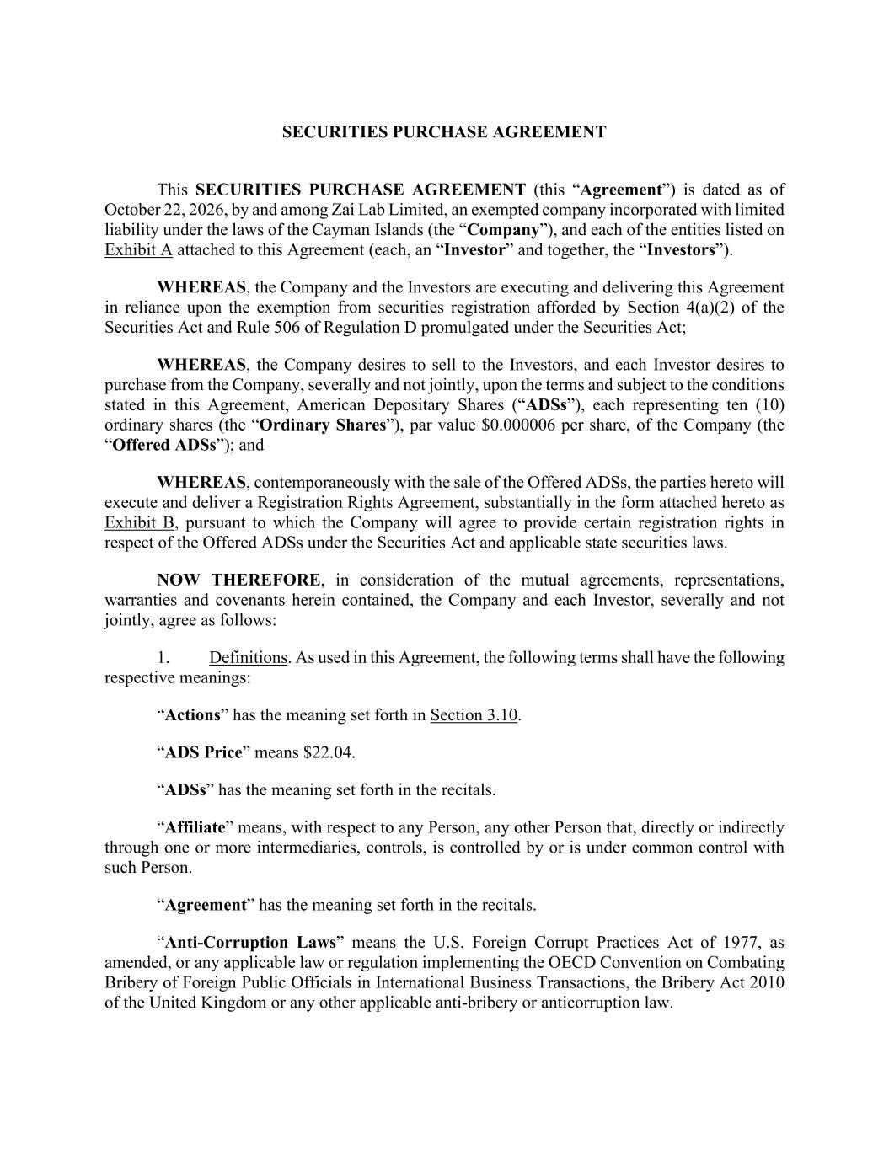

SECURITIES PURCHASE AGREEMENT This SECURITIES PURCHASE AGREEMENT (this “Agreement”) is dated as of October 22, 2026, by and among Zai Lab Limited, an exempted company incorporated with limited liability under the laws of the Cayman Islands (the “Company”), and each of the entities listed on Exhibit A attached to this Agreement (each, an “Investor” and together, the “Investors”). WHEREAS, the Company and the Investors are executing and delivering this Agreement in reliance upon the exemption from securities registration afforded by Section 4(a)(2) of the Securities Act and Rule 506 of Regulation D promulgated under the Securities Act; WHEREAS, the Company desires to sell to the Investors, and each Investor desires to purchase from the Company, severally and not jointly, upon the terms and subject to the conditions stated in this Agreement, American Depositary Shares (“ADSs”), each representing ten (10) ordinary shares (the “Ordinary Shares”), par value $0.000006 per share, of the Company (the “Offered ADSs”); and WHEREAS, contemporaneously with the sale of the Offered ADSs, the parties hereto will execute and deliver a Registration Rights Agreement, substantially in the form attached hereto as Exhibit B, pursuant to which the Company will agree to provide certain registration rights in respect of the Offered ADSs under the Securities Act and applicable state securities laws. NOW THEREFORE, in consideration of the mutual agreements, representations, warranties and covenants herein contained, the Company and each Investor, severally and not jointly, agree as follows: 1. Definitions. As used in this Agreement, the following terms shall have the following respective meanings: “Actions” has the meaning set forth in Section 3.10. “ADS Price” means $22.04. “ADSs” has the meaning set forth in the recitals. “Affiliate” means, with respect to any Person, any other Person that, directly or indirectly through one or more intermediaries, controls, is controlled by or is under common control with such Person. “Agreement” has the meaning set forth in the recitals. “Anti-Corruption Laws” means the U.S. Foreign Corrupt Practices Act of 1977, as amended, or any applicable law or regulation implementing the OECD Convention on Combating Bribery of Foreign Public Officials in International Business Transactions, the Bribery Act 2010 of the United Kingdom or any other applicable anti-bribery or anticorruption law.

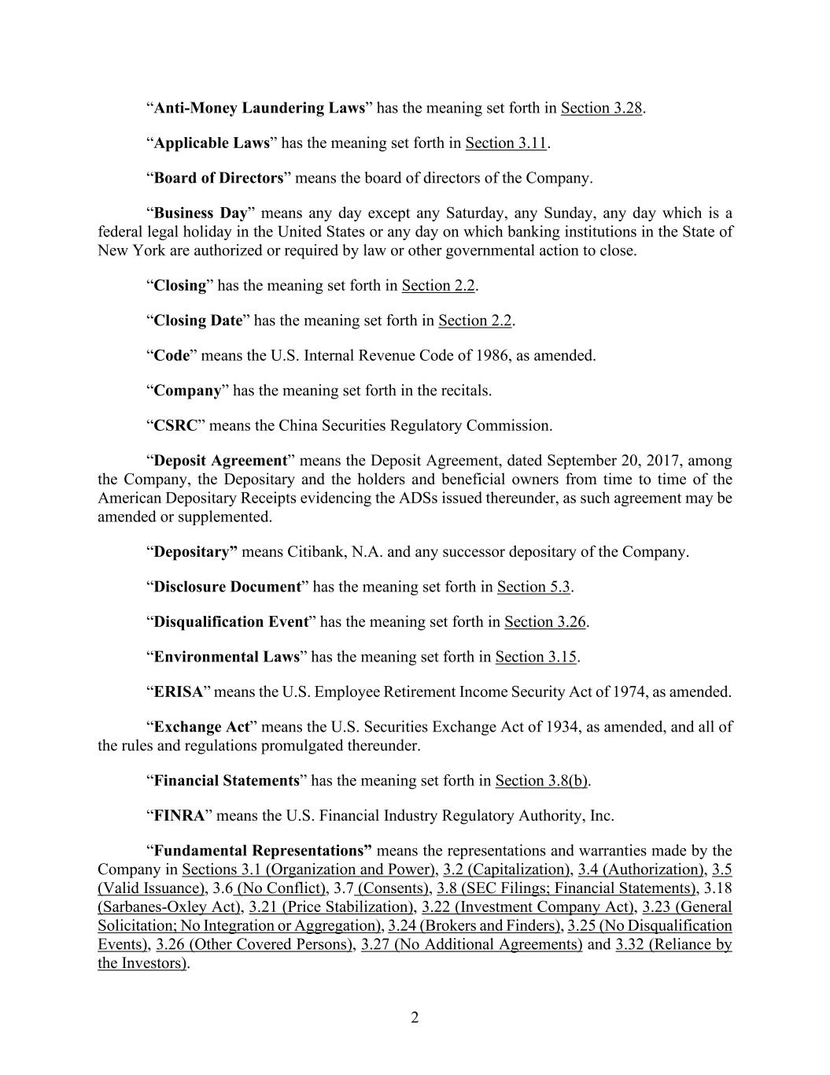
2 “Anti-Money Laundering Laws” has the meaning set forth in Section 3.28. “Applicable Laws” has the meaning set forth in Section 3.11. “Board of Directors” means the board of directors of the Company. “Business Day” means any day except any Saturday, any Sunday, any day which is a federal legal holiday in the United States or any day on which banking institutions in the State of New York are authorized or required by law or other governmental action to close. “Closing” has the meaning set forth in Section 2.2. “Closing Date” has the meaning set forth in Section 2.2. “Code” means the U.S. Internal Revenue Code of 1986, as amended. “Company” has the meaning set forth in the recitals. “CSRC” means the China Securities Regulatory Commission. “Deposit Agreement” means the Deposit Agreement, dated September 20, 2017, among the Company, the Depositary and the holders and beneficial owners from time to time of the American Depositary Receipts evidencing the ADSs issued thereunder, as such agreement may be amended or supplemented. “Depositary” means Citibank, N.A. and any successor depositary of the Company. “Disclosure Document” has the meaning set forth in Section 5.3. “Disqualification Event” has the meaning set forth in Section 3.26. “Environmental Laws” has the meaning set forth in Section 3.15. “ERISA” means the U.S. Employee Retirement Income Security Act of 1974, as amended. “Exchange Act” means the U.S. Securities Exchange Act of 1934, as amended, and all of the rules and regulations promulgated thereunder. “Financial Statements” has the meaning set forth in Section 3.8(b). “FINRA” means the U.S. Financial Industry Regulatory Authority, Inc. “Fundamental Representations” means the representations and warranties made by the Company in Sections 3.1 (Organization and Power), 3.2 (Capitalization), 3.4 (Authorization), 3.5 (Valid Issuance), 3.6 (No Conflict), 3.7 (Consents), 3.8 (SEC Filings; Financial Statements), 3.18 (Sarbanes-Oxley Act), 3.21 (Price Stabilization), 3.22 (Investment Company Act), 3.23 (General Solicitation; No Integration or Aggregation), 3.24 (Brokers and Finders), 3.25 (No Disqualification Events), 3.26 (Other Covered Persons), 3.27 (No Additional Agreements) and 3.32 (Reliance by the Investors).

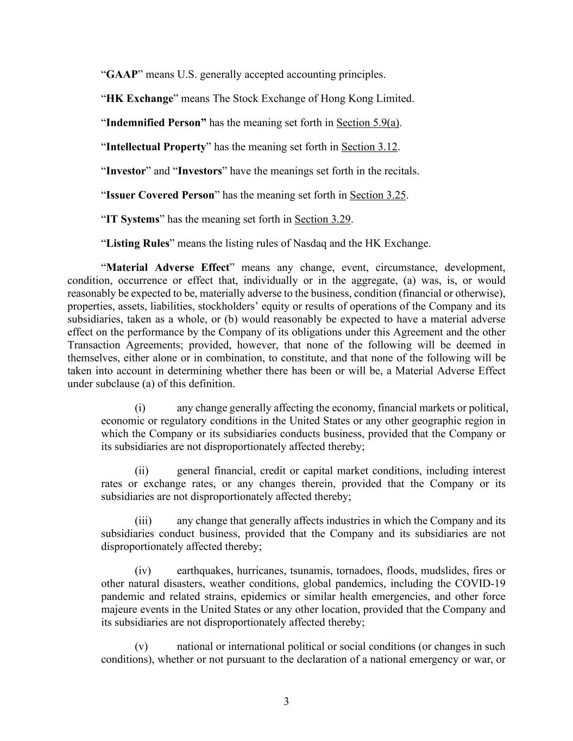
3 “GAAP” means U.S. generally accepted accounting principles. “HK Exchange” means The Stock Exchange of Hong Kong Limited. “Indemnified Person” has the meaning set forth in Section 5.9(a). “Intellectual Property” has the meaning set forth in Section 3.12. “Investor” and “Investors” have the meanings set forth in the recitals. “Issuer Covered Person” has the meaning set forth in Section 3.25. “IT Systems” has the meaning set forth in Section 3.29. “Listing Rules” means the listing rules of Nasdaq and the HK Exchange. “Material Adverse Effect” means any change, event, circumstance, development, condition, occurrence or effect that, individually or in the aggregate, (a) was, is, or would reasonably be expected to be, materially adverse to the business, condition (financial or otherwise), properties, assets, liabilities, stockholders’ equity or results of operations of the Company and its subsidiaries, taken as a whole, or (b) would reasonably be expected to have a material adverse effect on the performance by the Company of its obligations under this Agreement and the other Transaction Agreements; provided, however, that none of the following will be deemed in themselves, either alone or in combination, to constitute, and that none of the following will be taken into account in determining whether there has been or will be, a Material Adverse Effect under subclause (a) of this definition. (i) any change generally affecting the economy, financial markets or political, economic or regulatory conditions in the United States or any other geographic region in which the Company or its subsidiaries conducts business, provided that the Company or its subsidiaries are not disproportionately affected thereby; (ii) general financial, credit or capital market conditions, including interest rates or exchange rates, or any changes therein, provided that the Company or its subsidiaries are not disproportionately affected thereby; (iii) any change that generally affects industries in which the Company and its subsidiaries conduct business, provided that the Company and its subsidiaries are not disproportionately affected thereby; (iv) earthquakes, hurricanes, tsunamis, tornadoes, floods, mudslides, fires or other natural disasters, weather conditions, global pandemics, including the COVID-19 pandemic and related strains, epidemics or similar health emergencies, and other force majeure events in the United States or any other location, provided that the Company and its subsidiaries are not disproportionately affected thereby; (v) national or international political or social conditions (or changes in such conditions), whether or not pursuant to the declaration of a national emergency or war, or

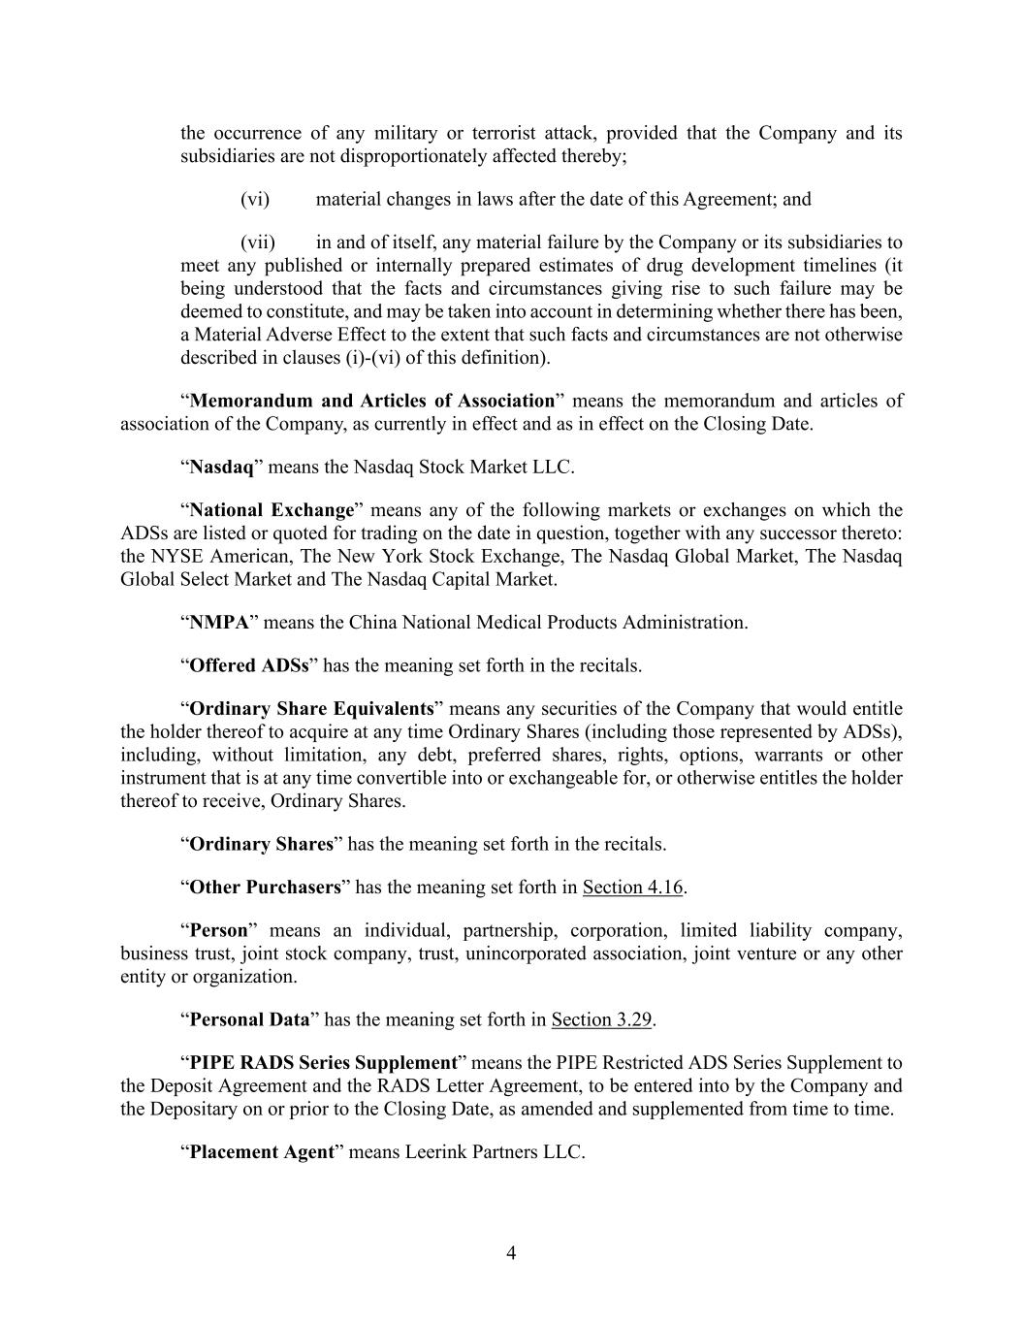
4 the occurrence of any military or terrorist attack, provided that the Company and its subsidiaries are not disproportionately affected thereby; (vi) material changes in laws after the date of this Agreement; and (vii) in and of itself, any material failure by the Company or its subsidiaries to meet any published or internally prepared estimates of drug development timelines (it being understood that the facts and circumstances giving rise to such failure may be deemed to constitute, and may be taken into account in determining whether there has been, a Material Adverse Effect to the extent that such facts and circumstances are not otherwise described in clauses (i)-(vi) of this definition). “Memorandum and Articles of Association” means the memorandum and articles of association of the Company, as currently in effect and as in effect on the Closing Date. “Nasdaq” means the Nasdaq Stock Market LLC. “National Exchange” means any of the following markets or exchanges on which the ADSs are listed or quoted for trading on the date in question, together with any successor thereto: the NYSE American, The New York Stock Exchange, The Nasdaq Global Market, The Nasdaq Global Select Market and The Nasdaq Capital Market. “NMPA” means the China National Medical Products Administration. “Offered ADSs” has the meaning set forth in the recitals. “Ordinary Share Equivalents” means any securities of the Company that would entitle the holder thereof to acquire at any time Ordinary Shares (including those represented by ADSs), including, without limitation, any debt, preferred shares, rights, options, warrants or other instrument that is at any time convertible into or exchangeable for, or otherwise entitles the holder thereof to receive, Ordinary Shares. “Ordinary Shares” has the meaning set forth in the recitals. “Other Purchasers” has the meaning set forth in Section 4.16. “Person” means an individual, partnership, corporation, limited liability company, business trust, joint stock company, trust, unincorporated association, joint venture or any other entity or organization. “Personal Data” has the meaning set forth in Section 3.29. “PIPE RADS Series Supplement” means the PIPE Restricted ADS Series Supplement to the Deposit Agreement and the RADS Letter Agreement, to be entered into by the Company and the Depositary on or prior to the Closing Date, as amended and supplemented from time to time. “Placement Agent” means Leerink Partners LLC.

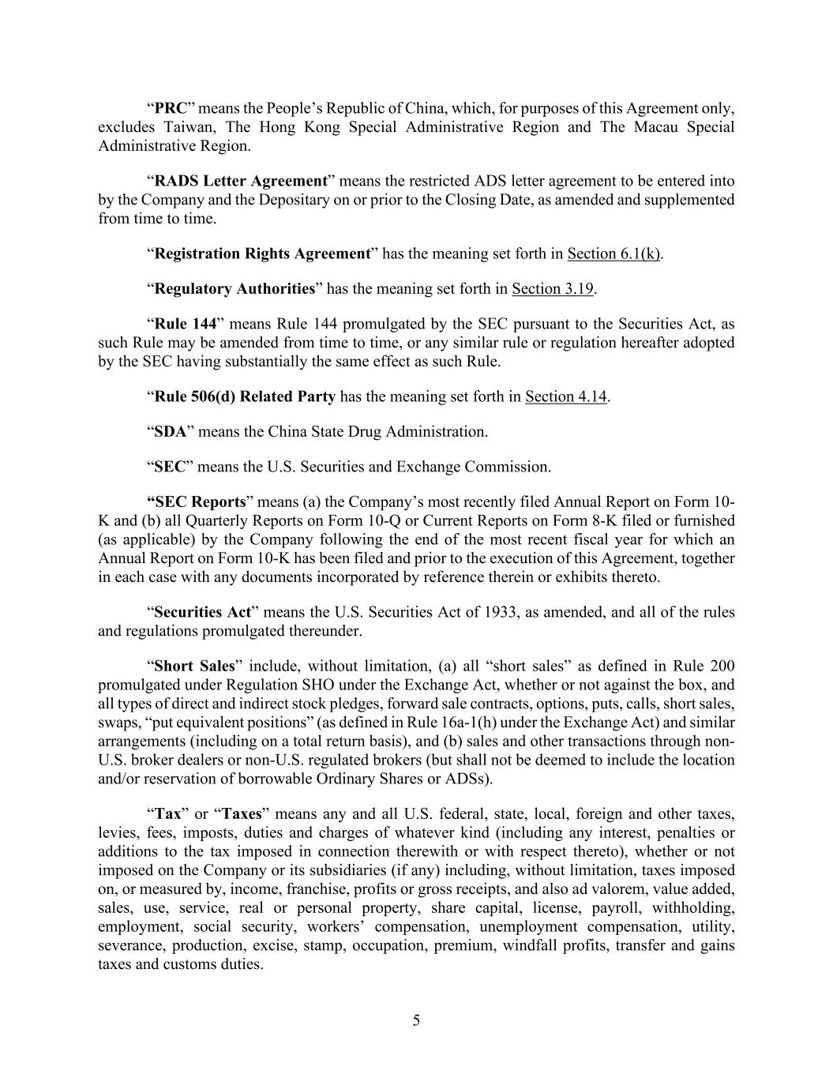
5 “PRC” means the People’s Republic of China, which, for purposes of this Agreement only, excludes Taiwan, The Hong Kong Special Administrative Region and The Macau Special Administrative Region. “RADS Letter Agreement” means the restricted ADS letter agreement to be entered into by the Company and the Depositary on or prior to the Closing Date, as amended and supplemented from time to time. “Registration Rights Agreement” has the meaning set forth in Section 6.1(k). “Regulatory Authorities” has the meaning set forth in Section 3.19. “Rule 144” means Rule 144 promulgated by the SEC pursuant to the Securities Act, as such Rule may be amended from time to time, or any similar rule or regulation hereafter adopted by the SEC having substantially the same effect as such Rule. “Rule 506(d) Related Party has the meaning set forth in Section 4.14. “SDA” means the China State Drug Administration. “SEC” means the U.S. Securities and Exchange Commission. “SEC Reports” means (a) the Company’s most recently filed Annual Report on Form 10- K and (b) all Quarterly Reports on Form 10-Q or Current Reports on Form 8-K filed or furnished (as applicable) by the Company following the end of the most recent fiscal year for which an Annual Report on Form 10-K has been filed and prior to the execution of this Agreement, together in each case with any documents incorporated by reference therein or exhibits thereto. “Securities Act” means the U.S. Securities Act of 1933, as amended, and all of the rules and regulations promulgated thereunder. “Short Sales” include, without limitation, (a) all “short sales” as defined in Rule 200 promulgated under Regulation SHO under the Exchange Act, whether or not against the box, and all types of direct and indirect stock pledges, forward sale contracts, options, puts, calls, short sales, swaps, “put equivalent positions” (as defined in Rule 16a-1(h) under the Exchange Act) and similar arrangements (including on a total return basis), and (b) sales and other transactions through non- U.S. broker dealers or non-U.S. regulated brokers (but shall not be deemed to include the location and/or reservation of borrowable Ordinary Shares or ADSs). “Tax” or “Taxes” means any and all U.S. federal, state, local, foreign and other taxes, levies, fees, imposts, duties and charges of whatever kind (including any interest, penalties or additions to the tax imposed in connection therewith or with respect thereto), whether or not imposed on the Company or its subsidiaries (if any) including, without limitation, taxes imposed on, or measured by, income, franchise, profits or gross receipts, and also ad valorem, value added, sales, use, service, real or personal property, share capital, license, payroll, withholding, employment, social security, workers’ compensation, unemployment compensation, utility, severance, production, excise, stamp, occupation, premium, windfall profits, transfer and gains taxes and customs duties.

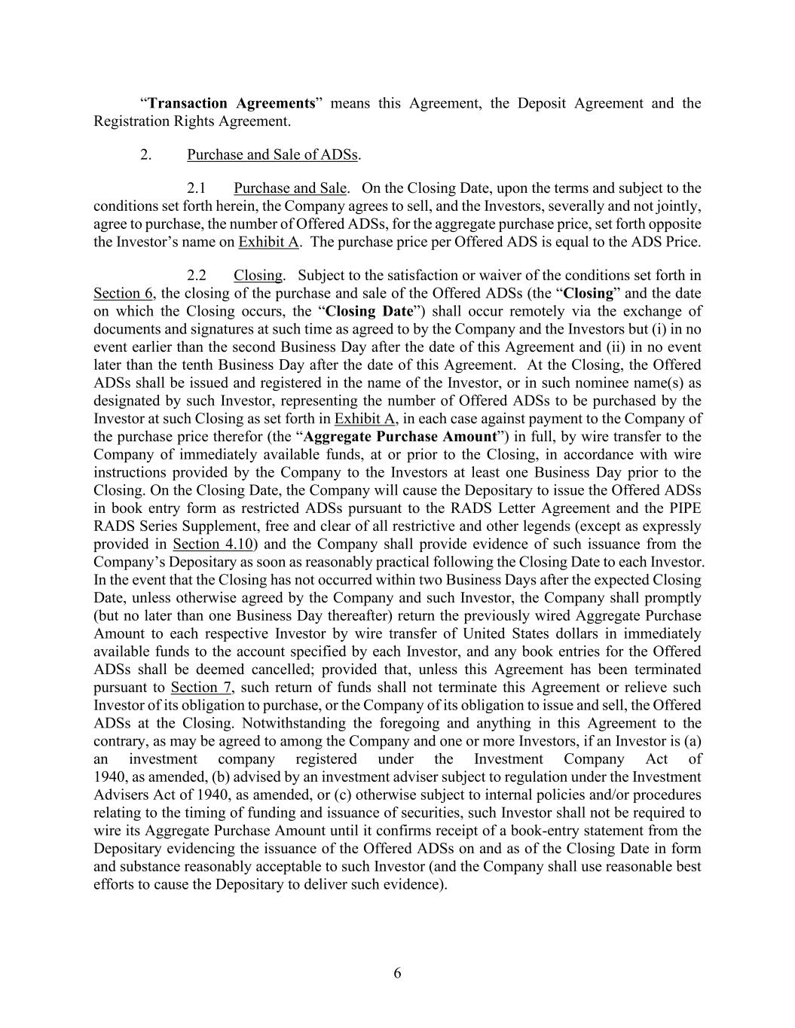
6 “Transaction Agreements” means this Agreement, the Deposit Agreement and the Registration Rights Agreement. 2. Purchase and Sale of ADSs. 2.1 Purchase and Sale. On the Closing Date, upon the terms and subject to the conditions set forth herein, the Company agrees to sell, and the Investors, severally and not jointly, agree to purchase, the number of Offered ADSs, for the aggregate purchase price, set forth opposite the Investor’s name on Exhibit A. The purchase price per Offered ADS is equal to the ADS Price. 2.2 Closing. Subject to the satisfaction or waiver of the conditions set forth in Section 6, the closing of the purchase and sale of the Offered ADSs (the “Closing” and the date on which the Closing occurs, the “Closing Date”) shall occur remotely via the exchange of documents and signatures at such time as agreed to by the Company and the Investors but (i) in no event earlier than the second Business Day after the date of this Agreement and (ii) in no event later than the tenth Business Day after the date of this Agreement. At the Closing, the Offered ADSs shall be issued and registered in the name of the Investor, or in such nominee name(s) as designated by such Investor, representing the number of Offered ADSs to be purchased by the Investor at such Closing as set forth in Exhibit A, in each case against payment to the Company of the purchase price therefor (the “Aggregate Purchase Amount”) in full, by wire transfer to the Company of immediately available funds, at or prior to the Closing, in accordance with wire instructions provided by the Company to the Investors at least one Business Day prior to the Closing. On the Closing Date, the Company will cause the Depositary to issue the Offered ADSs in book entry form as restricted ADSs pursuant to the RADS Letter Agreement and the PIPE RADS Series Supplement, free and clear of all restrictive and other legends (except as expressly provided in Section 4.10) and the Company shall provide evidence of such issuance from the Company’s Depositary as soon as reasonably practical following the Closing Date to each Investor. In the event that the Closing has not occurred within two Business Days after the expected Closing Date, unless otherwise agreed by the Company and such Investor, the Company shall promptly (but no later than one Business Day thereafter) return the previously wired Aggregate Purchase Amount to each respective Investor by wire transfer of United States dollars in immediately available funds to the account specified by each Investor, and any book entries for the Offered ADSs shall be deemed cancelled; provided that, unless this Agreement has been terminated pursuant to Section 7, such return of funds shall not terminate this Agreement or relieve such Investor of its obligation to purchase, or the Company of its obligation to issue and sell, the Offered ADSs at the Closing. Notwithstanding the foregoing and anything in this Agreement to the contrary, as may be agreed to among the Company and one or more Investors, if an Investor is (a) an investment company registered under the Investment Company Act of 1940, as amended, (b) advised by an investment adviser subject to regulation under the Investment Advisers Act of 1940, as amended, or (c) otherwise subject to internal policies and/or procedures relating to the timing of funding and issuance of securities, such Investor shall not be required to wire its Aggregate Purchase Amount until it confirms receipt of a book-entry statement from the Depositary evidencing the issuance of the Offered ADSs on and as of the Closing Date in form and substance reasonably acceptable to such Investor (and the Company shall use reasonable best efforts to cause the Depositary to deliver such evidence).

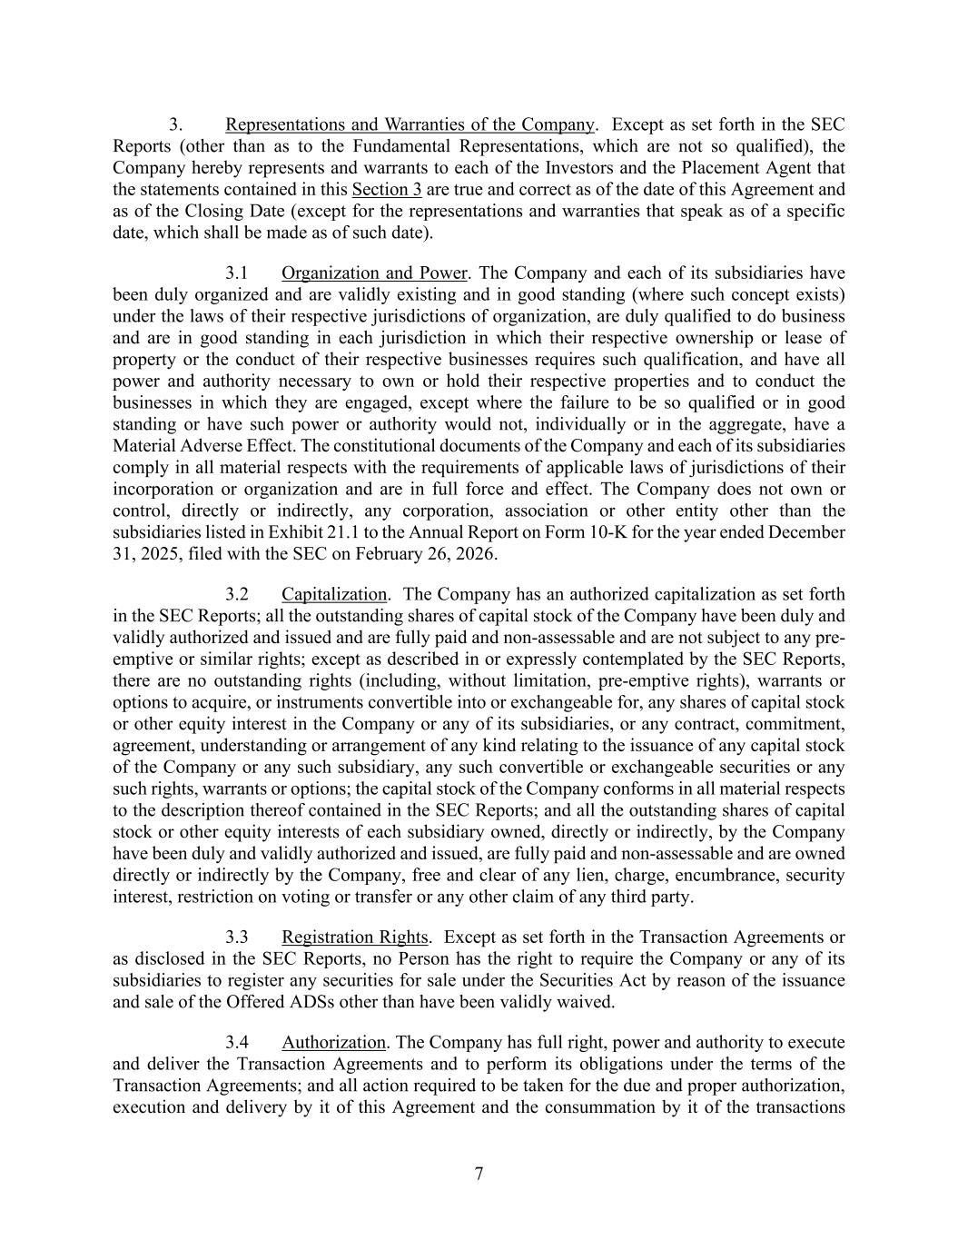
7 3. Representations and Warranties of the Company. Except as set forth in the SEC Reports (other than as to the Fundamental Representations, which are not so qualified), the Company hereby represents and warrants to each of the Investors and the Placement Agent that the statements contained in this Section 3 are true and correct as of the date of this Agreement and as of the Closing Date (except for the representations and warranties that speak as of a specific date, which shall be made as of such date). 3.1 Organization and Power. The Company and each of its subsidiaries have been duly organized and are validly existing and in good standing (where such concept exists) under the laws of their respective jurisdictions of organization, are duly qualified to do business and are in good standing in each jurisdiction in which their respective ownership or lease of property or the conduct of their respective businesses requires such qualification, and have all power and authority necessary to own or hold their respective properties and to conduct the businesses in which they are engaged, except where the failure to be so qualified or in good standing or have such power or authority would not, individually or in the aggregate, have a Material Adverse Effect. The constitutional documents of the Company and each of its subsidiaries comply in all material respects with the requirements of applicable laws of jurisdictions of their incorporation or organization and are in full force and effect. The Company does not own or control, directly or indirectly, any corporation, association or other entity other than the subsidiaries listed in Exhibit 21.1 to the Annual Report on Form 10-K for the year ended December 31, 2025, filed with the SEC on February 26, 2026. 3.2 Capitalization. The Company has an authorized capitalization as set forth in the SEC Reports; all the outstanding shares of capital stock of the Company have been duly and validly authorized and issued and are fully paid and non-assessable and are not subject to any pre- emptive or similar rights; except as described in or expressly contemplated by the SEC Reports, there are no outstanding rights (including, without limitation, pre-emptive rights), warrants or options to acquire, or instruments convertible into or exchangeable for, any shares of capital stock or other equity interest in the Company or any of its subsidiaries, or any contract, commitment, agreement, understanding or arrangement of any kind relating to the issuance of any capital stock of the Company or any such subsidiary, any such convertible or exchangeable securities or any such rights, warrants or options; the capital stock of the Company conforms in all material respects to the description thereof contained in the SEC Reports; and all the outstanding shares of capital stock or other equity interests of each subsidiary owned, directly or indirectly, by the Company have been duly and validly authorized and issued, are fully paid and non-assessable and are owned directly or indirectly by the Company, free and clear of any lien, charge, encumbrance, security interest, restriction on voting or transfer or any other claim of any third party. 3.3 Registration Rights. Except as set forth in the Transaction Agreements or as disclosed in the SEC Reports, no Person has the right to require the Company or any of its subsidiaries to register any securities for sale under the Securities Act by reason of the issuance and sale of the Offered ADSs other than have been validly waived. 3.4 Authorization. The Company has full right, power and authority to execute and deliver the Transaction Agreements and to perform its obligations under the terms of the Transaction Agreements; and all action required to be taken for the due and proper authorization, execution and delivery by it of this Agreement and the consummation by it of the transactions

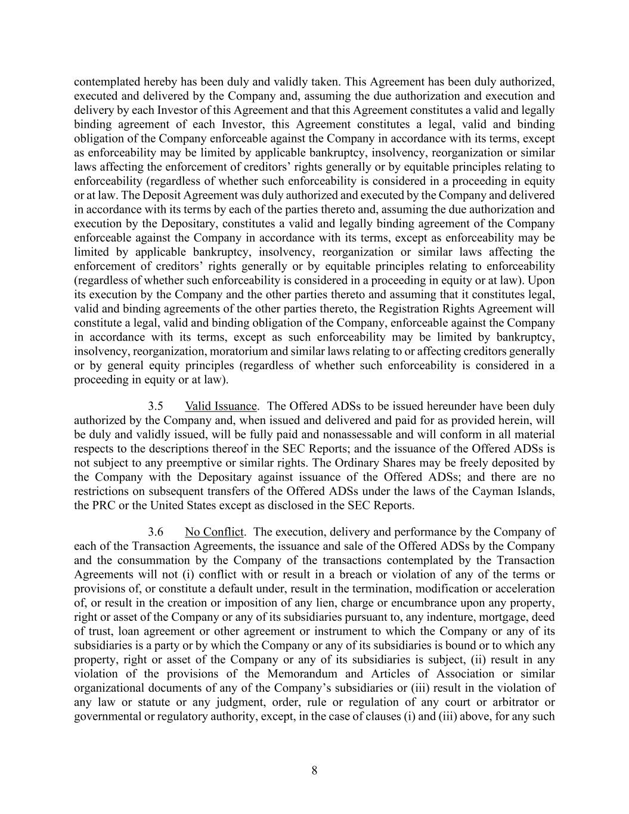
8 contemplated hereby has been duly and validly taken. This Agreement has been duly authorized, executed and delivered by the Company and, assuming the due authorization and execution and delivery by each Investor of this Agreement and that this Agreement constitutes a valid and legally binding agreement of each Investor, this Agreement constitutes a legal, valid and binding obligation of the Company enforceable against the Company in accordance with its terms, except as enforceability may be limited by applicable bankruptcy, insolvency, reorganization or similar laws affecting the enforcement of creditors’ rights generally or by equitable principles relating to enforceability (regardless of whether such enforceability is considered in a proceeding in equity or at law. The Deposit Agreement was duly authorized and executed by the Company and delivered in accordance with its terms by each of the parties thereto and, assuming the due authorization and execution by the Depositary, constitutes a valid and legally binding agreement of the Company enforceable against the Company in accordance with its terms, except as enforceability may be limited by applicable bankruptcy, insolvency, reorganization or similar laws affecting the enforcement of creditors’ rights generally or by equitable principles relating to enforceability (regardless of whether such enforceability is considered in a proceeding in equity or at law). Upon its execution by the Company and the other parties thereto and assuming that it constitutes legal, valid and binding agreements of the other parties thereto, the Registration Rights Agreement will constitute a legal, valid and binding obligation of the Company, enforceable against the Company in accordance with its terms, except as such enforceability may be limited by bankruptcy, insolvency, reorganization, moratorium and similar laws relating to or affecting creditors generally or by general equity principles (regardless of whether such enforceability is considered in a proceeding in equity or at law). 3.5 Valid Issuance. The Offered ADSs to be issued hereunder have been duly authorized by the Company and, when issued and delivered and paid for as provided herein, will be duly and validly issued, will be fully paid and nonassessable and will conform in all material respects to the descriptions thereof in the SEC Reports; and the issuance of the Offered ADSs is not subject to any preemptive or similar rights. The Ordinary Shares may be freely deposited by the Company with the Depositary against issuance of the Offered ADSs; and there are no restrictions on subsequent transfers of the Offered ADSs under the laws of the Cayman Islands, the PRC or the United States except as disclosed in the SEC Reports. 3.6 No Conflict. The execution, delivery and performance by the Company of each of the Transaction Agreements, the issuance and sale of the Offered ADSs by the Company and the consummation by the Company of the transactions contemplated by the Transaction Agreements will not (i) conflict with or result in a breach or violation of any of the terms or provisions of, or constitute a default under, result in the termination, modification or acceleration of, or result in the creation or imposition of any lien, charge or encumbrance upon any property, right or asset of the Company or any of its subsidiaries pursuant to, any indenture, mortgage, deed of trust, loan agreement or other agreement or instrument to which the Company or any of its subsidiaries is a party or by which the Company or any of its subsidiaries is bound or to which any property, right or asset of the Company or any of its subsidiaries is subject, (ii) result in any violation of the provisions of the Memorandum and Articles of Association or similar organizational documents of any of the Company’s subsidiaries or (iii) result in the violation of any law or statute or any judgment, order, rule or regulation of any court or arbitrator or governmental or regulatory authority, except, in the case of clauses (i) and (iii) above, for any such

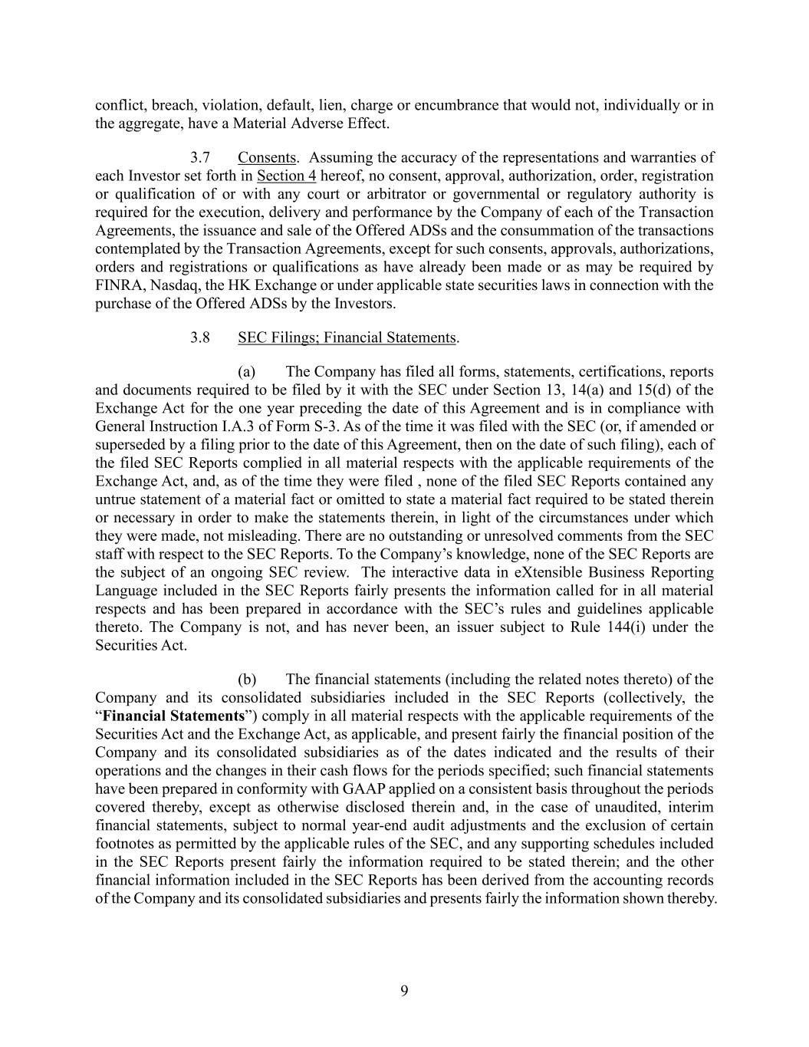
9 conflict, breach, violation, default, lien, charge or encumbrance that would not, individually or in the aggregate, have a Material Adverse Effect. 3.7 Consents. Assuming the accuracy of the representations and warranties of each Investor set forth in Section 4 hereof, no consent, approval, authorization, order, registration or qualification of or with any court or arbitrator or governmental or regulatory authority is required for the execution, delivery and performance by the Company of each of the Transaction Agreements, the issuance and sale of the Offered ADSs and the consummation of the transactions contemplated by the Transaction Agreements, except for such consents, approvals, authorizations, orders and registrations or qualifications as have already been made or as may be required by FINRA, Nasdaq, the HK Exchange or under applicable state securities laws in connection with the purchase of the Offered ADSs by the Investors. 3.8 SEC Filings; Financial Statements. (a) The Company has filed all forms, statements, certifications, reports and documents required to be filed by it with the SEC under Section 13, 14(a) and 15(d) of the Exchange Act for the one year preceding the date of this Agreement and is in compliance with General Instruction I.A.3 of Form S-3. As of the time it was filed with the SEC (or, if amended or superseded by a filing prior to the date of this Agreement, then on the date of such filing), each of the filed SEC Reports complied in all material respects with the applicable requirements of the Exchange Act, and, as of the time they were filed , none of the filed SEC Reports contained any untrue statement of a material fact or omitted to state a material fact required to be stated therein or necessary in order to make the statements therein, in light of the circumstances under which they were made, not misleading. There are no outstanding or unresolved comments from the SEC staff with respect to the SEC Reports. To the Company’s knowledge, none of the SEC Reports are the subject of an ongoing SEC review. The interactive data in eXtensible Business Reporting Language included in the SEC Reports fairly presents the information called for in all material respects and has been prepared in accordance with the SEC’s rules and guidelines applicable thereto. The Company is not, and has never been, an issuer subject to Rule 144(i) under the Securities Act. (b) The financial statements (including the related notes thereto) of the Company and its consolidated subsidiaries included in the SEC Reports (collectively, the “Financial Statements”) comply in all material respects with the applicable requirements of the Securities Act and the Exchange Act, as applicable, and present fairly the financial position of the Company and its consolidated subsidiaries as of the dates indicated and the results of their operations and the changes in their cash flows for the periods specified; such financial statements have been prepared in conformity with GAAP applied on a consistent basis throughout the periods covered thereby, except as otherwise disclosed therein and, in the case of unaudited, interim financial statements, subject to normal year-end audit adjustments and the exclusion of certain footnotes as permitted by the applicable rules of the SEC, and any supporting schedules included in the SEC Reports present fairly the information required to be stated therein; and the other financial information included in the SEC Reports has been derived from the accounting records of the Company and its consolidated subsidiaries and presents fairly the information shown thereby.

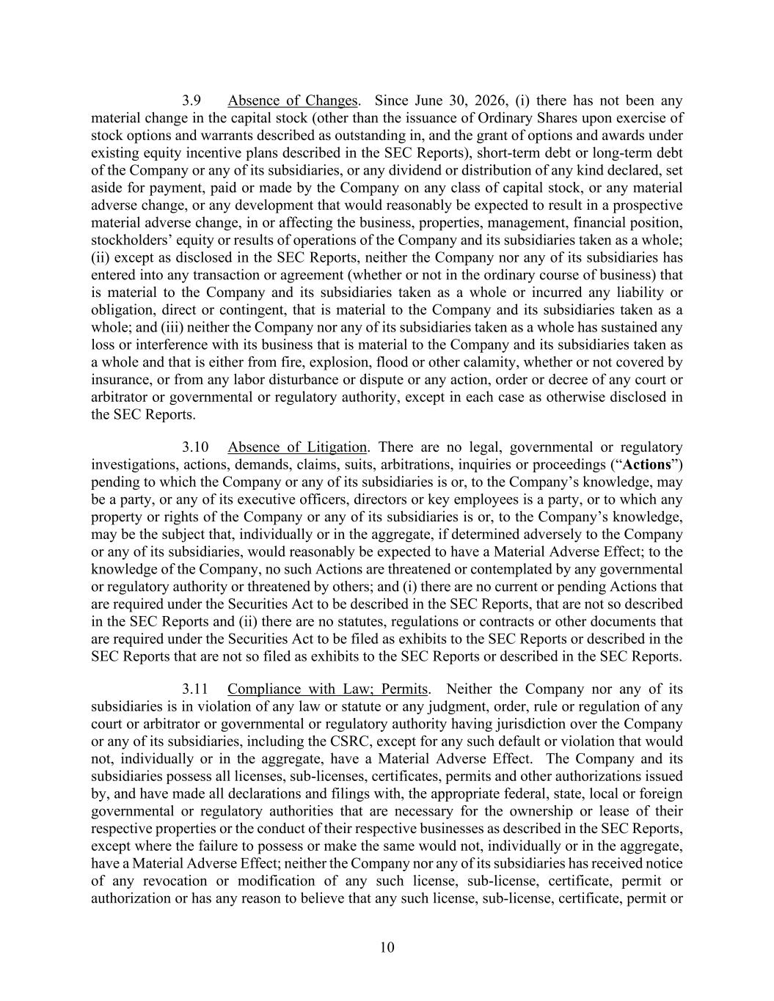
10 3.9 Absence of Changes. Since June 30, 2026, (i) there has not been any material change in the capital stock (other than the issuance of Ordinary Shares upon exercise of stock options and warrants described as outstanding in, and the grant of options and awards under existing equity incentive plans described in the SEC Reports), short-term debt or long-term debt of the Company or any of its subsidiaries, or any dividend or distribution of any kind declared, set aside for payment, paid or made by the Company on any class of capital stock, or any material adverse change, or any development that would reasonably be expected to result in a prospective material adverse change, in or affecting the business, properties, management, financial position, stockholders’ equity or results of operations of the Company and its subsidiaries taken as a whole; (ii) except as disclosed in the SEC Reports, neither the Company nor any of its subsidiaries has entered into any transaction or agreement (whether or not in the ordinary course of business) that is material to the Company and its subsidiaries taken as a whole or incurred any liability or obligation, direct or contingent, that is material to the Company and its subsidiaries taken as a whole; and (iii) neither the Company nor any of its subsidiaries taken as a whole has sustained any loss or interference with its business that is material to the Company and its subsidiaries taken as a whole and that is either from fire, explosion, flood or other calamity, whether or not covered by insurance, or from any labor disturbance or dispute or any action, order or decree of any court or arbitrator or governmental or regulatory authority, except in each case as otherwise disclosed in the SEC Reports. 3.10 Absence of Litigation. There are no legal, governmental or regulatory investigations, actions, demands, claims, suits, arbitrations, inquiries or proceedings (“Actions”) pending to which the Company or any of its subsidiaries is or, to the Company’s knowledge, may be a party, or any of its executive officers, directors or key employees is a party, or to which any property or rights of the Company or any of its subsidiaries is or, to the Company’s knowledge, may be the subject that, individually or in the aggregate, if determined adversely to the Company or any of its subsidiaries, would reasonably be expected to have a Material Adverse Effect; to the knowledge of the Company, no such Actions are threatened or contemplated by any governmental or regulatory authority or threatened by others; and (i) there are no current or pending Actions that are required under the Securities Act to be described in the SEC Reports, that are not so described in the SEC Reports and (ii) there are no statutes, regulations or contracts or other documents that are required under the Securities Act to be filed as exhibits to the SEC Reports or described in the SEC Reports that are not so filed as exhibits to the SEC Reports or described in the SEC Reports. 3.11 Compliance with Law; Permits. Neither the Company nor any of its subsidiaries is in violation of any law or statute or any judgment, order, rule or regulation of any court or arbitrator or governmental or regulatory authority having jurisdiction over the Company or any of its subsidiaries, including the CSRC, except for any such default or violation that would not, individually or in the aggregate, have a Material Adverse Effect. The Company and its subsidiaries possess all licenses, sub-licenses, certificates, permits and other authorizations issued by, and have made all declarations and filings with, the appropriate federal, state, local or foreign governmental or regulatory authorities that are necessary for the ownership or lease of their respective properties or the conduct of their respective businesses as described in the SEC Reports, except where the failure to possess or make the same would not, individually or in the aggregate, have a Material Adverse Effect; neither the Company nor any of its subsidiaries has received notice of any revocation or modification of any such license, sub-license, certificate, permit or authorization or has any reason to believe that any such license, sub-license, certificate, permit or

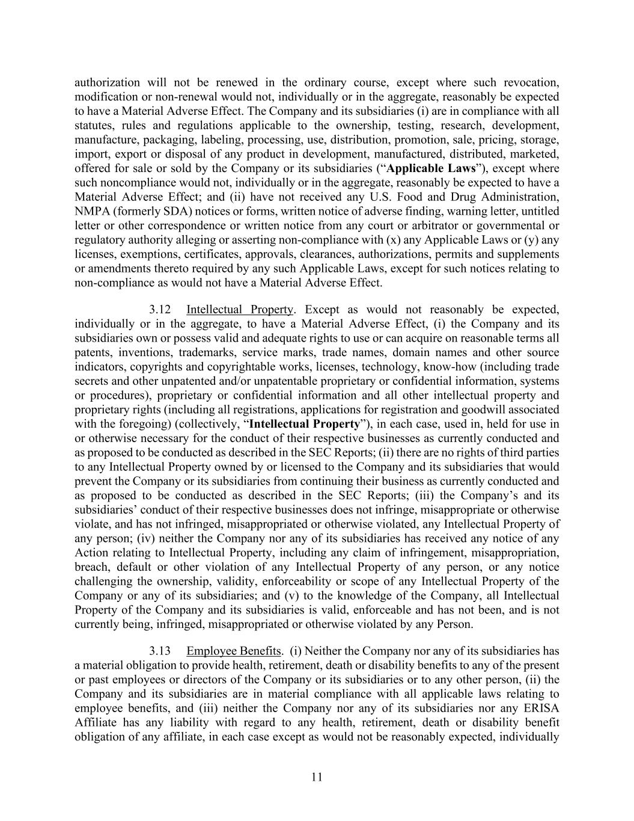
11 authorization will not be renewed in the ordinary course, except where such revocation, modification or non-renewal would not, individually or in the aggregate, reasonably be expected to have a Material Adverse Effect. The Company and its subsidiaries (i) are in compliance with all statutes, rules and regulations applicable to the ownership, testing, research, development, manufacture, packaging, labeling, processing, use, distribution, promotion, sale, pricing, storage, import, export or disposal of any product in development, manufactured, distributed, marketed, offered for sale or sold by the Company or its subsidiaries (“Applicable Laws”), except where such noncompliance would not, individually or in the aggregate, reasonably be expected to have a Material Adverse Effect; and (ii) have not received any U.S. Food and Drug Administration, NMPA (formerly SDA) notices or forms, written notice of adverse finding, warning letter, untitled letter or other correspondence or written notice from any court or arbitrator or governmental or regulatory authority alleging or asserting non-compliance with (x) any Applicable Laws or (y) any licenses, exemptions, certificates, approvals, clearances, authorizations, permits and supplements or amendments thereto required by any such Applicable Laws, except for such notices relating to non-compliance as would not have a Material Adverse Effect. 3.12 Intellectual Property. Except as would not reasonably be expected, individually or in the aggregate, to have a Material Adverse Effect, (i) the Company and its subsidiaries own or possess valid and adequate rights to use or can acquire on reasonable terms all patents, inventions, trademarks, service marks, trade names, domain names and other source indicators, copyrights and copyrightable works, licenses, technology, know-how (including trade secrets and other unpatented and/or unpatentable proprietary or confidential information, systems or procedures), proprietary or confidential information and all other intellectual property and proprietary rights (including all registrations, applications for registration and goodwill associated with the foregoing) (collectively, “Intellectual Property”), in each case, used in, held for use in or otherwise necessary for the conduct of their respective businesses as currently conducted and as proposed to be conducted as described in the SEC Reports; (ii) there are no rights of third parties to any Intellectual Property owned by or licensed to the Company and its subsidiaries that would prevent the Company or its subsidiaries from continuing their business as currently conducted and as proposed to be conducted as described in the SEC Reports; (iii) the Company’s and its subsidiaries’ conduct of their respective businesses does not infringe, misappropriate or otherwise violate, and has not infringed, misappropriated or otherwise violated, any Intellectual Property of any person; (iv) neither the Company nor any of its subsidiaries has received any notice of any Action relating to Intellectual Property, including any claim of infringement, misappropriation, breach, default or other violation of any Intellectual Property of any person, or any notice challenging the ownership, validity, enforceability or scope of any Intellectual Property of the Company or any of its subsidiaries; and (v) to the knowledge of the Company, all Intellectual Property of the Company and its subsidiaries is valid, enforceable and has not been, and is not currently being, infringed, misappropriated or otherwise violated by any Person. 3.13 Employee Benefits. (i) Neither the Company nor any of its subsidiaries has a material obligation to provide health, retirement, death or disability benefits to any of the present or past employees or directors of the Company or its subsidiaries or to any other person, (ii) the Company and its subsidiaries are in material compliance with all applicable laws relating to employee benefits, and (iii) neither the Company nor any of its subsidiaries nor any ERISA Affiliate has any liability with regard to any health, retirement, death or disability benefit obligation of any affiliate, in each case except as would not be reasonably expected, individually

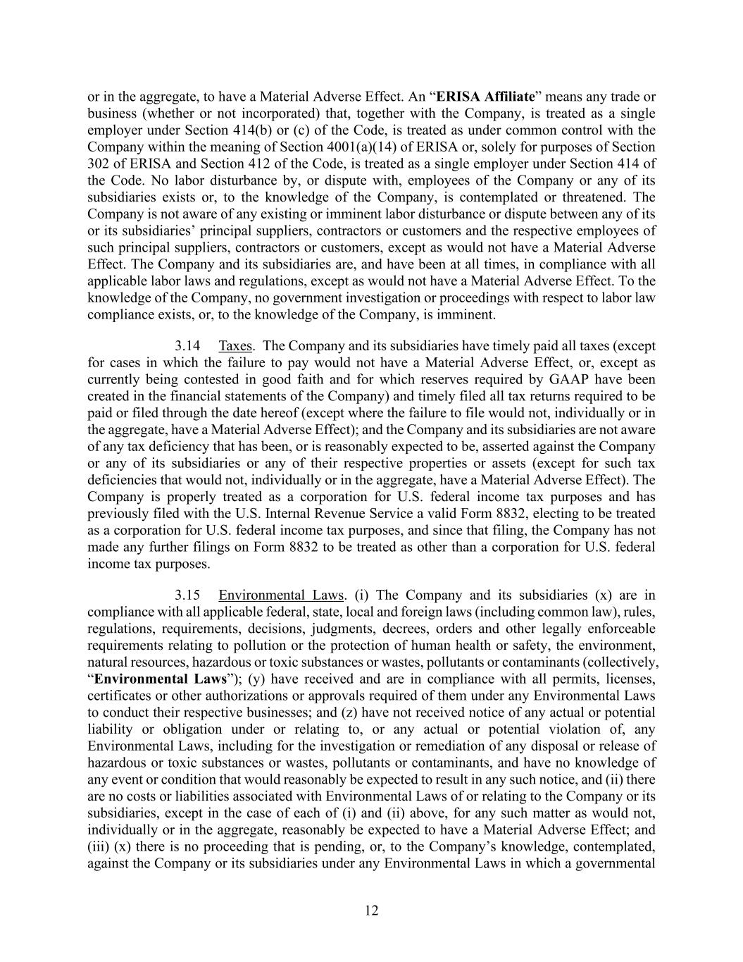
12 or in the aggregate, to have a Material Adverse Effect. An “ERISA Affiliate” means any trade or business (whether or not incorporated) that, together with the Company, is treated as a single employer under Section 414(b) or (c) of the Code, is treated as under common control with the Company within the meaning of Section 4001(a)(14) of ERISA or, solely for purposes of Section 302 of ERISA and Section 412 of the Code, is treated as a single employer under Section 414 of the Code. No labor disturbance by, or dispute with, employees of the Company or any of its subsidiaries exists or, to the knowledge of the Company, is contemplated or threatened. The Company is not aware of any existing or imminent labor disturbance or dispute between any of its or its subsidiaries’ principal suppliers, contractors or customers and the respective employees of such principal suppliers, contractors or customers, except as would not have a Material Adverse Effect. The Company and its subsidiaries are, and have been at all times, in compliance with all applicable labor laws and regulations, except as would not have a Material Adverse Effect. To the knowledge of the Company, no government investigation or proceedings with respect to labor law compliance exists, or, to the knowledge of the Company, is imminent. 3.14 Taxes. The Company and its subsidiaries have timely paid all taxes (except for cases in which the failure to pay would not have a Material Adverse Effect, or, except as currently being contested in good faith and for which reserves required by GAAP have been created in the financial statements of the Company) and timely filed all tax returns required to be paid or filed through the date hereof (except where the failure to file would not, individually or in the aggregate, have a Material Adverse Effect); and the Company and its subsidiaries are not aware of any tax deficiency that has been, or is reasonably expected to be, asserted against the Company or any of its subsidiaries or any of their respective properties or assets (except for such tax deficiencies that would not, individually or in the aggregate, have a Material Adverse Effect). The Company is properly treated as a corporation for U.S. federal income tax purposes and has previously filed with the U.S. Internal Revenue Service a valid Form 8832, electing to be treated as a corporation for U.S. federal income tax purposes, and since that filing, the Company has not made any further filings on Form 8832 to be treated as other than a corporation for U.S. federal income tax purposes. 3.15 Environmental Laws. (i) The Company and its subsidiaries (x) are in compliance with all applicable federal, state, local and foreign laws (including common law), rules, regulations, requirements, decisions, judgments, decrees, orders and other legally enforceable requirements relating to pollution or the protection of human health or safety, the environment, natural resources, hazardous or toxic substances or wastes, pollutants or contaminants (collectively, “Environmental Laws”); (y) have received and are in compliance with all permits, licenses, certificates or other authorizations or approvals required of them under any Environmental Laws to conduct their respective businesses; and (z) have not received notice of any actual or potential liability or obligation under or relating to, or any actual or potential violation of, any Environmental Laws, including for the investigation or remediation of any disposal or release of hazardous or toxic substances or wastes, pollutants or contaminants, and have no knowledge of any event or condition that would reasonably be expected to result in any such notice, and (ii) there are no costs or liabilities associated with Environmental Laws of or relating to the Company or its subsidiaries, except in the case of each of (i) and (ii) above, for any such matter as would not, individually or in the aggregate, reasonably be expected to have a Material Adverse Effect; and (iii) (x) there is no proceeding that is pending, or, to the Company’s knowledge, contemplated, against the Company or its subsidiaries under any Environmental Laws in which a governmental

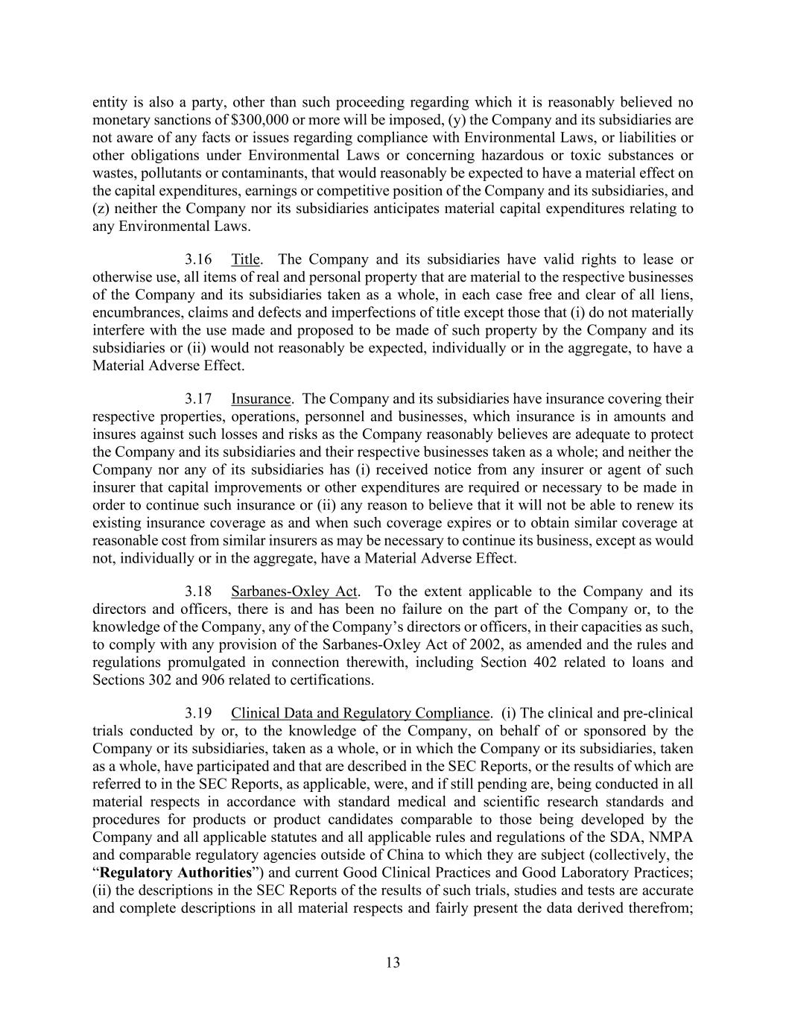
13 entity is also a party, other than such proceeding regarding which it is reasonably believed no monetary sanctions of $300,000 or more will be imposed, (y) the Company and its subsidiaries are not aware of any facts or issues regarding compliance with Environmental Laws, or liabilities or other obligations under Environmental Laws or concerning hazardous or toxic substances or wastes, pollutants or contaminants, that would reasonably be expected to have a material effect on the capital expenditures, earnings or competitive position of the Company and its subsidiaries, and (z) neither the Company nor its subsidiaries anticipates material capital expenditures relating to any Environmental Laws. 3.16 Title. The Company and its subsidiaries have valid rights to lease or otherwise use, all items of real and personal property that are material to the respective businesses of the Company and its subsidiaries taken as a whole, in each case free and clear of all liens, encumbrances, claims and defects and imperfections of title except those that (i) do not materially interfere with the use made and proposed to be made of such property by the Company and its subsidiaries or (ii) would not reasonably be expected, individually or in the aggregate, to have a Material Adverse Effect. 3.17 Insurance. The Company and its subsidiaries have insurance covering their respective properties, operations, personnel and businesses, which insurance is in amounts and insures against such losses and risks as the Company reasonably believes are adequate to protect the Company and its subsidiaries and their respective businesses taken as a whole; and neither the Company nor any of its subsidiaries has (i) received notice from any insurer or agent of such insurer that capital improvements or other expenditures are required or necessary to be made in order to continue such insurance or (ii) any reason to believe that it will not be able to renew its existing insurance coverage as and when such coverage expires or to obtain similar coverage at reasonable cost from similar insurers as may be necessary to continue its business, except as would not, individually or in the aggregate, have a Material Adverse Effect. 3.18 Sarbanes-Oxley Act. To the extent applicable to the Company and its directors and officers, there is and has been no failure on the part of the Company or, to the knowledge of the Company, any of the Company’s directors or officers, in their capacities as such, to comply with any provision of the Sarbanes-Oxley Act of 2002, as amended and the rules and regulations promulgated in connection therewith, including Section 402 related to loans and Sections 302 and 906 related to certifications. 3.19 Clinical Data and Regulatory Compliance. (i) The clinical and pre-clinical trials conducted by or, to the knowledge of the Company, on behalf of or sponsored by the Company or its subsidiaries, taken as a whole, or in which the Company or its subsidiaries, taken as a whole, have participated and that are described in the SEC Reports, or the results of which are referred to in the SEC Reports, as applicable, were, and if still pending are, being conducted in all material respects in accordance with standard medical and scientific research standards and procedures for products or product candidates comparable to those being developed by the Company and all applicable statutes and all applicable rules and regulations of the SDA, NMPA and comparable regulatory agencies outside of China to which they are subject (collectively, the “Regulatory Authorities”) and current Good Clinical Practices and Good Laboratory Practices; (ii) the descriptions in the SEC Reports of the results of such trials, studies and tests are accurate and complete descriptions in all material respects and fairly present the data derived therefrom;

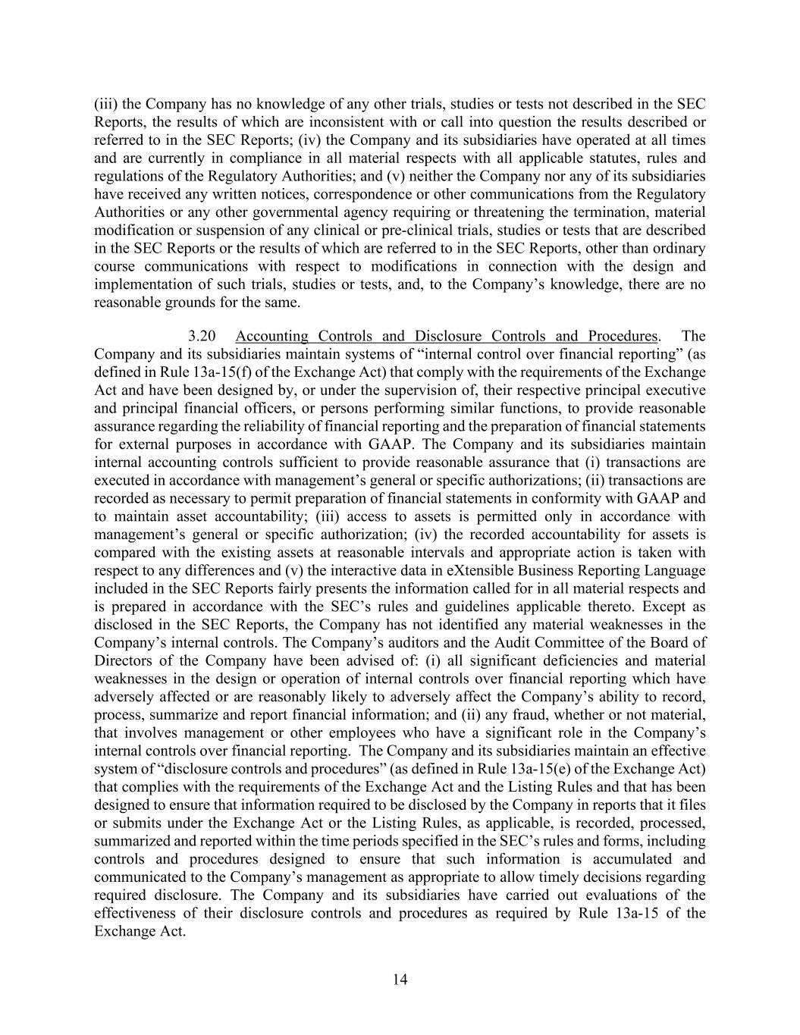
14 (iii) the Company has no knowledge of any other trials, studies or tests not described in the SEC Reports, the results of which are inconsistent with or call into question the results described or referred to in the SEC Reports; (iv) the Company and its subsidiaries have operated at all times and are currently in compliance in all material respects with all applicable statutes, rules and regulations of the Regulatory Authorities; and (v) neither the Company nor any of its subsidiaries have received any written notices, correspondence or other communications from the Regulatory Authorities or any other governmental agency requiring or threatening the termination, material modification or suspension of any clinical or pre-clinical trials, studies or tests that are described in the SEC Reports or the results of which are referred to in the SEC Reports, other than ordinary course communications with respect to modifications in connection with the design and implementation of such trials, studies or tests, and, to the Company’s knowledge, there are no reasonable grounds for the same. 3.20 Accounting Controls and Disclosure Controls and Procedures. The Company and its subsidiaries maintain systems of “internal control over financial reporting” (as defined in Rule 13a-15(f) of the Exchange Act) that comply with the requirements of the Exchange Act and have been designed by, or under the supervision of, their respective principal executive and principal financial officers, or persons performing similar functions, to provide reasonable assurance regarding the reliability of financial reporting and the preparation of financial statements for external purposes in accordance with GAAP. The Company and its subsidiaries maintain internal accounting controls sufficient to provide reasonable assurance that (i) transactions are executed in accordance with management’s general or specific authorizations; (ii) transactions are recorded as necessary to permit preparation of financial statements in conformity with GAAP and to maintain asset accountability; (iii) access to assets is permitted only in accordance with management’s general or specific authorization; (iv) the recorded accountability for assets is compared with the existing assets at reasonable intervals and appropriate action is taken with respect to any differences and (v) the interactive data in eXtensible Business Reporting Language included in the SEC Reports fairly presents the information called for in all material respects and is prepared in accordance with the SEC’s rules and guidelines applicable thereto. Except as disclosed in the SEC Reports, the Company has not identified any material weaknesses in the Company’s internal controls. The Company’s auditors and the Audit Committee of the Board of Directors of the Company have been advised of: (i) all significant deficiencies and material weaknesses in the design or operation of internal controls over financial reporting which have adversely affected or are reasonably likely to adversely affect the Company’s ability to record, process, summarize and report financial information; and (ii) any fraud, whether or not material, that involves management or other employees who have a significant role in the Company’s internal controls over financial reporting. The Company and its subsidiaries maintain an effective system of “disclosure controls and procedures” (as defined in Rule 13a-15(e) of the Exchange Act) that complies with the requirements of the Exchange Act and the Listing Rules and that has been designed to ensure that information required to be disclosed by the Company in reports that it files or submits under the Exchange Act or the Listing Rules, as applicable, is recorded, processed, summarized and reported within the time periods specified in the SEC’s rules and forms, including controls and procedures designed to ensure that such information is accumulated and communicated to the Company’s management as appropriate to allow timely decisions regarding required disclosure. The Company and its subsidiaries have carried out evaluations of the effectiveness of their disclosure controls and procedures as required by Rule 13a-15 of the Exchange Act.

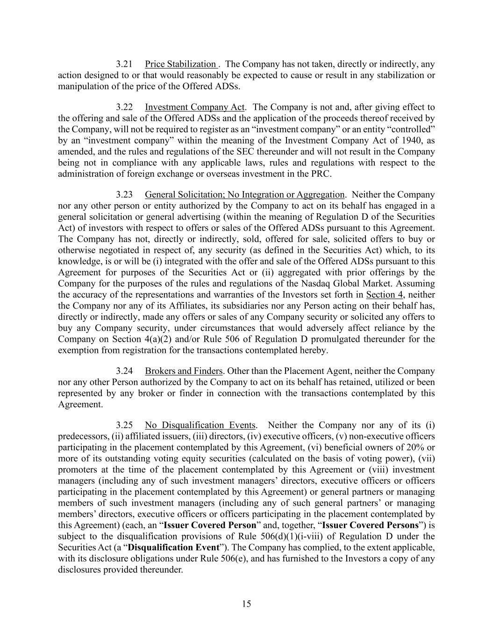
15 3.21 Price Stabilization . The Company has not taken, directly or indirectly, any action designed to or that would reasonably be expected to cause or result in any stabilization or manipulation of the price of the Offered ADSs. 3.22 Investment Company Act. The Company is not and, after giving effect to the offering and sale of the Offered ADSs and the application of the proceeds thereof received by the Company, will not be required to register as an “investment company” or an entity “controlled” by an “investment company” within the meaning of the Investment Company Act of 1940, as amended, and the rules and regulations of the SEC thereunder and will not result in the Company being not in compliance with any applicable laws, rules and regulations with respect to the administration of foreign exchange or overseas investment in the PRC. 3.23 General Solicitation; No Integration or Aggregation. Neither the Company nor any other person or entity authorized by the Company to act on its behalf has engaged in a general solicitation or general advertising (within the meaning of Regulation D of the Securities Act) of investors with respect to offers or sales of the Offered ADSs pursuant to this Agreement. The Company has not, directly or indirectly, sold, offered for sale, solicited offers to buy or otherwise negotiated in respect of, any security (as defined in the Securities Act) which, to its knowledge, is or will be (i) integrated with the offer and sale of the Offered ADSs pursuant to this Agreement for purposes of the Securities Act or (ii) aggregated with prior offerings by the Company for the purposes of the rules and regulations of the Nasdaq Global Market. Assuming the accuracy of the representations and warranties of the Investors set forth in Section 4, neither the Company nor any of its Affiliates, its subsidiaries nor any Person acting on their behalf has, directly or indirectly, made any offers or sales of any Company security or solicited any offers to buy any Company security, under circumstances that would adversely affect reliance by the Company on Section 4(a)(2) and/or Rule 506 of Regulation D promulgated thereunder for the exemption from registration for the transactions contemplated hereby. 3.24 Brokers and Finders. Other than the Placement Agent, neither the Company nor any other Person authorized by the Company to act on its behalf has retained, utilized or been represented by any broker or finder in connection with the transactions contemplated by this Agreement. 3.25 No Disqualification Events. Neither the Company nor any of its (i) predecessors, (ii) affiliated issuers, (iii) directors, (iv) executive officers, (v) non-executive officers participating in the placement contemplated by this Agreement, (vi) beneficial owners of 20% or more of its outstanding voting equity securities (calculated on the basis of voting power), (vii) promoters at the time of the placement contemplated by this Agreement or (viii) investment managers (including any of such investment managers’ directors, executive officers or officers participating in the placement contemplated by this Agreement) or general partners or managing members of such investment managers (including any of such general partners’ or managing members’ directors, executive officers or officers participating in the placement contemplated by this Agreement) (each, an “Issuer Covered Person” and, together, “Issuer Covered Persons”) is subject to the disqualification provisions of Rule 506(d)(1)(i-viii) of Regulation D under the Securities Act (a “Disqualification Event”). The Company has complied, to the extent applicable, with its disclosure obligations under Rule 506(e), and has furnished to the Investors a copy of any disclosures provided thereunder.

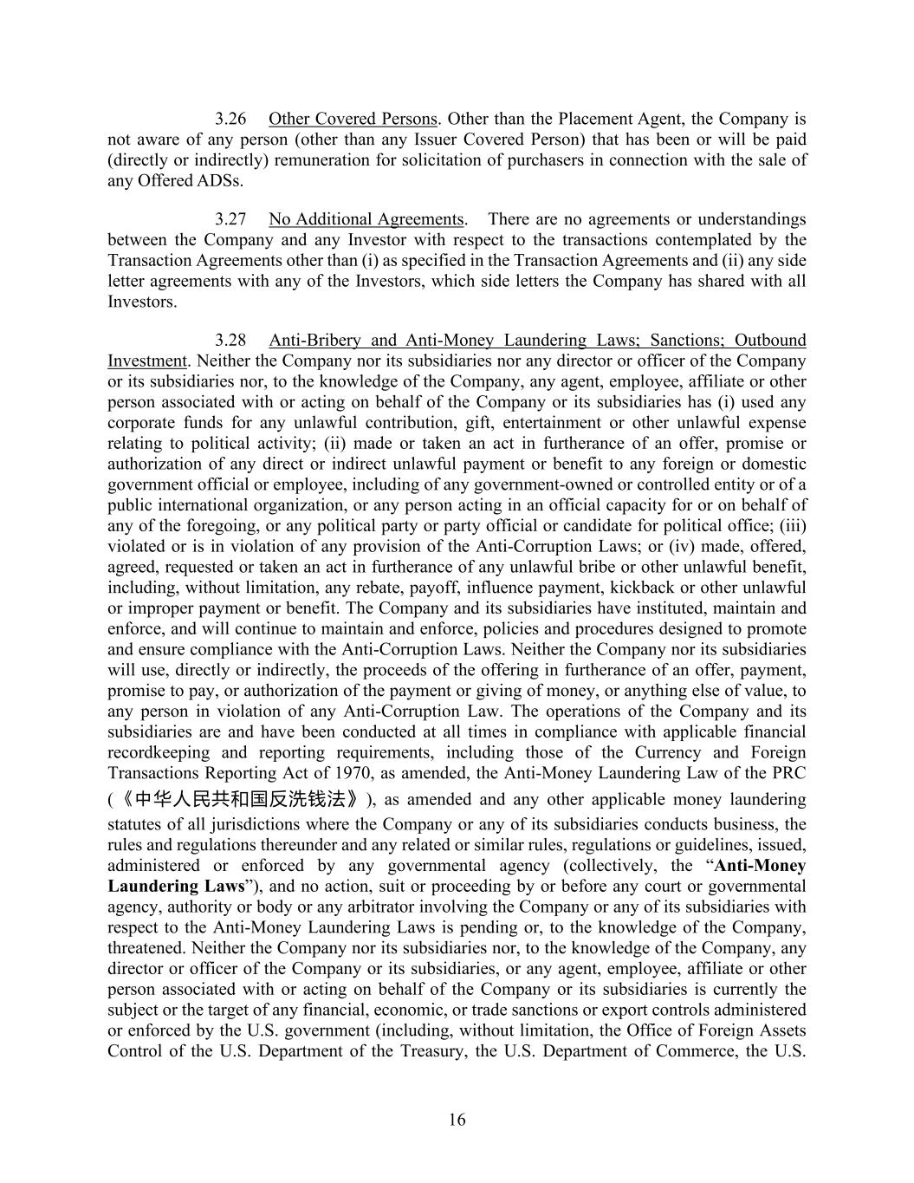
16 3.26 Other Covered Persons. Other than the Placement Agent, the Company is not aware of any person (other than any Issuer Covered Person) that has been or will be paid (directly or indirectly) remuneration for solicitation of purchasers in connection with the sale of any Offered ADSs. 3.27 No Additional Agreements. There are no agreements or understandings between the Company and any Investor with respect to the transactions contemplated by the Transaction Agreements other than (i) as specified in the Transaction Agreements and (ii) any side letter agreements with any of the Investors, which side letters the Company has shared with all Investors. 3.28 Anti-Bribery and Anti-Money Laundering Laws; Sanctions; Outbound Investment. Neither the Company nor its subsidiaries nor any director or officer of the Company or its subsidiaries nor, to the knowledge of the Company, any agent, employee, affiliate or other person associated with or acting on behalf of the Company or its subsidiaries has (i) used any corporate funds for any unlawful contribution, gift, entertainment or other unlawful expense relating to political activity; (ii) made or taken an act in furtherance of an offer, promise or authorization of any direct or indirect unlawful payment or benefit to any foreign or domestic government official or employee, including of any government-owned or controlled entity or of a public international organization, or any person acting in an official capacity for or on behalf of any of the foregoing, or any political party or party official or candidate for political office; (iii) violated or is in violation of any provision of the Anti-Corruption Laws; or (iv) made, offered, agreed, requested or taken an act in furtherance of any unlawful bribe or other unlawful benefit, including, without limitation, any rebate, payoff, influence payment, kickback or other unlawful or improper payment or benefit. The Company and its subsidiaries have instituted, maintain and enforce, and will continue to maintain and enforce, policies and procedures designed to promote and ensure compliance with the Anti-Corruption Laws. Neither the Company nor its subsidiaries will use, directly or indirectly, the proceeds of the offering in furtherance of an offer, payment, promise to pay, or authorization of the payment or giving of money, or anything else of value, to any person in violation of any Anti-Corruption Law. The operations of the Company and its subsidiaries are and have been conducted at all times in compliance with applicable financial recordkeeping and reporting requirements, including those of the Currency and Foreign Transactions Reporting Act of 1970, as amended, the Anti-Money Laundering Law of the PRC (《中华人民共和国反洗钱法》), as amended and any other applicable money laundering statutes of all jurisdictions where the Company or any of its subsidiaries conducts business, the rules and regulations thereunder and any related or similar rules, regulations or guidelines, issued, administered or enforced by any governmental agency (collectively, the “Anti-Money Laundering Laws”), and no action, suit or proceeding by or before any court or governmental agency, authority or body or any arbitrator involving the Company or any of its subsidiaries with respect to the Anti-Money Laundering Laws is pending or, to the knowledge of the Company, threatened. Neither the Company nor its subsidiaries nor, to the knowledge of the Company, any director or officer of the Company or its subsidiaries, or any agent, employee, affiliate or other person associated with or acting on behalf of the Company or its subsidiaries is currently the subject or the target of any financial, economic, or trade sanctions or export controls administered or enforced by the U.S. government (including, without limitation, the Office of Foreign Assets Control of the U.S. Department of the Treasury, the U.S. Department of Commerce, the U.S.

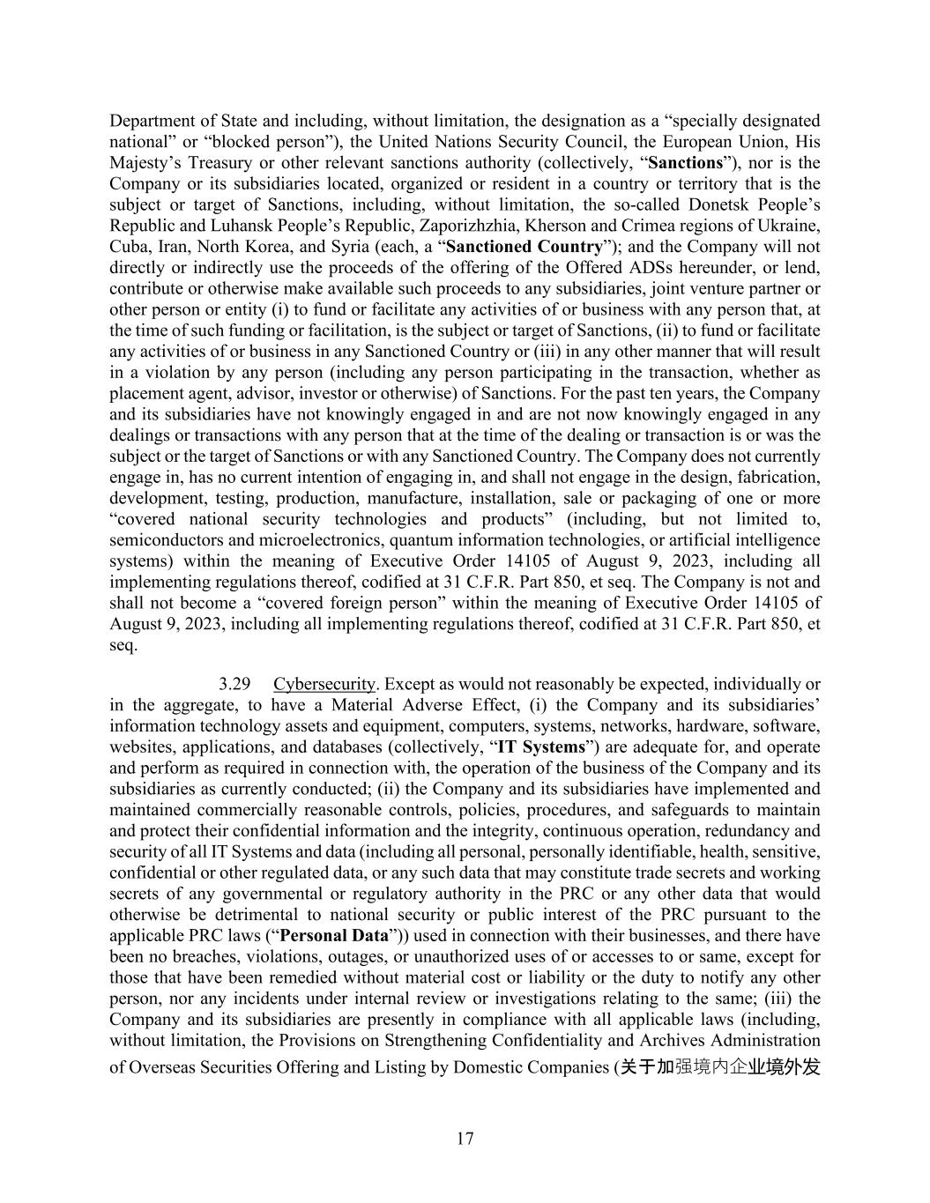
17 Department of State and including, without limitation, the designation as a “specially designated national” or “blocked person”), the United Nations Security Council, the European Union, His Majesty’s Treasury or other relevant sanctions authority (collectively, “Sanctions”), nor is the Company or its subsidiaries located, organized or resident in a country or territory that is the subject or target of Sanctions, including, without limitation, the so-called Donetsk People’s Republic and Luhansk People’s Republic, Zaporizhzhia, Kherson and Crimea regions of Ukraine, Cuba, Iran, North Korea, and Syria (each, a “Sanctioned Country”); and the Company will not directly or indirectly use the proceeds of the offering of the Offered ADSs hereunder, or lend, contribute or otherwise make available such proceeds to any subsidiaries, joint venture partner or other person or entity (i) to fund or facilitate any activities of or business with any person that, at the time of such funding or facilitation, is the subject or target of Sanctions, (ii) to fund or facilitate any activities of or business in any Sanctioned Country or (iii) in any other manner that will result in a violation by any person (including any person participating in the transaction, whether as placement agent, advisor, investor or otherwise) of Sanctions. For the past ten years, the Company and its subsidiaries have not knowingly engaged in and are not now knowingly engaged in any dealings or transactions with any person that at the time of the dealing or transaction is or was the subject or the target of Sanctions or with any Sanctioned Country. The Company does not currently engage in, has no current intention of engaging in, and shall not engage in the design, fabrication, development, testing, production, manufacture, installation, sale or packaging of one or more “covered national security technologies and products” (including, but not limited to, semiconductors and microelectronics, quantum information technologies, or artificial intelligence systems) within the meaning of Executive Order 14105 of August 9, 2023, including all implementing regulations thereof, codified at 31 C.F.R. Part 850, et seq. The Company is not and shall not become a “covered foreign person” within the meaning of Executive Order 14105 of August 9, 2023, including all implementing regulations thereof, codified at 31 C.F.R. Part 850, et seq. 3.29 Cybersecurity. Except as would not reasonably be expected, individually or in the aggregate, to have a Material Adverse Effect, (i) the Company and its subsidiaries’ information technology assets and equipment, computers, systems, networks, hardware, software, websites, applications, and databases (collectively, “IT Systems”) are adequate for, and operate and perform as required in connection with, the operation of the business of the Company and its subsidiaries as currently conducted; (ii) the Company and its subsidiaries have implemented and maintained commercially reasonable controls, policies, procedures, and safeguards to maintain and protect their confidential information and the integrity, continuous operation, redundancy and security of all IT Systems and data (including all personal, personally identifiable, health, sensitive, confidential or other regulated data, or any such data that may constitute trade secrets and working secrets of any governmental or regulatory authority in the PRC or any other data that would otherwise be detrimental to national security or public interest of the PRC pursuant to the applicable PRC laws (“Personal Data”)) used in connection with their businesses, and there have been no breaches, violations, outages, or unauthorized uses of or accesses to or same, except for those that have been remedied without material cost or liability or the duty to notify any other person, nor any incidents under internal review or investigations relating to the same; (iii) the Company and its subsidiaries are presently in compliance with all applicable laws (including, without limitation, the Provisions on Strengthening Confidentiality and Archives Administration of Overseas Securities Offering and Listing by Domestic Companies (关于加强境内企业境外发

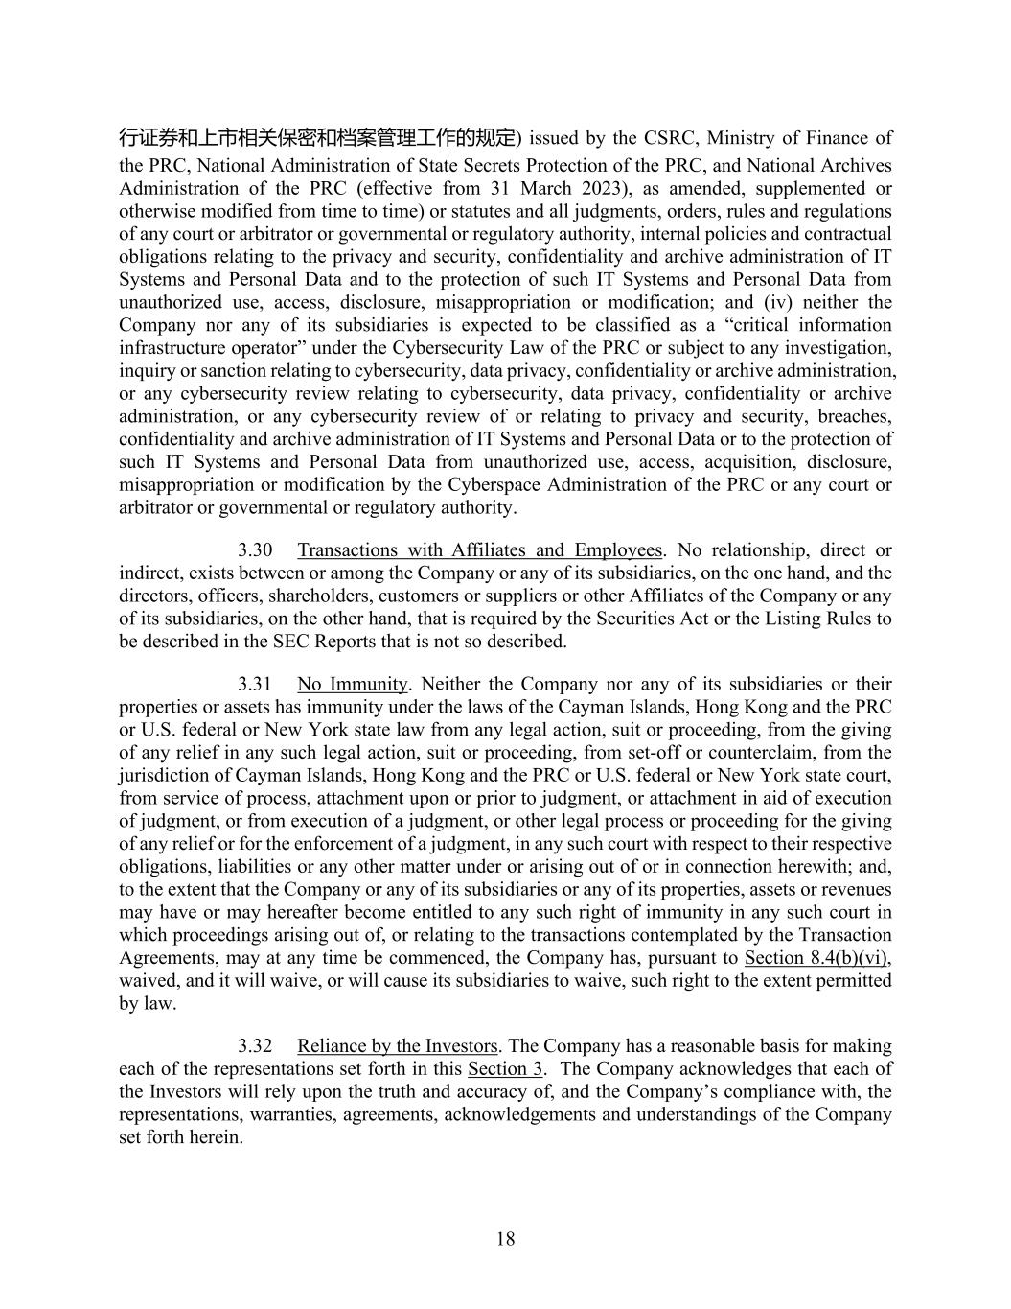
18 行证券和上市相关保密和档案管理工作的规定) issued by the CSRC, Ministry of Finance of the PRC, National Administration of State Secrets Protection of the PRC, and National Archives Administration of the PRC (effective from 31 March 2023), as amended, supplemented or otherwise modified from time to time) or statutes and all judgments, orders, rules and regulations of any court or arbitrator or governmental or regulatory authority, internal policies and contractual obligations relating to the privacy and security, confidentiality and archive administration of IT Systems and Personal Data and to the protection of such IT Systems and Personal Data from unauthorized use, access, disclosure, misappropriation or modification; and (iv) neither the Company nor any of its subsidiaries is expected to be classified as a “critical information infrastructure operator” under the Cybersecurity Law of the PRC or subject to any investigation, inquiry or sanction relating to cybersecurity, data privacy, confidentiality or archive administration, or any cybersecurity review relating to cybersecurity, data privacy, confidentiality or archive administration, or any cybersecurity review of or relating to privacy and security, breaches, confidentiality and archive administration of IT Systems and Personal Data or to the protection of such IT Systems and Personal Data from unauthorized use, access, acquisition, disclosure, misappropriation or modification by the Cyberspace Administration of the PRC or any court or arbitrator or governmental or regulatory authority. 3.30 Transactions with Affiliates and Employees. No relationship, direct or indirect, exists between or among the Company or any of its subsidiaries, on the one hand, and the directors, officers, shareholders, customers or suppliers or other Affiliates of the Company or any of its subsidiaries, on the other hand, that is required by the Securities Act or the Listing Rules to be described in the SEC Reports that is not so described. 3.31 No Immunity. Neither the Company nor any of its subsidiaries or their properties or assets has immunity under the laws of the Cayman Islands, Hong Kong and the PRC or U.S. federal or New York state law from any legal action, suit or proceeding, from the giving of any relief in any such legal action, suit or proceeding, from set-off or counterclaim, from the jurisdiction of Cayman Islands, Hong Kong and the PRC or U.S. federal or New York state court, from service of process, attachment upon or prior to judgment, or attachment in aid of execution of judgment, or from execution of a judgment, or other legal process or proceeding for the giving of any relief or for the enforcement of a judgment, in any such court with respect to their respective obligations, liabilities or any other matter under or arising out of or in connection herewith; and, to the extent that the Company or any of its subsidiaries or any of its properties, assets or revenues may have or may hereafter become entitled to any such right of immunity in any such court in which proceedings arising out of, or relating to the transactions contemplated by the Transaction Agreements, may at any time be commenced, the Company has, pursuant to Section 8.4(b)(vi), waived, and it will waive, or will cause its subsidiaries to waive, such right to the extent permitted by law. 3.32 Reliance by the Investors. The Company has a reasonable basis for making each of the representations set forth in this Section 3. The Company acknowledges that each of the Investors will rely upon the truth and accuracy of, and the Company’s compliance with, the representations, warranties, agreements, acknowledgements and understandings of the Company set forth herein.

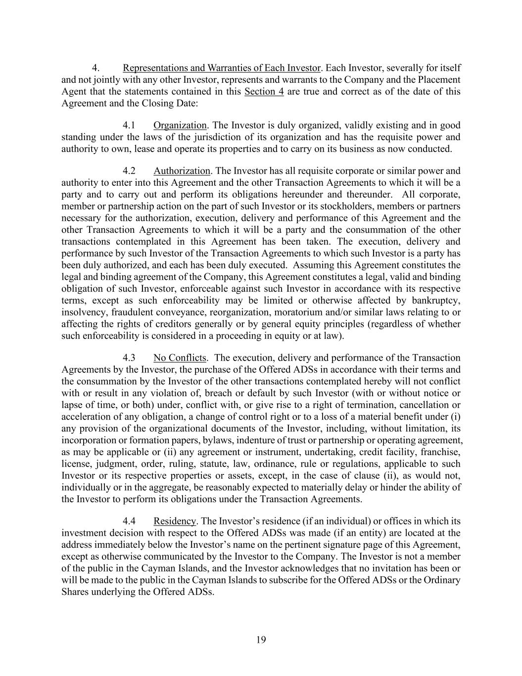
19 4. Representations and Warranties of Each Investor. Each Investor, severally for itself and not jointly with any other Investor, represents and warrants to the Company and the Placement Agent that the statements contained in this Section 4 are true and correct as of the date of this Agreement and the Closing Date: 4.1 Organization. The Investor is duly organized, validly existing and in good standing under the laws of the jurisdiction of its organization and has the requisite power and authority to own, lease and operate its properties and to carry on its business as now conducted. 4.2 Authorization. The Investor has all requisite corporate or similar power and authority to enter into this Agreement and the other Transaction Agreements to which it will be a party and to carry out and perform its obligations hereunder and thereunder. All corporate, member or partnership action on the part of such Investor or its stockholders, members or partners necessary for the authorization, execution, delivery and performance of this Agreement and the other Transaction Agreements to which it will be a party and the consummation of the other transactions contemplated in this Agreement has been taken. The execution, delivery and performance by such Investor of the Transaction Agreements to which such Investor is a party has been duly authorized, and each has been duly executed. Assuming this Agreement constitutes the legal and binding agreement of the Company, this Agreement constitutes a legal, valid and binding obligation of such Investor, enforceable against such Investor in accordance with its respective terms, except as such enforceability may be limited or otherwise affected by bankruptcy, insolvency, fraudulent conveyance, reorganization, moratorium and/or similar laws relating to or affecting the rights of creditors generally or by general equity principles (regardless of whether such enforceability is considered in a proceeding in equity or at law). 4.3 No Conflicts. The execution, delivery and performance of the Transaction Agreements by the Investor, the purchase of the Offered ADSs in accordance with their terms and the consummation by the Investor of the other transactions contemplated hereby will not conflict with or result in any violation of, breach or default by such Investor (with or without notice or lapse of time, or both) under, conflict with, or give rise to a right of termination, cancellation or acceleration of any obligation, a change of control right or to a loss of a material benefit under (i) any provision of the organizational documents of the Investor, including, without limitation, its incorporation or formation papers, bylaws, indenture of trust or partnership or operating agreement, as may be applicable or (ii) any agreement or instrument, undertaking, credit facility, franchise, license, judgment, order, ruling, statute, law, ordinance, rule or regulations, applicable to such Investor or its respective properties or assets, except, in the case of clause (ii), as would not, individually or in the aggregate, be reasonably expected to materially delay or hinder the ability of the Investor to perform its obligations under the Transaction Agreements. 4.4 Residency. The Investor’s residence (if an individual) or offices in which its investment decision with respect to the Offered ADSs was made (if an entity) are located at the address immediately below the Investor’s name on the pertinent signature page of this Agreement, except as otherwise communicated by the Investor to the Company. The Investor is not a member of the public in the Cayman Islands, and the Investor acknowledges that no invitation has been or will be made to the public in the Cayman Islands to subscribe for the Offered ADSs or the Ordinary Shares underlying the Offered ADSs.

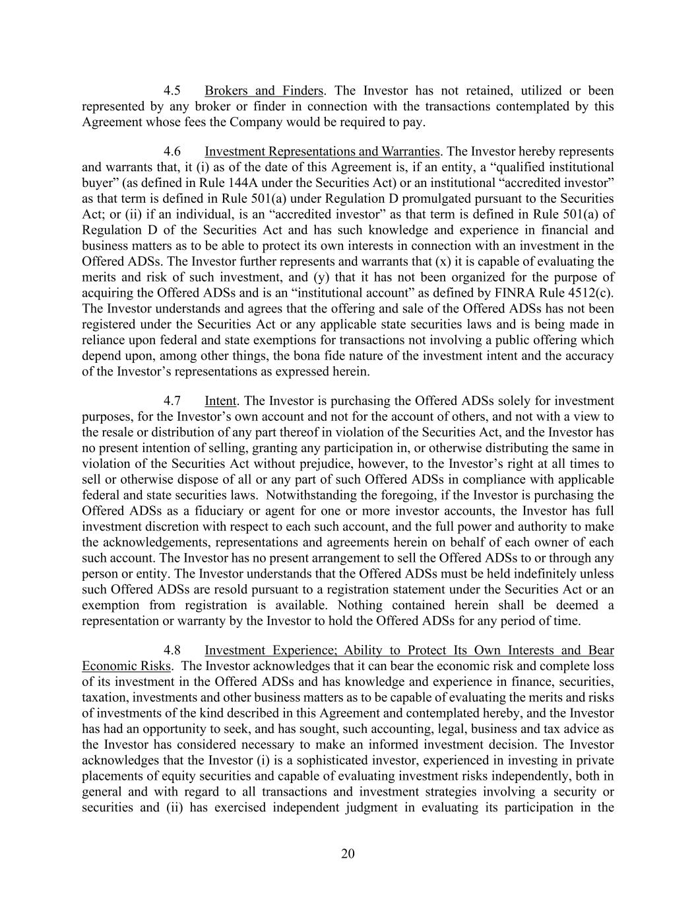
20 4.5 Brokers and Finders. The Investor has not retained, utilized or been represented by any broker or finder in connection with the transactions contemplated by this Agreement whose fees the Company would be required to pay. 4.6 Investment Representations and Warranties. The Investor hereby represents and warrants that, it (i) as of the date of this Agreement is, if an entity, a “qualified institutional buyer” (as defined in Rule 144A under the Securities Act) or an institutional “accredited investor” as that term is defined in Rule 501(a) under Regulation D promulgated pursuant to the Securities Act; or (ii) if an individual, is an “accredited investor” as that term is defined in Rule 501(a) of Regulation D of the Securities Act and has such knowledge and experience in financial and business matters as to be able to protect its own interests in connection with an investment in the Offered ADSs. The Investor further represents and warrants that (x) it is capable of evaluating the merits and risk of such investment, and (y) that it has not been organized for the purpose of acquiring the Offered ADSs and is an “institutional account” as defined by FINRA Rule 4512(c). The Investor understands and agrees that the offering and sale of the Offered ADSs has not been registered under the Securities Act or any applicable state securities laws and is being made in reliance upon federal and state exemptions for transactions not involving a public offering which depend upon, among other things, the bona fide nature of the investment intent and the accuracy of the Investor’s representations as expressed herein. 4.7 Intent. The Investor is purchasing the Offered ADSs solely for investment purposes, for the Investor’s own account and not for the account of others, and not with a view to the resale or distribution of any part thereof in violation of the Securities Act, and the Investor has no present intention of selling, granting any participation in, or otherwise distributing the same in violation of the Securities Act without prejudice, however, to the Investor’s right at all times to sell or otherwise dispose of all or any part of such Offered ADSs in compliance with applicable federal and state securities laws. Notwithstanding the foregoing, if the Investor is purchasing the Offered ADSs as a fiduciary or agent for one or more investor accounts, the Investor has full investment discretion with respect to each such account, and the full power and authority to make the acknowledgements, representations and agreements herein on behalf of each owner of each such account. The Investor has no present arrangement to sell the Offered ADSs to or through any person or entity. The Investor understands that the Offered ADSs must be held indefinitely unless such Offered ADSs are resold pursuant to a registration statement under the Securities Act or an exemption from registration is available. Nothing contained herein shall be deemed a representation or warranty by the Investor to hold the Offered ADSs for any period of time. 4.8 Investment Experience; Ability to Protect Its Own Interests and Bear Economic Risks. The Investor acknowledges that it can bear the economic risk and complete loss of its investment in the Offered ADSs and has knowledge and experience in finance, securities, taxation, investments and other business matters as to be capable of evaluating the merits and risks of investments of the kind described in this Agreement and contemplated hereby, and the Investor has had an opportunity to seek, and has sought, such accounting, legal, business and tax advice as the Investor has considered necessary to make an informed investment decision. The Investor acknowledges that the Investor (i) is a sophisticated investor, experienced in investing in private placements of equity securities and capable of evaluating investment risks independently, both in general and with regard to all transactions and investment strategies involving a security or securities and (ii) has exercised independent judgment in evaluating its participation in the

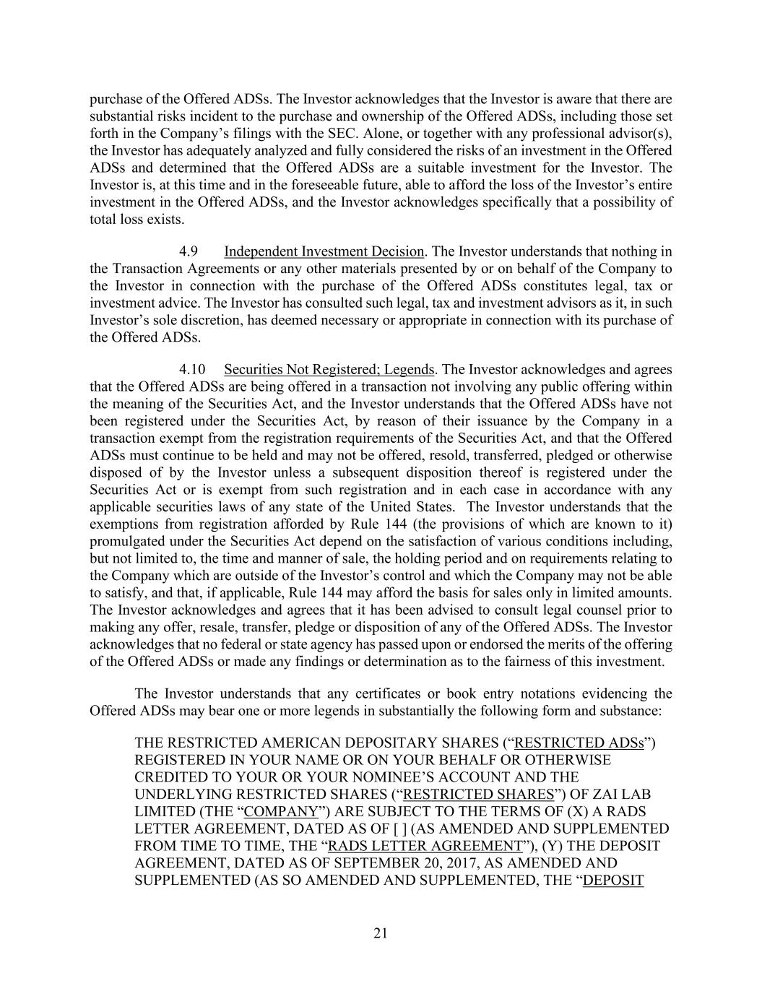
21 purchase of the Offered ADSs. The Investor acknowledges that the Investor is aware that there are substantial risks incident to the purchase and ownership of the Offered ADSs, including those set forth in the Company’s filings with the SEC. Alone, or together with any professional advisor(s), the Investor has adequately analyzed and fully considered the risks of an investment in the Offered ADSs and determined that the Offered ADSs are a suitable investment for the Investor. The Investor is, at this time and in the foreseeable future, able to afford the loss of the Investor’s entire investment in the Offered ADSs, and the Investor acknowledges specifically that a possibility of total loss exists. 4.9 Independent Investment Decision. The Investor understands that nothing in the Transaction Agreements or any other materials presented by or on behalf of the Company to the Investor in connection with the purchase of the Offered ADSs constitutes legal, tax or investment advice. The Investor has consulted such legal, tax and investment advisors as it, in such Investor’s sole discretion, has deemed necessary or appropriate in connection with its purchase of the Offered ADSs. 4.10 Securities Not Registered; Legends. The Investor acknowledges and agrees that the Offered ADSs are being offered in a transaction not involving any public offering within the meaning of the Securities Act, and the Investor understands that the Offered ADSs have not been registered under the Securities Act, by reason of their issuance by the Company in a transaction exempt from the registration requirements of the Securities Act, and that the Offered ADSs must continue to be held and may not be offered, resold, transferred, pledged or otherwise disposed of by the Investor unless a subsequent disposition thereof is registered under the Securities Act or is exempt from such registration and in each case in accordance with any applicable securities laws of any state of the United States. The Investor understands that the exemptions from registration afforded by Rule 144 (the provisions of which are known to it) promulgated under the Securities Act depend on the satisfaction of various conditions including, but not limited to, the time and manner of sale, the holding period and on requirements relating to the Company which are outside of the Investor’s control and which the Company may not be able to satisfy, and that, if applicable, Rule 144 may afford the basis for sales only in limited amounts. The Investor acknowledges and agrees that it has been advised to consult legal counsel prior to making any offer, resale, transfer, pledge or disposition of any of the Offered ADSs. The Investor acknowledges that no federal or state agency has passed upon or endorsed the merits of the offering of the Offered ADSs or made any findings or determination as to the fairness of this investment. The Investor understands that any certificates or book entry notations evidencing the Offered ADSs may bear one or more legends in substantially the following form and substance: THE RESTRICTED AMERICAN DEPOSITARY SHARES (“RESTRICTED ADSs”) REGISTERED IN YOUR NAME OR ON YOUR BEHALF OR OTHERWISE CREDITED TO YOUR OR YOUR NOMINEE’S ACCOUNT AND THE UNDERLYING RESTRICTED SHARES (“RESTRICTED SHARES”) OF ZAI LAB LIMITED (THE “COMPANY”) ARE SUBJECT TO THE TERMS OF (X) A RADS LETTER AGREEMENT, DATED AS OF [ ] (AS AMENDED AND SUPPLEMENTED FROM TIME TO TIME, THE “RADS LETTER AGREEMENT”), (Y) THE DEPOSIT AGREEMENT, DATED AS OF SEPTEMBER 20, 2017, AS AMENDED AND SUPPLEMENTED (AS SO AMENDED AND SUPPLEMENTED, THE “DEPOSIT

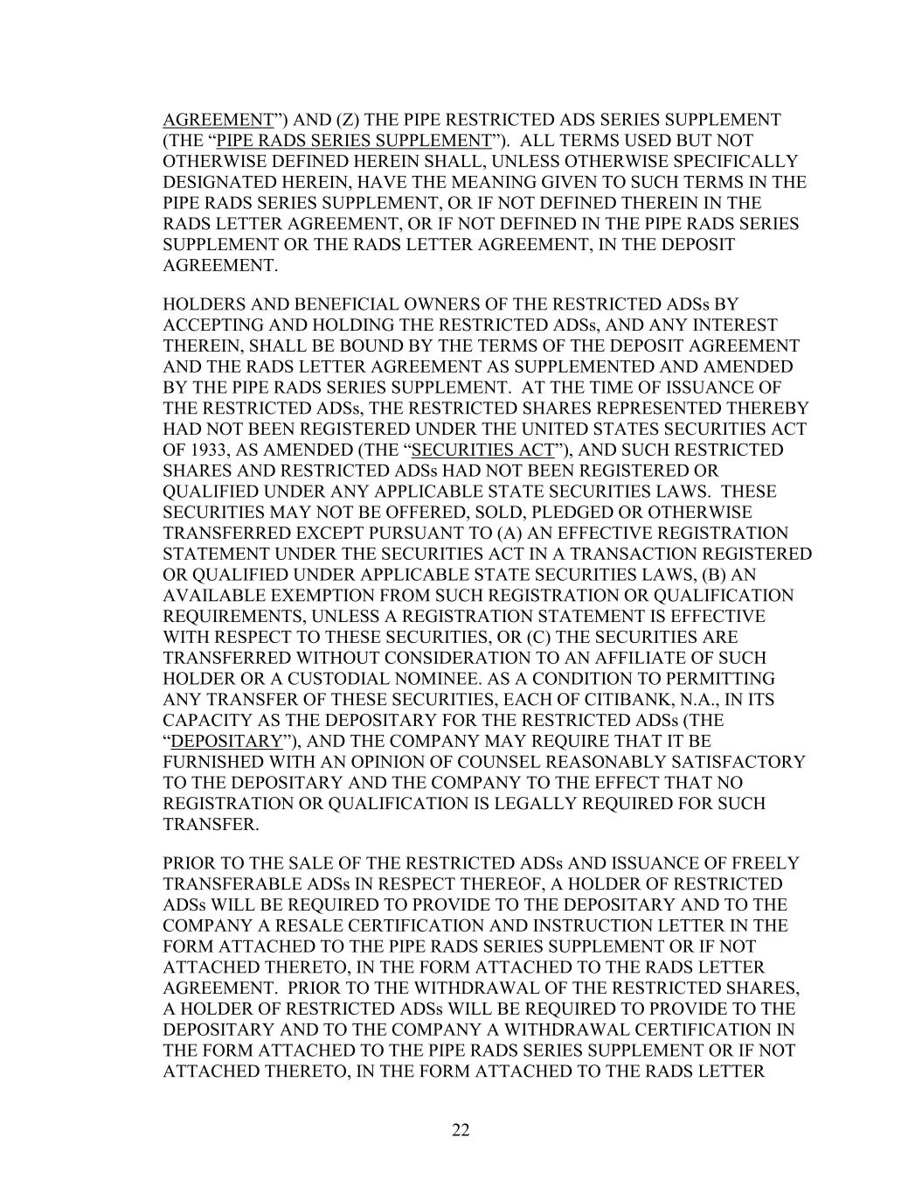
22 AGREEMENT”) AND (Z) THE PIPE RESTRICTED ADS SERIES SUPPLEMENT (THE “PIPE RADS SERIES SUPPLEMENT”). ALL TERMS USED BUT NOT OTHERWISE DEFINED HEREIN SHALL, UNLESS OTHERWISE SPECIFICALLY DESIGNATED HEREIN, HAVE THE MEANING GIVEN TO SUCH TERMS IN THE PIPE RADS SERIES SUPPLEMENT, OR IF NOT DEFINED THEREIN IN THE RADS LETTER AGREEMENT, OR IF NOT DEFINED IN THE PIPE RADS SERIES SUPPLEMENT OR THE RADS LETTER AGREEMENT, IN THE DEPOSIT AGREEMENT. HOLDERS AND BENEFICIAL OWNERS OF THE RESTRICTED ADSs BY ACCEPTING AND HOLDING THE RESTRICTED ADSs, AND ANY INTEREST THEREIN, SHALL BE BOUND BY THE TERMS OF THE DEPOSIT AGREEMENT AND THE RADS LETTER AGREEMENT AS SUPPLEMENTED AND AMENDED BY THE PIPE RADS SERIES SUPPLEMENT. AT THE TIME OF ISSUANCE OF THE RESTRICTED ADSs, THE RESTRICTED SHARES REPRESENTED THEREBY HAD NOT BEEN REGISTERED UNDER THE UNITED STATES SECURITIES ACT OF 1933, AS AMENDED (THE “SECURITIES ACT”), AND SUCH RESTRICTED SHARES AND RESTRICTED ADSs HAD NOT BEEN REGISTERED OR QUALIFIED UNDER ANY APPLICABLE STATE SECURITIES LAWS. THESE SECURITIES MAY NOT BE OFFERED, SOLD, PLEDGED OR OTHERWISE TRANSFERRED EXCEPT PURSUANT TO (A) AN EFFECTIVE REGISTRATION STATEMENT UNDER THE SECURITIES ACT IN A TRANSACTION REGISTERED OR QUALIFIED UNDER APPLICABLE STATE SECURITIES LAWS, (B) AN AVAILABLE EXEMPTION FROM SUCH REGISTRATION OR QUALIFICATION REQUIREMENTS, UNLESS A REGISTRATION STATEMENT IS EFFECTIVE WITH RESPECT TO THESE SECURITIES, OR (C) THE SECURITIES ARE TRANSFERRED WITHOUT CONSIDERATION TO AN AFFILIATE OF SUCH HOLDER OR A CUSTODIAL NOMINEE. AS A CONDITION TO PERMITTING ANY TRANSFER OF THESE SECURITIES, EACH OF CITIBANK, N.A., IN ITS CAPACITY AS THE DEPOSITARY FOR THE RESTRICTED ADSs (THE “DEPOSITARY”), AND THE COMPANY MAY REQUIRE THAT IT BE FURNISHED WITH AN OPINION OF COUNSEL REASONABLY SATISFACTORY TO THE DEPOSITARY AND THE COMPANY TO THE EFFECT THAT NO REGISTRATION OR QUALIFICATION IS LEGALLY REQUIRED FOR SUCH TRANSFER. PRIOR TO THE SALE OF THE RESTRICTED ADSs AND ISSUANCE OF FREELY TRANSFERABLE ADSs IN RESPECT THEREOF, A HOLDER OF RESTRICTED ADSs WILL BE REQUIRED TO PROVIDE TO THE DEPOSITARY AND TO THE COMPANY A RESALE CERTIFICATION AND INSTRUCTION LETTER IN THE FORM ATTACHED TO THE PIPE RADS SERIES SUPPLEMENT OR IF NOT ATTACHED THERETO, IN THE FORM ATTACHED TO THE RADS LETTER AGREEMENT. PRIOR TO THE WITHDRAWAL OF THE RESTRICTED SHARES, A HOLDER OF RESTRICTED ADSs WILL BE REQUIRED TO PROVIDE TO THE DEPOSITARY AND TO THE COMPANY A WITHDRAWAL CERTIFICATION IN THE FORM ATTACHED TO THE PIPE RADS SERIES SUPPLEMENT OR IF NOT ATTACHED THERETO, IN THE FORM ATTACHED TO THE RADS LETTER

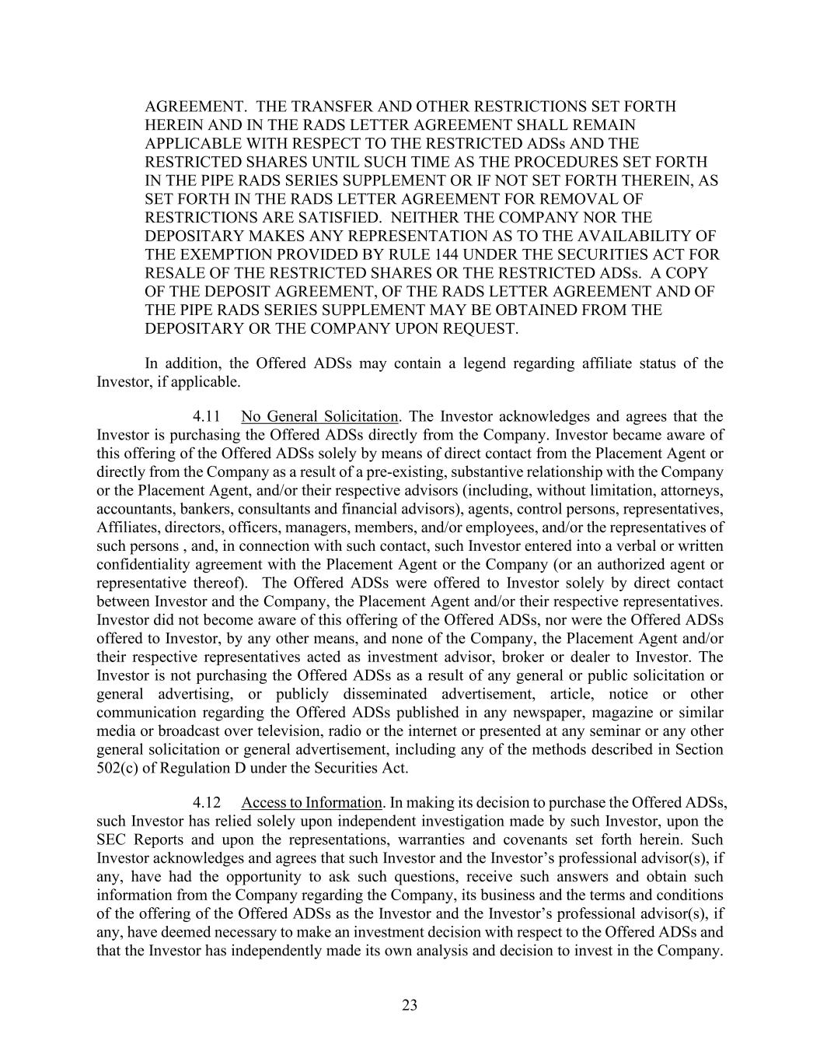
23 AGREEMENT. THE TRANSFER AND OTHER RESTRICTIONS SET FORTH HEREIN AND IN THE RADS LETTER AGREEMENT SHALL REMAIN APPLICABLE WITH RESPECT TO THE RESTRICTED ADSs AND THE RESTRICTED SHARES UNTIL SUCH TIME AS THE PROCEDURES SET FORTH IN THE PIPE RADS SERIES SUPPLEMENT OR IF NOT SET FORTH THEREIN, AS SET FORTH IN THE RADS LETTER AGREEMENT FOR REMOVAL OF RESTRICTIONS ARE SATISFIED. NEITHER THE COMPANY NOR THE DEPOSITARY MAKES ANY REPRESENTATION AS TO THE AVAILABILITY OF THE EXEMPTION PROVIDED BY RULE 144 UNDER THE SECURITIES ACT FOR RESALE OF THE RESTRICTED SHARES OR THE RESTRICTED ADSs. A COPY OF THE DEPOSIT AGREEMENT, OF THE RADS LETTER AGREEMENT AND OF THE PIPE RADS SERIES SUPPLEMENT MAY BE OBTAINED FROM THE DEPOSITARY OR THE COMPANY UPON REQUEST. In addition, the Offered ADSs may contain a legend regarding affiliate status of the Investor, if applicable. 4.11 No General Solicitation. The Investor acknowledges and agrees that the Investor is purchasing the Offered ADSs directly from the Company. Investor became aware of this offering of the Offered ADSs solely by means of direct contact from the Placement Agent or directly from the Company as a result of a pre-existing, substantive relationship with the Company or the Placement Agent, and/or their respective advisors (including, without limitation, attorneys, accountants, bankers, consultants and financial advisors), agents, control persons, representatives, Affiliates, directors, officers, managers, members, and/or employees, and/or the representatives of such persons , and, in connection with such contact, such Investor entered into a verbal or written confidentiality agreement with the Placement Agent or the Company (or an authorized agent or representative thereof). The Offered ADSs were offered to Investor solely by direct contact between Investor and the Company, the Placement Agent and/or their respective representatives. Investor did not become aware of this offering of the Offered ADSs, nor were the Offered ADSs offered to Investor, by any other means, and none of the Company, the Placement Agent and/or their respective representatives acted as investment advisor, broker or dealer to Investor. The Investor is not purchasing the Offered ADSs as a result of any general or public solicitation or general advertising, or publicly disseminated advertisement, article, notice or other communication regarding the Offered ADSs published in any newspaper, magazine or similar media or broadcast over television, radio or the internet or presented at any seminar or any other general solicitation or general advertisement, including any of the methods described in Section 502(c) of Regulation D under the Securities Act. 4.12 Access to Information. In making its decision to purchase the Offered ADSs, such Investor has relied solely upon independent investigation made by such Investor, upon the SEC Reports and upon the representations, warranties and covenants set forth herein. Such Investor acknowledges and agrees that such Investor and the Investor’s professional advisor(s), if any, have had the opportunity to ask such questions, receive such answers and obtain such information from the Company regarding the Company, its business and the terms and conditions of the offering of the Offered ADSs as the Investor and the Investor’s professional advisor(s), if any, have deemed necessary to make an investment decision with respect to the Offered ADSs and that the Investor has independently made its own analysis and decision to invest in the Company.

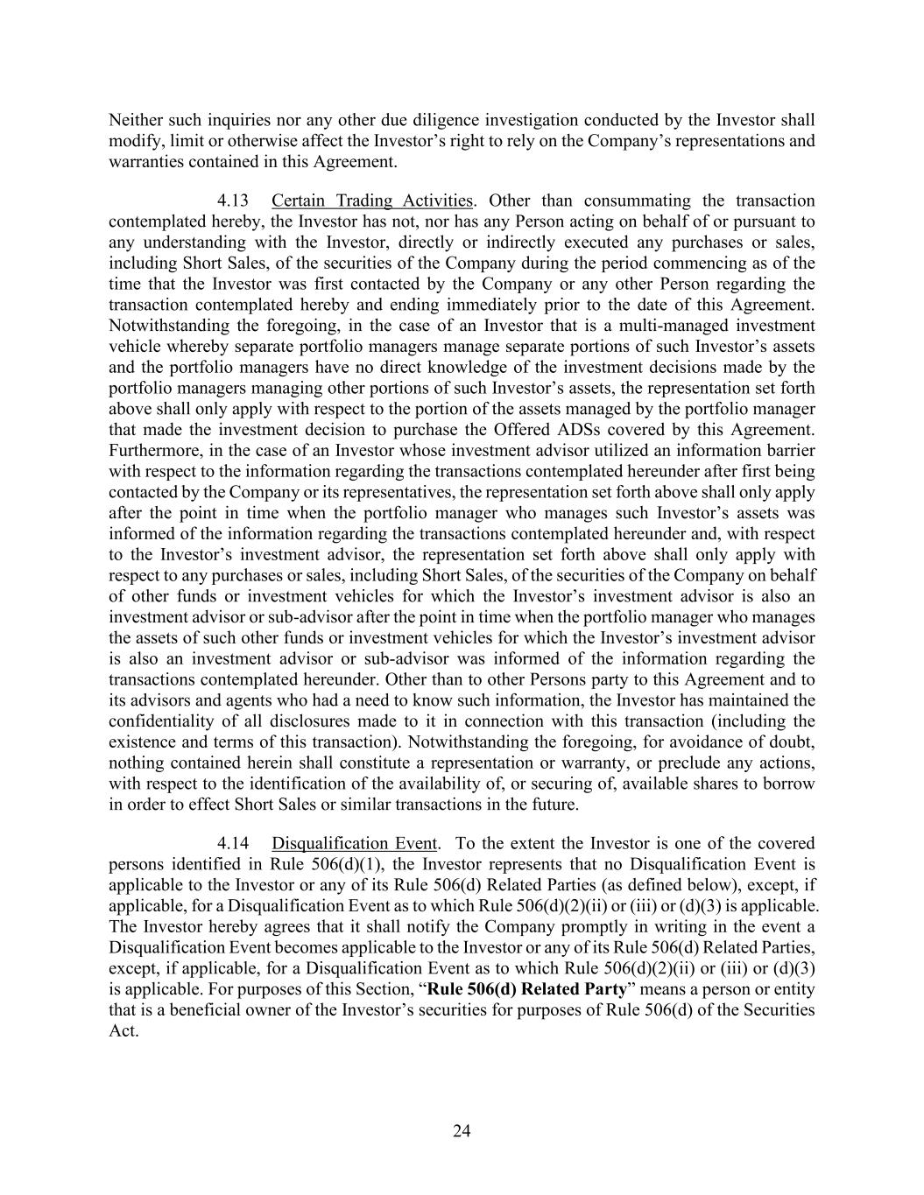
24 Neither such inquiries nor any other due diligence investigation conducted by the Investor shall modify, limit or otherwise affect the Investor’s right to rely on the Company’s representations and warranties contained in this Agreement. 4.13 Certain Trading Activities. Other than consummating the transaction contemplated hereby, the Investor has not, nor has any Person acting on behalf of or pursuant to any understanding with the Investor, directly or indirectly executed any purchases or sales, including Short Sales, of the securities of the Company during the period commencing as of the time that the Investor was first contacted by the Company or any other Person regarding the transaction contemplated hereby and ending immediately prior to the date of this Agreement. Notwithstanding the foregoing, in the case of an Investor that is a multi-managed investment vehicle whereby separate portfolio managers manage separate portions of such Investor’s assets and the portfolio managers have no direct knowledge of the investment decisions made by the portfolio managers managing other portions of such Investor’s assets, the representation set forth above shall only apply with respect to the portion of the assets managed by the portfolio manager that made the investment decision to purchase the Offered ADSs covered by this Agreement. Furthermore, in the case of an Investor whose investment advisor utilized an information barrier with respect to the information regarding the transactions contemplated hereunder after first being contacted by the Company or its representatives, the representation set forth above shall only apply after the point in time when the portfolio manager who manages such Investor’s assets was informed of the information regarding the transactions contemplated hereunder and, with respect to the Investor’s investment advisor, the representation set forth above shall only apply with respect to any purchases or sales, including Short Sales, of the securities of the Company on behalf of other funds or investment vehicles for which the Investor’s investment advisor is also an investment advisor or sub-advisor after the point in time when the portfolio manager who manages the assets of such other funds or investment vehicles for which the Investor’s investment advisor is also an investment advisor or sub-advisor was informed of the information regarding the transactions contemplated hereunder. Other than to other Persons party to this Agreement and to its advisors and agents who had a need to know such information, the Investor has maintained the confidentiality of all disclosures made to it in connection with this transaction (including the existence and terms of this transaction). Notwithstanding the foregoing, for avoidance of doubt, nothing contained herein shall constitute a representation or warranty, or preclude any actions, with respect to the identification of the availability of, or securing of, available shares to borrow in order to effect Short Sales or similar transactions in the future. 4.14 Disqualification Event. To the extent the Investor is one of the covered persons identified in Rule 506(d)(1), the Investor represents that no Disqualification Event is applicable to the Investor or any of its Rule 506(d) Related Parties (as defined below), except, if applicable, for a Disqualification Event as to which Rule 506(d)(2)(ii) or (iii) or (d)(3) is applicable. The Investor hereby agrees that it shall notify the Company promptly in writing in the event a Disqualification Event becomes applicable to the Investor or any of its Rule 506(d) Related Parties, except, if applicable, for a Disqualification Event as to which Rule 506(d)(2)(ii) or (iii) or (d)(3) is applicable. For purposes of this Section, “Rule 506(d) Related Party” means a person or entity that is a beneficial owner of the Investor’s securities for purposes of Rule 506(d) of the Securities Act.

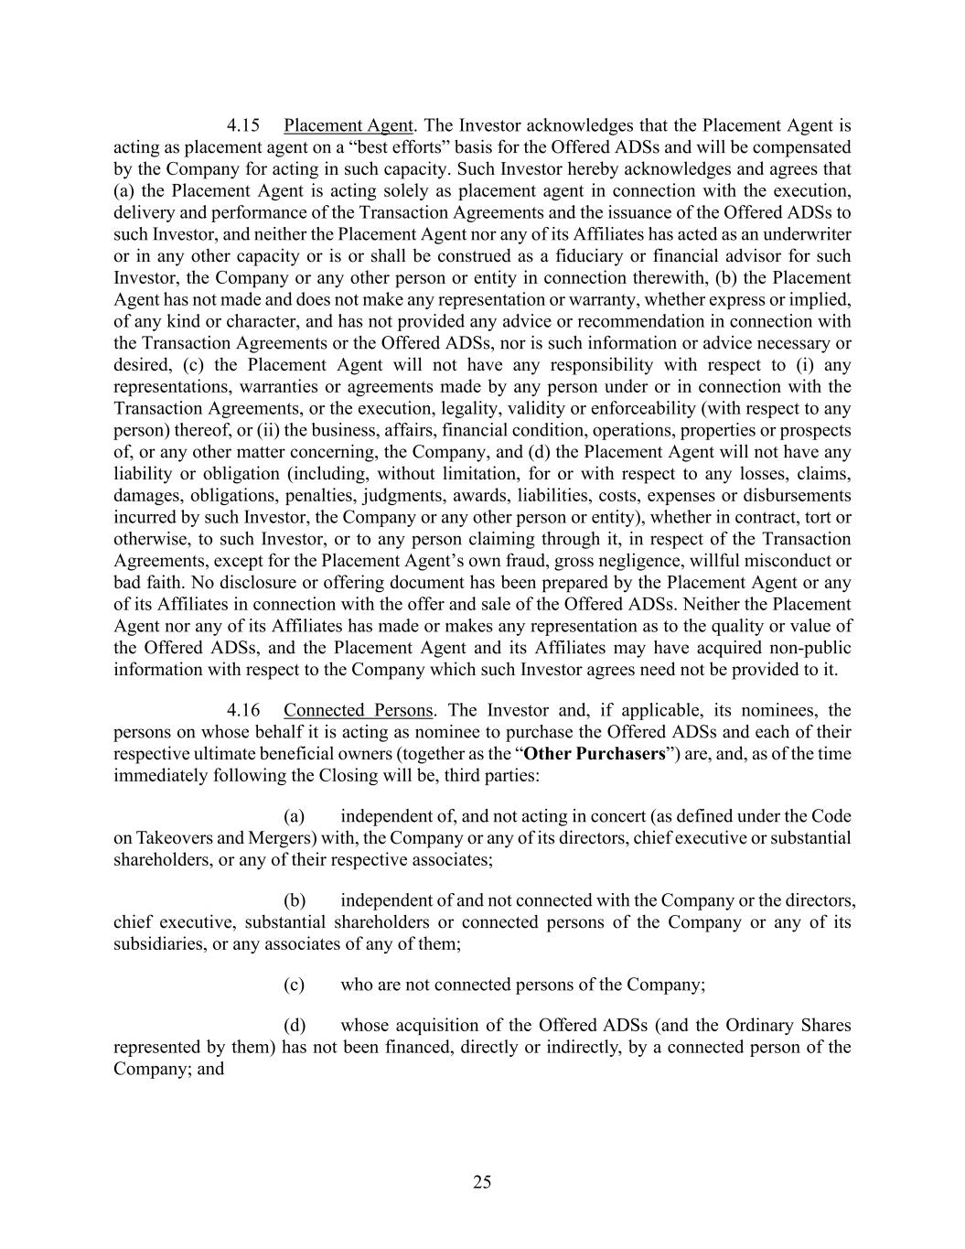
25 4.15 Placement Agent. The Investor acknowledges that the Placement Agent is acting as placement agent on a “best efforts” basis for the Offered ADSs and will be compensated by the Company for acting in such capacity. Such Investor hereby acknowledges and agrees that (a) the Placement Agent is acting solely as placement agent in connection with the execution, delivery and performance of the Transaction Agreements and the issuance of the Offered ADSs to such Investor, and neither the Placement Agent nor any of its Affiliates has acted as an underwriter or in any other capacity or is or shall be construed as a fiduciary or financial advisor for such Investor, the Company or any other person or entity in connection therewith, (b) the Placement Agent has not made and does not make any representation or warranty, whether express or implied, of any kind or character, and has not provided any advice or recommendation in connection with the Transaction Agreements or the Offered ADSs, nor is such information or advice necessary or desired, (c) the Placement Agent will not have any responsibility with respect to (i) any representations, warranties or agreements made by any person under or in connection with the Transaction Agreements, or the execution, legality, validity or enforceability (with respect to any person) thereof, or (ii) the business, affairs, financial condition, operations, properties or prospects of, or any other matter concerning, the Company, and (d) the Placement Agent will not have any liability or obligation (including, without limitation, for or with respect to any losses, claims, damages, obligations, penalties, judgments, awards, liabilities, costs, expenses or disbursements incurred by such Investor, the Company or any other person or entity), whether in contract, tort or otherwise, to such Investor, or to any person claiming through it, in respect of the Transaction Agreements, except for the Placement Agent’s own fraud, gross negligence, willful misconduct or bad faith. No disclosure or offering document has been prepared by the Placement Agent or any of its Affiliates in connection with the offer and sale of the Offered ADSs. Neither the Placement Agent nor any of its Affiliates has made or makes any representation as to the quality or value of the Offered ADSs, and the Placement Agent and its Affiliates may have acquired non-public information with respect to the Company which such Investor agrees need not be provided to it. 4.16 Connected Persons. The Investor and, if applicable, its nominees, the persons on whose behalf it is acting as nominee to purchase the Offered ADSs and each of their respective ultimate beneficial owners (together as the “Other Purchasers”) are, and, as of the time immediately following the Closing will be, third parties: (a) independent of, and not acting in concert (as defined under the Code on Takeovers and Mergers) with, the Company or any of its directors, chief executive or substantial shareholders, or any of their respective associates; (b) independent of and not connected with the Company or the directors, chief executive, substantial shareholders or connected persons of the Company or any of its subsidiaries, or any associates of any of them; (c) who are not connected persons of the Company; (d) whose acquisition of the Offered ADSs (and the Ordinary Shares represented by them) has not been financed, directly or indirectly, by a connected person of the Company; and

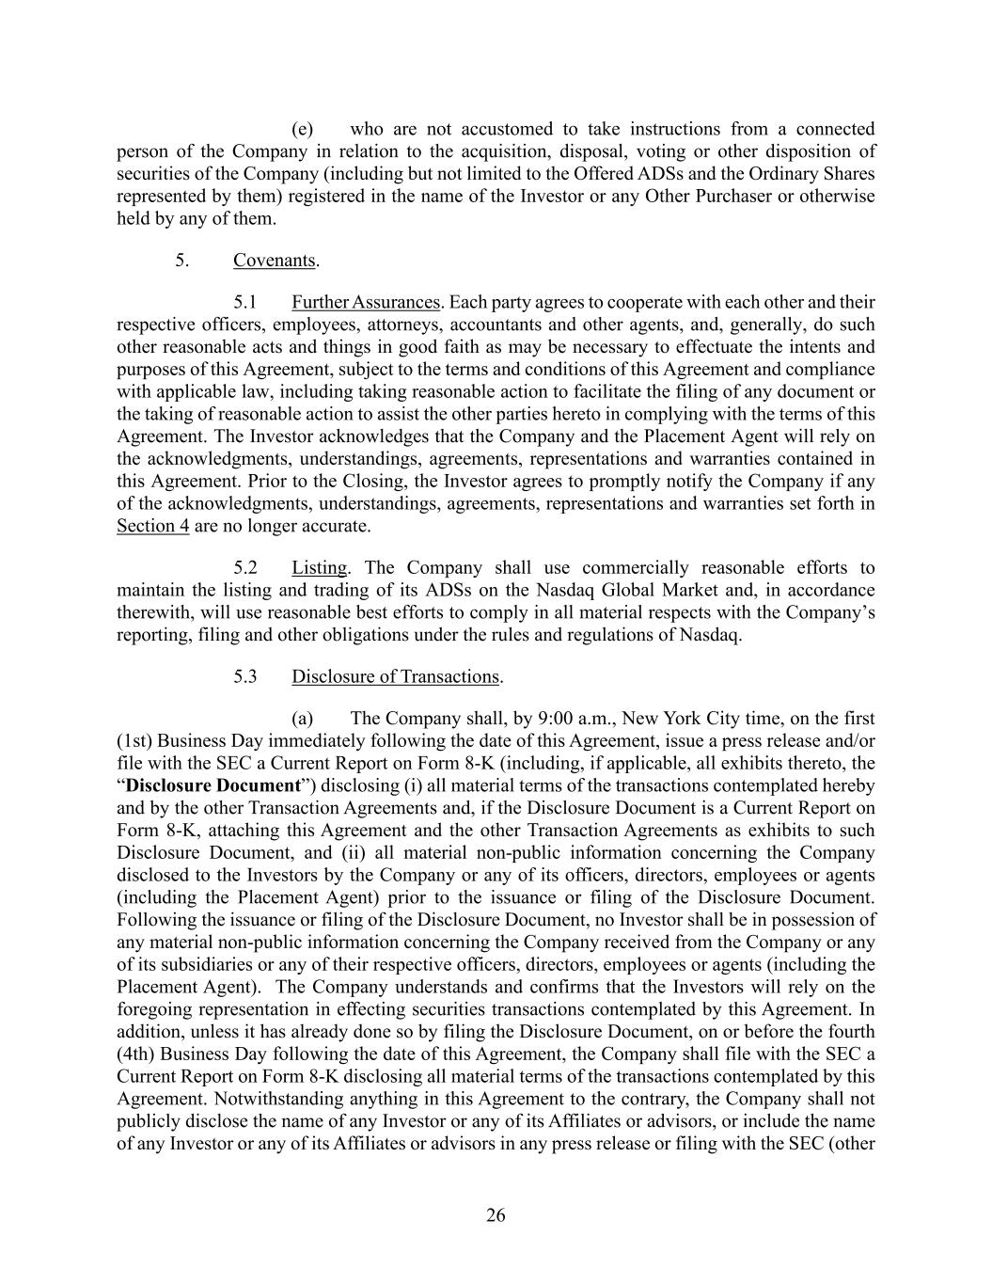
26 (e) who are not accustomed to take instructions from a connected person of the Company in relation to the acquisition, disposal, voting or other disposition of securities of the Company (including but not limited to the Offered ADSs and the Ordinary Shares represented by them) registered in the name of the Investor or any Other Purchaser or otherwise held by any of them. 5. Covenants. 5.1 Further Assurances. Each party agrees to cooperate with each other and their respective officers, employees, attorneys, accountants and other agents, and, generally, do such other reasonable acts and things in good faith as may be necessary to effectuate the intents and purposes of this Agreement, subject to the terms and conditions of this Agreement and compliance with applicable law, including taking reasonable action to facilitate the filing of any document or the taking of reasonable action to assist the other parties hereto in complying with the terms of this Agreement. The Investor acknowledges that the Company and the Placement Agent will rely on the acknowledgments, understandings, agreements, representations and warranties contained in this Agreement. Prior to the Closing, the Investor agrees to promptly notify the Company if any of the acknowledgments, understandings, agreements, representations and warranties set forth in Section 4 are no longer accurate. 5.2 Listing. The Company shall use commercially reasonable efforts to maintain the listing and trading of its ADSs on the Nasdaq Global Market and, in accordance therewith, will use reasonable best efforts to comply in all material respects with the Company’s reporting, filing and other obligations under the rules and regulations of Nasdaq. 5.3 Disclosure of Transactions. (a) The Company shall, by 9:00 a.m., New York City time, on the first (1st) Business Day immediately following the date of this Agreement, issue a press release and/or file with the SEC a Current Report on Form 8-K (including, if applicable, all exhibits thereto, the “Disclosure Document”) disclosing (i) all material terms of the transactions contemplated hereby and by the other Transaction Agreements and, if the Disclosure Document is a Current Report on Form 8-K, attaching this Agreement and the other Transaction Agreements as exhibits to such Disclosure Document, and (ii) all material non-public information concerning the Company disclosed to the Investors by the Company or any of its officers, directors, employees or agents (including the Placement Agent) prior to the issuance or filing of the Disclosure Document. Following the issuance or filing of the Disclosure Document, no Investor shall be in possession of any material non-public information concerning the Company received from the Company or any of its subsidiaries or any of their respective officers, directors, employees or agents (including the Placement Agent). The Company understands and confirms that the Investors will rely on the foregoing representation in effecting securities transactions contemplated by this Agreement. In addition, unless it has already done so by filing the Disclosure Document, on or before the fourth (4th) Business Day following the date of this Agreement, the Company shall file with the SEC a Current Report on Form 8-K disclosing all material terms of the transactions contemplated by this Agreement. Notwithstanding anything in this Agreement to the contrary, the Company shall not publicly disclose the name of any Investor or any of its Affiliates or advisors, or include the name of any Investor or any of its Affiliates or advisors in any press release or filing with the SEC (other

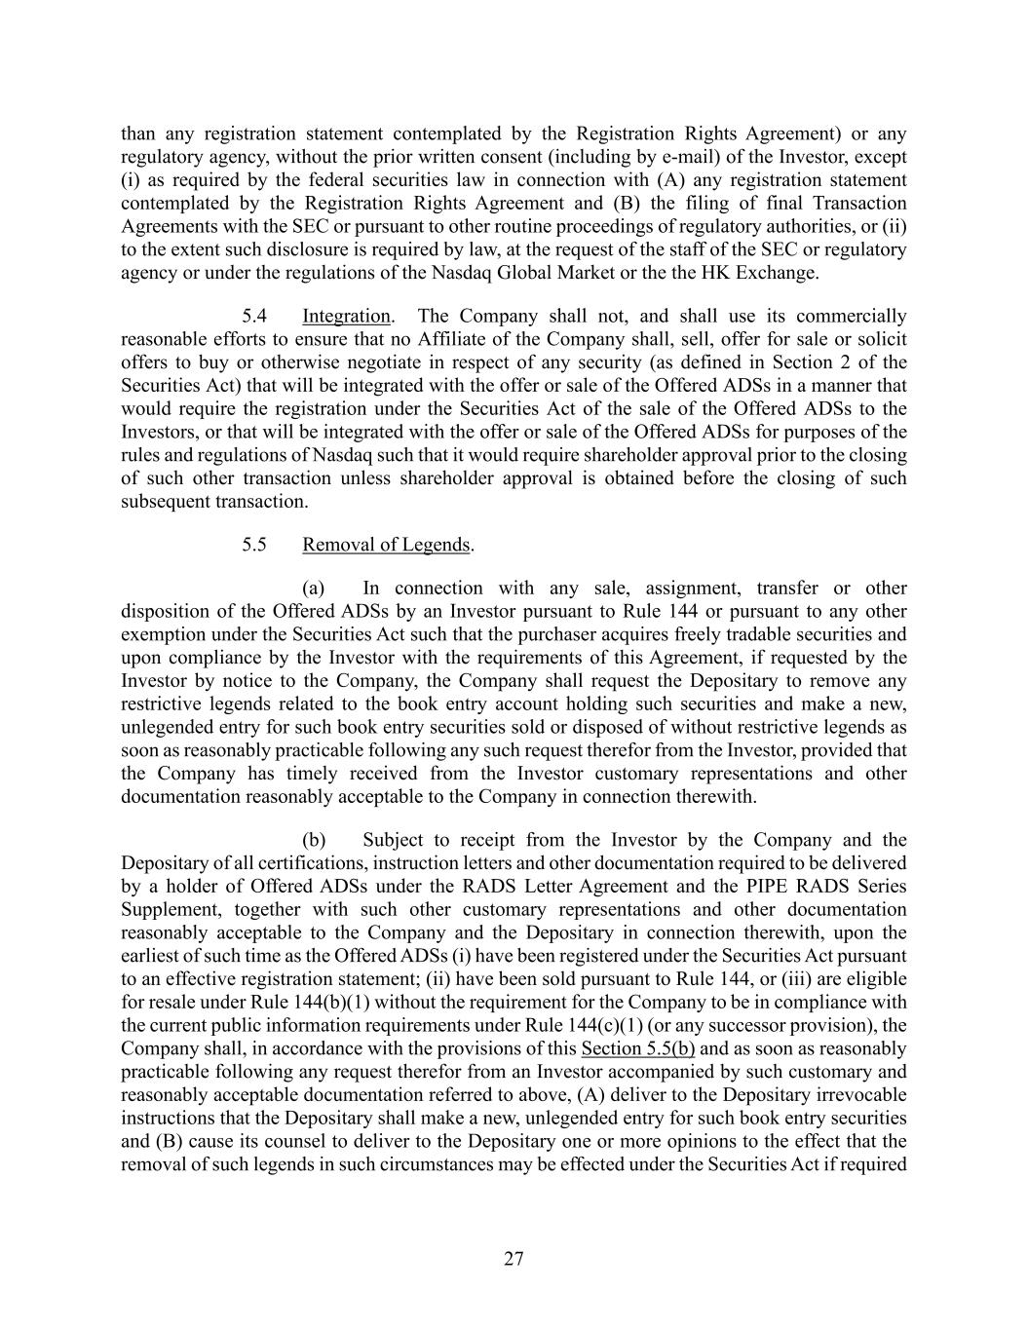
27 than any registration statement contemplated by the Registration Rights Agreement) or any regulatory agency, without the prior written consent (including by e-mail) of the Investor, except (i) as required by the federal securities law in connection with (A) any registration statement contemplated by the Registration Rights Agreement and (B) the filing of final Transaction Agreements with the SEC or pursuant to other routine proceedings of regulatory authorities, or (ii) to the extent such disclosure is required by law, at the request of the staff of the SEC or regulatory agency or under the regulations of the Nasdaq Global Market or the the HK Exchange. 5.4 Integration. The Company shall not, and shall use its commercially reasonable efforts to ensure that no Affiliate of the Company shall, sell, offer for sale or solicit offers to buy or otherwise negotiate in respect of any security (as defined in Section 2 of the Securities Act) that will be integrated with the offer or sale of the Offered ADSs in a manner that would require the registration under the Securities Act of the sale of the Offered ADSs to the Investors, or that will be integrated with the offer or sale of the Offered ADSs for purposes of the rules and regulations of Nasdaq such that it would require shareholder approval prior to the closing of such other transaction unless shareholder approval is obtained before the closing of such subsequent transaction. 5.5 Removal of Legends. (a) In connection with any sale, assignment, transfer or other disposition of the Offered ADSs by an Investor pursuant to Rule 144 or pursuant to any other exemption under the Securities Act such that the purchaser acquires freely tradable securities and upon compliance by the Investor with the requirements of this Agreement, if requested by the Investor by notice to the Company, the Company shall request the Depositary to remove any restrictive legends related to the book entry account holding such securities and make a new, unlegended entry for such book entry securities sold or disposed of without restrictive legends as soon as reasonably practicable following any such request therefor from the Investor, provided that the Company has timely received from the Investor customary representations and other documentation reasonably acceptable to the Company in connection therewith. (b) Subject to receipt from the Investor by the Company and the Depositary of all certifications, instruction letters and other documentation required to be delivered by a holder of Offered ADSs under the RADS Letter Agreement and the PIPE RADS Series Supplement, together with such other customary representations and other documentation reasonably acceptable to the Company and the Depositary in connection therewith, upon the earliest of such time as the Offered ADSs (i) have been registered under the Securities Act pursuant to an effective registration statement; (ii) have been sold pursuant to Rule 144, or (iii) are eligible for resale under Rule 144(b)(1) without the requirement for the Company to be in compliance with the current public information requirements under Rule 144(c)(1) (or any successor provision), the Company shall, in accordance with the provisions of this Section 5.5(b) and as soon as reasonably practicable following any request therefor from an Investor accompanied by such customary and reasonably acceptable documentation referred to above, (A) deliver to the Depositary irrevocable instructions that the Depositary shall make a new, unlegended entry for such book entry securities and (B) cause its counsel to deliver to the Depositary one or more opinions to the effect that the removal of such legends in such circumstances may be effected under the Securities Act if required

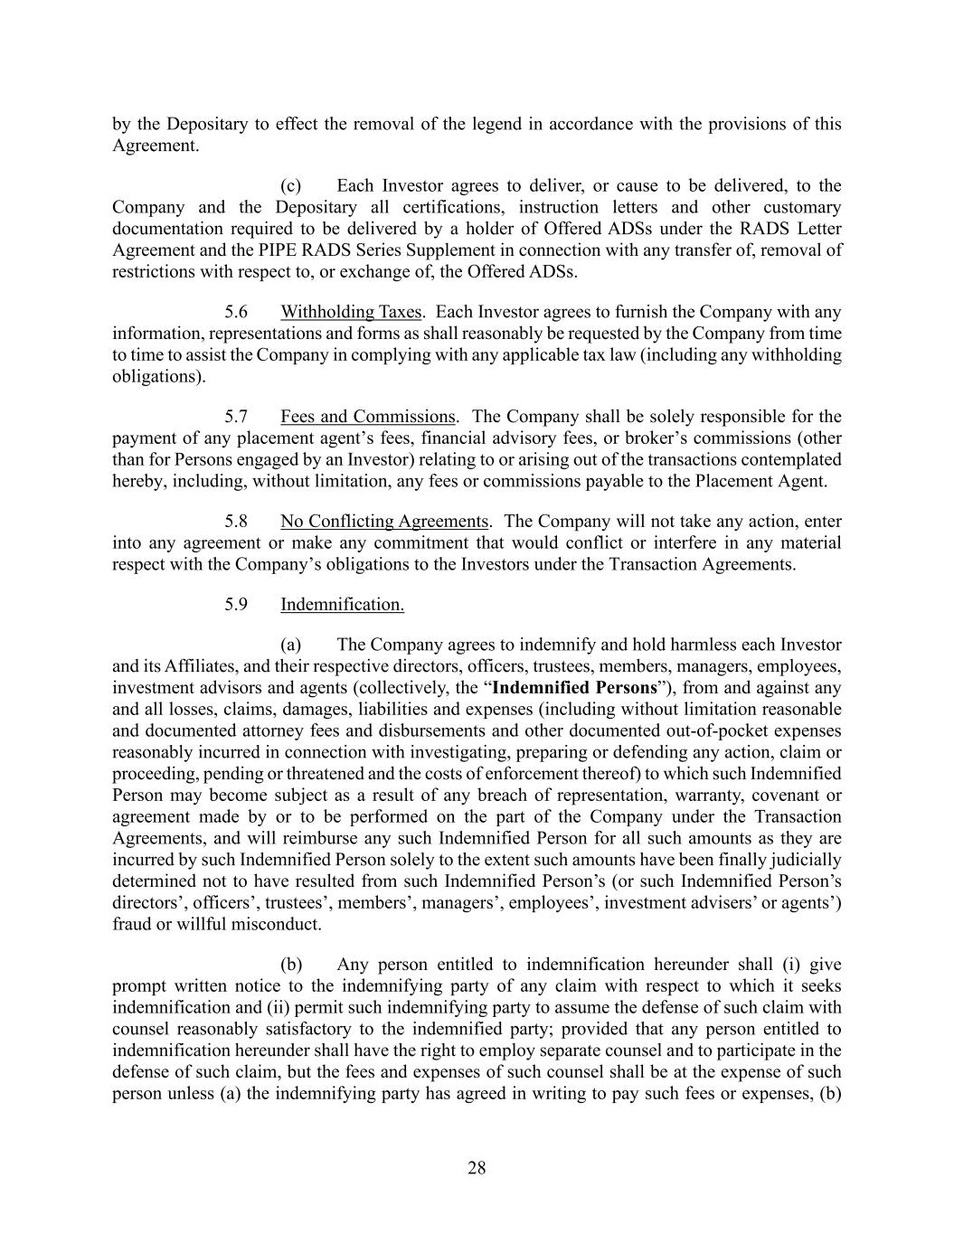
28 by the Depositary to effect the removal of the legend in accordance with the provisions of this Agreement. (c) Each Investor agrees to deliver, or cause to be delivered, to the Company and the Depositary all certifications, instruction letters and other customary documentation required to be delivered by a holder of Offered ADSs under the RADS Letter Agreement and the PIPE RADS Series Supplement in connection with any transfer of, removal of restrictions with respect to, or exchange of, the Offered ADSs. 5.6 Withholding Taxes. Each Investor agrees to furnish the Company with any information, representations and forms as shall reasonably be requested by the Company from time to time to assist the Company in complying with any applicable tax law (including any withholding obligations). 5.7 Fees and Commissions. The Company shall be solely responsible for the payment of any placement agent’s fees, financial advisory fees, or broker’s commissions (other than for Persons engaged by an Investor) relating to or arising out of the transactions contemplated hereby, including, without limitation, any fees or commissions payable to the Placement Agent. 5.8 No Conflicting Agreements. The Company will not take any action, enter into any agreement or make any commitment that would conflict or interfere in any material respect with the Company’s obligations to the Investors under the Transaction Agreements. 5.9 Indemnification. (a) The Company agrees to indemnify and hold harmless each Investor and its Affiliates, and their respective directors, officers, trustees, members, managers, employees, investment advisors and agents (collectively, the “Indemnified Persons”), from and against any and all losses, claims, damages, liabilities and expenses (including without limitation reasonable and documented attorney fees and disbursements and other documented out-of-pocket expenses reasonably incurred in connection with investigating, preparing or defending any action, claim or proceeding, pending or threatened and the costs of enforcement thereof) to which such Indemnified Person may become subject as a result of any breach of representation, warranty, covenant or agreement made by or to be performed on the part of the Company under the Transaction Agreements, and will reimburse any such Indemnified Person for all such amounts as they are incurred by such Indemnified Person solely to the extent such amounts have been finally judicially determined not to have resulted from such Indemnified Person’s (or such Indemnified Person’s directors’, officers’, trustees’, members’, managers’, employees’, investment advisers’ or agents’) fraud or willful misconduct. (b) Any person entitled to indemnification hereunder shall (i) give prompt written notice to the indemnifying party of any claim with respect to which it seeks indemnification and (ii) permit such indemnifying party to assume the defense of such claim with counsel reasonably satisfactory to the indemnified party; provided that any person entitled to indemnification hereunder shall have the right to employ separate counsel and to participate in the defense of such claim, but the fees and expenses of such counsel shall be at the expense of such person unless (a) the indemnifying party has agreed in writing to pay such fees or expenses, (b)

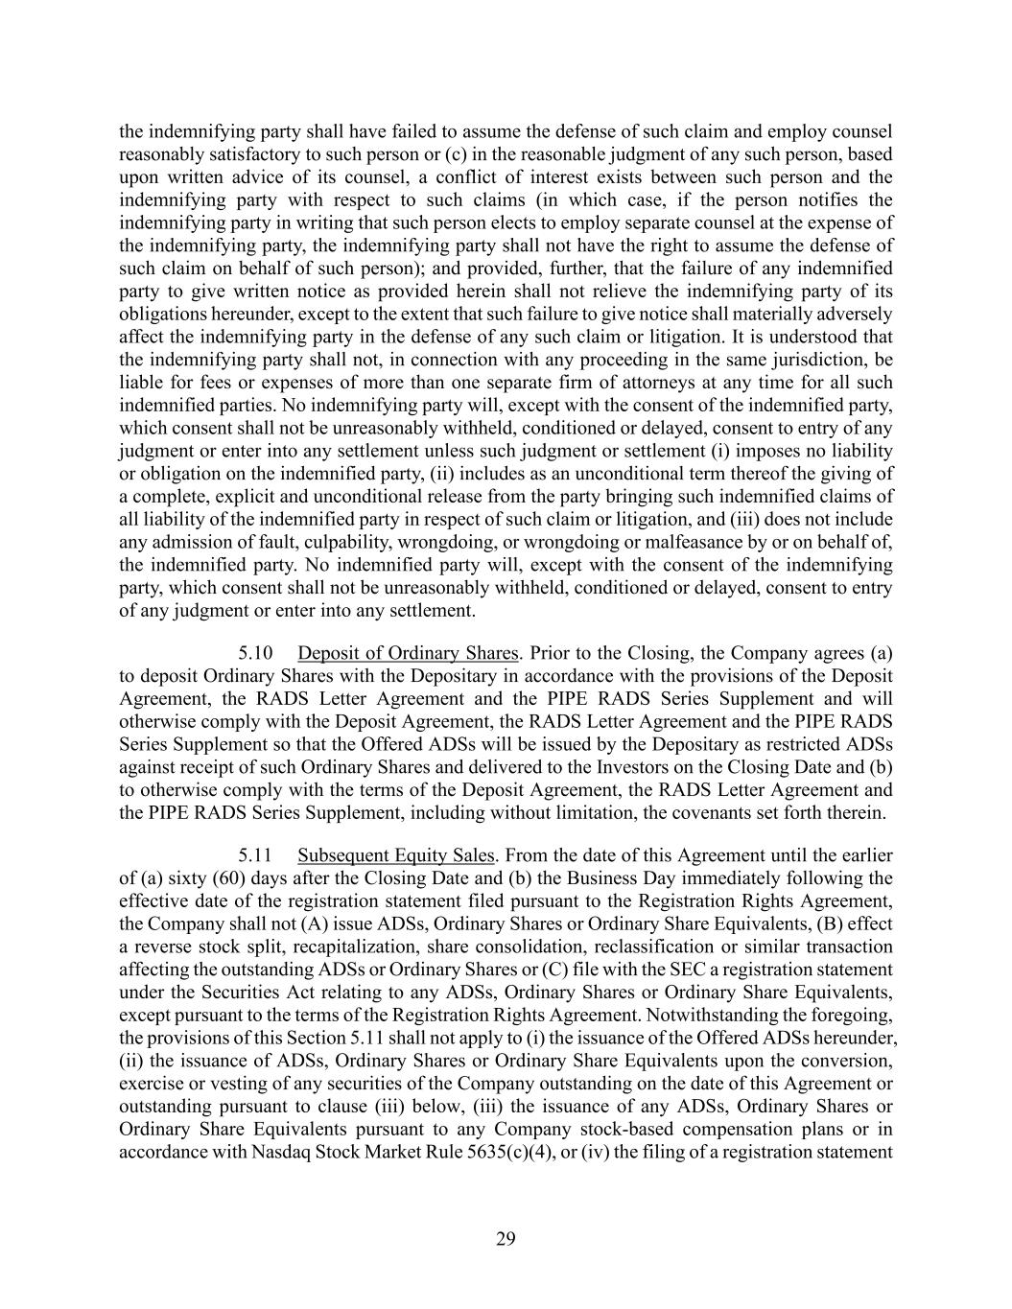
29 the indemnifying party shall have failed to assume the defense of such claim and employ counsel reasonably satisfactory to such person or (c) in the reasonable judgment of any such person, based upon written advice of its counsel, a conflict of interest exists between such person and the indemnifying party with respect to such claims (in which case, if the person notifies the indemnifying party in writing that such person elects to employ separate counsel at the expense of the indemnifying party, the indemnifying party shall not have the right to assume the defense of such claim on behalf of such person); and provided, further, that the failure of any indemnified party to give written notice as provided herein shall not relieve the indemnifying party of its obligations hereunder, except to the extent that such failure to give notice shall materially adversely affect the indemnifying party in the defense of any such claim or litigation. It is understood that the indemnifying party shall not, in connection with any proceeding in the same jurisdiction, be liable for fees or expenses of more than one separate firm of attorneys at any time for all such indemnified parties. No indemnifying party will, except with the consent of the indemnified party, which consent shall not be unreasonably withheld, conditioned or delayed, consent to entry of any judgment or enter into any settlement unless such judgment or settlement (i) imposes no liability or obligation on the indemnified party, (ii) includes as an unconditional term thereof the giving of a complete, explicit and unconditional release from the party bringing such indemnified claims of all liability of the indemnified party in respect of such claim or litigation, and (iii) does not include any admission of fault, culpability, wrongdoing, or wrongdoing or malfeasance by or on behalf of, the indemnified party. No indemnified party will, except with the consent of the indemnifying party, which consent shall not be unreasonably withheld, conditioned or delayed, consent to entry of any judgment or enter into any settlement. 5.10 Deposit of Ordinary Shares. Prior to the Closing, the Company agrees (a) to deposit Ordinary Shares with the Depositary in accordance with the provisions of the Deposit Agreement, the RADS Letter Agreement and the PIPE RADS Series Supplement and will otherwise comply with the Deposit Agreement, the RADS Letter Agreement and the PIPE RADS Series Supplement so that the Offered ADSs will be issued by the Depositary as restricted ADSs against receipt of such Ordinary Shares and delivered to the Investors on the Closing Date and (b) to otherwise comply with the terms of the Deposit Agreement, the RADS Letter Agreement and the PIPE RADS Series Supplement, including without limitation, the covenants set forth therein. 5.11 Subsequent Equity Sales. From the date of this Agreement until the earlier of (a) sixty (60) days after the Closing Date and (b) the Business Day immediately following the effective date of the registration statement filed pursuant to the Registration Rights Agreement, the Company shall not (A) issue ADSs, Ordinary Shares or Ordinary Share Equivalents, (B) effect a reverse stock split, recapitalization, share consolidation, reclassification or similar transaction affecting the outstanding ADSs or Ordinary Shares or (C) file with the SEC a registration statement under the Securities Act relating to any ADSs, Ordinary Shares or Ordinary Share Equivalents, except pursuant to the terms of the Registration Rights Agreement. Notwithstanding the foregoing, the provisions of this Section 5.11 shall not apply to (i) the issuance of the Offered ADSs hereunder, (ii) the issuance of ADSs, Ordinary Shares or Ordinary Share Equivalents upon the conversion, exercise or vesting of any securities of the Company outstanding on the date of this Agreement or outstanding pursuant to clause (iii) below, (iii) the issuance of any ADSs, Ordinary Shares or Ordinary Share Equivalents pursuant to any Company stock-based compensation plans or in accordance with Nasdaq Stock Market Rule 5635(c)(4), or (iv) the filing of a registration statement

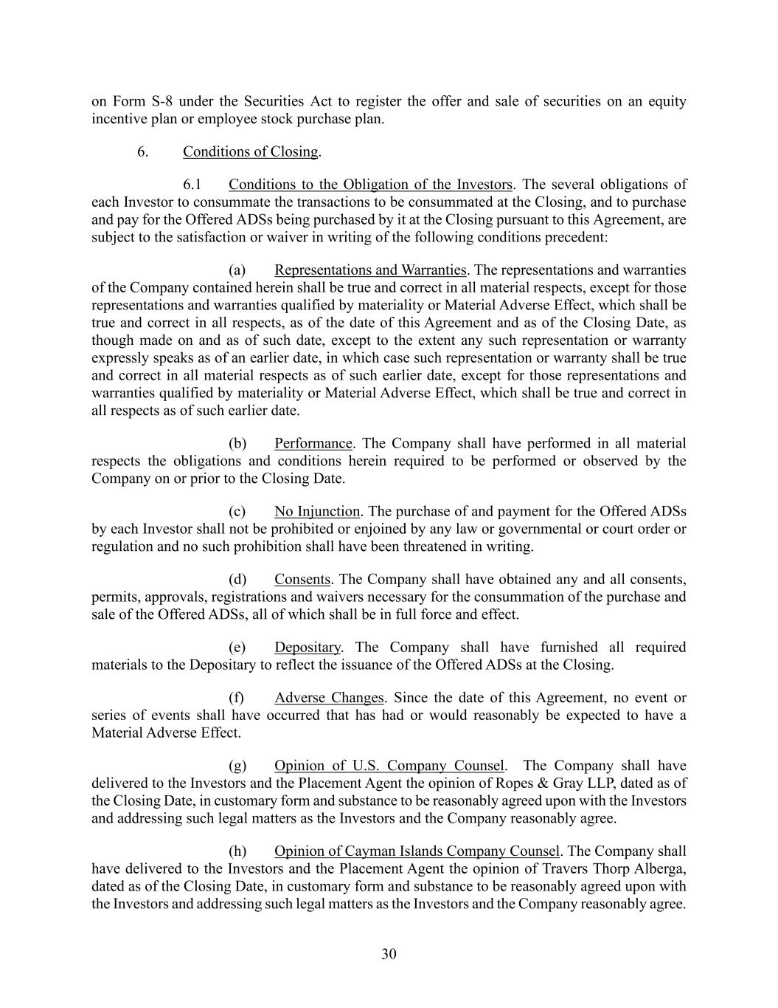
30 on Form S-8 under the Securities Act to register the offer and sale of securities on an equity incentive plan or employee stock purchase plan. 6. Conditions of Closing. 6.1 Conditions to the Obligation of the Investors. The several obligations of each Investor to consummate the transactions to be consummated at the Closing, and to purchase and pay for the Offered ADSs being purchased by it at the Closing pursuant to this Agreement, are subject to the satisfaction or waiver in writing of the following conditions precedent: (a) Representations and Warranties. The representations and warranties of the Company contained herein shall be true and correct in all material respects, except for those representations and warranties qualified by materiality or Material Adverse Effect, which shall be true and correct in all respects, as of the date of this Agreement and as of the Closing Date, as though made on and as of such date, except to the extent any such representation or warranty expressly speaks as of an earlier date, in which case such representation or warranty shall be true and correct in all material respects as of such earlier date, except for those representations and warranties qualified by materiality or Material Adverse Effect, which shall be true and correct in all respects as of such earlier date. (b) Performance. The Company shall have performed in all material respects the obligations and conditions herein required to be performed or observed by the Company on or prior to the Closing Date. (c) No Injunction. The purchase of and payment for the Offered ADSs by each Investor shall not be prohibited or enjoined by any law or governmental or court order or regulation and no such prohibition shall have been threatened in writing. (d) Consents. The Company shall have obtained any and all consents, permits, approvals, registrations and waivers necessary for the consummation of the purchase and sale of the Offered ADSs, all of which shall be in full force and effect. (e) Depositary. The Company shall have furnished all required materials to the Depositary to reflect the issuance of the Offered ADSs at the Closing. (f) Adverse Changes. Since the date of this Agreement, no event or series of events shall have occurred that has had or would reasonably be expected to have a Material Adverse Effect. (g) Opinion of U.S. Company Counsel. The Company shall have delivered to the Investors and the Placement Agent the opinion of Ropes & Gray LLP, dated as of the Closing Date, in customary form and substance to be reasonably agreed upon with the Investors and addressing such legal matters as the Investors and the Company reasonably agree. (h) Opinion of Cayman Islands Company Counsel. The Company shall have delivered to the Investors and the Placement Agent the opinion of Travers Thorp Alberga, dated as of the Closing Date, in customary form and substance to be reasonably agreed upon with the Investors and addressing such legal matters as the Investors and the Company reasonably agree.

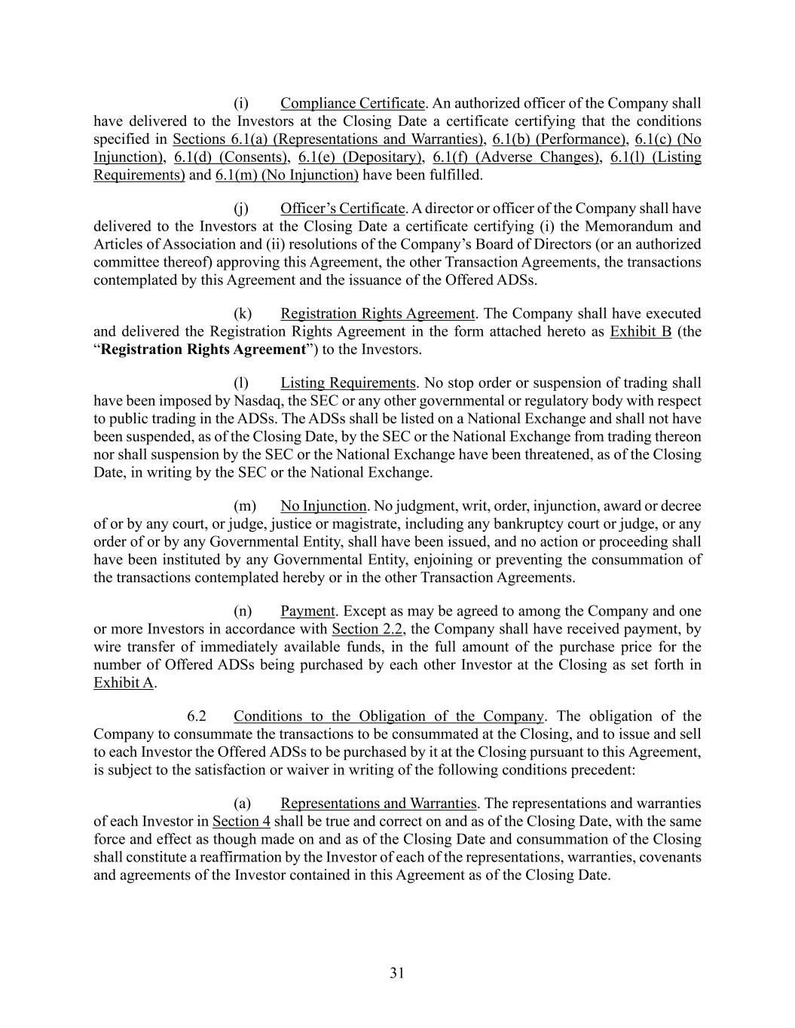
31 (i) Compliance Certificate. An authorized officer of the Company shall have delivered to the Investors at the Closing Date a certificate certifying that the conditions specified in Sections 6.1(a) (Representations and Warranties), 6.1(b) (Performance), 6.1(c) (No Injunction), 6.1(d) (Consents), 6.1(e) (Depositary), 6.1(f) (Adverse Changes), 6.1(l) (Listing Requirements) and 6.1(m) (No Injunction) have been fulfilled. (j) Officer’s Certificate. A director or officer of the Company shall have delivered to the Investors at the Closing Date a certificate certifying (i) the Memorandum and Articles of Association and (ii) resolutions of the Company’s Board of Directors (or an authorized committee thereof) approving this Agreement, the other Transaction Agreements, the transactions contemplated by this Agreement and the issuance of the Offered ADSs. (k) Registration Rights Agreement. The Company shall have executed and delivered the Registration Rights Agreement in the form attached hereto as Exhibit B (the “Registration Rights Agreement”) to the Investors. (l) Listing Requirements. No stop order or suspension of trading shall have been imposed by Nasdaq, the SEC or any other governmental or regulatory body with respect to public trading in the ADSs. The ADSs shall be listed on a National Exchange and shall not have been suspended, as of the Closing Date, by the SEC or the National Exchange from trading thereon nor shall suspension by the SEC or the National Exchange have been threatened, as of the Closing Date, in writing by the SEC or the National Exchange. (m) No Injunction. No judgment, writ, order, injunction, award or decree of or by any court, or judge, justice or magistrate, including any bankruptcy court or judge, or any order of or by any Governmental Entity, shall have been issued, and no action or proceeding shall have been instituted by any Governmental Entity, enjoining or preventing the consummation of the transactions contemplated hereby or in the other Transaction Agreements. (n) Payment. Except as may be agreed to among the Company and one or more Investors in accordance with Section 2.2, the Company shall have received payment, by wire transfer of immediately available funds, in the full amount of the purchase price for the number of Offered ADSs being purchased by each other Investor at the Closing as set forth in Exhibit A. 6.2 Conditions to the Obligation of the Company. The obligation of the Company to consummate the transactions to be consummated at the Closing, and to issue and sell to each Investor the Offered ADSs to be purchased by it at the Closing pursuant to this Agreement, is subject to the satisfaction or waiver in writing of the following conditions precedent: (a) Representations and Warranties. The representations and warranties of each Investor in Section 4 shall be true and correct on and as of the Closing Date, with the same force and effect as though made on and as of the Closing Date and consummation of the Closing shall constitute a reaffirmation by the Investor of each of the representations, warranties, covenants and agreements of the Investor contained in this Agreement as of the Closing Date.

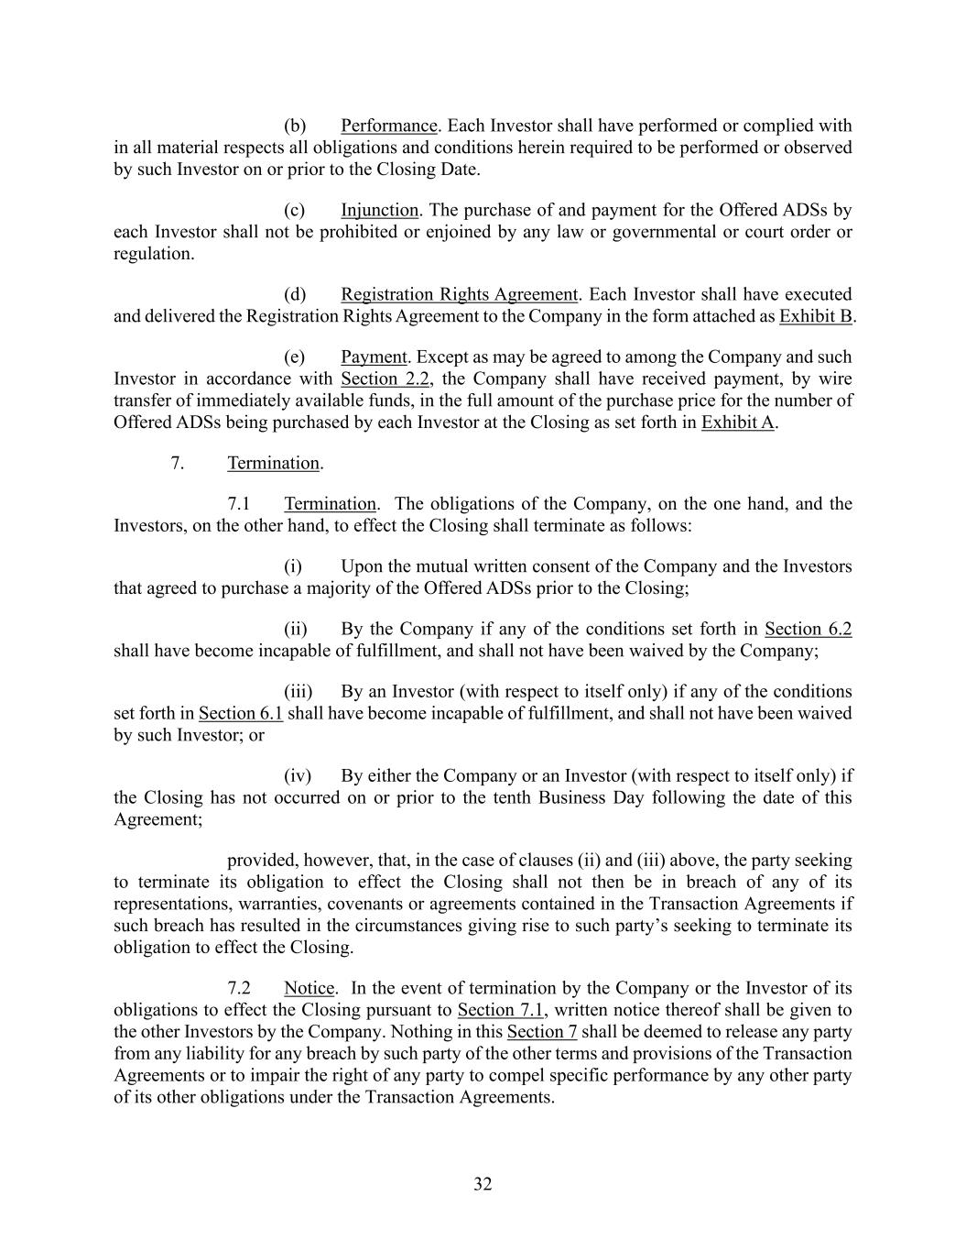
32 (b) Performance. Each Investor shall have performed or complied with in all material respects all obligations and conditions herein required to be performed or observed by such Investor on or prior to the Closing Date. (c) Injunction. The purchase of and payment for the Offered ADSs by each Investor shall not be prohibited or enjoined by any law or governmental or court order or regulation. (d) Registration Rights Agreement. Each Investor shall have executed and delivered the Registration Rights Agreement to the Company in the form attached as Exhibit B. (e) Payment. Except as may be agreed to among the Company and such Investor in accordance with Section 2.2, the Company shall have received payment, by wire transfer of immediately available funds, in the full amount of the purchase price for the number of Offered ADSs being purchased by each Investor at the Closing as set forth in Exhibit A. 7. Termination. 7.1 Termination. The obligations of the Company, on the one hand, and the Investors, on the other hand, to effect the Closing shall terminate as follows: (i) Upon the mutual written consent of the Company and the Investors that agreed to purchase a majority of the Offered ADSs prior to the Closing; (ii) By the Company if any of the conditions set forth in Section 6.2 shall have become incapable of fulfillment, and shall not have been waived by the Company; (iii) By an Investor (with respect to itself only) if any of the conditions set forth in Section 6.1 shall have become incapable of fulfillment, and shall not have been waived by such Investor; or (iv) By either the Company or an Investor (with respect to itself only) if the Closing has not occurred on or prior to the tenth Business Day following the date of this Agreement; provided, however, that, in the case of clauses (ii) and (iii) above, the party seeking to terminate its obligation to effect the Closing shall not then be in breach of any of its representations, warranties, covenants or agreements contained in the Transaction Agreements if such breach has resulted in the circumstances giving rise to such party’s seeking to terminate its obligation to effect the Closing. 7.2 Notice. In the event of termination by the Company or the Investor of its obligations to effect the Closing pursuant to Section 7.1, written notice thereof shall be given to the other Investors by the Company. Nothing in this Section 7 shall be deemed to release any party from any liability for any breach by such party of the other terms and provisions of the Transaction Agreements or to impair the right of any party to compel specific performance by any other party of its other obligations under the Transaction Agreements.

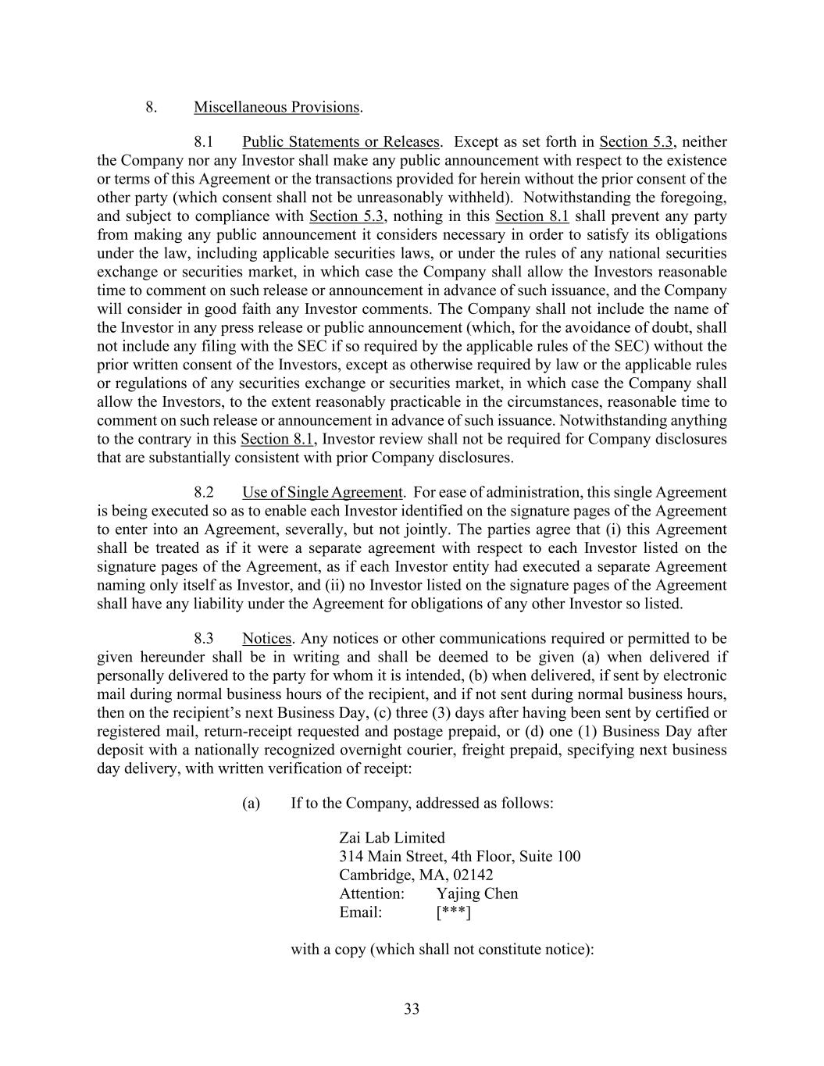
33 8. Miscellaneous Provisions. 8.1 Public Statements or Releases. Except as set forth in Section 5.3, neither the Company nor any Investor shall make any public announcement with respect to the existence or terms of this Agreement or the transactions provided for herein without the prior consent of the other party (which consent shall not be unreasonably withheld). Notwithstanding the foregoing, and subject to compliance with Section 5.3, nothing in this Section 8.1 shall prevent any party from making any public announcement it considers necessary in order to satisfy its obligations under the law, including applicable securities laws, or under the rules of any national securities exchange or securities market, in which case the Company shall allow the Investors reasonable time to comment on such release or announcement in advance of such issuance, and the Company will consider in good faith any Investor comments. The Company shall not include the name of the Investor in any press release or public announcement (which, for the avoidance of doubt, shall not include any filing with the SEC if so required by the applicable rules of the SEC) without the prior written consent of the Investors, except as otherwise required by law or the applicable rules or regulations of any securities exchange or securities market, in which case the Company shall allow the Investors, to the extent reasonably practicable in the circumstances, reasonable time to comment on such release or announcement in advance of such issuance. Notwithstanding anything to the contrary in this Section 8.1, Investor review shall not be required for Company disclosures that are substantially consistent with prior Company disclosures. 8.2 Use of Single Agreement. For ease of administration, this single Agreement is being executed so as to enable each Investor identified on the signature pages of the Agreement to enter into an Agreement, severally, but not jointly. The parties agree that (i) this Agreement shall be treated as if it were a separate agreement with respect to each Investor listed on the signature pages of the Agreement, as if each Investor entity had executed a separate Agreement naming only itself as Investor, and (ii) no Investor listed on the signature pages of the Agreement shall have any liability under the Agreement for obligations of any other Investor so listed. 8.3 Notices. Any notices or other communications required or permitted to be given hereunder shall be in writing and shall be deemed to be given (a) when delivered if personally delivered to the party for whom it is intended, (b) when delivered, if sent by electronic mail during normal business hours of the recipient, and if not sent during normal business hours, then on the recipient’s next Business Day, (c) three (3) days after having been sent by certified or registered mail, return-receipt requested and postage prepaid, or (d) one (1) Business Day after deposit with a nationally recognized overnight courier, freight prepaid, specifying next business day delivery, with written verification of receipt: (a) If to the Company, addressed as follows: Zai Lab Limited 314 Main Street, 4th Floor, Suite 100 Cambridge, MA, 02142 Attention: Yajing Chen Email: [***] with a copy (which shall not constitute notice):

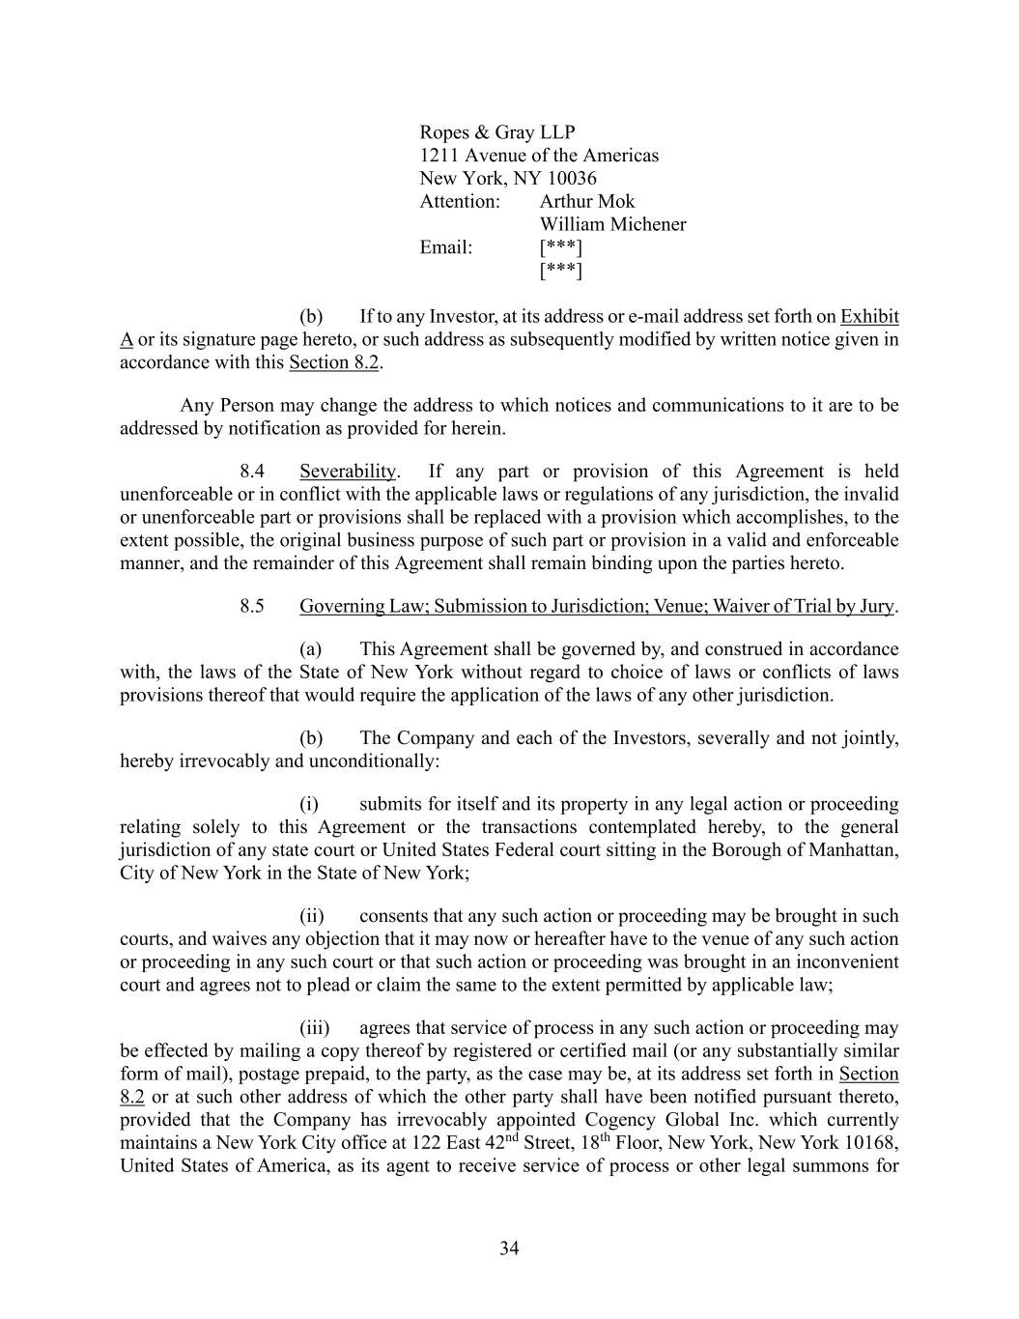
34 Ropes & Gray LLP 1211 Avenue of the Americas New York, NY 10036 Attention: Arthur Mok William Michener Email: [***] [***] (b) If to any Investor, at its address or e-mail address set forth on Exhibit A or its signature page hereto, or such address as subsequently modified by written notice given in accordance with this Section 8.2. Any Person may change the address to which notices and communications to it are to be addressed by notification as provided for herein. 8.4 Severability. If any part or provision of this Agreement is held unenforceable or in conflict with the applicable laws or regulations of any jurisdiction, the invalid or unenforceable part or provisions shall be replaced with a provision which accomplishes, to the extent possible, the original business purpose of such part or provision in a valid and enforceable manner, and the remainder of this Agreement shall remain binding upon the parties hereto. 8.5 Governing Law; Submission to Jurisdiction; Venue; Waiver of Trial by Jury. (a) This Agreement shall be governed by, and construed in accordance with, the laws of the State of New York without regard to choice of laws or conflicts of laws provisions thereof that would require the application of the laws of any other jurisdiction. (b) The Company and each of the Investors, severally and not jointly, hereby irrevocably and unconditionally: (i) submits for itself and its property in any legal action or proceeding relating solely to this Agreement or the transactions contemplated hereby, to the general jurisdiction of any state court or United States Federal court sitting in the Borough of Manhattan, City of New York in the State of New York; (ii) consents that any such action or proceeding may be brought in such courts, and waives any objection that it may now or hereafter have to the venue of any such action or proceeding in any such court or that such action or proceeding was brought in an inconvenient court and agrees not to plead or claim the same to the extent permitted by applicable law; (iii) agrees that service of process in any such action or proceeding may be effected by mailing a copy thereof by registered or certified mail (or any substantially similar form of mail), postage prepaid, to the party, as the case may be, at its address set forth in Section 8.2 or at such other address of which the other party shall have been notified pursuant thereto, provided that the Company has irrevocably appointed Cogency Global Inc. which currently maintains a New York City office at 122 East 42nd Street, 18th Floor, New York, New York 10168, United States of America, as its agent to receive service of process or other legal summons for

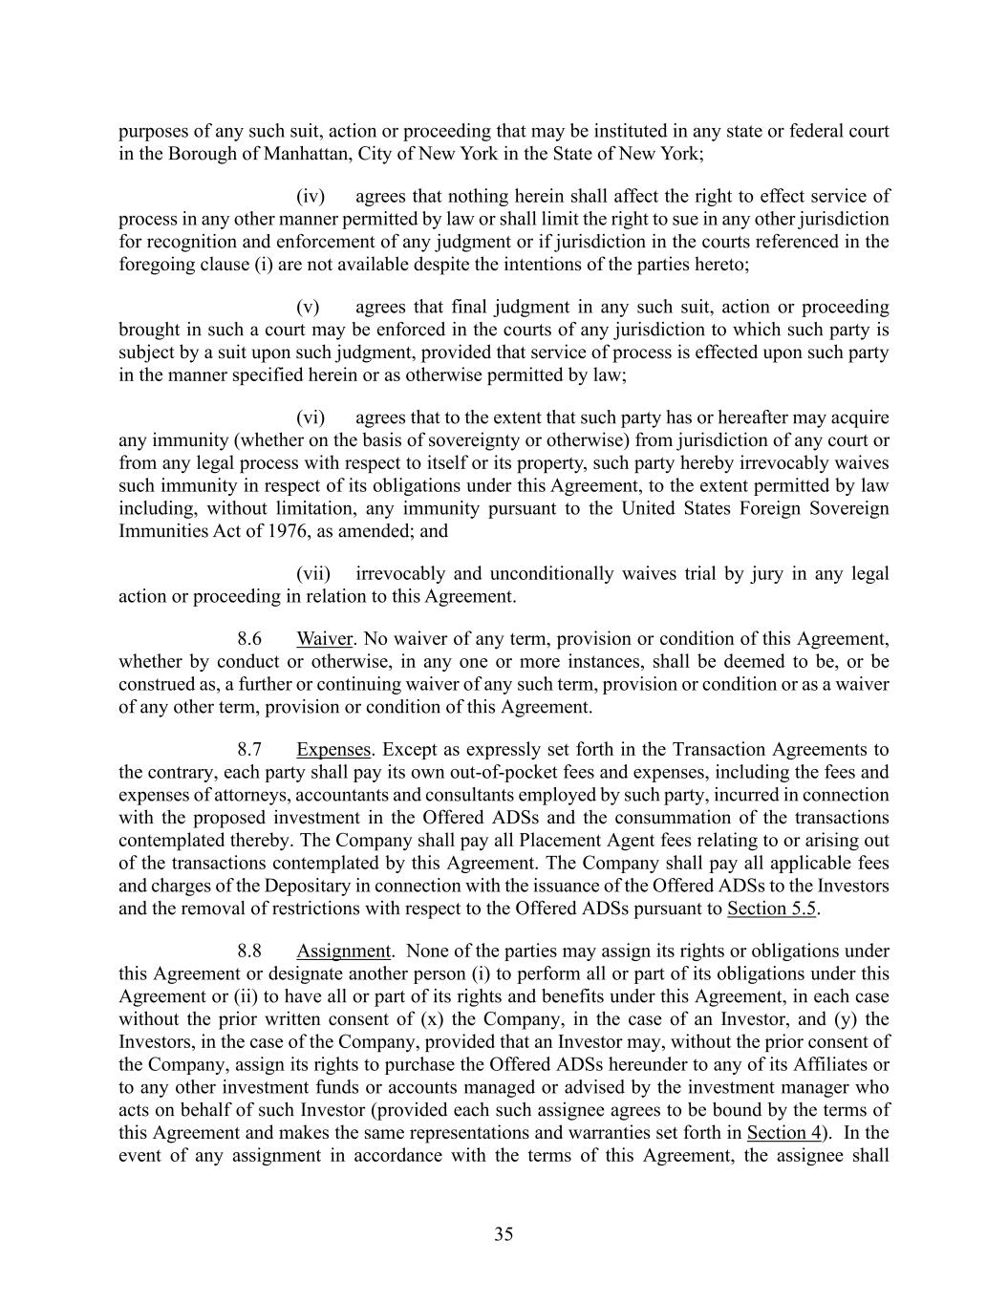
35 purposes of any such suit, action or proceeding that may be instituted in any state or federal court in the Borough of Manhattan, City of New York in the State of New York; (iv) agrees that nothing herein shall affect the right to effect service of process in any other manner permitted by law or shall limit the right to sue in any other jurisdiction for recognition and enforcement of any judgment or if jurisdiction in the courts referenced in the foregoing clause (i) are not available despite the intentions of the parties hereto; (v) agrees that final judgment in any such suit, action or proceeding brought in such a court may be enforced in the courts of any jurisdiction to which such party is subject by a suit upon such judgment, provided that service of process is effected upon such party in the manner specified herein or as otherwise permitted by law; (vi) agrees that to the extent that such party has or hereafter may acquire any immunity (whether on the basis of sovereignty or otherwise) from jurisdiction of any court or from any legal process with respect to itself or its property, such party hereby irrevocably waives such immunity in respect of its obligations under this Agreement, to the extent permitted by law including, without limitation, any immunity pursuant to the United States Foreign Sovereign Immunities Act of 1976, as amended; and (vii) irrevocably and unconditionally waives trial by jury in any legal action or proceeding in relation to this Agreement. 8.6 Waiver. No waiver of any term, provision or condition of this Agreement, whether by conduct or otherwise, in any one or more instances, shall be deemed to be, or be construed as, a further or continuing waiver of any such term, provision or condition or as a waiver of any other term, provision or condition of this Agreement. 8.7 Expenses. Except as expressly set forth in the Transaction Agreements to the contrary, each party shall pay its own out-of-pocket fees and expenses, including the fees and expenses of attorneys, accountants and consultants employed by such party, incurred in connection with the proposed investment in the Offered ADSs and the consummation of the transactions contemplated thereby. The Company shall pay all Placement Agent fees relating to or arising out of the transactions contemplated by this Agreement. The Company shall pay all applicable fees and charges of the Depositary in connection with the issuance of the Offered ADSs to the Investors and the removal of restrictions with respect to the Offered ADSs pursuant to Section 5.5. 8.8 Assignment. None of the parties may assign its rights or obligations under this Agreement or designate another person (i) to perform all or part of its obligations under this Agreement or (ii) to have all or part of its rights and benefits under this Agreement, in each case without the prior written consent of (x) the Company, in the case of an Investor, and (y) the Investors, in the case of the Company, provided that an Investor may, without the prior consent of the Company, assign its rights to purchase the Offered ADSs hereunder to any of its Affiliates or to any other investment funds or accounts managed or advised by the investment manager who acts on behalf of such Investor (provided each such assignee agrees to be bound by the terms of this Agreement and makes the same representations and warranties set forth in Section 4). In the event of any assignment in accordance with the terms of this Agreement, the assignee shall

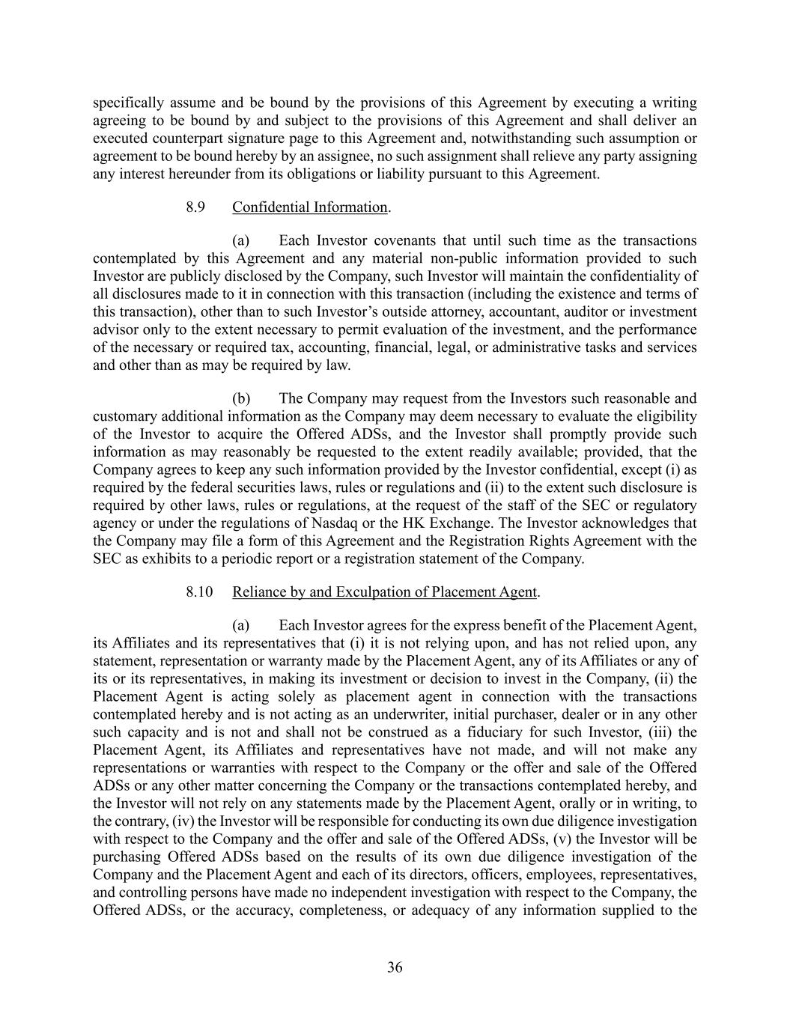
36 specifically assume and be bound by the provisions of this Agreement by executing a writing agreeing to be bound by and subject to the provisions of this Agreement and shall deliver an executed counterpart signature page to this Agreement and, notwithstanding such assumption or agreement to be bound hereby by an assignee, no such assignment shall relieve any party assigning any interest hereunder from its obligations or liability pursuant to this Agreement. 8.9 Confidential Information. (a) Each Investor covenants that until such time as the transactions contemplated by this Agreement and any material non-public information provided to such Investor are publicly disclosed by the Company, such Investor will maintain the confidentiality of all disclosures made to it in connection with this transaction (including the existence and terms of this transaction), other than to such Investor’s outside attorney, accountant, auditor or investment advisor only to the extent necessary to permit evaluation of the investment, and the performance of the necessary or required tax, accounting, financial, legal, or administrative tasks and services and other than as may be required by law. (b) The Company may request from the Investors such reasonable and customary additional information as the Company may deem necessary to evaluate the eligibility of the Investor to acquire the Offered ADSs, and the Investor shall promptly provide such information as may reasonably be requested to the extent readily available; provided, that the Company agrees to keep any such information provided by the Investor confidential, except (i) as required by the federal securities laws, rules or regulations and (ii) to the extent such disclosure is required by other laws, rules or regulations, at the request of the staff of the SEC or regulatory agency or under the regulations of Nasdaq or the HK Exchange. The Investor acknowledges that the Company may file a form of this Agreement and the Registration Rights Agreement with the SEC as exhibits to a periodic report or a registration statement of the Company. 8.10 Reliance by and Exculpation of Placement Agent. (a) Each Investor agrees for the express benefit of the Placement Agent, its Affiliates and its representatives that (i) it is not relying upon, and has not relied upon, any statement, representation or warranty made by the Placement Agent, any of its Affiliates or any of its or its representatives, in making its investment or decision to invest in the Company, (ii) the Placement Agent is acting solely as placement agent in connection with the transactions contemplated hereby and is not acting as an underwriter, initial purchaser, dealer or in any other such capacity and is not and shall not be construed as a fiduciary for such Investor, (iii) the Placement Agent, its Affiliates and representatives have not made, and will not make any representations or warranties with respect to the Company or the offer and sale of the Offered ADSs or any other matter concerning the Company or the transactions contemplated hereby, and the Investor will not rely on any statements made by the Placement Agent, orally or in writing, to the contrary, (iv) the Investor will be responsible for conducting its own due diligence investigation with respect to the Company and the offer and sale of the Offered ADSs, (v) the Investor will be purchasing Offered ADSs based on the results of its own due diligence investigation of the Company and the Placement Agent and each of its directors, officers, employees, representatives, and controlling persons have made no independent investigation with respect to the Company, the Offered ADSs, or the accuracy, completeness, or adequacy of any information supplied to the

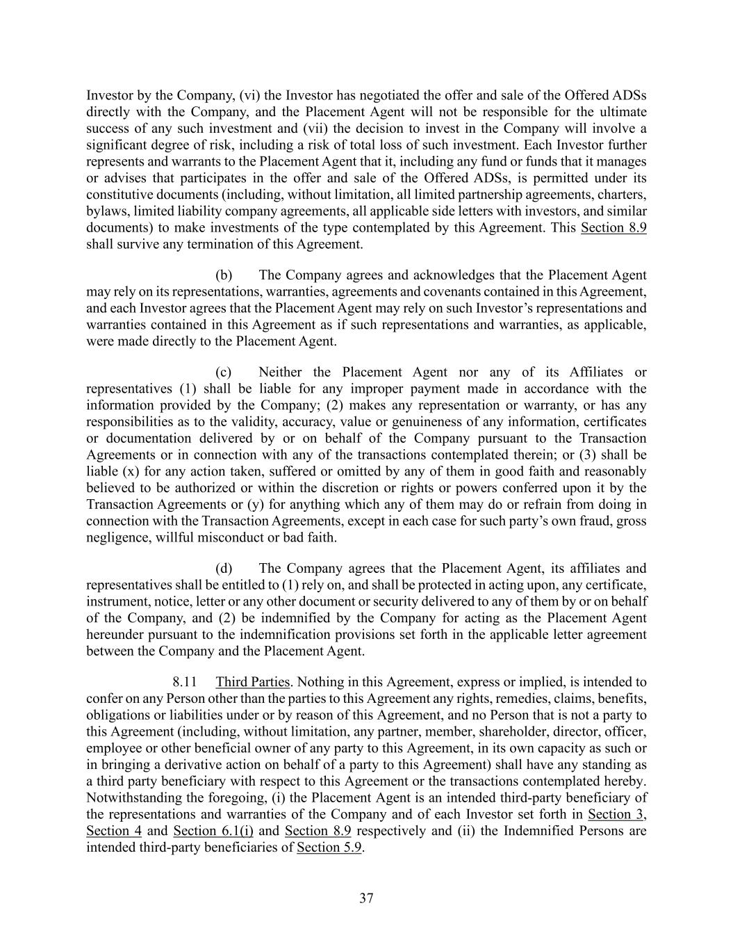
37 Investor by the Company, (vi) the Investor has negotiated the offer and sale of the Offered ADSs directly with the Company, and the Placement Agent will not be responsible for the ultimate success of any such investment and (vii) the decision to invest in the Company will involve a significant degree of risk, including a risk of total loss of such investment. Each Investor further represents and warrants to the Placement Agent that it, including any fund or funds that it manages or advises that participates in the offer and sale of the Offered ADSs, is permitted under its constitutive documents (including, without limitation, all limited partnership agreements, charters, bylaws, limited liability company agreements, all applicable side letters with investors, and similar documents) to make investments of the type contemplated by this Agreement. This Section 8.9 shall survive any termination of this Agreement. (b) The Company agrees and acknowledges that the Placement Agent may rely on its representations, warranties, agreements and covenants contained in this Agreement, and each Investor agrees that the Placement Agent may rely on such Investor’s representations and warranties contained in this Agreement as if such representations and warranties, as applicable, were made directly to the Placement Agent. (c) Neither the Placement Agent nor any of its Affiliates or representatives (1) shall be liable for any improper payment made in accordance with the information provided by the Company; (2) makes any representation or warranty, or has any responsibilities as to the validity, accuracy, value or genuineness of any information, certificates or documentation delivered by or on behalf of the Company pursuant to the Transaction Agreements or in connection with any of the transactions contemplated therein; or (3) shall be liable (x) for any action taken, suffered or omitted by any of them in good faith and reasonably believed to be authorized or within the discretion or rights or powers conferred upon it by the Transaction Agreements or (y) for anything which any of them may do or refrain from doing in connection with the Transaction Agreements, except in each case for such party’s own fraud, gross negligence, willful misconduct or bad faith. (d) The Company agrees that the Placement Agent, its affiliates and representatives shall be entitled to (1) rely on, and shall be protected in acting upon, any certificate, instrument, notice, letter or any other document or security delivered to any of them by or on behalf of the Company, and (2) be indemnified by the Company for acting as the Placement Agent hereunder pursuant to the indemnification provisions set forth in the applicable letter agreement between the Company and the Placement Agent. 8.11 Third Parties. Nothing in this Agreement, express or implied, is intended to confer on any Person other than the parties to this Agreement any rights, remedies, claims, benefits, obligations or liabilities under or by reason of this Agreement, and no Person that is not a party to this Agreement (including, without limitation, any partner, member, shareholder, director, officer, employee or other beneficial owner of any party to this Agreement, in its own capacity as such or in bringing a derivative action on behalf of a party to this Agreement) shall have any standing as a third party beneficiary with respect to this Agreement or the transactions contemplated hereby. Notwithstanding the foregoing, (i) the Placement Agent is an intended third-party beneficiary of the representations and warranties of the Company and of each Investor set forth in Section 3, Section 4 and Section 6.1(i) and Section 8.9 respectively and (ii) the Indemnified Persons are intended third-party beneficiaries of Section 5.9.

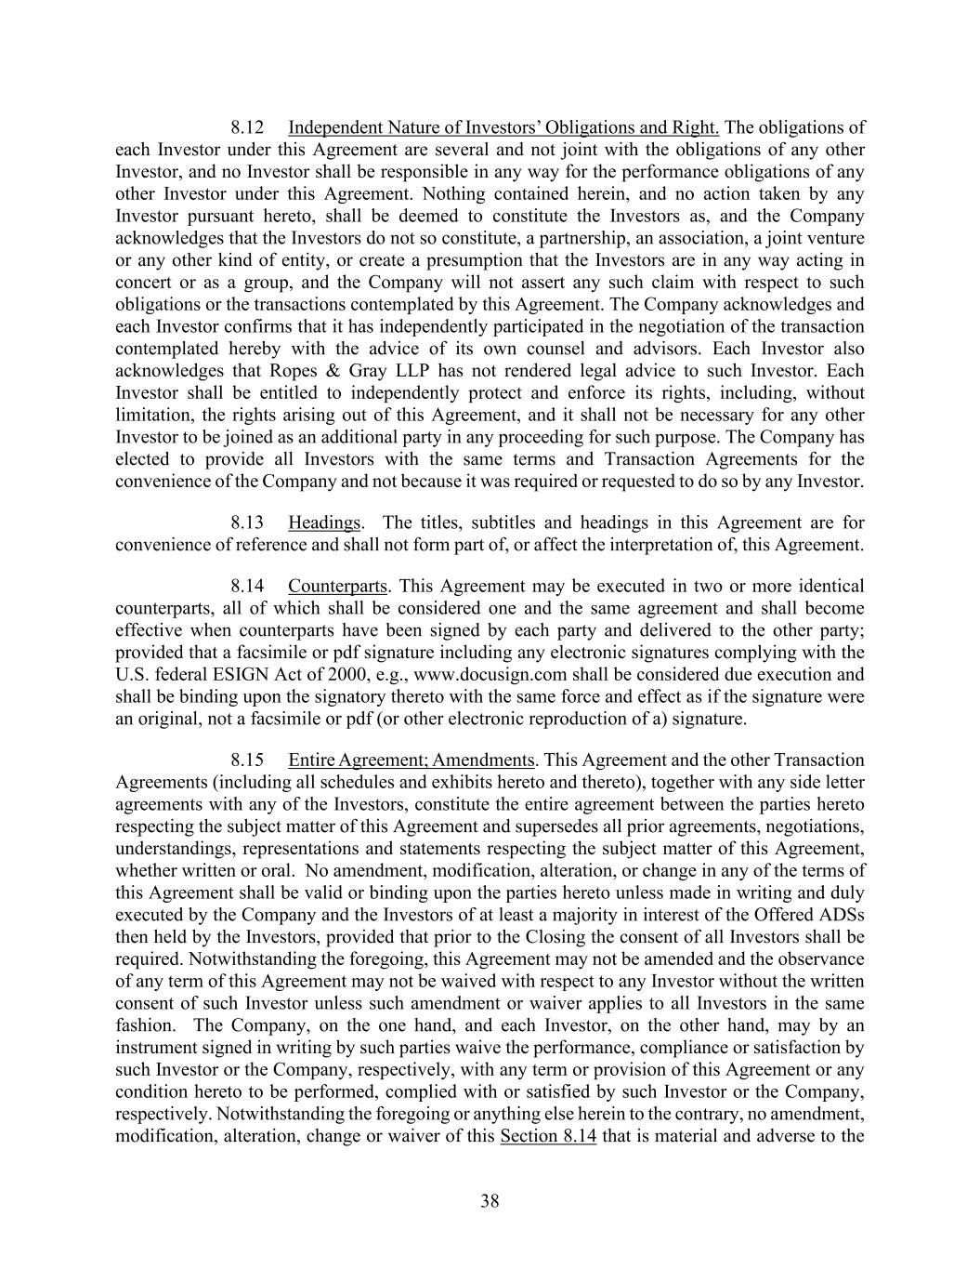
38 8.12 Independent Nature of Investors’ Obligations and Right. The obligations of each Investor under this Agreement are several and not joint with the obligations of any other Investor, and no Investor shall be responsible in any way for the performance obligations of any other Investor under this Agreement. Nothing contained herein, and no action taken by any Investor pursuant hereto, shall be deemed to constitute the Investors as, and the Company acknowledges that the Investors do not so constitute, a partnership, an association, a joint venture or any other kind of entity, or create a presumption that the Investors are in any way acting in concert or as a group, and the Company will not assert any such claim with respect to such obligations or the transactions contemplated by this Agreement. The Company acknowledges and each Investor confirms that it has independently participated in the negotiation of the transaction contemplated hereby with the advice of its own counsel and advisors. Each Investor also acknowledges that Ropes & Gray LLP has not rendered legal advice to such Investor. Each Investor shall be entitled to independently protect and enforce its rights, including, without limitation, the rights arising out of this Agreement, and it shall not be necessary for any other Investor to be joined as an additional party in any proceeding for such purpose. The Company has elected to provide all Investors with the same terms and Transaction Agreements for the convenience of the Company and not because it was required or requested to do so by any Investor. 8.13 Headings. The titles, subtitles and headings in this Agreement are for convenience of reference and shall not form part of, or affect the interpretation of, this Agreement. 8.14 Counterparts. This Agreement may be executed in two or more identical counterparts, all of which shall be considered one and the same agreement and shall become effective when counterparts have been signed by each party and delivered to the other party; provided that a facsimile or pdf signature including any electronic signatures complying with the U.S. federal ESIGN Act of 2000, e.g., www.docusign.com shall be considered due execution and shall be binding upon the signatory thereto with the same force and effect as if the signature were an original, not a facsimile or pdf (or other electronic reproduction of a) signature. 8.15 Entire Agreement; Amendments. This Agreement and the other Transaction Agreements (including all schedules and exhibits hereto and thereto), together with any side letter agreements with any of the Investors, constitute the entire agreement between the parties hereto respecting the subject matter of this Agreement and supersedes all prior agreements, negotiations, understandings, representations and statements respecting the subject matter of this Agreement, whether written or oral. No amendment, modification, alteration, or change in any of the terms of this Agreement shall be valid or binding upon the parties hereto unless made in writing and duly executed by the Company and the Investors of at least a majority in interest of the Offered ADSs then held by the Investors, provided that prior to the Closing the consent of all Investors shall be required. Notwithstanding the foregoing, this Agreement may not be amended and the observance of any term of this Agreement may not be waived with respect to any Investor without the written consent of such Investor unless such amendment or waiver applies to all Investors in the same fashion. The Company, on the one hand, and each Investor, on the other hand, may by an instrument signed in writing by such parties waive the performance, compliance or satisfaction by such Investor or the Company, respectively, with any term or provision of this Agreement or any condition hereto to be performed, complied with or satisfied by such Investor or the Company, respectively. Notwithstanding the foregoing or anything else herein to the contrary, no amendment, modification, alteration, change or waiver of this Section 8.14 that is material and adverse to the

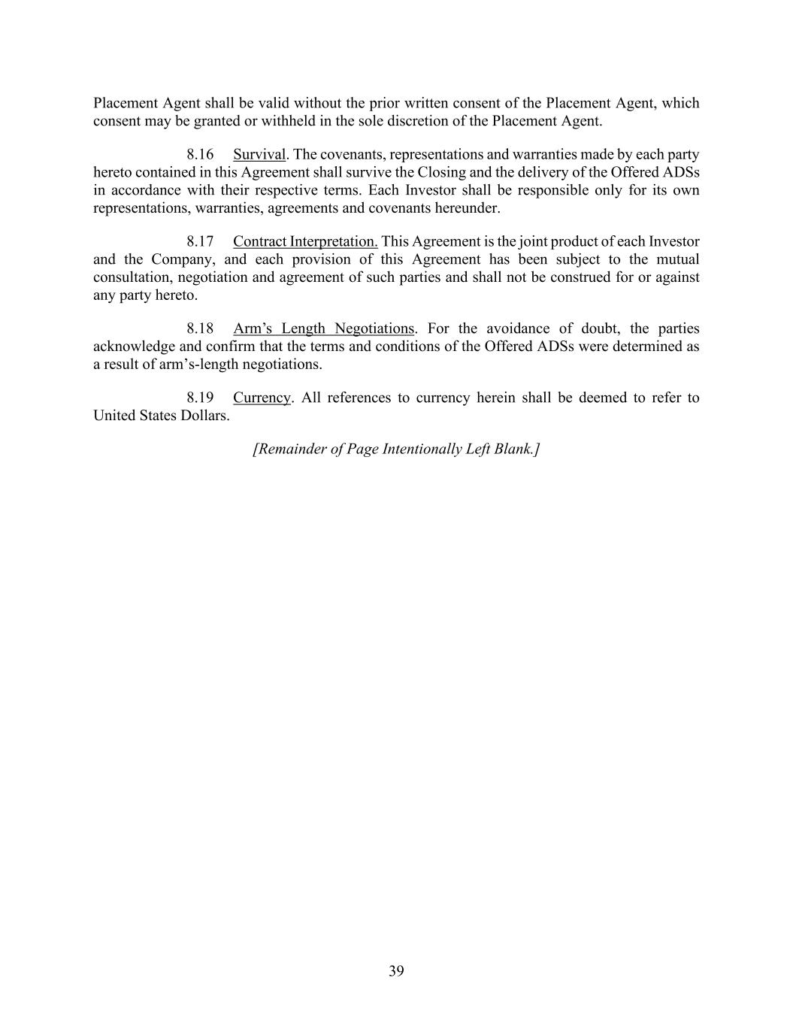
39 Placement Agent shall be valid without the prior written consent of the Placement Agent, which consent may be granted or withheld in the sole discretion of the Placement Agent. 8.16 Survival. The covenants, representations and warranties made by each party hereto contained in this Agreement shall survive the Closing and the delivery of the Offered ADSs in accordance with their respective terms. Each Investor shall be responsible only for its own representations, warranties, agreements and covenants hereunder. 8.17 Contract Interpretation. This Agreement is the joint product of each Investor and the Company, and each provision of this Agreement has been subject to the mutual consultation, negotiation and agreement of such parties and shall not be construed for or against any party hereto. 8.18 Arm’s Length Negotiations. For the avoidance of doubt, the parties acknowledge and confirm that the terms and conditions of the Offered ADSs were determined as a result of arm’s-length negotiations. 8.19 Currency. All references to currency herein shall be deemed to refer to United States Dollars. [Remainder of Page Intentionally Left Blank.]

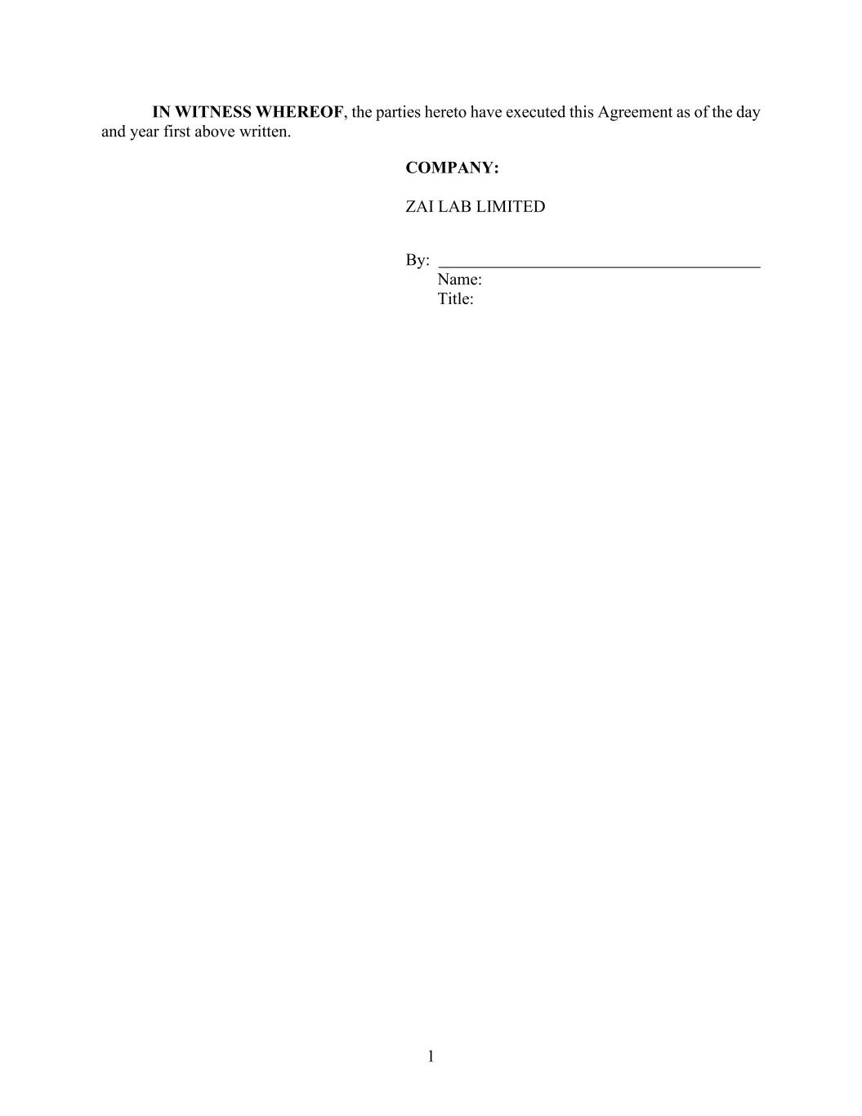
1 IN WITNESS WHEREOF, the parties hereto have executed this Agreement as of the day and year first above written. COMPANY: ZAI LAB LIMITED By: Name: Title:

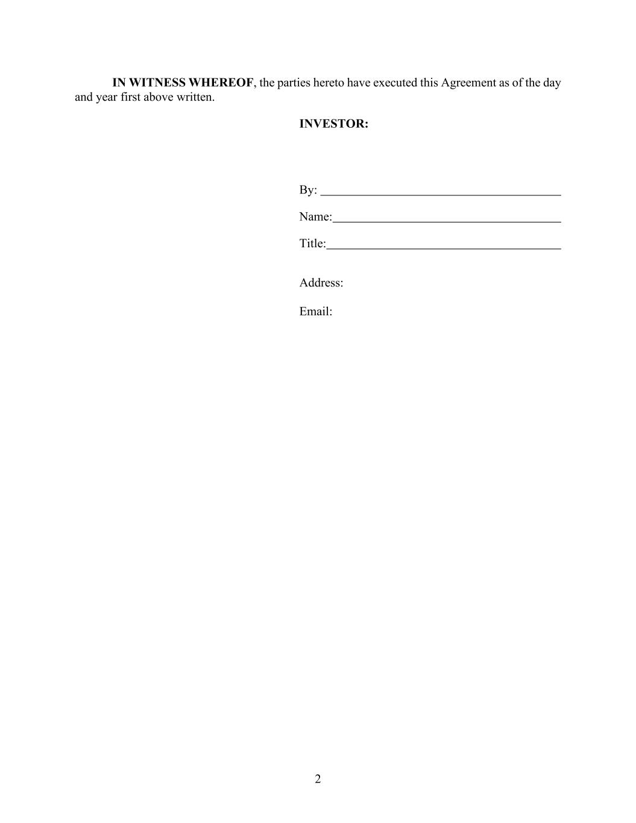
2 IN WITNESS WHEREOF, the parties hereto have executed this Agreement as of the day and year first above written. INVESTOR: By: Name: Title: Address: Email:


3 EXHIBIT A INVESTORS

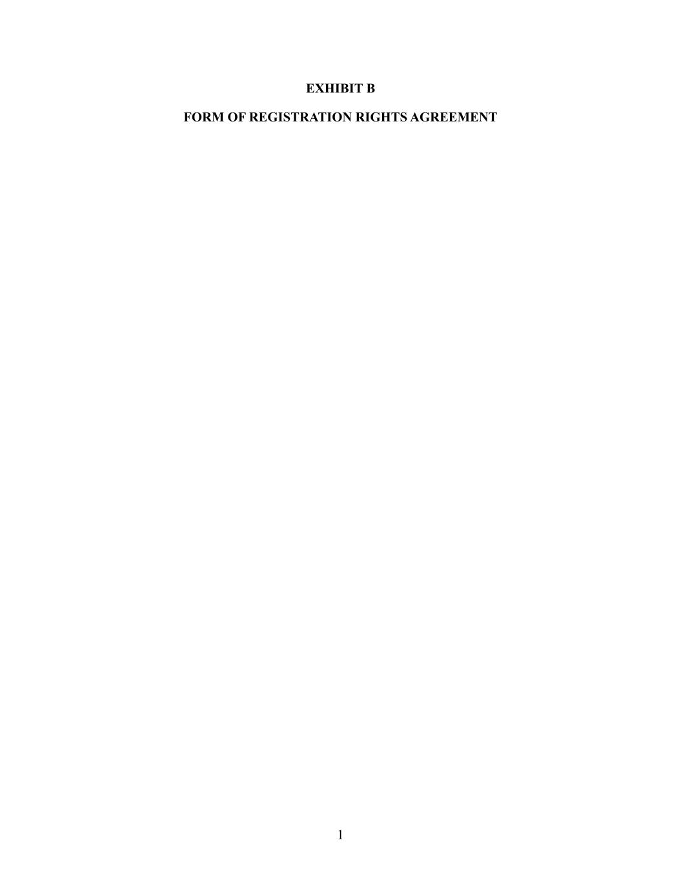
1 EXHIBIT B FORM OF REGISTRATION RIGHTS AGREEMENT

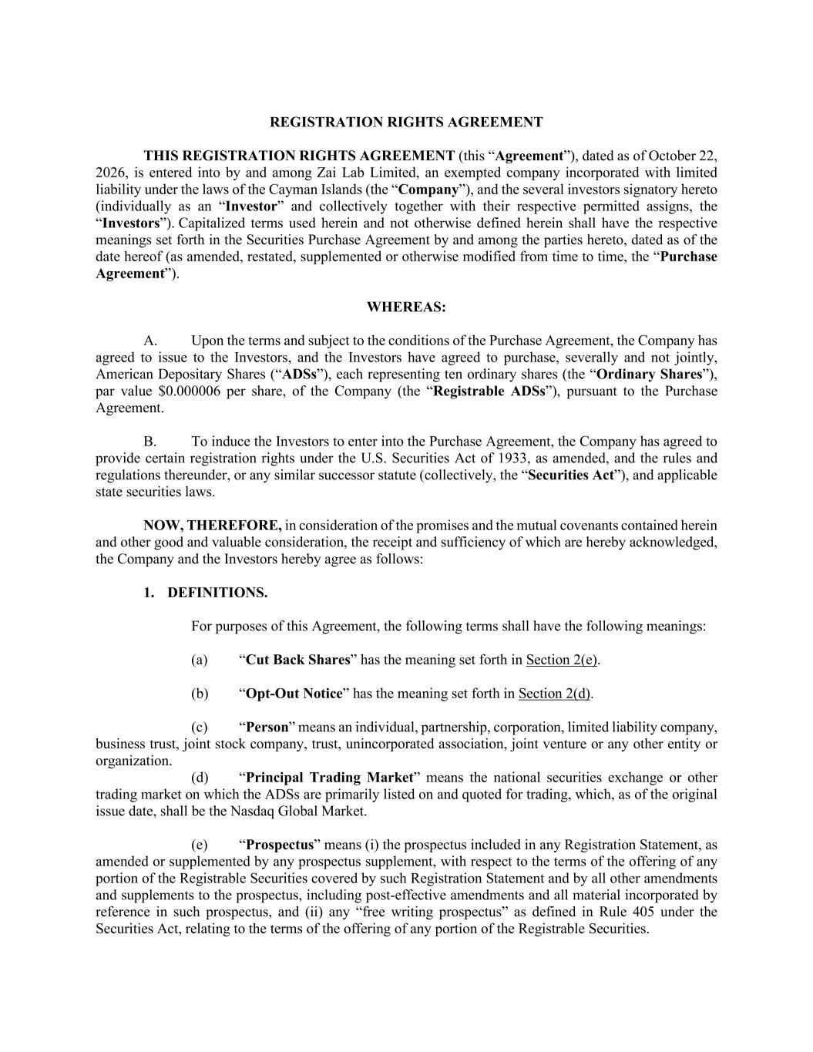
REGISTRATION RIGHTS AGREEMENT THIS REGISTRATION RIGHTS AGREEMENT (this “Agreement”), dated as of October 22, 2026, is entered into by and among Zai Lab Limited, an exempted company incorporated with limited liability under the laws of the Cayman Islands (the “Company”), and the several investors signatory hereto (individually as an “Investor” and collectively together with their respective permitted assigns, the “Investors”). Capitalized terms used herein and not otherwise defined herein shall have the respective meanings set forth in the Securities Purchase Agreement by and among the parties hereto, dated as of the date hereof (as amended, restated, supplemented or otherwise modified from time to time, the “Purchase Agreement”). WHEREAS: A. Upon the terms and subject to the conditions of the Purchase Agreement, the Company has agreed to issue to the Investors, and the Investors have agreed to purchase, severally and not jointly, American Depositary Shares (“ADSs”), each representing ten ordinary shares (the “Ordinary Shares”), par value $0.000006 per share, of the Company (the “Registrable ADSs”), pursuant to the Purchase Agreement. B. To induce the Investors to enter into the Purchase Agreement, the Company has agreed to provide certain registration rights under the U.S. Securities Act of 1933, as amended, and the rules and regulations thereunder, or any similar successor statute (collectively, the “Securities Act”), and applicable state securities laws. NOW, THEREFORE, in consideration of the promises and the mutual covenants contained herein and other good and valuable consideration, the receipt and sufficiency of which are hereby acknowledged, the Company and the Investors hereby agree as follows: 1. DEFINITIONS. For purposes of this Agreement, the following terms shall have the following meanings: (a) “Cut Back Shares” has the meaning set forth in Section 2(e). (b) “Opt-Out Notice” has the meaning set forth in Section 2(d). (c) “Person” means an individual, partnership, corporation, limited liability company, business trust, joint stock company, trust, unincorporated association, joint venture or any other entity or organization. (d) “Principal Trading Market” means the national securities exchange or other trading market on which the ADSs are primarily listed on and quoted for trading, which, as of the original issue date, shall be the Nasdaq Global Market. (e) “Prospectus” means (i) the prospectus included in any Registration Statement, as amended or supplemented by any prospectus supplement, with respect to the terms of the offering of any portion of the Registrable Securities covered by such Registration Statement and by all other amendments and supplements to the prospectus, including post-effective amendments and all material incorporated by reference in such prospectus, and (ii) any “free writing prospectus” as defined in Rule 405 under the Securities Act, relating to the terms of the offering of any portion of the Registrable Securities.

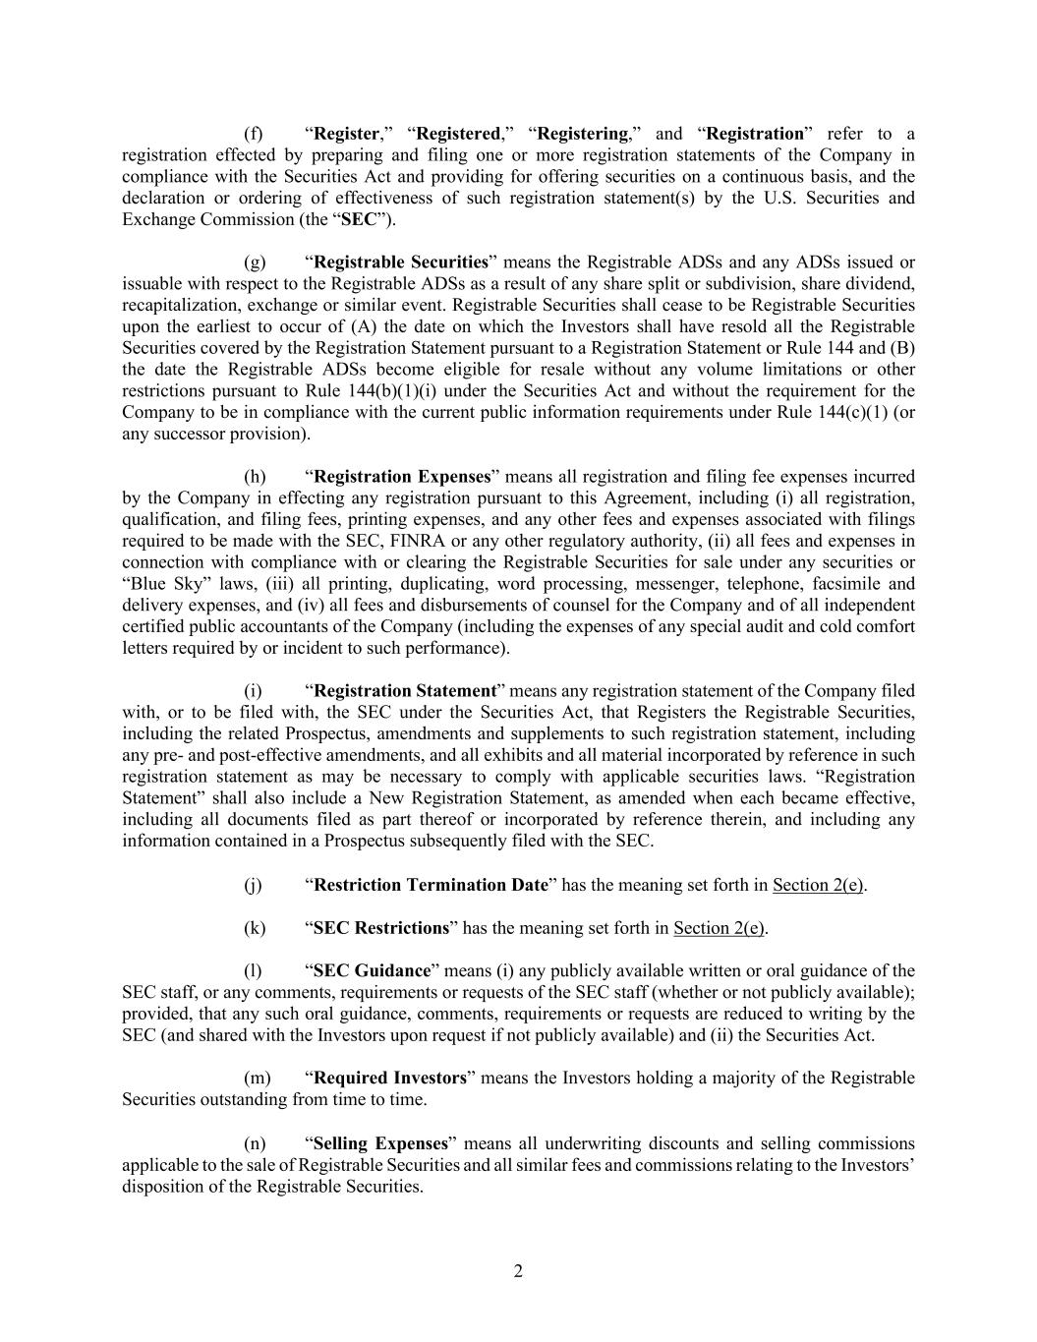
2 (f) “Register,” “Registered,” “Registering,” and “Registration” refer to a registration effected by preparing and filing one or more registration statements of the Company in compliance with the Securities Act and providing for offering securities on a continuous basis, and the declaration or ordering of effectiveness of such registration statement(s) by the U.S. Securities and Exchange Commission (the “SEC”). (g) “Registrable Securities” means the Registrable ADSs and any ADSs issued or issuable with respect to the Registrable ADSs as a result of any share split or subdivision, share dividend, recapitalization, exchange or similar event. Registrable Securities shall cease to be Registrable Securities upon the earliest to occur of (A) the date on which the Investors shall have resold all the Registrable Securities covered by the Registration Statement pursuant to a Registration Statement or Rule 144 and (B) the date the Registrable ADSs become eligible for resale without any volume limitations or other restrictions pursuant to Rule 144(b)(1)(i) under the Securities Act and without the requirement for the Company to be in compliance with the current public information requirements under Rule 144(c)(1) (or any successor provision). (h) “Registration Expenses” means all registration and filing fee expenses incurred by the Company in effecting any registration pursuant to this Agreement, including (i) all registration, qualification, and filing fees, printing expenses, and any other fees and expenses associated with filings required to be made with the SEC, FINRA or any other regulatory authority, (ii) all fees and expenses in connection with compliance with or clearing the Registrable Securities for sale under any securities or “Blue Sky” laws, (iii) all printing, duplicating, word processing, messenger, telephone, facsimile and delivery expenses, and (iv) all fees and disbursements of counsel for the Company and of all independent certified public accountants of the Company (including the expenses of any special audit and cold comfort letters required by or incident to such performance). (i) “Registration Statement” means any registration statement of the Company filed with, or to be filed with, the SEC under the Securities Act, that Registers the Registrable Securities, including the related Prospectus, amendments and supplements to such registration statement, including any pre- and post-effective amendments, and all exhibits and all material incorporated by reference in such registration statement as may be necessary to comply with applicable securities laws. “Registration Statement” shall also include a New Registration Statement, as amended when each became effective, including all documents filed as part thereof or incorporated by reference therein, and including any information contained in a Prospectus subsequently filed with the SEC. (j) “Restriction Termination Date” has the meaning set forth in Section 2(e). (k) “SEC Restrictions” has the meaning set forth in Section 2(e). (l) “SEC Guidance” means (i) any publicly available written or oral guidance of the SEC staff, or any comments, requirements or requests of the SEC staff (whether or not publicly available); provided, that any such oral guidance, comments, requirements or requests are reduced to writing by the SEC (and shared with the Investors upon request if not publicly available) and (ii) the Securities Act. (m) “Required Investors” means the Investors holding a majority of the Registrable Securities outstanding from time to time. (n) “Selling Expenses” means all underwriting discounts and selling commissions applicable to the sale of Registrable Securities and all similar fees and commissions relating to the Investors’ disposition of the Registrable Securities.

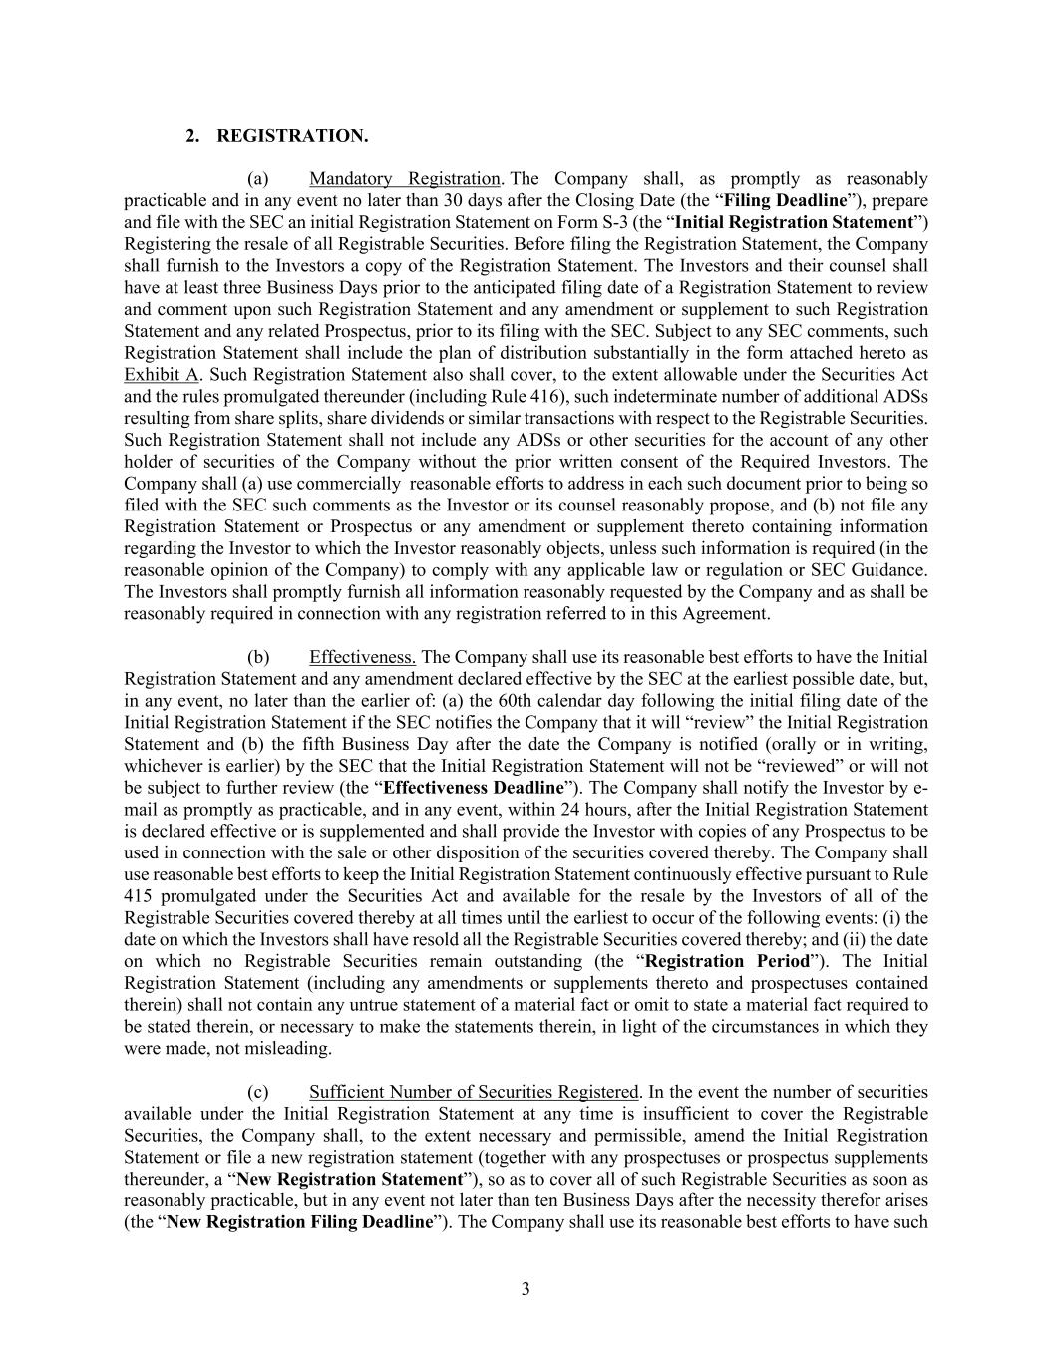
3 2. REGISTRATION. (a) Mandatory Registration. The Company shall, as promptly as reasonably practicable and in any event no later than 30 days after the Closing Date (the “Filing Deadline”), prepare and file with the SEC an initial Registration Statement on Form S-3 (the “Initial Registration Statement”) Registering the resale of all Registrable Securities. Before filing the Registration Statement, the Company shall furnish to the Investors a copy of the Registration Statement. The Investors and their counsel shall have at least three Business Days prior to the anticipated filing date of a Registration Statement to review and comment upon such Registration Statement and any amendment or supplement to such Registration Statement and any related Prospectus, prior to its filing with the SEC. Subject to any SEC comments, such Registration Statement shall include the plan of distribution substantially in the form attached hereto as Exhibit A. Such Registration Statement also shall cover, to the extent allowable under the Securities Act and the rules promulgated thereunder (including Rule 416), such indeterminate number of additional ADSs resulting from share splits, share dividends or similar transactions with respect to the Registrable Securities. Such Registration Statement shall not include any ADSs or other securities for the account of any other holder of securities of the Company without the prior written consent of the Required Investors. The Company shall (a) use commercially reasonable efforts to address in each such document prior to being so filed with the SEC such comments as the Investor or its counsel reasonably propose, and (b) not file any Registration Statement or Prospectus or any amendment or supplement thereto containing information regarding the Investor to which the Investor reasonably objects, unless such information is required (in the reasonable opinion of the Company) to comply with any applicable law or regulation or SEC Guidance. The Investors shall promptly furnish all information reasonably requested by the Company and as shall be reasonably required in connection with any registration referred to in this Agreement. (b) Effectiveness. The Company shall use its reasonable best efforts to have the Initial Registration Statement and any amendment declared effective by the SEC at the earliest possible date, but, in any event, no later than the earlier of: (a) the 60th calendar day following the initial filing date of the Initial Registration Statement if the SEC notifies the Company that it will “review” the Initial Registration Statement and (b) the fifth Business Day after the date the Company is notified (orally or in writing, whichever is earlier) by the SEC that the Initial Registration Statement will not be “reviewed” or will not be subject to further review (the “Effectiveness Deadline”). The Company shall notify the Investor by e- mail as promptly as practicable, and in any event, within 24 hours, after the Initial Registration Statement is declared effective or is supplemented and shall provide the Investor with copies of any Prospectus to be used in connection with the sale or other disposition of the securities covered thereby. The Company shall use reasonable best efforts to keep the Initial Registration Statement continuously effective pursuant to Rule 415 promulgated under the Securities Act and available for the resale by the Investors of all of the Registrable Securities covered thereby at all times until the earliest to occur of the following events: (i) the date on which the Investors shall have resold all the Registrable Securities covered thereby; and (ii) the date on which no Registrable Securities remain outstanding (the “Registration Period”). The Initial Registration Statement (including any amendments or supplements thereto and prospectuses contained therein) shall not contain any untrue statement of a material fact or omit to state a material fact required to be stated therein, or necessary to make the statements therein, in light of the circumstances in which they were made, not misleading. (c) Sufficient Number of Securities Registered. In the event the number of securities available under the Initial Registration Statement at any time is insufficient to cover the Registrable Securities, the Company shall, to the extent necessary and permissible, amend the Initial Registration Statement or file a new registration statement (together with any prospectuses or prospectus supplements thereunder, a “New Registration Statement”), so as to cover all of such Registrable Securities as soon as reasonably practicable, but in any event not later than ten Business Days after the necessity therefor arises (the “New Registration Filing Deadline”). The Company shall use its reasonable best efforts to have such

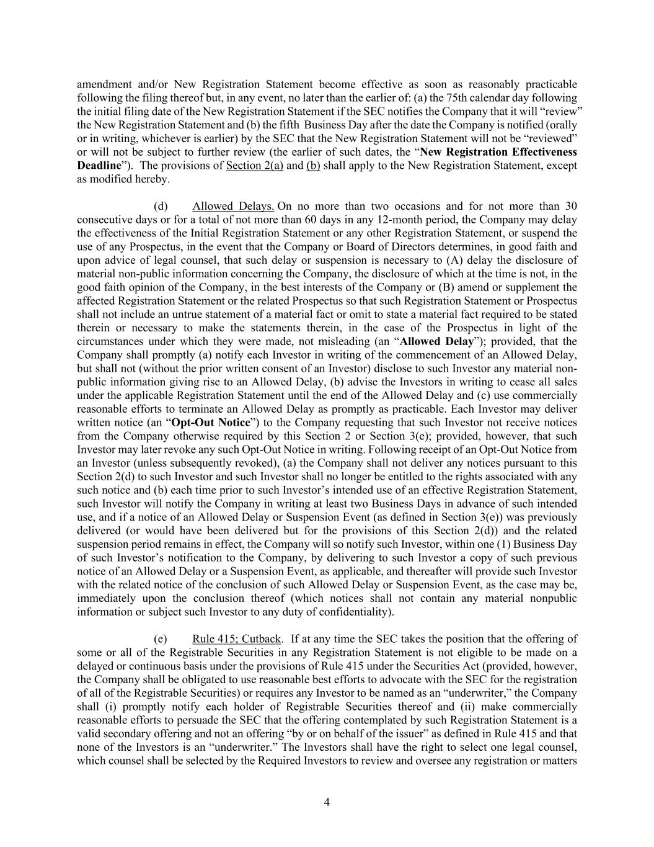
4 amendment and/or New Registration Statement become effective as soon as reasonably practicable following the filing thereof but, in any event, no later than the earlier of: (a) the 75th calendar day following the initial filing date of the New Registration Statement if the SEC notifies the Company that it will “review” the New Registration Statement and (b) the fifth Business Day after the date the Company is notified (orally or in writing, whichever is earlier) by the SEC that the New Registration Statement will not be “reviewed” or will not be subject to further review (the earlier of such dates, the “New Registration Effectiveness Deadline”). The provisions of Section 2(a) and (b) shall apply to the New Registration Statement, except as modified hereby. (d) Allowed Delays. On no more than two occasions and for not more than 30 consecutive days or for a total of not more than 60 days in any 12-month period, the Company may delay the effectiveness of the Initial Registration Statement or any other Registration Statement, or suspend the use of any Prospectus, in the event that the Company or Board of Directors determines, in good faith and upon advice of legal counsel, that such delay or suspension is necessary to (A) delay the disclosure of material non-public information concerning the Company, the disclosure of which at the time is not, in the good faith opinion of the Company, in the best interests of the Company or (B) amend or supplement the affected Registration Statement or the related Prospectus so that such Registration Statement or Prospectus shall not include an untrue statement of a material fact or omit to state a material fact required to be stated therein or necessary to make the statements therein, in the case of the Prospectus in light of the circumstances under which they were made, not misleading (an “Allowed Delay”); provided, that the Company shall promptly (a) notify each Investor in writing of the commencement of an Allowed Delay, but shall not (without the prior written consent of an Investor) disclose to such Investor any material non- public information giving rise to an Allowed Delay, (b) advise the Investors in writing to cease all sales under the applicable Registration Statement until the end of the Allowed Delay and (c) use commercially reasonable efforts to terminate an Allowed Delay as promptly as practicable. Each Investor may deliver written notice (an “Opt-Out Notice”) to the Company requesting that such Investor not receive notices from the Company otherwise required by this Section 2 or Section 3(e); provided, however, that such Investor may later revoke any such Opt-Out Notice in writing. Following receipt of an Opt-Out Notice from an Investor (unless subsequently revoked), (a) the Company shall not deliver any notices pursuant to this Section 2(d) to such Investor and such Investor shall no longer be entitled to the rights associated with any such notice and (b) each time prior to such Investor’s intended use of an effective Registration Statement, such Investor will notify the Company in writing at least two Business Days in advance of such intended use, and if a notice of an Allowed Delay or Suspension Event (as defined in Section 3(e)) was previously delivered (or would have been delivered but for the provisions of this Section 2(d)) and the related suspension period remains in effect, the Company will so notify such Investor, within one (1) Business Day of such Investor’s notification to the Company, by delivering to such Investor a copy of such previous notice of an Allowed Delay or a Suspension Event, as applicable, and thereafter will provide such Investor with the related notice of the conclusion of such Allowed Delay or Suspension Event, as the case may be, immediately upon the conclusion thereof (which notices shall not contain any material nonpublic information or subject such Investor to any duty of confidentiality). (e) Rule 415; Cutback. If at any time the SEC takes the position that the offering of some or all of the Registrable Securities in any Registration Statement is not eligible to be made on a delayed or continuous basis under the provisions of Rule 415 under the Securities Act (provided, however, the Company shall be obligated to use reasonable best efforts to advocate with the SEC for the registration of all of the Registrable Securities) or requires any Investor to be named as an “underwriter,” the Company shall (i) promptly notify each holder of Registrable Securities thereof and (ii) make commercially reasonable efforts to persuade the SEC that the offering contemplated by such Registration Statement is a valid secondary offering and not an offering “by or on behalf of the issuer” as defined in Rule 415 and that none of the Investors is an “underwriter.” The Investors shall have the right to select one legal counsel, which counsel shall be selected by the Required Investors to review and oversee any registration or matters

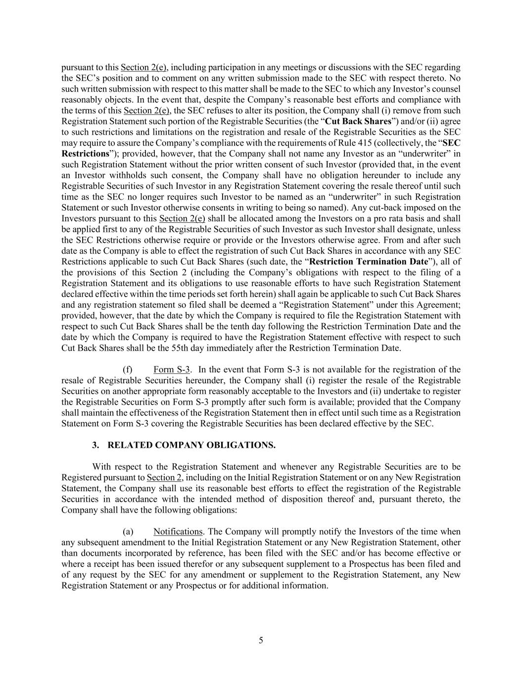
5 pursuant to this Section 2(e), including participation in any meetings or discussions with the SEC regarding the SEC’s position and to comment on any written submission made to the SEC with respect thereto. No such written submission with respect to this matter shall be made to the SEC to which any Investor’s counsel reasonably objects. In the event that, despite the Company’s reasonable best efforts and compliance with the terms of this Section 2(e), the SEC refuses to alter its position, the Company shall (i) remove from such Registration Statement such portion of the Registrable Securities (the “Cut Back Shares”) and/or (ii) agree to such restrictions and limitations on the registration and resale of the Registrable Securities as the SEC may require to assure the Company’s compliance with the requirements of Rule 415 (collectively, the “SEC Restrictions”); provided, however, that the Company shall not name any Investor as an “underwriter” in such Registration Statement without the prior written consent of such Investor (provided that, in the event an Investor withholds such consent, the Company shall have no obligation hereunder to include any Registrable Securities of such Investor in any Registration Statement covering the resale thereof until such time as the SEC no longer requires such Investor to be named as an “underwriter” in such Registration Statement or such Investor otherwise consents in writing to being so named). Any cut-back imposed on the Investors pursuant to this Section 2(e) shall be allocated among the Investors on a pro rata basis and shall be applied first to any of the Registrable Securities of such Investor as such Investor shall designate, unless the SEC Restrictions otherwise require or provide or the Investors otherwise agree. From and after such date as the Company is able to effect the registration of such Cut Back Shares in accordance with any SEC Restrictions applicable to such Cut Back Shares (such date, the “Restriction Termination Date”), all of the provisions of this Section 2 (including the Company’s obligations with respect to the filing of a Registration Statement and its obligations to use reasonable efforts to have such Registration Statement declared effective within the time periods set forth herein) shall again be applicable to such Cut Back Shares and any registration statement so filed shall be deemed a “Registration Statement” under this Agreement; provided, however, that the date by which the Company is required to file the Registration Statement with respect to such Cut Back Shares shall be the tenth day following the Restriction Termination Date and the date by which the Company is required to have the Registration Statement effective with respect to such Cut Back Shares shall be the 55th day immediately after the Restriction Termination Date. (f) Form S-3. In the event that Form S-3 is not available for the registration of the resale of Registrable Securities hereunder, the Company shall (i) register the resale of the Registrable Securities on another appropriate form reasonably acceptable to the Investors and (ii) undertake to register the Registrable Securities on Form S-3 promptly after such form is available; provided that the Company shall maintain the effectiveness of the Registration Statement then in effect until such time as a Registration Statement on Form S-3 covering the Registrable Securities has been declared effective by the SEC. 3. RELATED COMPANY OBLIGATIONS. With respect to the Registration Statement and whenever any Registrable Securities are to be Registered pursuant to Section 2, including on the Initial Registration Statement or on any New Registration Statement, the Company shall use its reasonable best efforts to effect the registration of the Registrable Securities in accordance with the intended method of disposition thereof and, pursuant thereto, the Company shall have the following obligations: (a) Notifications. The Company will promptly notify the Investors of the time when any subsequent amendment to the Initial Registration Statement or any New Registration Statement, other than documents incorporated by reference, has been filed with the SEC and/or has become effective or where a receipt has been issued therefor or any subsequent supplement to a Prospectus has been filed and of any request by the SEC for any amendment or supplement to the Registration Statement, any New Registration Statement or any Prospectus or for additional information.

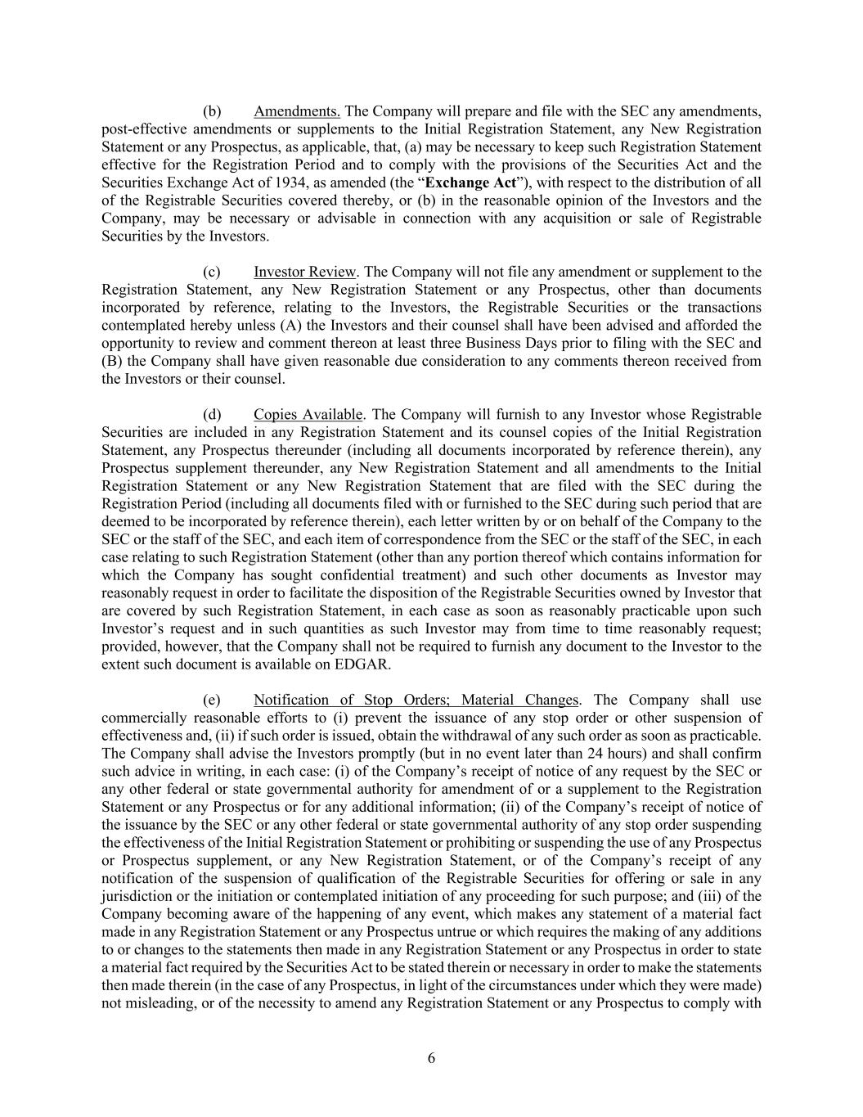
6 (b) Amendments. The Company will prepare and file with the SEC any amendments, post-effective amendments or supplements to the Initial Registration Statement, any New Registration Statement or any Prospectus, as applicable, that, (a) may be necessary to keep such Registration Statement effective for the Registration Period and to comply with the provisions of the Securities Act and the Securities Exchange Act of 1934, as amended (the “Exchange Act”), with respect to the distribution of all of the Registrable Securities covered thereby, or (b) in the reasonable opinion of the Investors and the Company, may be necessary or advisable in connection with any acquisition or sale of Registrable Securities by the Investors. (c) Investor Review. The Company will not file any amendment or supplement to the Registration Statement, any New Registration Statement or any Prospectus, other than documents incorporated by reference, relating to the Investors, the Registrable Securities or the transactions contemplated hereby unless (A) the Investors and their counsel shall have been advised and afforded the opportunity to review and comment thereon at least three Business Days prior to filing with the SEC and (B) the Company shall have given reasonable due consideration to any comments thereon received from the Investors or their counsel. (d) Copies Available. The Company will furnish to any Investor whose Registrable Securities are included in any Registration Statement and its counsel copies of the Initial Registration Statement, any Prospectus thereunder (including all documents incorporated by reference therein), any Prospectus supplement thereunder, any New Registration Statement and all amendments to the Initial Registration Statement or any New Registration Statement that are filed with the SEC during the Registration Period (including all documents filed with or furnished to the SEC during such period that are deemed to be incorporated by reference therein), each letter written by or on behalf of the Company to the SEC or the staff of the SEC, and each item of correspondence from the SEC or the staff of the SEC, in each case relating to such Registration Statement (other than any portion thereof which contains information for which the Company has sought confidential treatment) and such other documents as Investor may reasonably request in order to facilitate the disposition of the Registrable Securities owned by Investor that are covered by such Registration Statement, in each case as soon as reasonably practicable upon such Investor’s request and in such quantities as such Investor may from time to time reasonably request; provided, however, that the Company shall not be required to furnish any document to the Investor to the extent such document is available on EDGAR. (e) Notification of Stop Orders; Material Changes. The Company shall use commercially reasonable efforts to (i) prevent the issuance of any stop order or other suspension of effectiveness and, (ii) if such order is issued, obtain the withdrawal of any such order as soon as practicable. The Company shall advise the Investors promptly (but in no event later than 24 hours) and shall confirm such advice in writing, in each case: (i) of the Company’s receipt of notice of any request by the SEC or any other federal or state governmental authority for amendment of or a supplement to the Registration Statement or any Prospectus or for any additional information; (ii) of the Company’s receipt of notice of the issuance by the SEC or any other federal or state governmental authority of any stop order suspending the effectiveness of the Initial Registration Statement or prohibiting or suspending the use of any Prospectus or Prospectus supplement, or any New Registration Statement, or of the Company’s receipt of any notification of the suspension of qualification of the Registrable Securities for offering or sale in any jurisdiction or the initiation or contemplated initiation of any proceeding for such purpose; and (iii) of the Company becoming aware of the happening of any event, which makes any statement of a material fact made in any Registration Statement or any Prospectus untrue or which requires the making of any additions to or changes to the statements then made in any Registration Statement or any Prospectus in order to state a material fact required by the Securities Act to be stated therein or necessary in order to make the statements then made therein (in the case of any Prospectus, in light of the circumstances under which they were made) not misleading, or of the necessity to amend any Registration Statement or any Prospectus to comply with

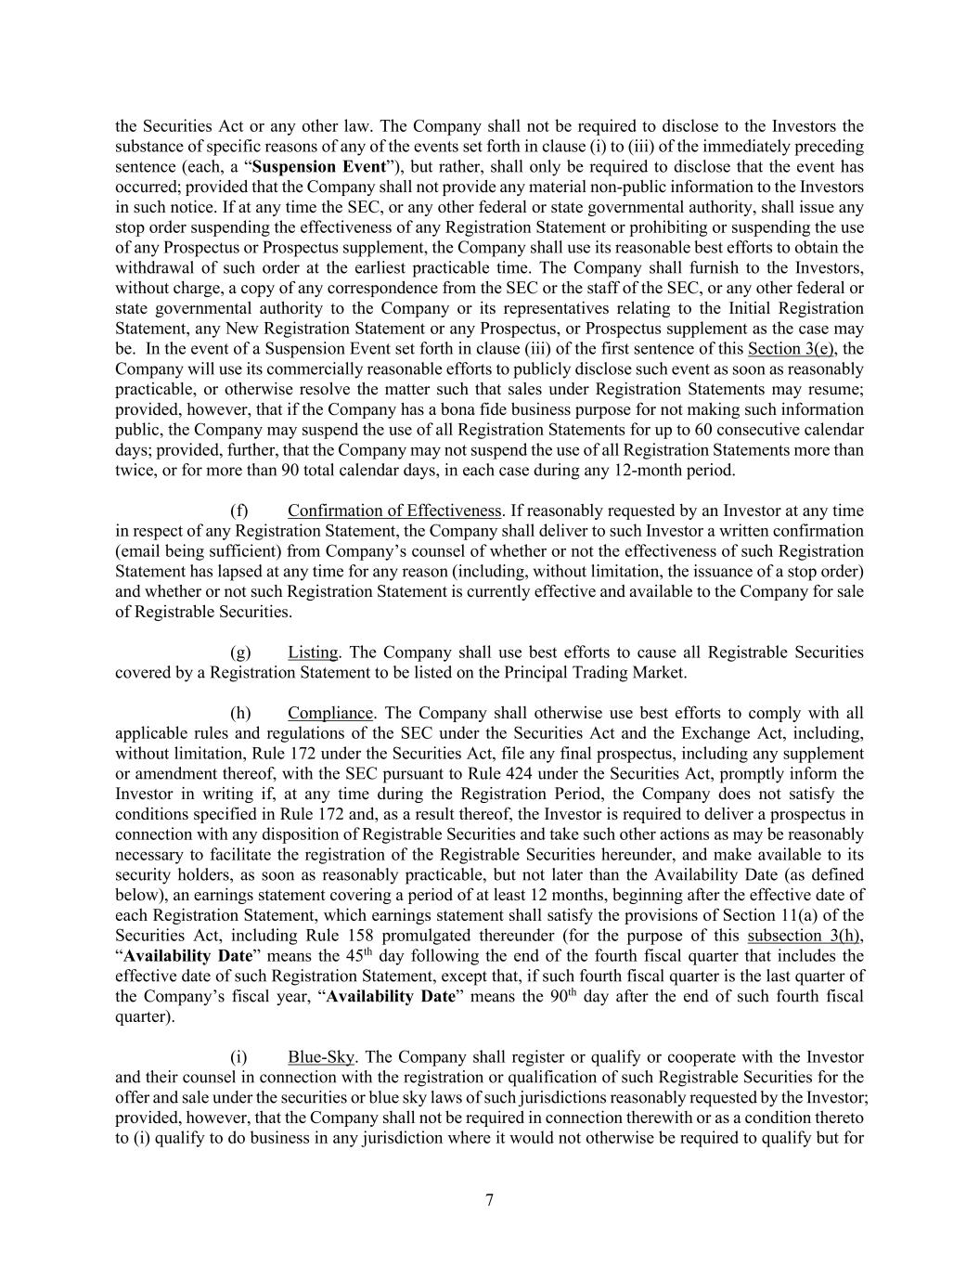
7 the Securities Act or any other law. The Company shall not be required to disclose to the Investors the substance of specific reasons of any of the events set forth in clause (i) to (iii) of the immediately preceding sentence (each, a “Suspension Event”), but rather, shall only be required to disclose that the event has occurred; provided that the Company shall not provide any material non-public information to the Investors in such notice. If at any time the SEC, or any other federal or state governmental authority, shall issue any stop order suspending the effectiveness of any Registration Statement or prohibiting or suspending the use of any Prospectus or Prospectus supplement, the Company shall use its reasonable best efforts to obtain the withdrawal of such order at the earliest practicable time. The Company shall furnish to the Investors, without charge, a copy of any correspondence from the SEC or the staff of the SEC, or any other federal or state governmental authority to the Company or its representatives relating to the Initial Registration Statement, any New Registration Statement or any Prospectus, or Prospectus supplement as the case may be. In the event of a Suspension Event set forth in clause (iii) of the first sentence of this Section 3(e), the Company will use its commercially reasonable efforts to publicly disclose such event as soon as reasonably practicable, or otherwise resolve the matter such that sales under Registration Statements may resume; provided, however, that if the Company has a bona fide business purpose for not making such information public, the Company may suspend the use of all Registration Statements for up to 60 consecutive calendar days; provided, further, that the Company may not suspend the use of all Registration Statements more than twice, or for more than 90 total calendar days, in each case during any 12-month period. (f) Confirmation of Effectiveness. If reasonably requested by an Investor at any time in respect of any Registration Statement, the Company shall deliver to such Investor a written confirmation (email being sufficient) from Company’s counsel of whether or not the effectiveness of such Registration Statement has lapsed at any time for any reason (including, without limitation, the issuance of a stop order) and whether or not such Registration Statement is currently effective and available to the Company for sale of Registrable Securities. (g) Listing. The Company shall use best efforts to cause all Registrable Securities covered by a Registration Statement to be listed on the Principal Trading Market. (h) Compliance. The Company shall otherwise use best efforts to comply with all applicable rules and regulations of the SEC under the Securities Act and the Exchange Act, including, without limitation, Rule 172 under the Securities Act, file any final prospectus, including any supplement or amendment thereof, with the SEC pursuant to Rule 424 under the Securities Act, promptly inform the Investor in writing if, at any time during the Registration Period, the Company does not satisfy the conditions specified in Rule 172 and, as a result thereof, the Investor is required to deliver a prospectus in connection with any disposition of Registrable Securities and take such other actions as may be reasonably necessary to facilitate the registration of the Registrable Securities hereunder, and make available to its security holders, as soon as reasonably practicable, but not later than the Availability Date (as defined below), an earnings statement covering a period of at least 12 months, beginning after the effective date of each Registration Statement, which earnings statement shall satisfy the provisions of Section 11(a) of the Securities Act, including Rule 158 promulgated thereunder (for the purpose of this subsection 3(h), “Availability Date” means the 45th day following the end of the fourth fiscal quarter that includes the effective date of such Registration Statement, except that, if such fourth fiscal quarter is the last quarter of the Company’s fiscal year, “Availability Date” means the 90th day after the end of such fourth fiscal quarter). (i) Blue-Sky. The Company shall register or qualify or cooperate with the Investor and their counsel in connection with the registration or qualification of such Registrable Securities for the offer and sale under the securities or blue sky laws of such jurisdictions reasonably requested by the Investor; provided, however, that the Company shall not be required in connection therewith or as a condition thereto to (i) qualify to do business in any jurisdiction where it would not otherwise be required to qualify but for

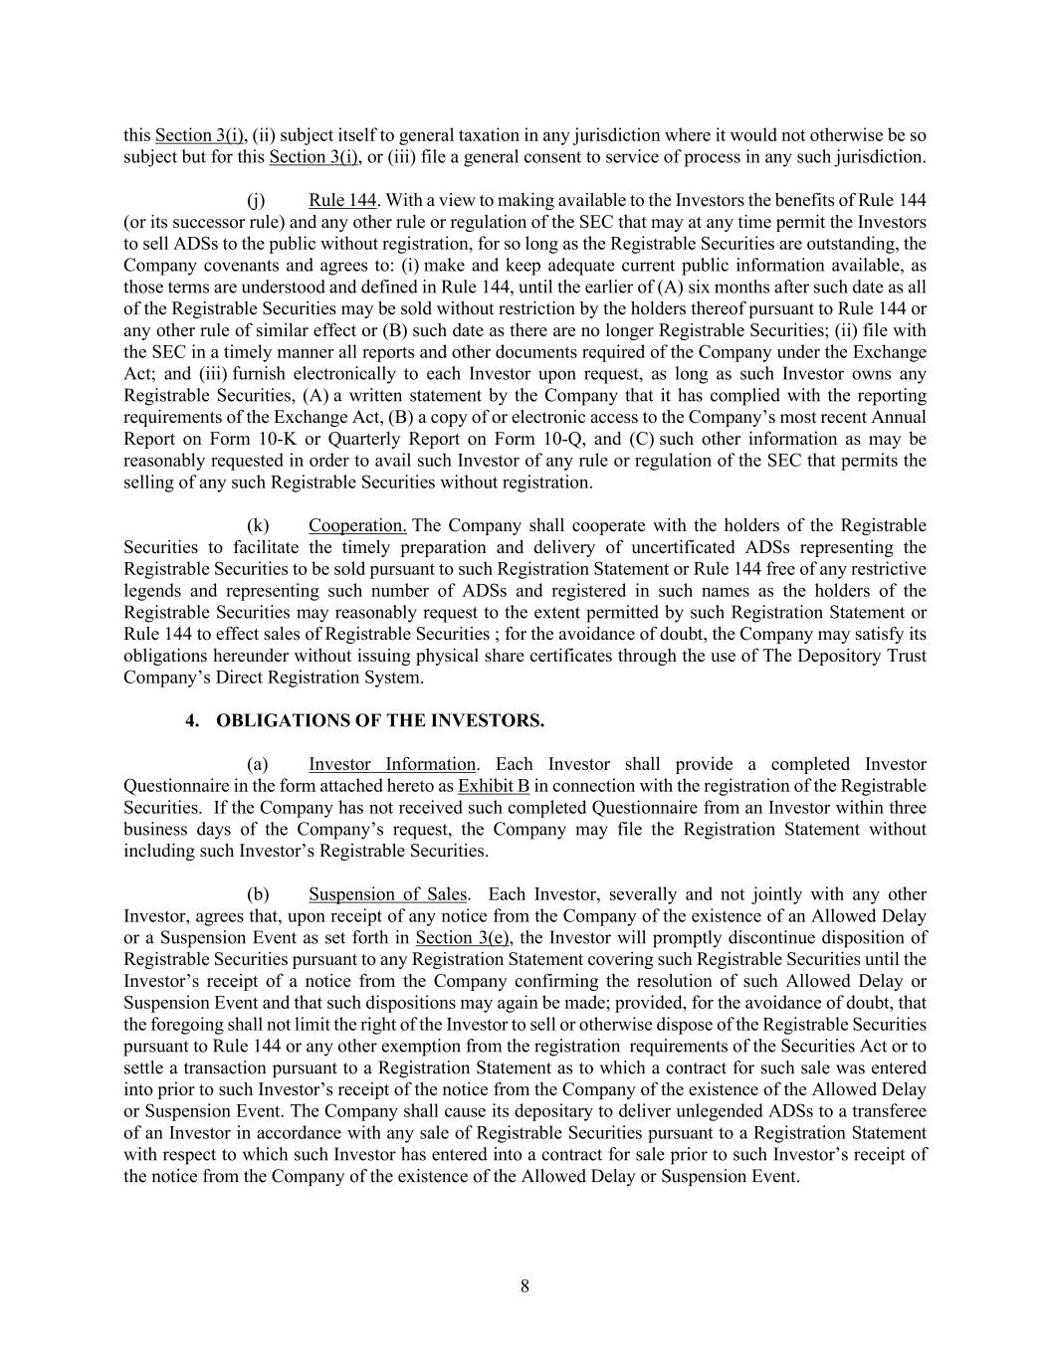
8 this Section 3(i), (ii) subject itself to general taxation in any jurisdiction where it would not otherwise be so subject but for this Section 3(i), or (iii) file a general consent to service of process in any such jurisdiction. (j) Rule 144. With a view to making available to the Investors the benefits of Rule 144 (or its successor rule) and any other rule or regulation of the SEC that may at any time permit the Investors to sell ADSs to the public without registration, for so long as the Registrable Securities are outstanding, the Company covenants and agrees to: (i) make and keep adequate current public information available, as those terms are understood and defined in Rule 144, until the earlier of (A) six months after such date as all of the Registrable Securities may be sold without restriction by the holders thereof pursuant to Rule 144 or any other rule of similar effect or (B) such date as there are no longer Registrable Securities; (ii) file with the SEC in a timely manner all reports and other documents required of the Company under the Exchange Act; and (iii) furnish electronically to each Investor upon request, as long as such Investor owns any Registrable Securities, (A) a written statement by the Company that it has complied with the reporting requirements of the Exchange Act, (B) a copy of or electronic access to the Company’s most recent Annual Report on Form 10-K or Quarterly Report on Form 10-Q, and (C) such other information as may be reasonably requested in order to avail such Investor of any rule or regulation of the SEC that permits the selling of any such Registrable Securities without registration. (k) Cooperation. The Company shall cooperate with the holders of the Registrable Securities to facilitate the timely preparation and delivery of uncertificated ADSs representing the Registrable Securities to be sold pursuant to such Registration Statement or Rule 144 free of any restrictive legends and representing such number of ADSs and registered in such names as the holders of the Registrable Securities may reasonably request to the extent permitted by such Registration Statement or Rule 144 to effect sales of Registrable Securities ; for the avoidance of doubt, the Company may satisfy its obligations hereunder without issuing physical share certificates through the use of The Depository Trust Company’s Direct Registration System. 4. OBLIGATIONS OF THE INVESTORS. (a) Investor Information. Each Investor shall provide a completed Investor Questionnaire in the form attached hereto as Exhibit B in connection with the registration of the Registrable Securities. If the Company has not received such completed Questionnaire from an Investor within three business days of the Company’s request, the Company may file the Registration Statement without including such Investor’s Registrable Securities. (b) Suspension of Sales. Each Investor, severally and not jointly with any other Investor, agrees that, upon receipt of any notice from the Company of the existence of an Allowed Delay or a Suspension Event as set forth in Section 3(e), the Investor will promptly discontinue disposition of Registrable Securities pursuant to any Registration Statement covering such Registrable Securities until the Investor’s receipt of a notice from the Company confirming the resolution of such Allowed Delay or Suspension Event and that such dispositions may again be made; provided, for the avoidance of doubt, that the foregoing shall not limit the right of the Investor to sell or otherwise dispose of the Registrable Securities pursuant to Rule 144 or any other exemption from the registration requirements of the Securities Act or to settle a transaction pursuant to a Registration Statement as to which a contract for such sale was entered into prior to such Investor’s receipt of the notice from the Company of the existence of the Allowed Delay or Suspension Event. The Company shall cause its depositary to deliver unlegended ADSs to a transferee of an Investor in accordance with any sale of Registrable Securities pursuant to a Registration Statement with respect to which such Investor has entered into a contract for sale prior to such Investor’s receipt of the notice from the Company of the existence of the Allowed Delay or Suspension Event.

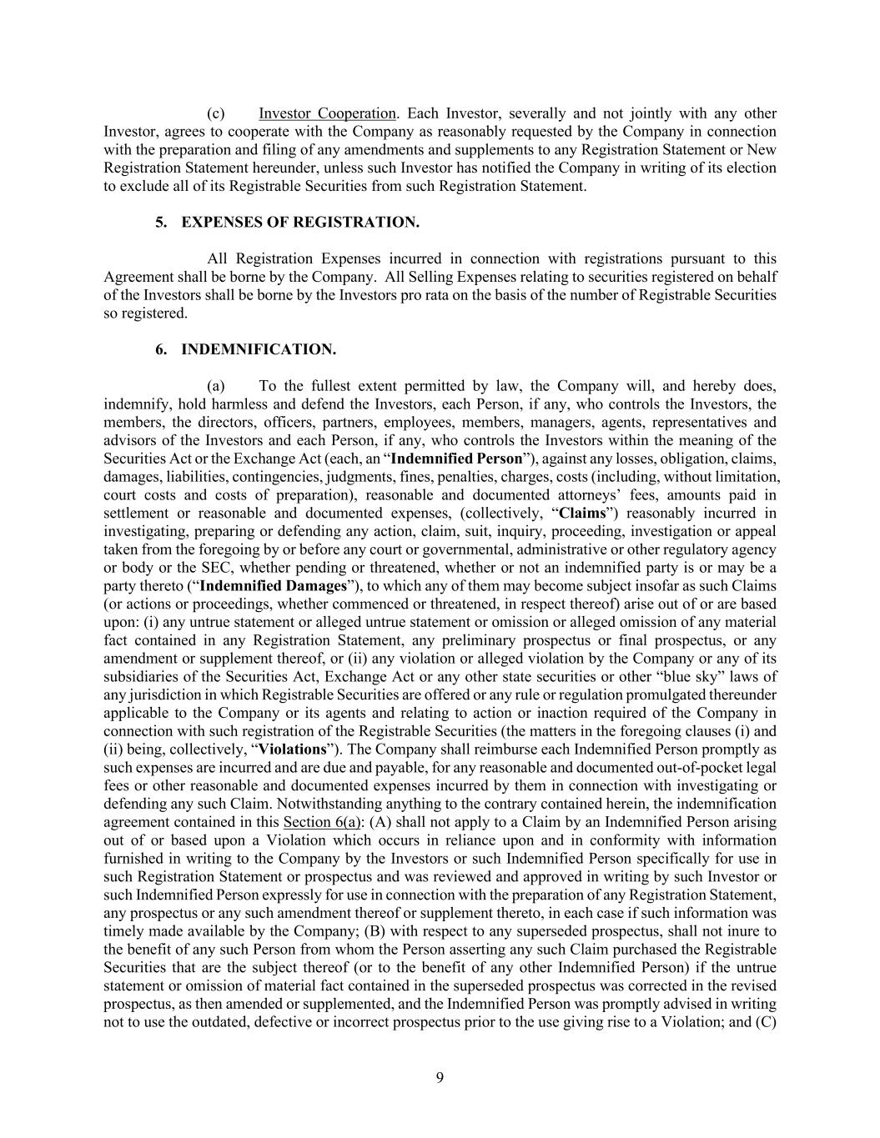
9 (c) Investor Cooperation. Each Investor, severally and not jointly with any other Investor, agrees to cooperate with the Company as reasonably requested by the Company in connection with the preparation and filing of any amendments and supplements to any Registration Statement or New Registration Statement hereunder, unless such Investor has notified the Company in writing of its election to exclude all of its Registrable Securities from such Registration Statement. 5. EXPENSES OF REGISTRATION. All Registration Expenses incurred in connection with registrations pursuant to this Agreement shall be borne by the Company. All Selling Expenses relating to securities registered on behalf of the Investors shall be borne by the Investors pro rata on the basis of the number of Registrable Securities so registered. 6. INDEMNIFICATION. (a) To the fullest extent permitted by law, the Company will, and hereby does, indemnify, hold harmless and defend the Investors, each Person, if any, who controls the Investors, the members, the directors, officers, partners, employees, members, managers, agents, representatives and advisors of the Investors and each Person, if any, who controls the Investors within the meaning of the Securities Act or the Exchange Act (each, an “Indemnified Person”), against any losses, obligation, claims, damages, liabilities, contingencies, judgments, fines, penalties, charges, costs (including, without limitation, court costs and costs of preparation), reasonable and documented attorneys’ fees, amounts paid in settlement or reasonable and documented expenses, (collectively, “Claims”) reasonably incurred in investigating, preparing or defending any action, claim, suit, inquiry, proceeding, investigation or appeal taken from the foregoing by or before any court or governmental, administrative or other regulatory agency or body or the SEC, whether pending or threatened, whether or not an indemnified party is or may be a party thereto (“Indemnified Damages”), to which any of them may become subject insofar as such Claims (or actions or proceedings, whether commenced or threatened, in respect thereof) arise out of or are based upon: (i) any untrue statement or alleged untrue statement or omission or alleged omission of any material fact contained in any Registration Statement, any preliminary prospectus or final prospectus, or any amendment or supplement thereof, or (ii) any violation or alleged violation by the Company or any of its subsidiaries of the Securities Act, Exchange Act or any other state securities or other “blue sky” laws of any jurisdiction in which Registrable Securities are offered or any rule or regulation promulgated thereunder applicable to the Company or its agents and relating to action or inaction required of the Company in connection with such registration of the Registrable Securities (the matters in the foregoing clauses (i) and (ii) being, collectively, “Violations”). The Company shall reimburse each Indemnified Person promptly as such expenses are incurred and are due and payable, for any reasonable and documented out-of-pocket legal fees or other reasonable and documented expenses incurred by them in connection with investigating or defending any such Claim. Notwithstanding anything to the contrary contained herein, the indemnification agreement contained in this Section 6(a): (A) shall not apply to a Claim by an Indemnified Person arising out of or based upon a Violation which occurs in reliance upon and in conformity with information furnished in writing to the Company by the Investors or such Indemnified Person specifically for use in such Registration Statement or prospectus and was reviewed and approved in writing by such Investor or such Indemnified Person expressly for use in connection with the preparation of any Registration Statement, any prospectus or any such amendment thereof or supplement thereto, in each case if such information was timely made available by the Company; (B) with respect to any superseded prospectus, shall not inure to the benefit of any such Person from whom the Person asserting any such Claim purchased the Registrable Securities that are the subject thereof (or to the benefit of any other Indemnified Person) if the untrue statement or omission of material fact contained in the superseded prospectus was corrected in the revised prospectus, as then amended or supplemented, and the Indemnified Person was promptly advised in writing not to use the outdated, defective or incorrect prospectus prior to the use giving rise to a Violation; and (C)

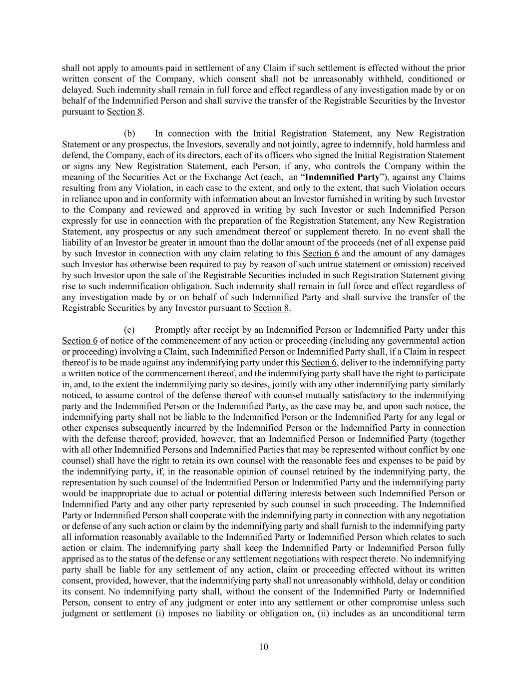
10 shall not apply to amounts paid in settlement of any Claim if such settlement is effected without the prior written consent of the Company, which consent shall not be unreasonably withheld, conditioned or delayed. Such indemnity shall remain in full force and effect regardless of any investigation made by or on behalf of the Indemnified Person and shall survive the transfer of the Registrable Securities by the Investor pursuant to Section 8. (b) In connection with the Initial Registration Statement, any New Registration Statement or any prospectus, the Investors, severally and not jointly, agree to indemnify, hold harmless and defend, the Company, each of its directors, each of its officers who signed the Initial Registration Statement or signs any New Registration Statement, each Person, if any, who controls the Company within the meaning of the Securities Act or the Exchange Act (each, an “Indemnified Party”), against any Claims resulting from any Violation, in each case to the extent, and only to the extent, that such Violation occurs in reliance upon and in conformity with information about an Investor furnished in writing by such Investor to the Company and reviewed and approved in writing by such Investor or such Indemnified Person expressly for use in connection with the preparation of the Registration Statement, any New Registration Statement, any prospectus or any such amendment thereof or supplement thereto. In no event shall the liability of an Investor be greater in amount than the dollar amount of the proceeds (net of all expense paid by such Investor in connection with any claim relating to this Section 6 and the amount of any damages such Investor has otherwise been required to pay by reason of such untrue statement or omission) received by such Investor upon the sale of the Registrable Securities included in such Registration Statement giving rise to such indemnification obligation. Such indemnity shall remain in full force and effect regardless of any investigation made by or on behalf of such Indemnified Party and shall survive the transfer of the Registrable Securities by any Investor pursuant to Section 8. (c) Promptly after receipt by an Indemnified Person or Indemnified Party under this Section 6 of notice of the commencement of any action or proceeding (including any governmental action or proceeding) involving a Claim, such Indemnified Person or Indemnified Party shall, if a Claim in respect thereof is to be made against any indemnifying party under this Section 6, deliver to the indemnifying party a written notice of the commencement thereof, and the indemnifying party shall have the right to participate in, and, to the extent the indemnifying party so desires, jointly with any other indemnifying party similarly noticed, to assume control of the defense thereof with counsel mutually satisfactory to the indemnifying party and the Indemnified Person or the Indemnified Party, as the case may be, and upon such notice, the indemnifying party shall not be liable to the Indemnified Person or the Indemnified Party for any legal or other expenses subsequently incurred by the Indemnified Person or the Indemnified Party in connection with the defense thereof; provided, however, that an Indemnified Person or Indemnified Party (together with all other Indemnified Persons and Indemnified Parties that may be represented without conflict by one counsel) shall have the right to retain its own counsel with the reasonable fees and expenses to be paid by the indemnifying party, if, in the reasonable opinion of counsel retained by the indemnifying party, the representation by such counsel of the Indemnified Person or Indemnified Party and the indemnifying party would be inappropriate due to actual or potential differing interests between such Indemnified Person or Indemnified Party and any other party represented by such counsel in such proceeding. The Indemnified Party or Indemnified Person shall cooperate with the indemnifying party in connection with any negotiation or defense of any such action or claim by the indemnifying party and shall furnish to the indemnifying party all information reasonably available to the Indemnified Party or Indemnified Person which relates to such action or claim. The indemnifying party shall keep the Indemnified Party or Indemnified Person fully apprised as to the status of the defense or any settlement negotiations with respect thereto. No indemnifying party shall be liable for any settlement of any action, claim or proceeding effected without its written consent, provided, however, that the indemnifying party shall not unreasonably withhold, delay or condition its consent. No indemnifying party shall, without the consent of the Indemnified Party or Indemnified Person, consent to entry of any judgment or enter into any settlement or other compromise unless such judgment or settlement (i) imposes no liability or obligation on, (ii) includes as an unconditional term

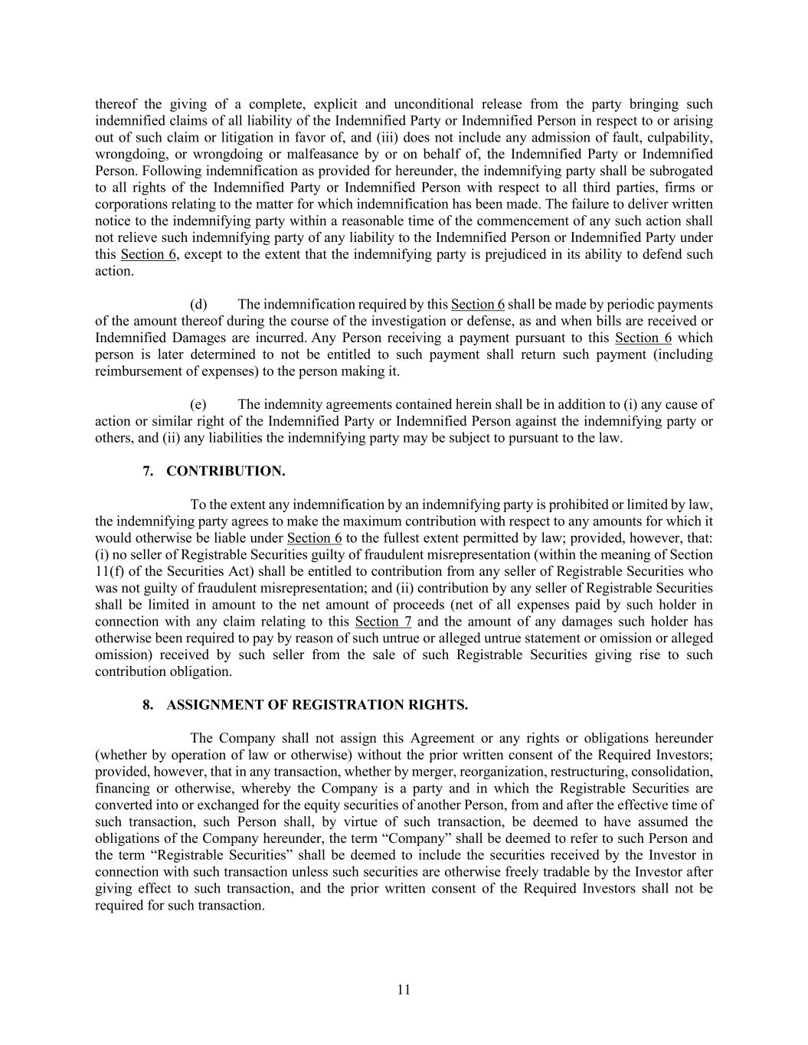
11 thereof the giving of a complete, explicit and unconditional release from the party bringing such indemnified claims of all liability of the Indemnified Party or Indemnified Person in respect to or arising out of such claim or litigation in favor of, and (iii) does not include any admission of fault, culpability, wrongdoing, or wrongdoing or malfeasance by or on behalf of, the Indemnified Party or Indemnified Person. Following indemnification as provided for hereunder, the indemnifying party shall be subrogated to all rights of the Indemnified Party or Indemnified Person with respect to all third parties, firms or corporations relating to the matter for which indemnification has been made. The failure to deliver written notice to the indemnifying party within a reasonable time of the commencement of any such action shall not relieve such indemnifying party of any liability to the Indemnified Person or Indemnified Party under this Section 6, except to the extent that the indemnifying party is prejudiced in its ability to defend such action. (d) The indemnification required by this Section 6 shall be made by periodic payments of the amount thereof during the course of the investigation or defense, as and when bills are received or Indemnified Damages are incurred. Any Person receiving a payment pursuant to this Section 6 which person is later determined to not be entitled to such payment shall return such payment (including reimbursement of expenses) to the person making it. (e) The indemnity agreements contained herein shall be in addition to (i) any cause of action or similar right of the Indemnified Party or Indemnified Person against the indemnifying party or others, and (ii) any liabilities the indemnifying party may be subject to pursuant to the law. 7. CONTRIBUTION. To the extent any indemnification by an indemnifying party is prohibited or limited by law, the indemnifying party agrees to make the maximum contribution with respect to any amounts for which it would otherwise be liable under Section 6 to the fullest extent permitted by law; provided, however, that: (i) no seller of Registrable Securities guilty of fraudulent misrepresentation (within the meaning of Section 11(f) of the Securities Act) shall be entitled to contribution from any seller of Registrable Securities who was not guilty of fraudulent misrepresentation; and (ii) contribution by any seller of Registrable Securities shall be limited in amount to the net amount of proceeds (net of all expenses paid by such holder in connection with any claim relating to this Section 7 and the amount of any damages such holder has otherwise been required to pay by reason of such untrue or alleged untrue statement or omission or alleged omission) received by such seller from the sale of such Registrable Securities giving rise to such contribution obligation. 8. ASSIGNMENT OF REGISTRATION RIGHTS. The Company shall not assign this Agreement or any rights or obligations hereunder (whether by operation of law or otherwise) without the prior written consent of the Required Investors; provided, however, that in any transaction, whether by merger, reorganization, restructuring, consolidation, financing or otherwise, whereby the Company is a party and in which the Registrable Securities are converted into or exchanged for the equity securities of another Person, from and after the effective time of such transaction, such Person shall, by virtue of such transaction, be deemed to have assumed the obligations of the Company hereunder, the term “Company” shall be deemed to refer to such Person and the term “Registrable Securities” shall be deemed to include the securities received by the Investor in connection with such transaction unless such securities are otherwise freely tradable by the Investor after giving effect to such transaction, and the prior written consent of the Required Investors shall not be required for such transaction.

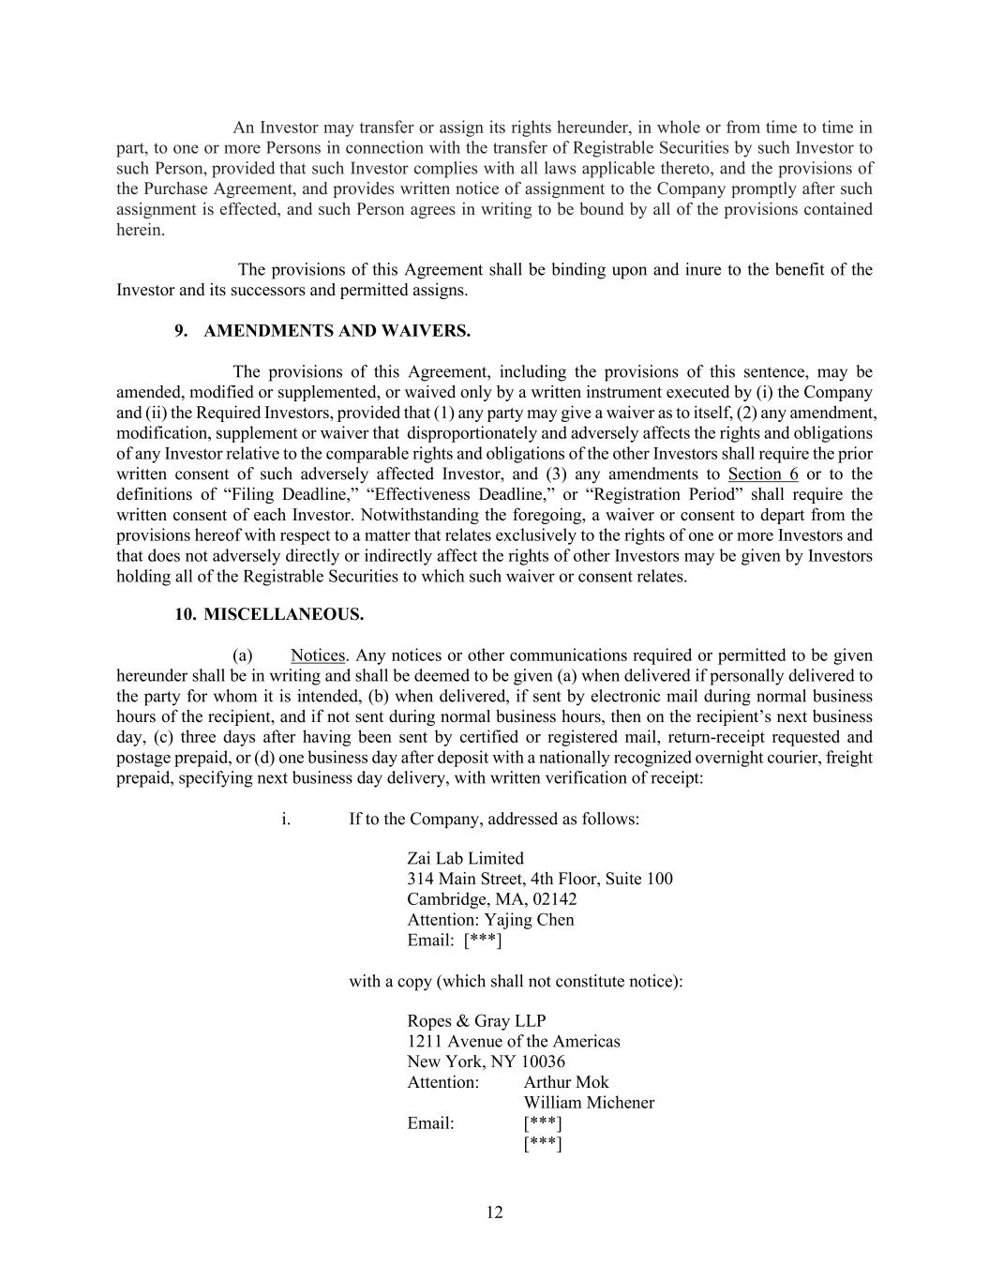
12 An Investor may transfer or assign its rights hereunder, in whole or from time to time in part, to one or more Persons in connection with the transfer of Registrable Securities by such Investor to such Person, provided that such Investor complies with all laws applicable thereto, and the provisions of the Purchase Agreement, and provides written notice of assignment to the Company promptly after such assignment is effected, and such Person agrees in writing to be bound by all of the provisions contained herein. The provisions of this Agreement shall be binding upon and inure to the benefit of the Investor and its successors and permitted assigns. 9. AMENDMENTS AND WAIVERS. The provisions of this Agreement, including the provisions of this sentence, may be amended, modified or supplemented, or waived only by a written instrument executed by (i) the Company and (ii) the Required Investors, provided that (1) any party may give a waiver as to itself, (2) any amendment, modification, supplement or waiver that disproportionately and adversely affects the rights and obligations of any Investor relative to the comparable rights and obligations of the other Investors shall require the prior written consent of such adversely affected Investor, and (3) any amendments to Section 6 or to the definitions of “Filing Deadline,” “Effectiveness Deadline,” or “Registration Period” shall require the written consent of each Investor. Notwithstanding the foregoing, a waiver or consent to depart from the provisions hereof with respect to a matter that relates exclusively to the rights of one or more Investors and that does not adversely directly or indirectly affect the rights of other Investors may be given by Investors holding all of the Registrable Securities to which such waiver or consent relates. 10. MISCELLANEOUS. (a) Notices. Any notices or other communications required or permitted to be given hereunder shall be in writing and shall be deemed to be given (a) when delivered if personally delivered to the party for whom it is intended, (b) when delivered, if sent by electronic mail during normal business hours of the recipient, and if not sent during normal business hours, then on the recipient’s next business day, (c) three days after having been sent by certified or registered mail, return-receipt requested and postage prepaid, or (d) one business day after deposit with a nationally recognized overnight courier, freight prepaid, specifying next business day delivery, with written verification of receipt: i. If to the Company, addressed as follows: Zai Lab Limited 314 Main Street, 4th Floor, Suite 100 Cambridge, MA, 02142 Attention: Yajing Chen Email: [***] with a copy (which shall not constitute notice): Ropes & Gray LLP 1211 Avenue of the Americas New York, NY 10036 Attention: Arthur Mok William Michener Email: [***] [***]

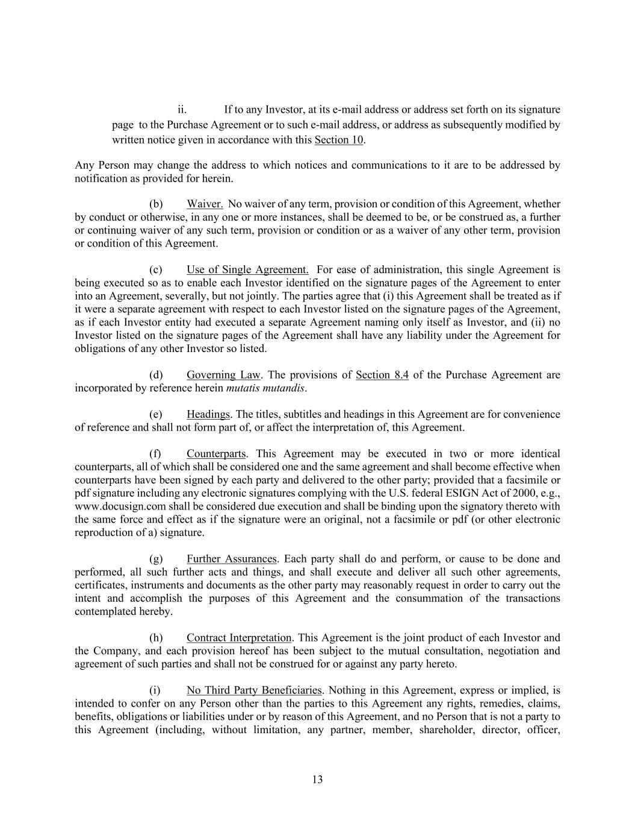
13 ii. If to any Investor, at its e-mail address or address set forth on its signature page to the Purchase Agreement or to such e-mail address, or address as subsequently modified by written notice given in accordance with this Section 10. Any Person may change the address to which notices and communications to it are to be addressed by notification as provided for herein. (b) Waiver. No waiver of any term, provision or condition of this Agreement, whether by conduct or otherwise, in any one or more instances, shall be deemed to be, or be construed as, a further or continuing waiver of any such term, provision or condition or as a waiver of any other term, provision or condition of this Agreement. (c) Use of Single Agreement. For ease of administration, this single Agreement is being executed so as to enable each Investor identified on the signature pages of the Agreement to enter into an Agreement, severally, but not jointly. The parties agree that (i) this Agreement shall be treated as if it were a separate agreement with respect to each Investor listed on the signature pages of the Agreement, as if each Investor entity had executed a separate Agreement naming only itself as Investor, and (ii) no Investor listed on the signature pages of the Agreement shall have any liability under the Agreement for obligations of any other Investor so listed. (d) Governing Law. The provisions of Section 8.4 of the Purchase Agreement are incorporated by reference herein mutatis mutandis. (e) Headings. The titles, subtitles and headings in this Agreement are for convenience of reference and shall not form part of, or affect the interpretation of, this Agreement. (f) Counterparts. This Agreement may be executed in two or more identical counterparts, all of which shall be considered one and the same agreement and shall become effective when counterparts have been signed by each party and delivered to the other party; provided that a facsimile or pdf signature including any electronic signatures complying with the U.S. federal ESIGN Act of 2000, e.g., www.docusign.com shall be considered due execution and shall be binding upon the signatory thereto with the same force and effect as if the signature were an original, not a facsimile or pdf (or other electronic reproduction of a) signature. (g) Further Assurances. Each party shall do and perform, or cause to be done and performed, all such further acts and things, and shall execute and deliver all such other agreements, certificates, instruments and documents as the other party may reasonably request in order to carry out the intent and accomplish the purposes of this Agreement and the consummation of the transactions contemplated hereby. (h) Contract Interpretation. This Agreement is the joint product of each Investor and the Company, and each provision hereof has been subject to the mutual consultation, negotiation and agreement of such parties and shall not be construed for or against any party hereto. (i) No Third Party Beneficiaries. Nothing in this Agreement, express or implied, is intended to confer on any Person other than the parties to this Agreement any rights, remedies, claims, benefits, obligations or liabilities under or by reason of this Agreement, and no Person that is not a party to this Agreement (including, without limitation, any partner, member, shareholder, director, officer,

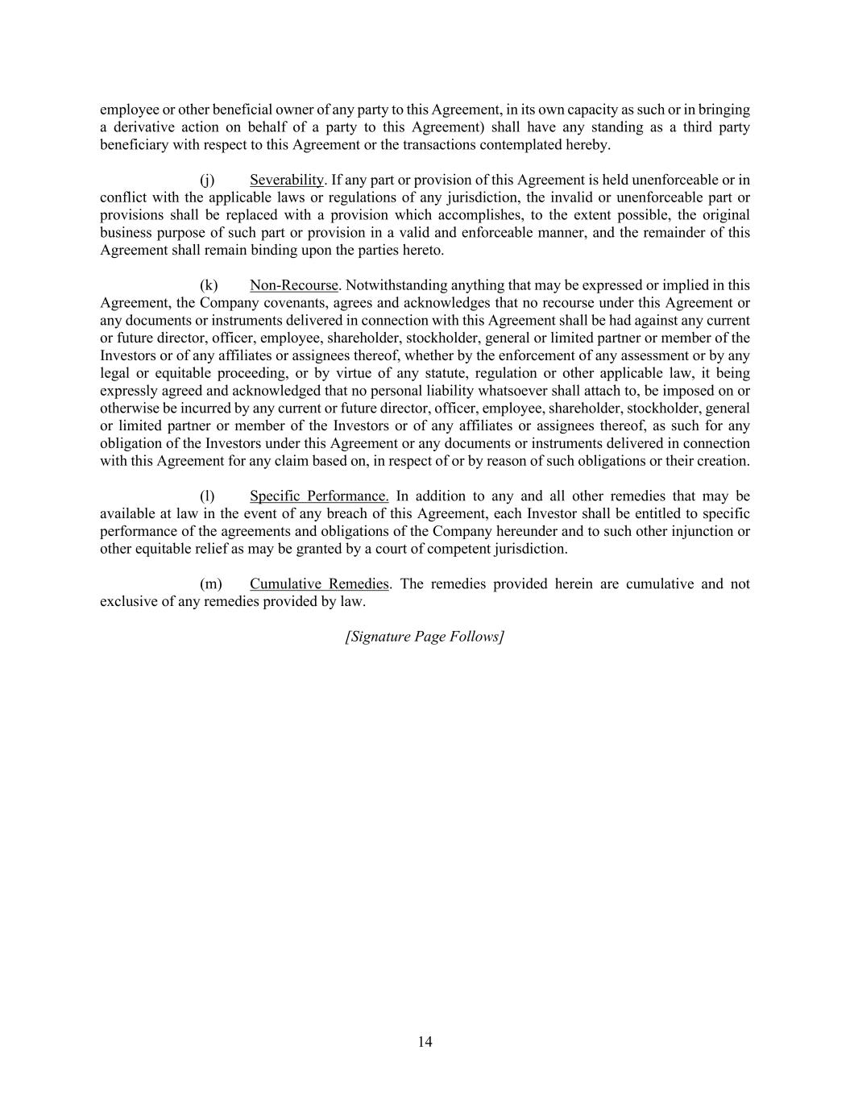
14 employee or other beneficial owner of any party to this Agreement, in its own capacity as such or in bringing a derivative action on behalf of a party to this Agreement) shall have any standing as a third party beneficiary with respect to this Agreement or the transactions contemplated hereby. (j) Severability. If any part or provision of this Agreement is held unenforceable or in conflict with the applicable laws or regulations of any jurisdiction, the invalid or unenforceable part or provisions shall be replaced with a provision which accomplishes, to the extent possible, the original business purpose of such part or provision in a valid and enforceable manner, and the remainder of this Agreement shall remain binding upon the parties hereto. (k) Non-Recourse. Notwithstanding anything that may be expressed or implied in this Agreement, the Company covenants, agrees and acknowledges that no recourse under this Agreement or any documents or instruments delivered in connection with this Agreement shall be had against any current or future director, officer, employee, shareholder, stockholder, general or limited partner or member of the Investors or of any affiliates or assignees thereof, whether by the enforcement of any assessment or by any legal or equitable proceeding, or by virtue of any statute, regulation or other applicable law, it being expressly agreed and acknowledged that no personal liability whatsoever shall attach to, be imposed on or otherwise be incurred by any current or future director, officer, employee, shareholder, stockholder, general or limited partner or member of the Investors or of any affiliates or assignees thereof, as such for any obligation of the Investors under this Agreement or any documents or instruments delivered in connection with this Agreement for any claim based on, in respect of or by reason of such obligations or their creation. (l) Specific Performance. In addition to any and all other remedies that may be available at law in the event of any breach of this Agreement, each Investor shall be entitled to specific performance of the agreements and obligations of the Company hereunder and to such other injunction or other equitable relief as may be granted by a court of competent jurisdiction. (m) Cumulative Remedies. The remedies provided herein are cumulative and not exclusive of any remedies provided by law. [Signature Page Follows]

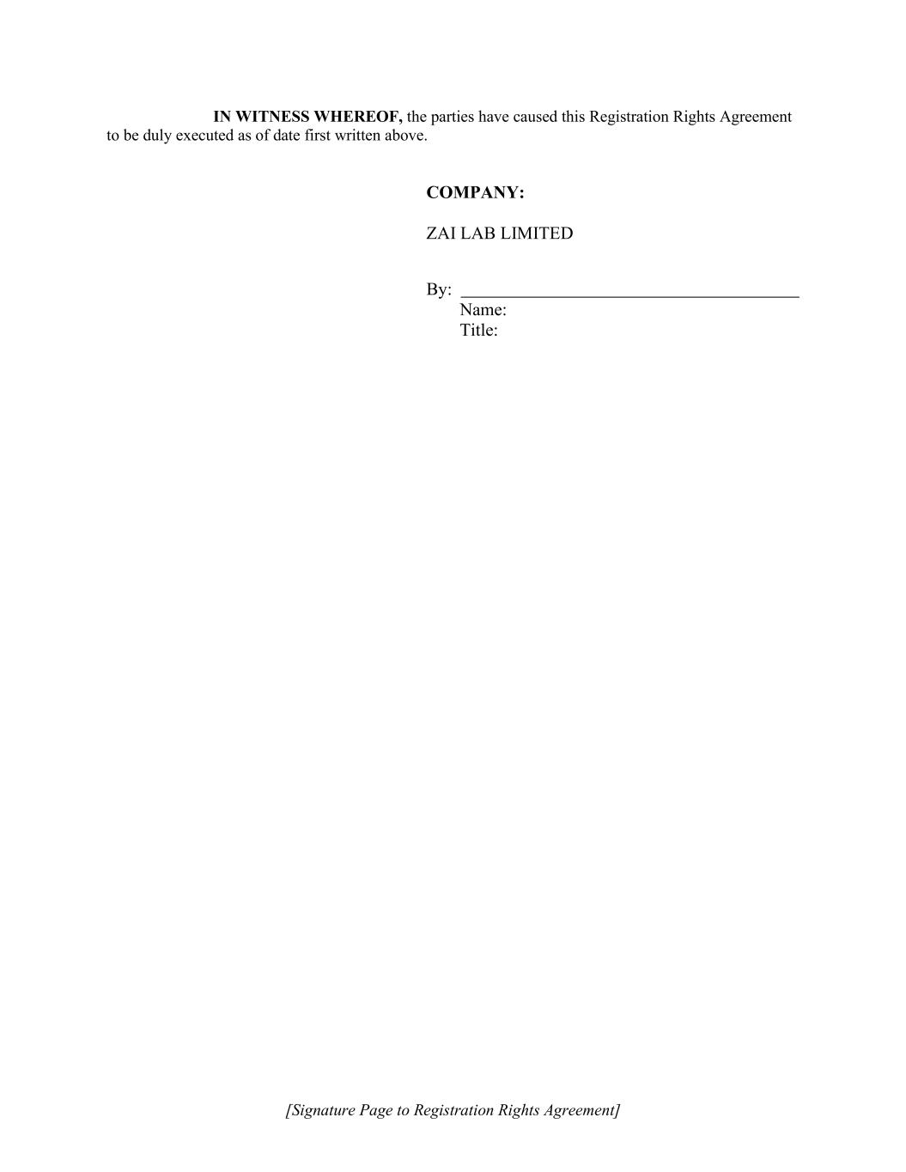
[Signature Page to Registration Rights Agreement] IN WITNESS WHEREOF, the parties have caused this Registration Rights Agreement to be duly executed as of date first written above. COMPANY: ZAI LAB LIMITED By: Name: Title:

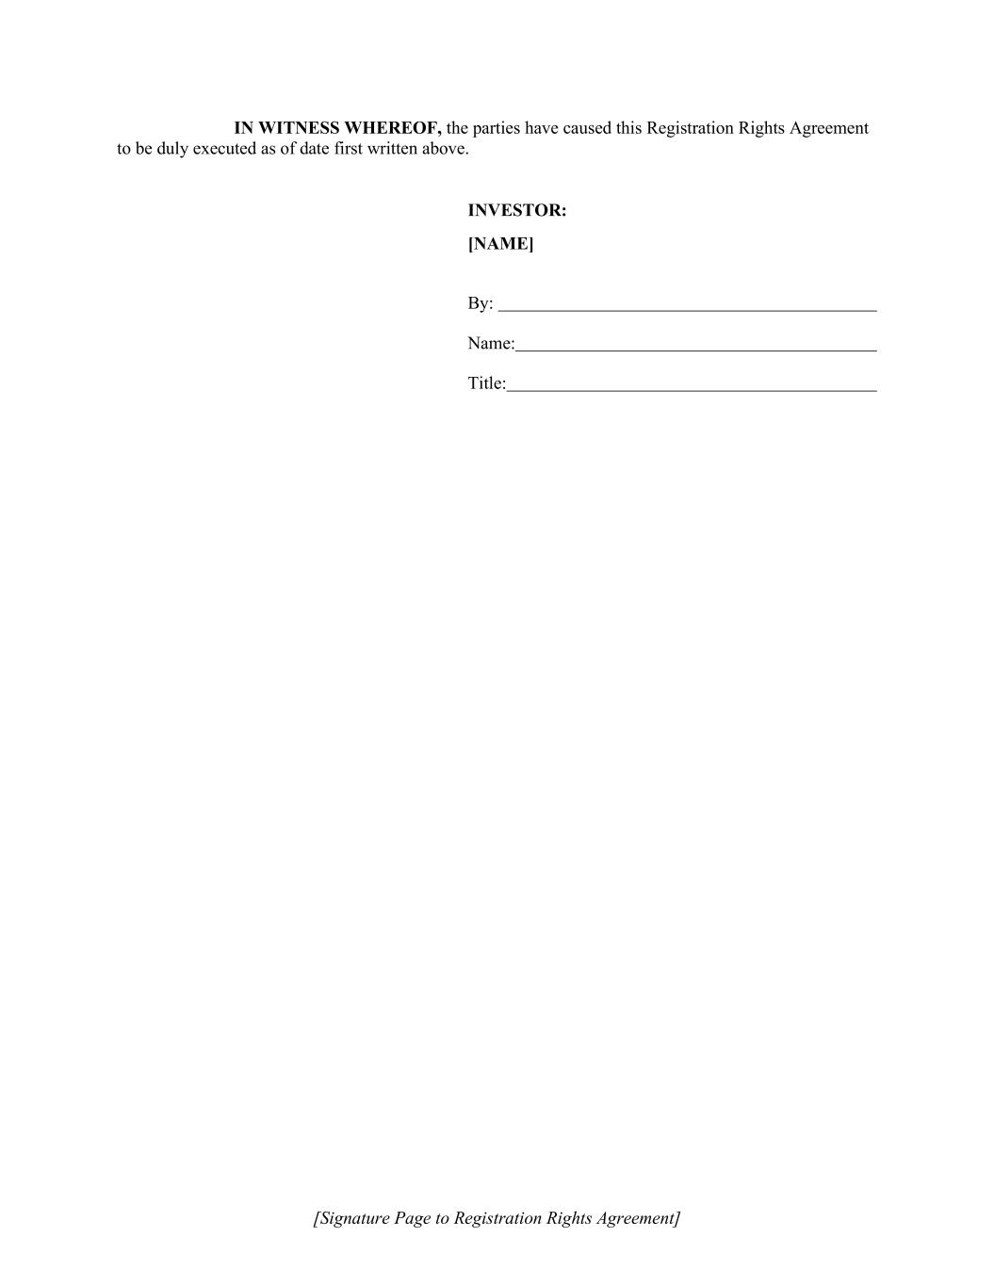
[Signature Page to Registration Rights Agreement] IN WITNESS WHEREOF, the parties have caused this Registration Rights Agreement to be duly executed as of date first written above. INVESTOR: [NAME] By: Name: Title:


1 Exhibit A PLAN OF DISTRIBUTION


2 Exhibit B Investor Questionnaire


© 2026. Zai Lab. All Rights Reserved.NASDAQ:ZLAB | HKEX:9688 Advancing First- and Best-in- Class Therapies in Oncology and Immunology October 2026

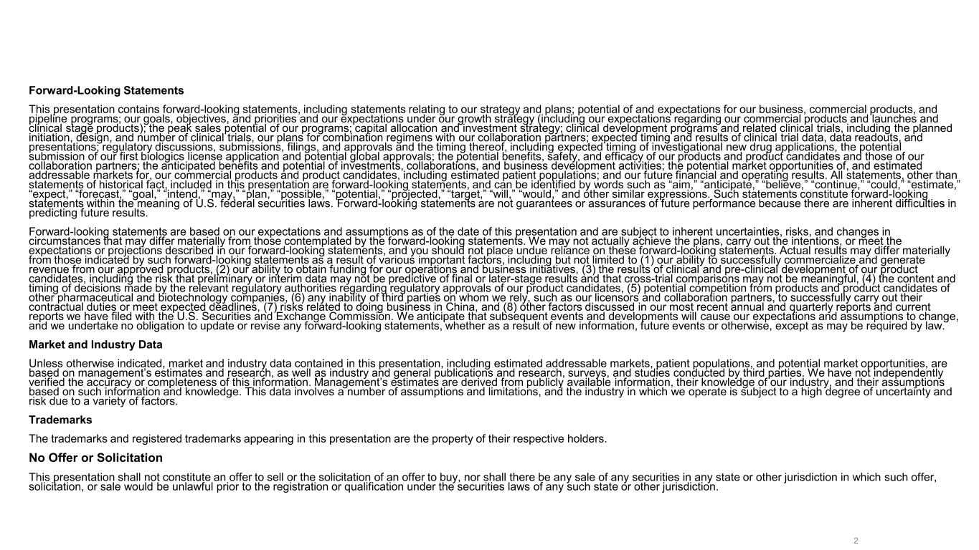
Forward-Looking Statements 2 Forward-Looking Statements This presentation contains forward-looking statements, including statements relating to our strategy and plans; potential of and expectations for our business, commercial products, and pipeline programs; our goals, objectives, and priorities and our expectations under our growth strategy (including our expectations regarding our commercial products and launches and clinical stage products); the peak sales potential of our programs; capital allocation and investment strategy; clinical development programs and related clinical trials, including the planned initiation, design, and number of clinical trials, our plans for combination regimens with our collaboration partners; expected timing and results of clinical trial data, data readouts, and presentations; regulatory discussions, submissions, filings, and approvals and the timing thereof, including expected timing of investigational new drug applications, the potential submission of our first biologics license application and potential global approvals; the potential benefits, safety, and efficacy of our products and product candidates and those of our collaboration partners; the anticipated benefits and potential of investments, collaborations, and business development activities; the potential market opportunities of, and estimated addressable markets for, our commercial products and product candidates, including estimated patient populations; and our future financial and operating results. All statements, other than statements of historical fact, included in this presentation are forward-looking statements, and can be identified by words such as “aim,” “anticipate,” “believe,” “continue,” “could,” “estimate,” “expect,” “forecast,” “goal,” “intend,” “may,” “plan,” “possible,” “potential,” “projected,” “target,” “will,” “would,” and other similar expressions. Such statements constitute forward-looking statements within the meaning of U.S. federal securities laws. Forward-looking statements are not guarantees or assurances of future performance because there are inherent difficulties in predicting future results. Forward-looking statements are based on our expectations and assumptions as of the date of this presentation and are subject to inherent uncertainties, risks, and changes in circumstances that may differ materially from those contemplated by the forward-looking statements. We may not actually achieve the plans, carry out the intentions, or meet the expectations or projections described in our forward-looking statements, and you should not place undue reliance on these forward-looking statements. Actual results may differ materially from those indicated by such forward-looking statements as a result of various important factors, including but not limited to (1) our ability to successfully commercialize and generate revenue from our approved products, (2) our ability to obtain funding for our operations and business initiatives, (3) the results of clinical and pre-clinical development of our product candidates, including the risk that preliminary or interim data may not be predictive of final or later-stage results and that cross-trial comparisons may not be meaningful, (4) the content and timing of decisions made by the relevant regulatory authorities regarding regulatory approvals of our product candidates, (5) potential competition from products and product candidates of other pharmaceutical and biotechnology companies, (6) any inability of third parties on whom we rely, such as our licensors and collaboration partners, to successfully carry out their contractual duties or meet expected deadlines, (7) risks related to doing business in China, and (8) other factors discussed in our most recent annual and quarterly reports and current reports we have filed with the U.S. Securities and Exchange Commission. We anticipate that subsequent events and developments will cause our expectations and assumptions to change, and we undertake no obligation to update or revise any forward-looking statements, whether as a result of new information, future events or otherwise, except as may be required by law. Market and Industry Data Unless otherwise indicated, market and industry data contained in this presentation, including estimated addressable markets, patient populations, and potential market opportunities, are based on management’s estimates and research, as well as industry and general publications and research, surveys, and studies conducted by third parties. We have not independently verified the accuracy or completeness of this information. Management’s estimates are derived from publicly available information, their knowledge of our industry, and their assumptions based on such information and knowledge. This data involves a number of assumptions and limitations, and the industry in which we operate is subject to a high degree of uncertainty and risk due to a variety of factors. Trademarks The trademarks and registered trademarks appearing in this presentation are the property of their respective holders. No Offer or Solicitation This presentation shall not constitute an offer to sell or the solicitation of an offer to buy, nor shall there be any sale of any securities in any state or other jurisdiction in which such offer, solicitation, or sale would be unlawful prior to the registration or qualification under the securities laws of any such state or other jurisdiction.

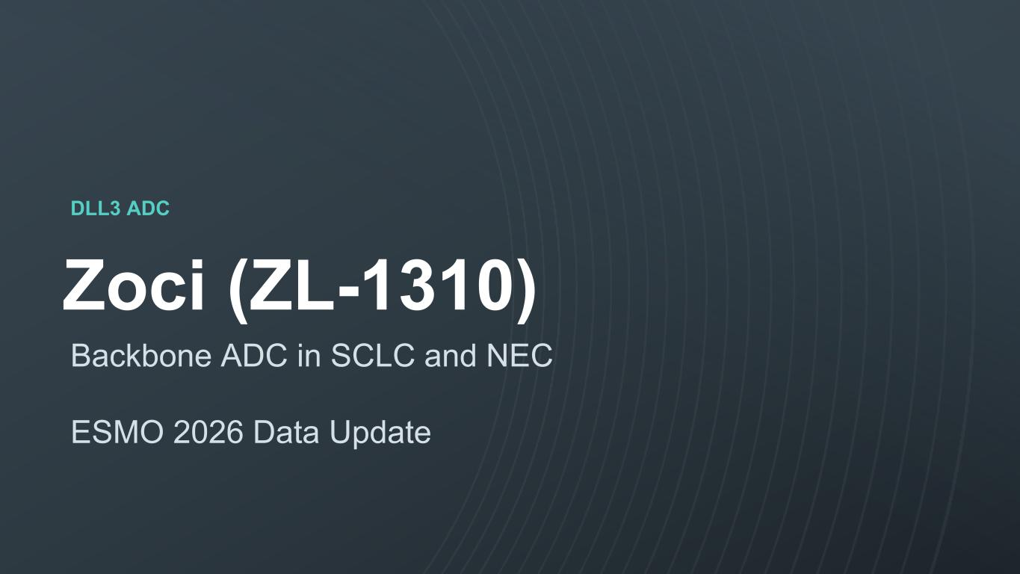
© 2023. Zai Lab. All Rights Reserved.NASDAQ:ZLAB | HKEX:9688 DLL3 ADC Zoci (ZL-1310) Backbone ADC in SCLC and NEC ESMO 2026 Data Update

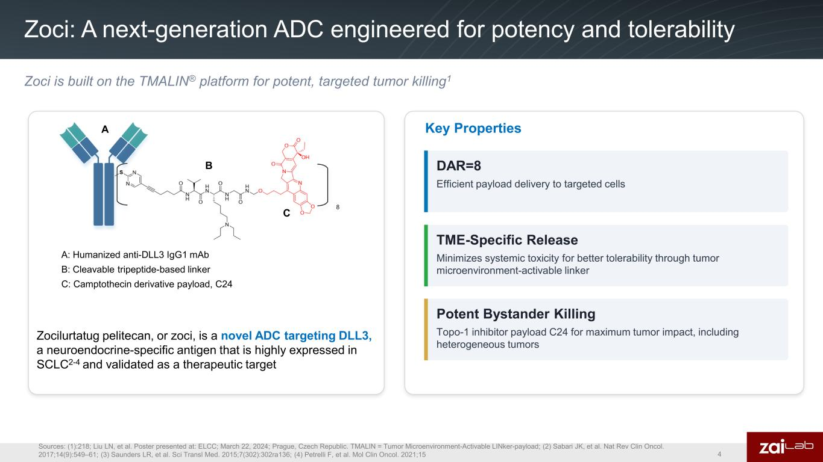
Zoci: A next-generation ADC engineered for potency and tolerability Sources: (1):218; Liu LN, et al. Poster presented at: ELCC; March 22, 2024; Prague, Czech Republic. TMALIN = Tumor Microenvironment-Activable LINker-payload; (2) Sabari JK, et al. Nat Rev Clin Oncol. 2017;14(9):549‒61; (3) Saunders LR, et al. Sci Transl Med. 2015;7(302):302ra136; (4) Petrelli F, et al. Mol Clin Oncol. 2021;15 4 Zocilurtatug pelitecan, or zoci, is a novel ADC targeting DLL3, a neuroendocrine-specific antigen that is highly expressed in SCLC2-4 and validated as a therapeutic target A: Humanized anti-DLL3 IgG1 mAb B: Cleavable tripeptide-based linker C: Camptothecin derivative payload, C24 A B C Key Properties Zoci is built on the TMALIN® platform for potent, targeted tumor killing1 DAR=8 Efficient payload delivery to targeted cells Potent Bystander Killing Topo-1 inhibitor payload C24 for maximum tumor impact, including heterogeneous tumors TME-Specific Release Minimizes systemic toxicity for better tolerability through tumor microenvironment-activable linker

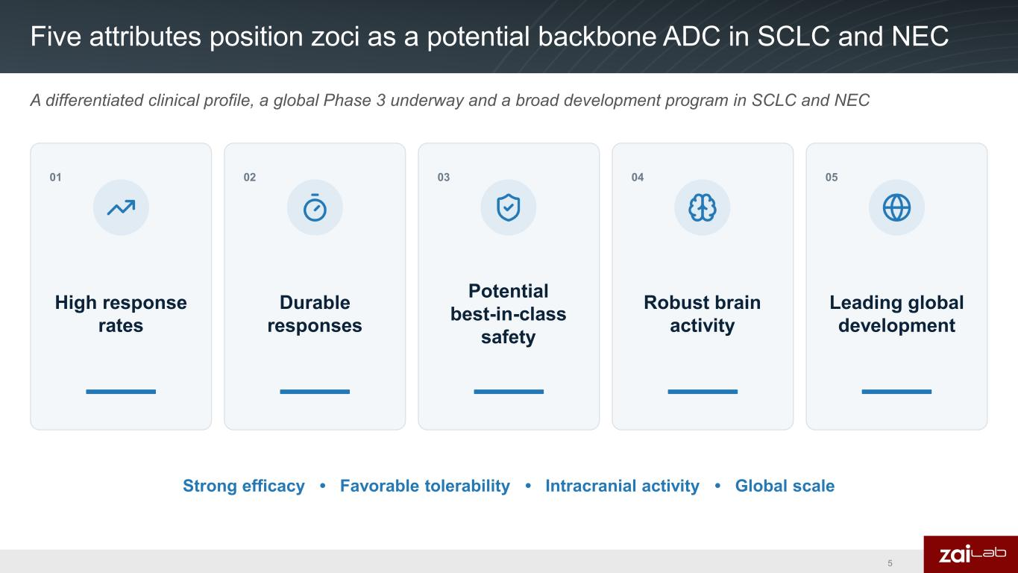
Five attributes position zoci as a potential backbone ADC in SCLC and NEC 5 A differentiated clinical profile, a global Phase 3 underway and a broad development program in SCLC and NEC 01 High response rates 02 Durable responses 03 04 05 Leading global development Strong efficacy • Favorable tolerability • Intracranial activity • Global scale Robust brain activity Potential best-in-class safety

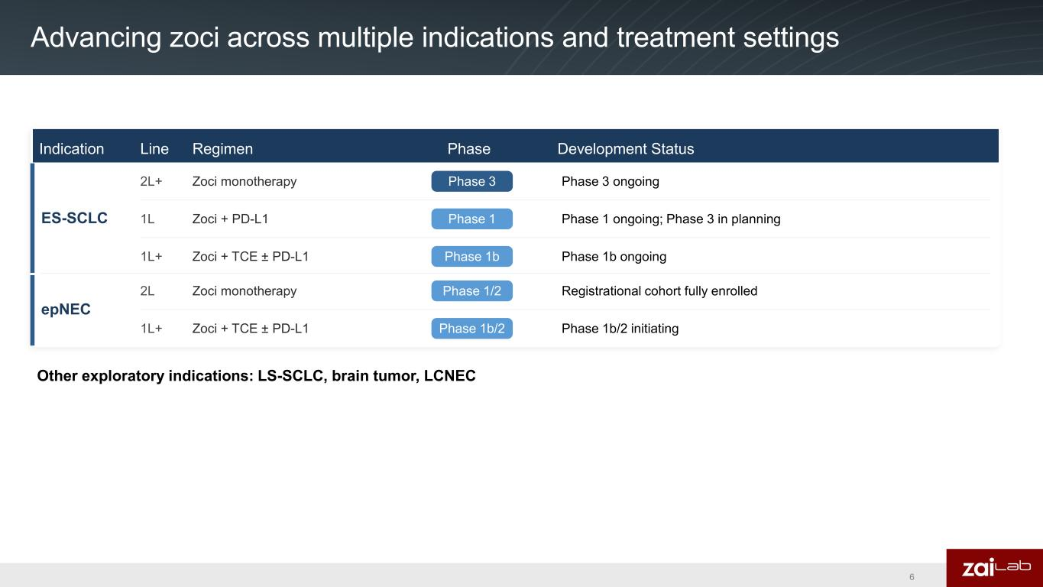
Advancing zoci across multiple indications and treatment settings 6 Indication Line Regimen Phase Development Status ES-SCLC 2L+ Zoci monotherapy Phase 3 Phase 3 ongoing 1L Zoci + PD-L1 Phase 1 Phase 1 ongoing; Phase 3 in planning 1L+ Zoci + TCE ± PD-L1 Phase 1b Phase 1b ongoing epNEC 2L Zoci monotherapy Phase 1/2 Registrational cohort fully enrolled 1L+ Zoci + TCE ± PD-L1 Phase 1b/2 Phase 1b/2 initiating Other exploratory indications: LS-SCLC, brain tumor, LCNEC

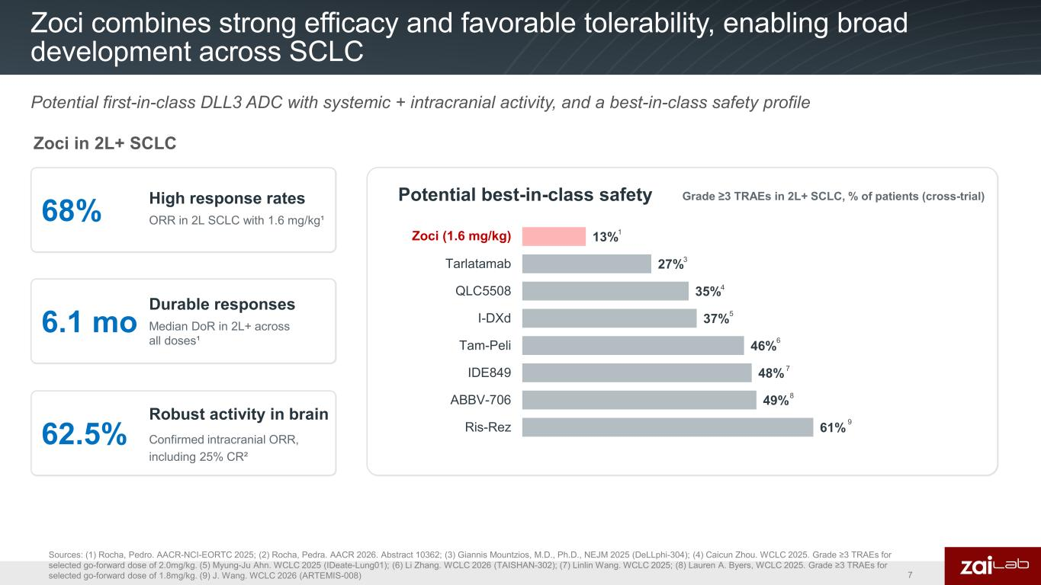
Zoci combines strong efficacy and favorable tolerability, enabling broad development across SCLC Sources: (1) Rocha, Pedro. AACR-NCI-EORTC 2025; (2) Rocha, Pedra. AACR 2026. Abstract 10362; (3) Giannis Mountzios, M.D., Ph.D., NEJM 2025 (DeLLphi-304); (4) Caicun Zhou. WCLC 2025. Grade ≥3 TRAEs for selected go-forward dose of 2.0mg/kg. (5) Myung-Ju Ahn. WCLC 2025 (IDeate-Lung01); (6) Li Zhang. WCLC 2026 (TAISHAN-302); (7) Linlin Wang. WCLC 2025; (8) Lauren A. Byers, WCLC 2025. Grade ≥3 TRAEs for selected go-forward dose of 1.8mg/kg. (9) J. Wang. WCLC 2026 (ARTEMIS-008) 7 Potential first-in-class DLL3 ADC with systemic + intracranial activity, and a best-in-class safety profile 68% High response rates ORR in 2L SCLC with 1.6 mg/kg¹ 6.1 mo Durable responses Median DoR in 2L+ across all doses¹ 62.5% Robust activity in brain Confirmed intracranial ORR, including 25% CR² Potential best-in-class safety Grade ≥3 TRAEs in 2L+ SCLC, % of patients (cross-trial) 13% 27% 35% 37% 46% 48% 49% 61% Zoci (1.6 mg/kg) Tarlatamab QLC5508 I-DXd Tam-Peli IDE849 ABBV-706 Ris-Rez Zoci (1.6 / 1 3 4 5 6 7 8 9 Zoci in 2L+ SCLC

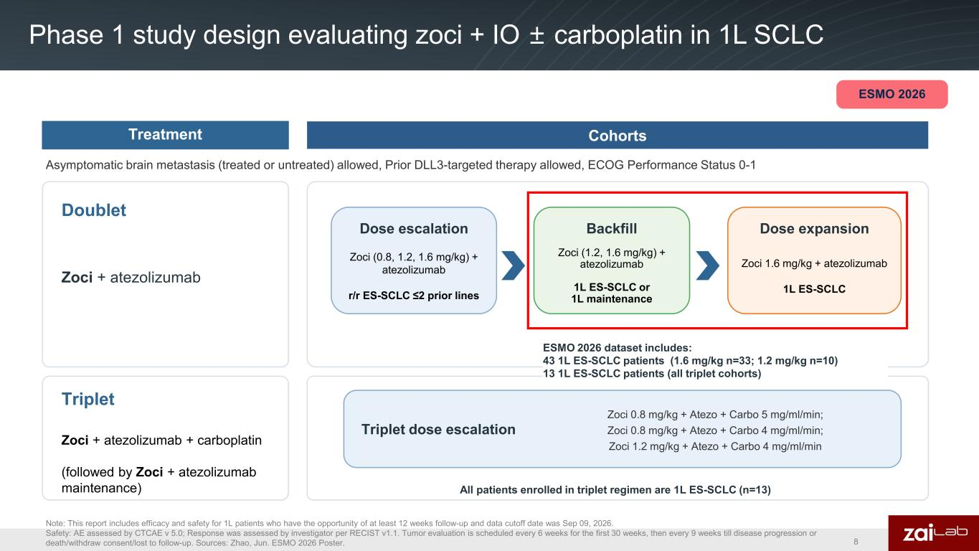
Phase 1 study design evaluating zoci + IO ± carboplatin in 1L SCLC Note: This report includes efficacy and safety for 1L patients who have the opportunity of at least 12 weeks follow-up and data cutoff date was Sep 09, 2026. Safety: AE assessed by CTCAE v 5.0; Response was assessed by investigator per RECIST v1.1. Tumor evaluation is scheduled every 6 weeks for the first 30 weeks, then every 9 weeks till disease progression or death/withdraw consent/lost to follow-up. Sources: Zhao, Jun. ESMO 2026 Poster. CohortsTreatment Doublet Zoci + atezolizumab Triplet Zoci + atezolizumab + carboplatin (followed by Zoci + atezolizumab maintenance) Dose escalation Zoci (0.8, 1.2, 1.6 mg/kg) + atezolizumab r/r ES-SCLC ≤2 prior lines Backfill Zoci (1.2, 1.6 mg/kg) + atezolizumab 1L ES-SCLC or 1L maintenance Dose expansion Zoci 1.6 mg/kg + atezolizumab 1L ES-SCLC Triplet dose escalation Zoci 0.8 mg/kg + Atezo + Carbo 5 mg/ml/min; Zoci 0.8 mg/kg + Atezo + Carbo 4 mg/ml/min; Zoci 1.2 mg/kg + Atezo + Carbo 4 mg/ml/min All patients enrolled in triplet regimen are 1L ES-SCLC (n=13) Asymptomatic brain metastasis (treated or untreated) allowed, Prior DLL3-targeted therapy allowed, ECOG Performance Status 0-1 8 ESMO 2026 ESMO 2026 dataset includes: 43 1L ES-SCLC patients (1.6 mg/kg n=33; 1.2 mg/kg n=10) 13 1L ES-SCLC patients (all triplet cohorts)

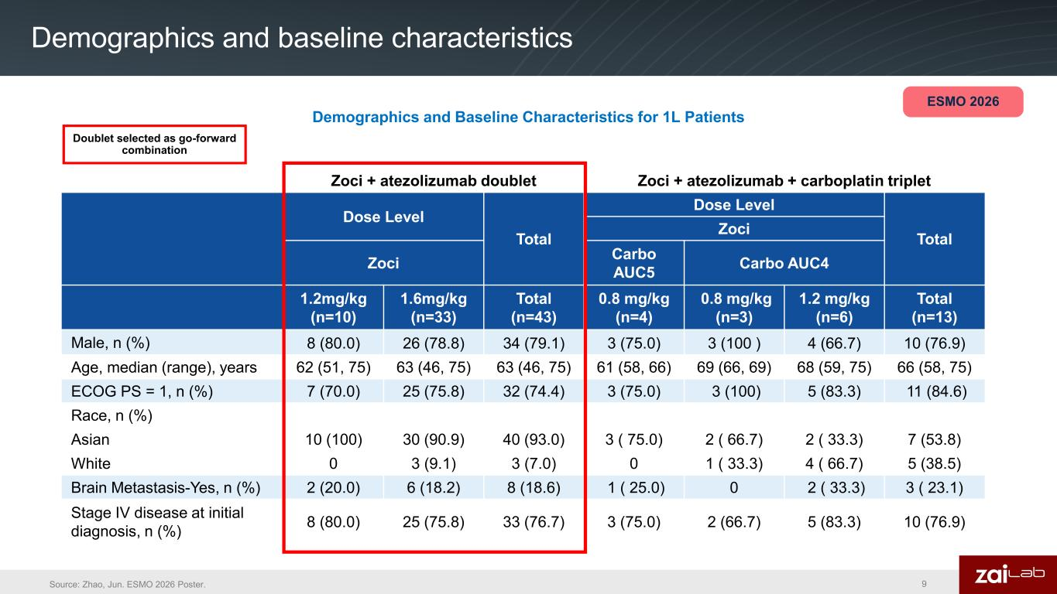
Demographics and baseline characteristics 9Source: Zhao, Jun. ESMO 2026 Poster. Demographics and Baseline Characteristics for 1L Patients Doublet selected as go-forward combination ESMO 2026 Zoci + atezolizumab doublet Zoci + atezolizumab + carboplatin triplet Dose Level Total Dose Level TotalZoci Zoci Carbo AUC5 Carbo AUC4 1.2mg/kg (n=10) 1.6mg/kg (n=33) Total (n=43) 0.8 mg/kg (n=4) 0.8 mg/kg (n=3) 1.2 mg/kg (n=6) Total (n=13) Male, n (%) 8 (80.0) 26 (78.8) 34 (79.1) 3 (75.0) 3 (100 ) 4 (66.7) 10 (76.9) Age, median (range), years 62 (51, 75) 63 (46, 75) 63 (46, 75) 61 (58, 66) 69 (66, 69) 68 (59, 75) 66 (58, 75) ECOG PS = 1, n (%) 7 (70.0) 25 (75.8) 32 (74.4) 3 (75.0) 3 (100) 5 (83.3) 11 (84.6) Race, n (%) Asian 10 (100) 30 (90.9) 40 (93.0) 3 ( 75.0) 2 ( 66.7) 2 ( 33.3) 7 (53.8) White 0 3 (9.1) 3 (7.0) 0 1 ( 33.3) 4 ( 66.7) 5 (38.5) Brain Metastasis-Yes, n (%) 2 (20.0) 6 (18.2) 8 (18.6) 1 ( 25.0) 0 2 ( 33.3) 3 ( 23.1) Stage IV disease at initial diagnosis, n (%) 8 (80.0) 25 (75.8) 33 (76.7) 3 (75.0) 2 (66.7) 5 (83.3) 10 (76.9)

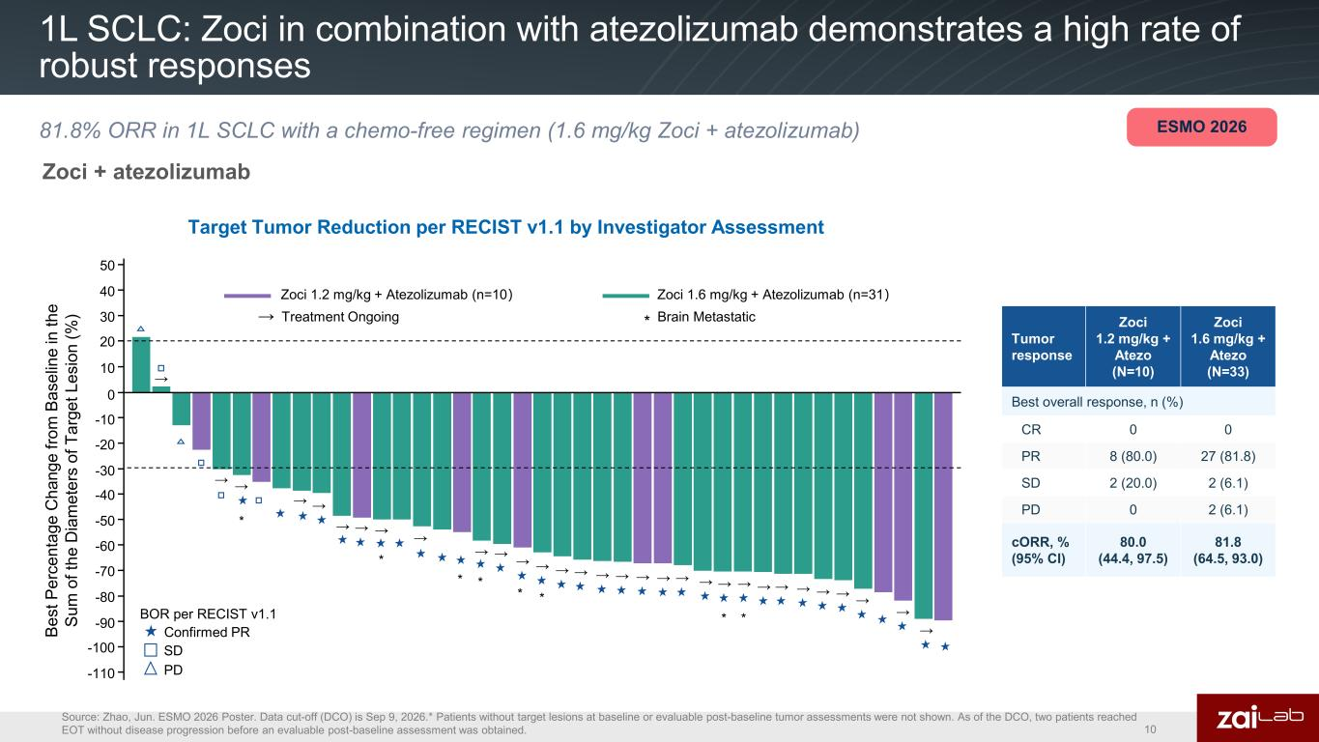
1L SCLC: Zoci in combination with atezolizumab demonstrates a high rate of robust responses Source: Zhao, Jun. ESMO 2026 Poster. Data cut-off (DCO) is Sep 9, 2026.* Patients without target lesions at baseline or evaluable post-baseline tumor assessments were not shown. As of the DCO, two patients reached EOT without disease progression before an evaluable post-baseline assessment was obtained. Target Tumor Reduction per RECIST v1.1 by Investigator Assessment 10 81.8% ORR in 1L SCLC with a chemo-free regimen (1.6 mg/kg Zoci + atezolizumab) Tumor response Zoci 1.2 mg/kg + Atezo (N=10) Zoci 1.6 mg/kg + Atezo (N=33) Best overall response, n (%) CR 0 0 PR 8 (80.0) 27 (81.8) SD 2 (20.0) 2 (6.1) PD 0 2 (6.1) cORR, % (95% CI) 80.0 (44.4, 97.5) 81.8 (64.5, 93.0) ESMO 2026 -110 -100 -90 -80 -70 -60 -50 -40 -30 -20 -10 0 10 20 30 40 50 → → → * → → → → → → * * → → → → → → → → → → → → → → → → → → → → → → * *BOR per RECIST v1.1 SD PD Zoci 1.2 mg/kg + Atezolizumab (n=10） Zoci 1.6 mg/kg + Atezolizumab (n=31） → Treatment Ongoing * Brain Metastatic Be st P er ce nt ag e C ha ng e fro m B as el in e in th e Su m o f t he D ia m et er s of T ar ge t L es io n (% ) * * * Confirmed PR Zoci + atezolizumab

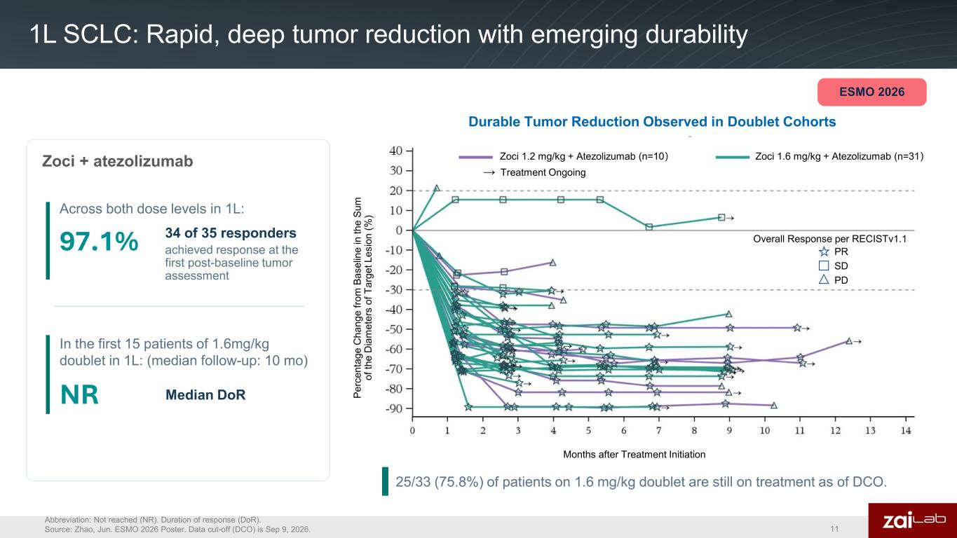
1L SCLC: Rapid, deep tumor reduction with emerging durability Abbreviation: Not reached (NR). Duration of response (DoR). Source: Zhao, Jun. ESMO 2026 Poster. Data cut-off (DCO) is Sep 9, 2026. 11 ESMO 2026 97.1% 34 of 35 responders achieved response at the first post-baseline tumor assessment NR Median DoR In the first 15 patients of 1.6mg/kg doublet in 1L: (median follow-up: 10 mo) Across both dose levels in 1L: Durable Tumor Reduction Observed in Doublet Cohorts Zoci + atezolizumab Pe rc en ta ge C ha ng e fro m B as el in e in th e Su m of th e D ia m et er s of T ar ge t L es io n (% ) Months after Treatment Initiation Zoci 1.6 mg/kg + Atezolizumab (n=31） → Treatment Ongoing Overall Response per RECISTv1.1 PR SD PD Zoci 1.2 mg/kg + Atezolizumab (n=10） 25/33 (75.8%) of patients on 1.6 mg/kg doublet are still on treatment as of DCO. Zoci 1.2 mg/kg + Atezolizumab (n=10） Zoci 1.6 mg/kg + Atezolizumab (n=31） → Treatment Ongoing Overall Response per RECISTv1.1 PR SD PD

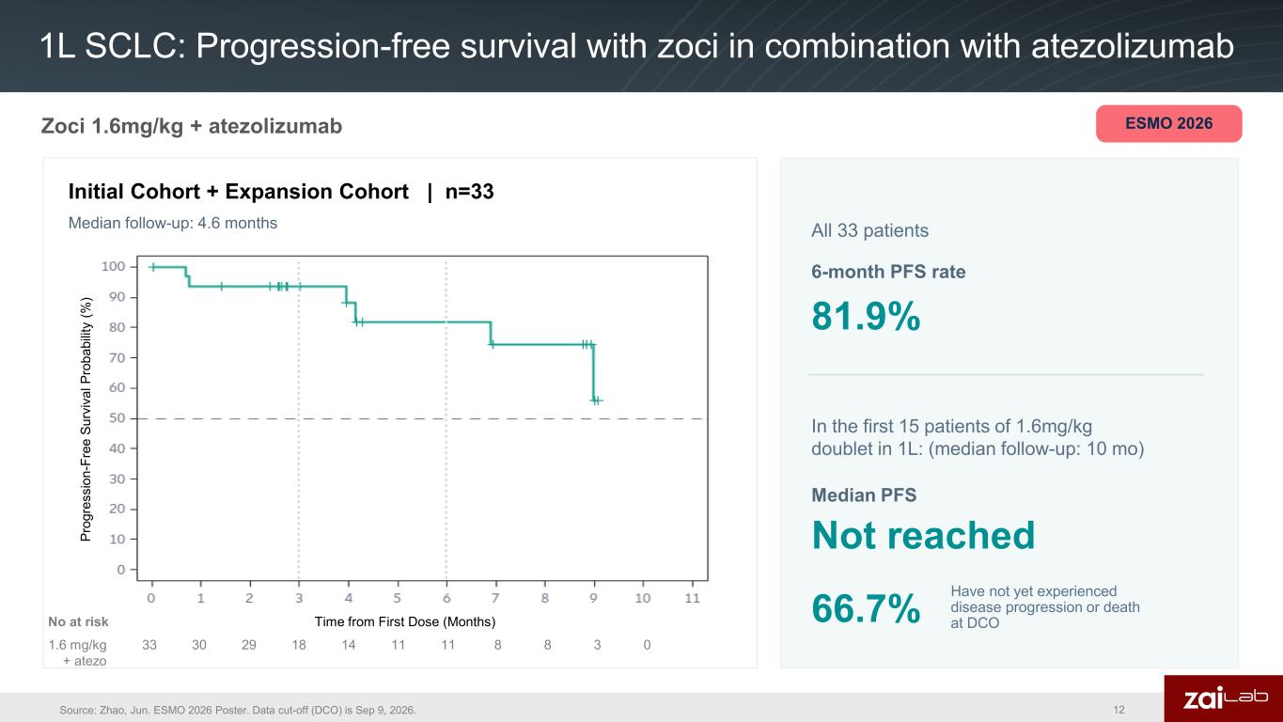
1L SCLC: Progression-free survival with zoci in combination with atezolizumab Source: Zhao, Jun. ESMO 2026 Poster. Data cut-off (DCO) is Sep 9, 2026. Zoci 1.6mg/kg + atezolizumab ESMO 2026 6-month PFS rate 81.9% Median follow-up: 4.6 months Pr og re ss io n- Fr ee S ur vi va l P ro ba bi lit y (% ) Time from First Dose (Months)No at risk 1.6 mg/kg + atezo 33 30 29 18 14 11 11 8 8 3 0 In the first 15 patients of 1.6mg/kg doublet in 1L: (median follow-up: 10 mo) 66.7% Have not yet experienced disease progression or death at DCO Initial Cohort + Expansion Cohort | n=33 Median PFS Not reached 12 All 33 patients

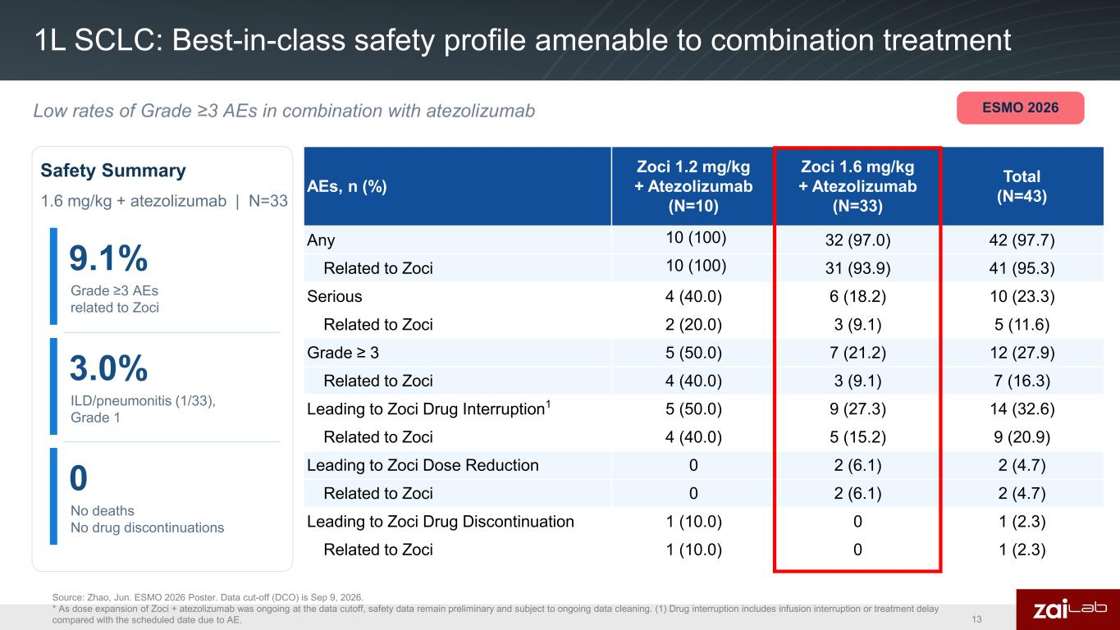
1L SCLC: Best-in-class safety profile amenable to combination treatment Low rates of Grade ≥3 AEs in combination with atezolizumab Source: Zhao, Jun. ESMO 2026 Poster. Data cut-off (DCO) is Sep 9, 2026. * As dose expansion of Zoci + atezolizumab was ongoing at the data cutoff, safety data remain preliminary and subject to ongoing data cleaning. (1) Drug interruption includes infusion interruption or treatment delay compared with the scheduled date due to AE. 13 AEs, n (%) Zoci 1.2 mg/kg + Atezolizumab (N=10) Zoci 1.6 mg/kg + Atezolizumab (N=33) Total (N=43) Any 10 (100) 32 (97.0) 42 (97.7) Related to Zoci 10 (100) 31 (93.9) 41 (95.3) Serious 4 (40.0) 6 (18.2) 10 (23.3) Related to Zoci 2 (20.0) 3 (9.1) 5 (11.6) Grade ≥ 3 5 (50.0) 7 (21.2) 12 (27.9) Related to Zoci 4 (40.0) 3 (9.1) 7 (16.3) Leading to Zoci Drug Interruption1 5 (50.0) 9 (27.3) 14 (32.6) Related to Zoci 4 (40.0) 5 (15.2) 9 (20.9) Leading to Zoci Dose Reduction 0 2 (6.1) 2 (4.7) Related to Zoci 0 2 (6.1) 2 (4.7) Leading to Zoci Drug Discontinuation 1 (10.0) 0 1 (2.3) Related to Zoci 1 (10.0) 0 1 (2.3) Safety Summary 1.6 mg/kg + atezolizumab | N=33 9.1% Grade ≥3 AEs related to Zoci 3.0% ILD/pneumonitis (1/33), Grade 1 0 No deaths No drug discontinuations ESMO 2026

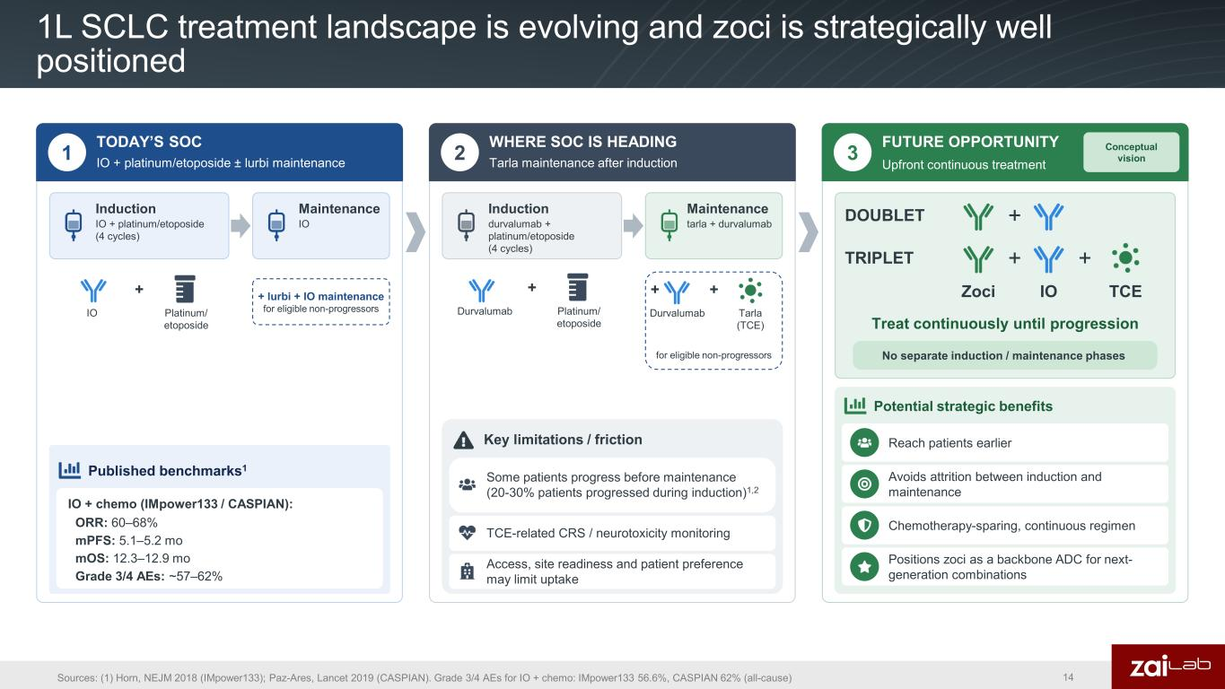
1L SCLC treatment landscape is evolving and zoci is strategically well positioned Sources: (1) Horn, NEJM 2018 (IMpower133); Paz-Ares, Lancet 2019 (CASPIAN). Grade 3/4 AEs for IO + chemo: IMpower133 56.6%, CASPIAN 62% (all-cause) 14 1 TODAY’S SOC IO + platinum/etoposide ± lurbi maintenance 2 WHERE SOC IS HEADING Tarla maintenance after induction 3 FUTURE OPPORTUNITY Upfront continuous treatment Conceptual vision Induction IO + platinum/etoposide (4 cycles) Maintenance IO IO + Platinum/ etoposide + lurbi + IO maintenance for eligible non-progressors Published benchmarks1 IO + chemo (IMpower133 / CASPIAN): ORR: 60–68% mPFS: 5.1–5.2 mo mOS: 12.3–12.9 mo Grade 3/4 AEs: ~57–62% Induction durvalumab + platinum/etoposide (4 cycles) Maintenance tarla + durvalumab Durvalumab + Platinum/ etoposide Key limitations / friction Some patients progress before maintenance (20-30% patients progressed during induction)1,2 Access, site readiness and patient preference may limit uptake Zoci + IO + TCE Treat continuously until progression No separate induction / maintenance phases Potential strategic benefits Reach patients earlier Avoids attrition between induction and maintenance Chemotherapy-sparing, continuous regimen Positions zoci as a backbone ADC for next- generation combinations TCE-related CRS / neurotoxicity monitoring TRIPLET +DOUBLET Durvalumab + Tarla (TCE) + for eligible non-progressors

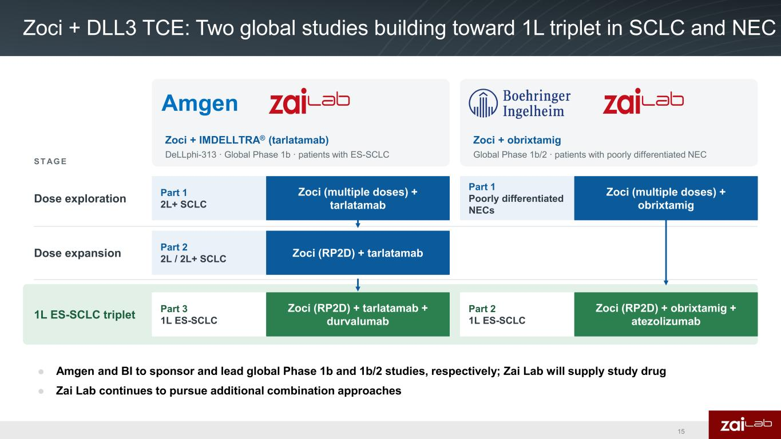
● Amgen and BI to sponsor and lead global Phase 1b and 1b/2 studies, respectively; Zai Lab will supply study drug  Zai Lab continues to pursue additional combination approaches Zoci + DLL3 TCE: Two global studies building toward 1L triplet in SCLC and NEC Dose exploration Dose expansion 1L ES-SCLC triplet S T AG E Zoci + IMDELLTRA® (tarlatamab) DeLLphi-313 · Global Phase 1b · patients with ES-SCLC Part 1 2L+ SCLC Zoci (multiple doses) + tarlatamab Part 2 2L / 2L+ SCLC Zoci (RP2D) + tarlatamab Part 3 1L ES-SCLC Zoci (RP2D) + tarlatamab + durvalumab Zoci + obrixtamig Global Phase 1b/2 · patients with poorly differentiated NEC Part 1 Poorly differentiated NECs Zoci (multiple doses) + obrixtamig Part 2 1L ES-SCLC Zoci (RP2D) + obrixtamig + atezolizumab Amgen 15

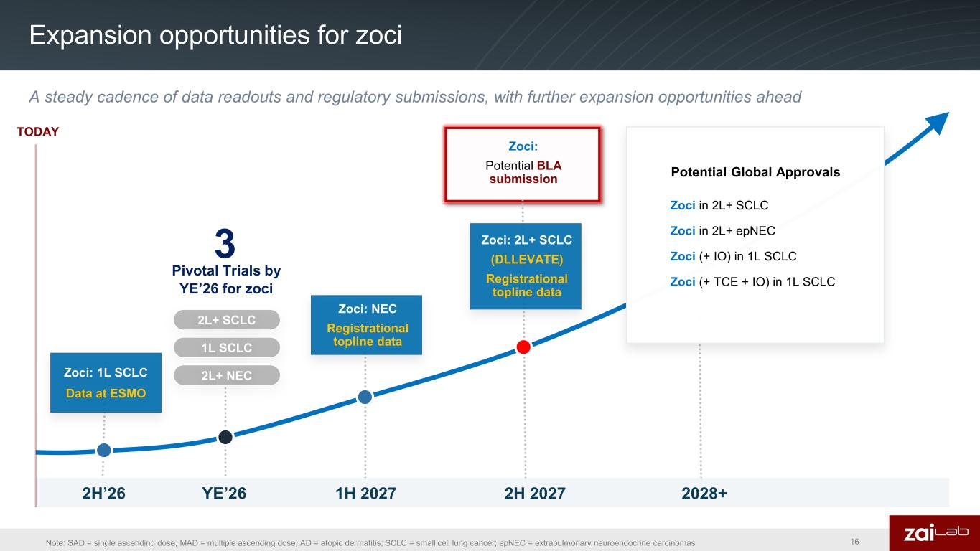
Zoci: 1L SCLC Data at ESMO Expansion opportunities for zoci 3 Pivotal Trials by YE’26 for zoci 1H 2027 2H 2027 2028+2H’26 TODAY YE’26 2L+ SCLC 1L SCLC 2L+ NEC Zoci: Potential BLA submission A steady cadence of data readouts and regulatory submissions, with further expansion opportunities ahead Zoci: 2L+ SCLC (DLLEVATE) Registrational topline data Zoci: NEC Registrational topline data Note: SAD = single ascending dose; MAD = multiple ascending dose; AD = atopic dermatitis; SCLC = small cell lung cancer; epNEC = extrapulmonary neuroendocrine carcinomas Potential Global Approvals Zoci in 2L+ SCLC Zoci in 2L+ epNEC Zoci (+ IO) in 1L SCLC Zoci (+ TCE + IO) in 1L SCLC 16

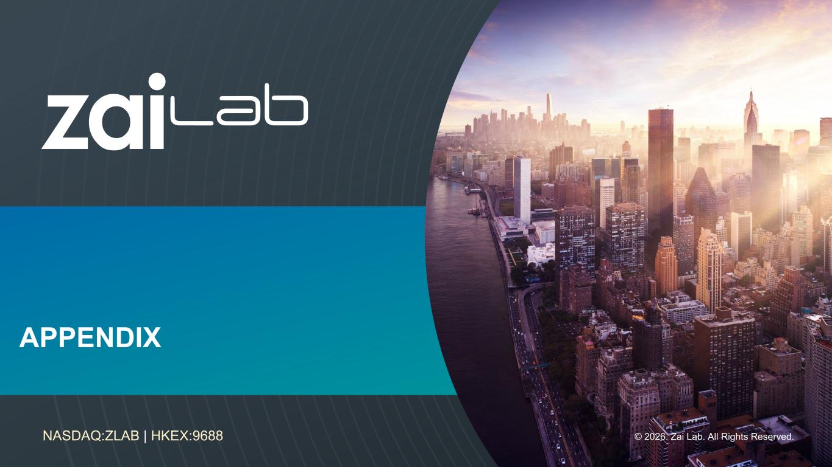
© 2026. Zai Lab. All Rights Reserved.NASDAQ:ZLAB | HKEX:9688 APPENDIX

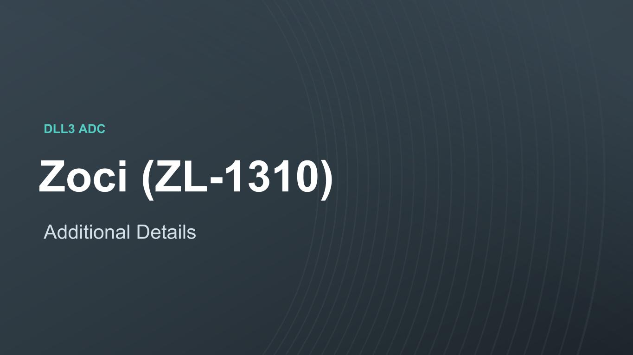
© 2023. Zai Lab. All Rights Reserved.NASDAQ:ZLAB | HKEX:9688 DLL3 ADC Zoci (ZL-1310) Additional Details

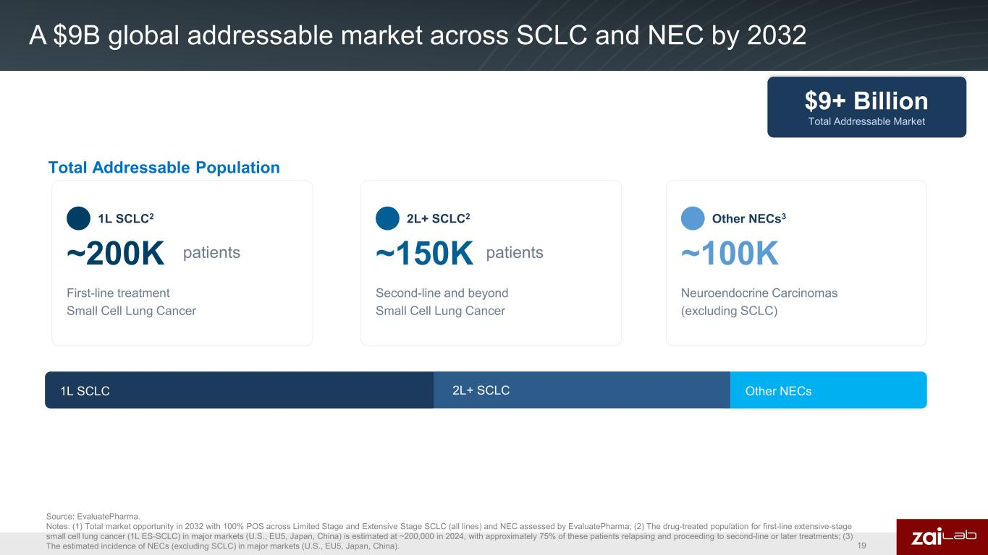
A $9B global addressable market across SCLC and NEC by 2032 Source: EvaluatePharma. Notes: (1) Total market opportunity in 2032 with 100% POS across Limited Stage and Extensive Stage SCLC (all lines) and NEC assessed by EvaluatePharma; (2) The drug-treated population for first-line extensive-stage small cell lung cancer (1L ES-SCLC) in major markets (U.S., EU5, Japan, China) is estimated at ~200,000 in 2024, with approximately 75% of these patients relapsing and proceeding to second-line or later treatments; (3) The estimated incidence of NECs (excluding SCLC) in major markets (U.S., EU5, Japan, China). 19 1L SCLC2 ~200K First-line treatment Small Cell Lung Cancer Other NECs3 ~100K Neuroendocrine Carcinomas (excluding SCLC) patients Total Addressable Population $9+ Billion Total Addressable Market Other NECs1L SCLC 2L+ SCLC2 ~150K patients Second-line and beyond Small Cell Lung Cancer 2L+ SCLC

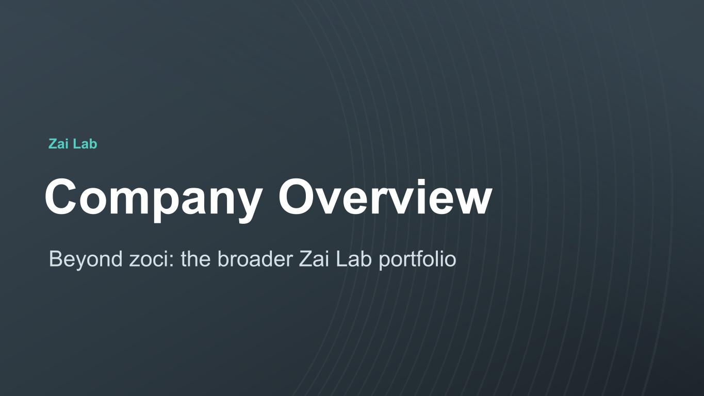
© 2023. Zai Lab. All Rights Reserved.NASDAQ:ZLAB | HKEX:9688 Zai Lab Company Overview Beyond zoci: the broader Zai Lab portfolio

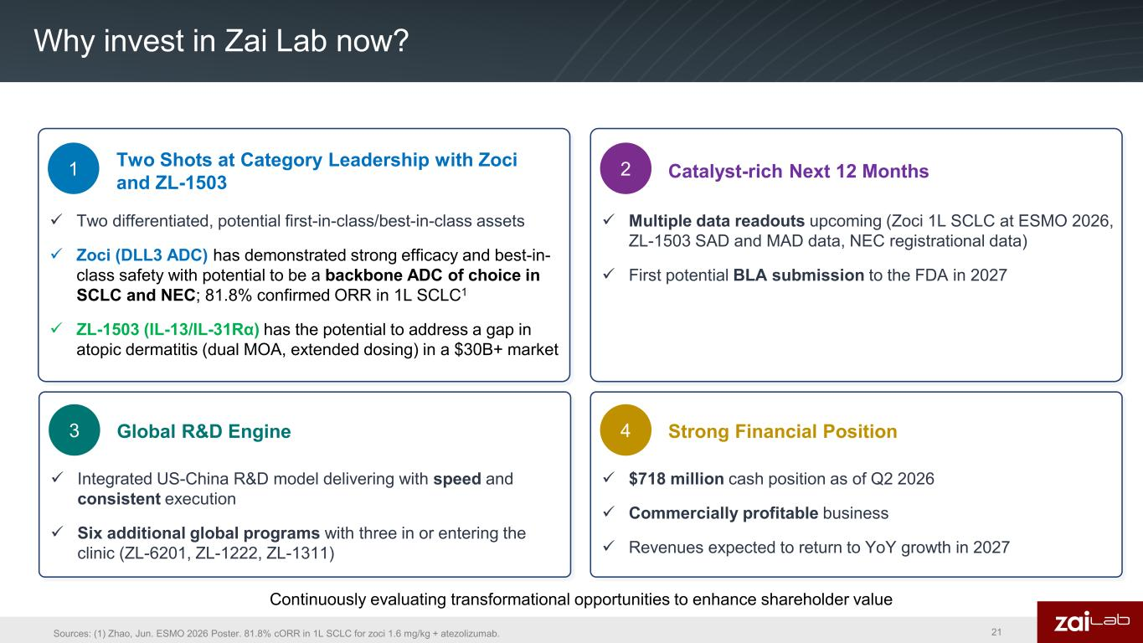
Why invest in Zai Lab now? Two Shots at Category Leadership with Zoci and ZL-1503 ✓ Two differentiated, potential first-in-class/best-in-class assets ✓ Zoci (DLL3 ADC) has demonstrated strong efficacy and best-in- class safety with potential to be a backbone ADC of choice in SCLC and NEC; 81.8% confirmed ORR in 1L SCLC1 ✓ ZL-1503 (IL-13/IL-31Rα) has the potential to address a gap in atopic dermatitis (dual MOA, extended dosing) in a $30B+ market Catalyst-rich Next 12 Months ✓ Multiple data readouts upcoming (Zoci 1L SCLC at ESMO 2026, ZL-1503 SAD and MAD data, NEC registrational data) ✓ First potential BLA submission to the FDA in 2027 1 2 Strong Financial Position ✓ $718 million cash position as of Q2 2026 ✓ Commercially profitable business ✓ Revenues expected to return to YoY growth in 2027 4Global R&D Engine ✓ Integrated US-China R&D model delivering with speed and consistent execution ✓ Six additional global programs with three in or entering the clinic (ZL-6201, ZL-1222, ZL-1311) 3 Sources: (1) Zhao, Jun. ESMO 2026 Poster. 81.8% cORR in 1L SCLC for zoci 1.6 mg/kg + atezolizumab. Continuously evaluating transformational opportunities to enhance shareholder value 21

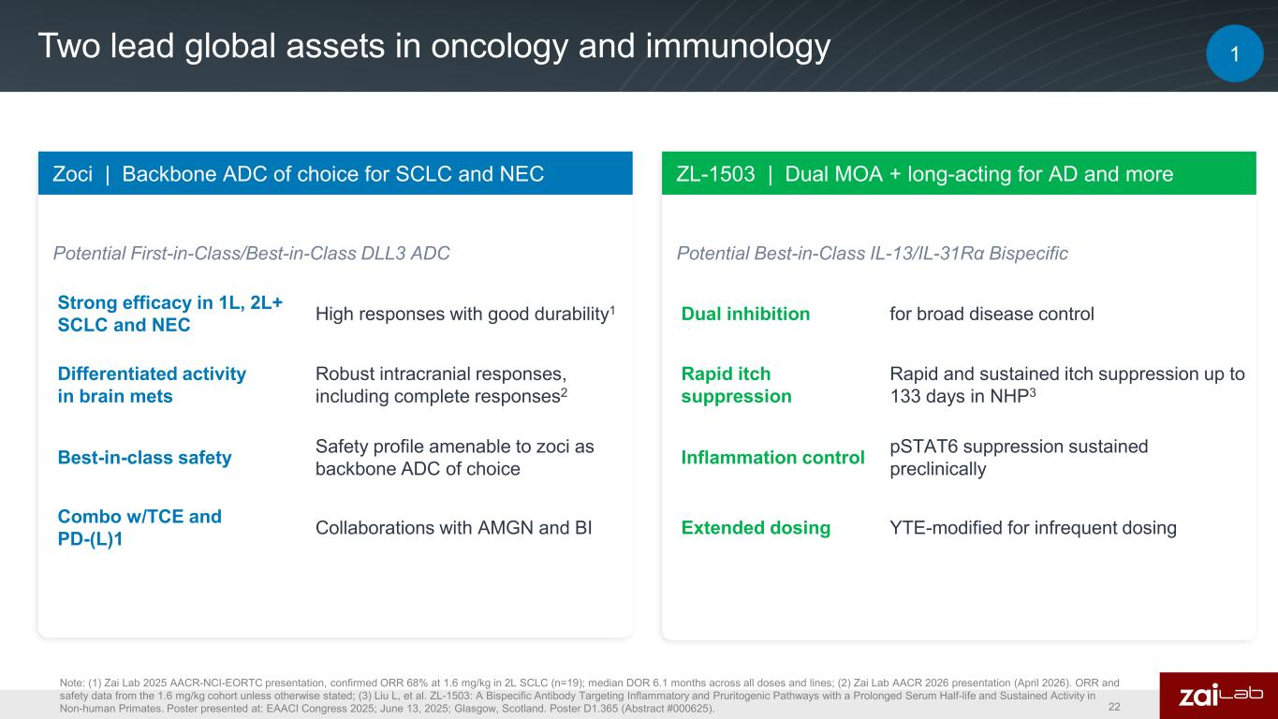
Two lead global assets in oncology and immunology Zoci | Backbone ADC of choice for SCLC and NEC Potential First-in-Class/Best-in-Class DLL3 ADC Best-in-class safety Safety profile amenable to zoci as backbone ADC of choice ZL-1503 | Dual MOA + long-acting for AD and more Potential Best-in-Class IL-13/IL-31Rα Bispecific Dual inhibition for broad disease control Rapid itch suppression Rapid and sustained itch suppression up to 133 days in NHP3 Note: (1) Zai Lab 2025 AACR-NCI-EORTC presentation, confirmed ORR 68% at 1.6 mg/kg in 2L SCLC (n=19); median DOR 6.1 months across all doses and lines; (2) Zai Lab AACR 2026 presentation (April 2026). ORR and safety data from the 1.6 mg/kg cohort unless otherwise stated; (3) Liu L, et al. ZL-1503: A Bispecific Antibody Targeting Inflammatory and Pruritogenic Pathways with a Prolonged Serum Half-life and Sustained Activity in Non-human Primates. Poster presented at: EAACI Congress 2025; June 13, 2025; Glasgow, Scotland. Poster D1.365 (Abstract #000625). Extended dosing YTE-modified for infrequent dosing Inflammation control pSTAT6 suppression sustained preclinically Combo w/TCE and PD-(L)1 Collaborations with AMGN and BI 1 Strong efficacy in 1L, 2L+ SCLC and NEC High responses with good durability1 Differentiated activity in brain mets Robust intracranial responses, including complete responses2 22

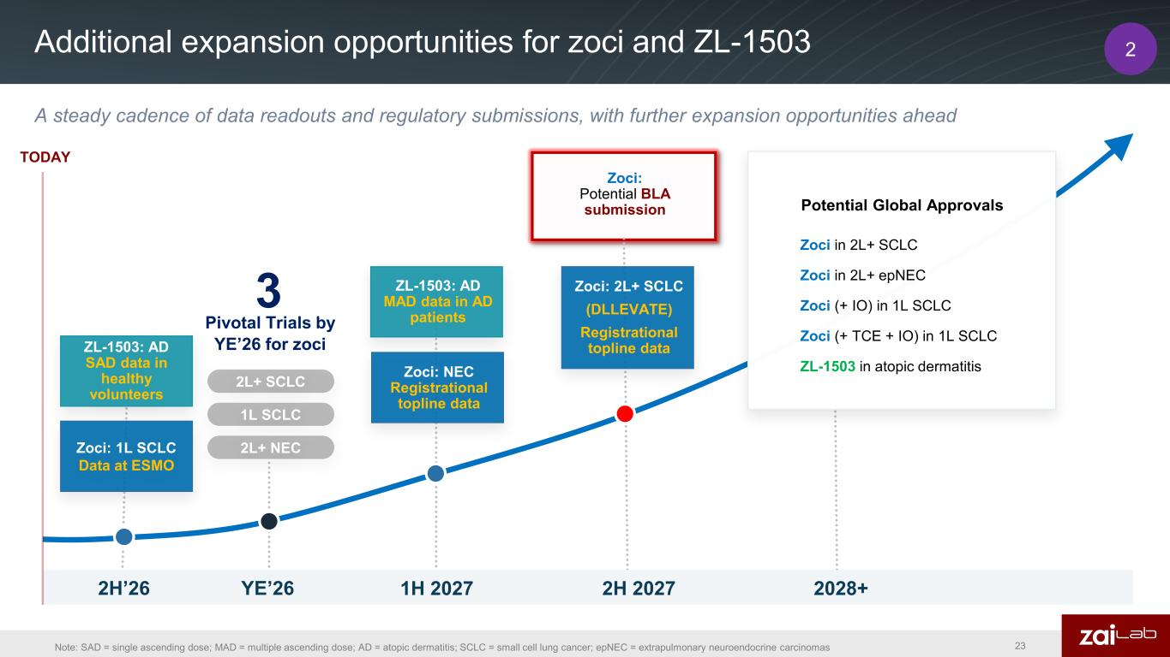
Zoci: 1L SCLC Data at ESMO Additional expansion opportunities for zoci and ZL-1503 3 Pivotal Trials by YE’26 for zoci 1H 2027 2H 2027 2028+2H’26 TODAY YE’26 ZL-1503: AD SAD data in healthy volunteers 2L+ SCLC 1L SCLC 2L+ NEC Zoci: Potential BLA submission A steady cadence of data readouts and regulatory submissions, with further expansion opportunities ahead Zoci: NEC Registrational topline data ZL-1503: AD MAD data in AD patients Note: SAD = single ascending dose; MAD = multiple ascending dose; AD = atopic dermatitis; SCLC = small cell lung cancer; epNEC = extrapulmonary neuroendocrine carcinomas Potential Global Approvals Zoci in 2L+ SCLC Zoci in 2L+ epNEC Zoci (+ IO) in 1L SCLC Zoci (+ TCE + IO) in 1L SCLC ZL-1503 in atopic dermatitis 2 23 Zoci: 2L+ SCLC (DLLEVATE) Registrational topline data

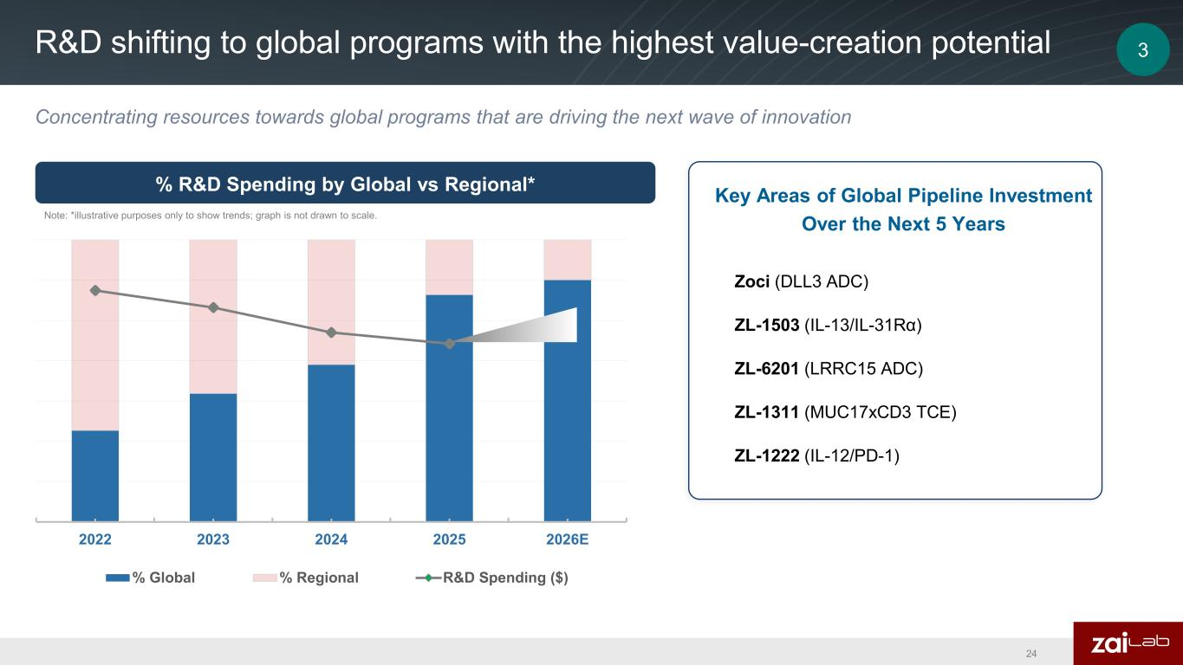
2022 2023 2024 2025 2026E % Global % Regional R&D Spending ($) R&D shifting to global programs with the highest value-creation potential Zoci (DLL3 ADC) ZL-1503 (IL-13/IL-31Rα) ZL-6201 (LRRC15 ADC) ZL-1222 (IL-12/PD-1) ZL-1311 (MUC17xCD3 TCE) % R&D Spending by Global vs Regional* Key Areas of Global Pipeline Investment Over the Next 5 YearsNote: *illustrative purposes only to show trends; graph is not drawn to scale. Concentrating resources towards global programs that are driving the next wave of innovation 24 3

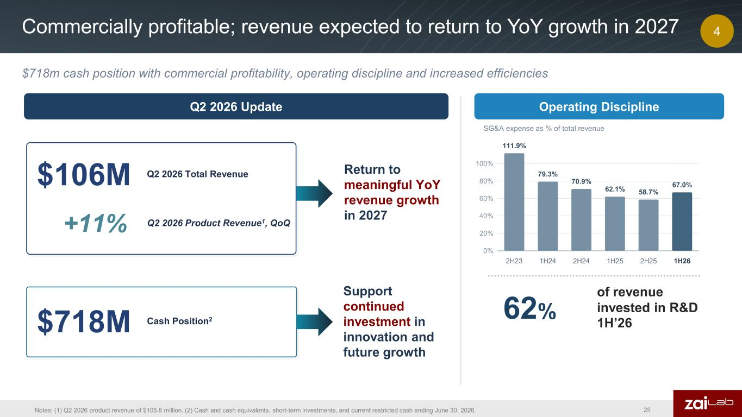
Commercially profitable; revenue expected to return to YoY growth in 2027 $106M Q2 2026 Total Revenue +11% Q2 2026 Product Revenue1, QoQ $718M Cash Position2 Return to meaningful YoY revenue growth in 2027 SG&A expense as % of total revenue 0% 20% 40% 60% 80% 100% 111.9% 2H23 79.3% 1H24 70.9% 2H24 62.1% 1H25 58.7% 2H25 67.0% 1H26 62% of revenue invested in R&D 1H’26 Operating DisciplineQ2 2026 Update Support continued investment in innovation and future growth Notes: (1) Q2 2026 product revenue of $105.8 million. (2) Cash and cash equivalents, short-term investments, and current restricted cash ending June 30, 2026. $718m cash position with commercial profitability, operating discipline and increased efficiencies 25 4

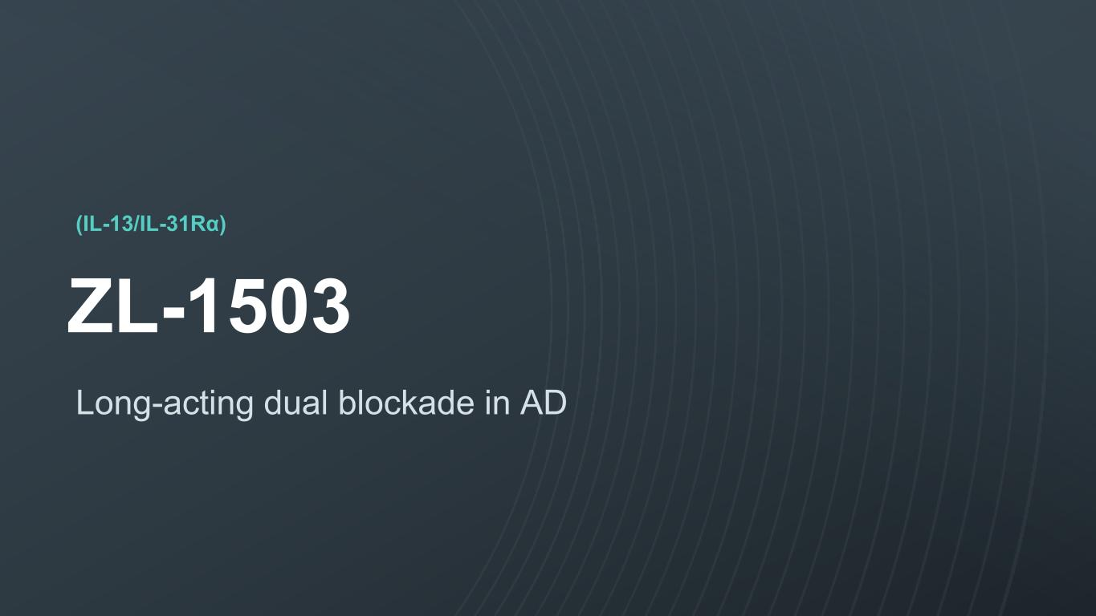
© 2023. Zai Lab. All Rights Reserved.NASDAQ:ZLAB | HKEX:9688 (IL-13/IL-31Rα) ZL-1503 Long-acting dual blockade in AD

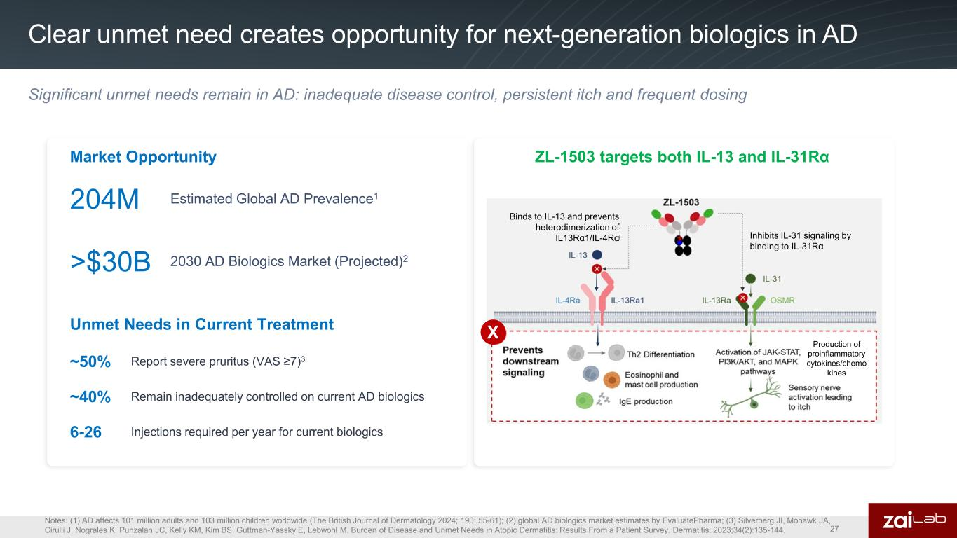
Clear unmet need creates opportunity for next-generation biologics in AD 204M Estimated Global AD Prevalence1 Notes: (1) AD affects 101 million adults and 103 million children worldwide (The British Journal of Dermatology 2024; 190: 55-61); (2) global AD biologics market estimates by EvaluatePharma; (3) Silverberg JI, Mohawk JA, Cirulli J, Nograles K, Punzalan JC, Kelly KM, Kim BS, Guttman-Yassky E, Lebwohl M. Burden of Disease and Unmet Needs in Atopic Dermatitis: Results From a Patient Survey. Dermatitis. 2023;34(2):135-144. Market Opportunity ZL-1503 targets both IL-13 and IL-31Rα >$30B 2030 AD Biologics Market (Projected)2 Unmet Needs in Current Treatment ~50% Report severe pruritus (VAS ≥7)3 ~40% Remain inadequately controlled on current AD biologics 6-26 Injections required per year for current biologics Binds to IL-13 and prevents heterodimerization of IL13Rα1/IL-4Rα Inhibits IL-31 signaling by binding to IL-31Rα Production of proinflammatory cytokines/chemo kines X Significant unmet needs remain in AD: inadequate disease control, persistent itch and frequent dosing 27

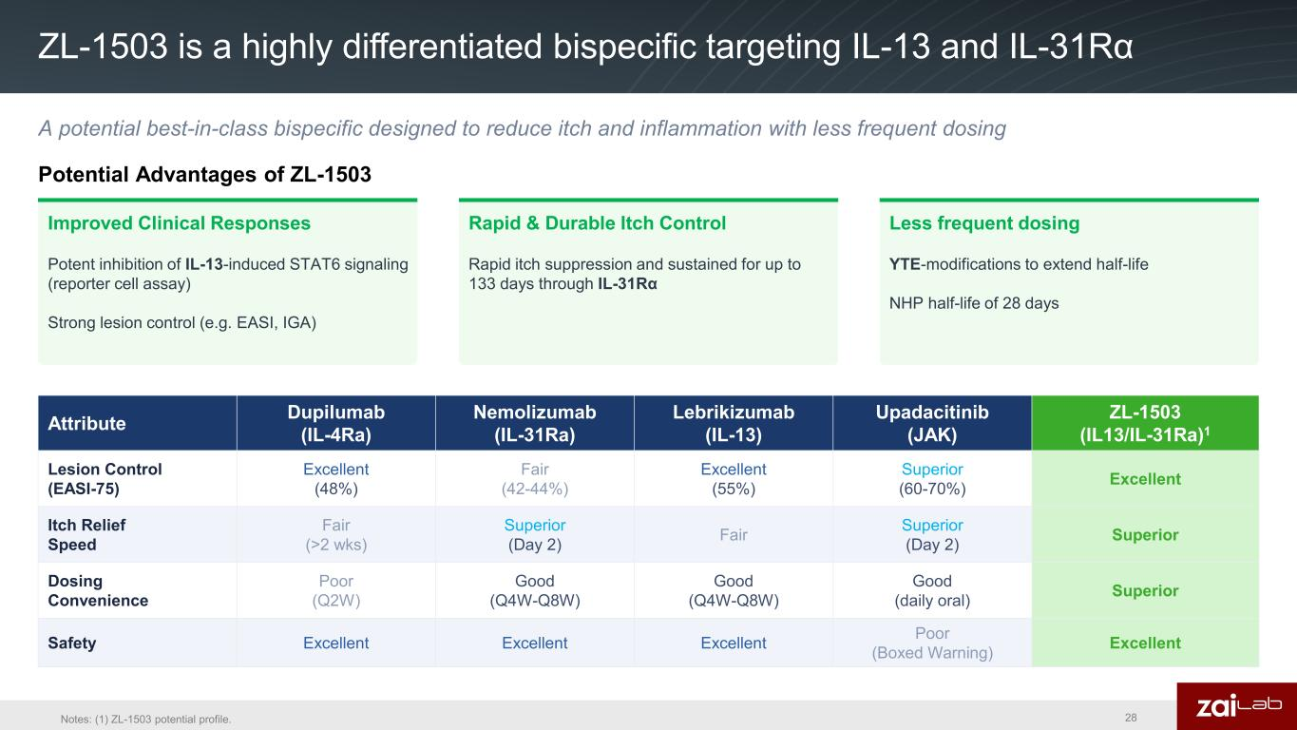
ZL-1503 is a highly differentiated bispecific targeting IL-13 and IL-31Rα Improved Clinical Responses Potent inhibition of IL-13-induced STAT6 signaling (reporter cell assay) Strong lesion control (e.g. EASI, IGA) Rapid & Durable Itch Control Rapid itch suppression and sustained for up to 133 days through IL-31Rα Less frequent dosing YTE-modifications to extend half-life NHP half-life of 28 days Potential Advantages of ZL-1503 Attribute Dupilumab (IL-4Ra) Nemolizumab (IL-31Ra) Lebrikizumab (IL-13) Upadacitinib (JAK) ZL-1503 (IL13/IL-31Ra)1 Lesion Control (EASI-75) Excellent (48%) Fair (42-44%) Excellent (55%) Superior (60-70%) Excellent Itch Relief Speed Fair (>2 wks) Superior (Day 2) Fair Superior (Day 2) Superior Dosing Convenience Poor (Q2W) Good (Q4W-Q8W) Good (Q4W-Q8W) Good (daily oral) Superior Safety Excellent Excellent Excellent Poor (Boxed Warning) Excellent A potential best-in-class bispecific designed to reduce itch and inflammation with less frequent dosing 28Notes: (1) ZL-1503 potential profile.

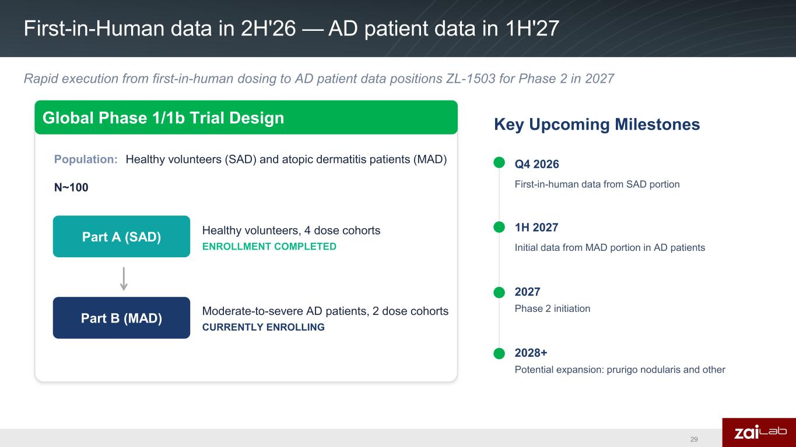
First-in-Human data in 2H'26 — AD patient data in 1H'27 Population: Healthy volunteers (SAD) and atopic dermatitis patients (MAD) N~100 Q4 2026 First-in-human data from SAD portion 2027 Phase 2 initiation Key Upcoming MilestonesGlobal Phase 1/1b Trial Design Part A (SAD) Healthy volunteers, 4 dose cohorts ENROLLMENT COMPLETED Part B (MAD) Moderate-to-severe AD patients, 2 dose cohorts CURRENTLY ENROLLING 1H 2027 Initial data from MAD portion in AD patients 2028+ Potential expansion: prurigo nodularis and other Rapid execution from first-in-human dosing to AD patient data positions ZL-1503 for Phase 2 in 2027 29

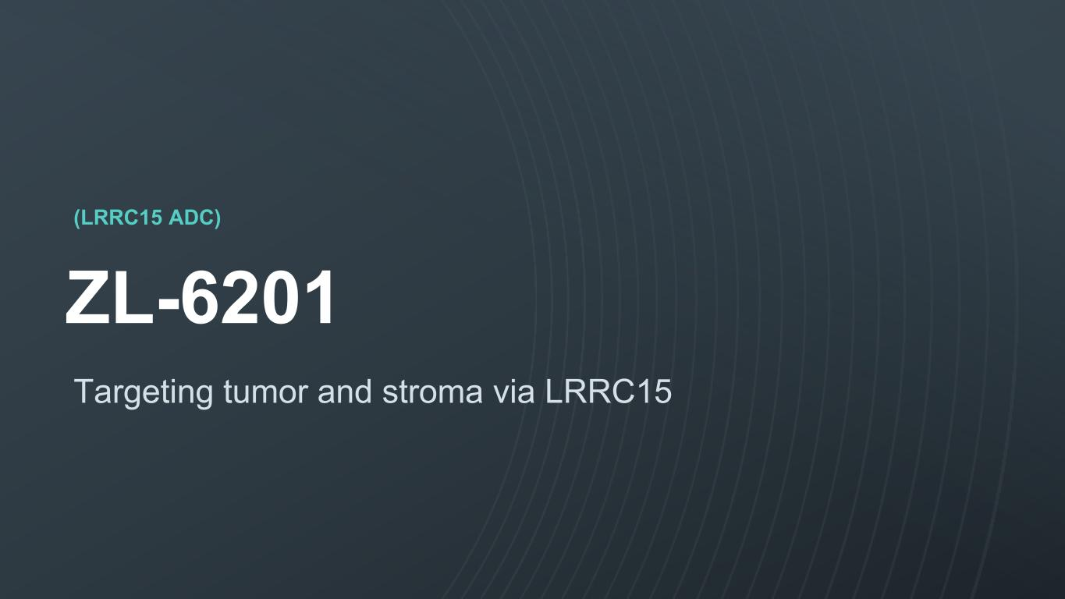
© 2023. Zai Lab. All Rights Reserved.NASDAQ:ZLAB | HKEX:9688 (LRRC15 ADC) ZL-6201 Targeting tumor and stroma via LRRC15

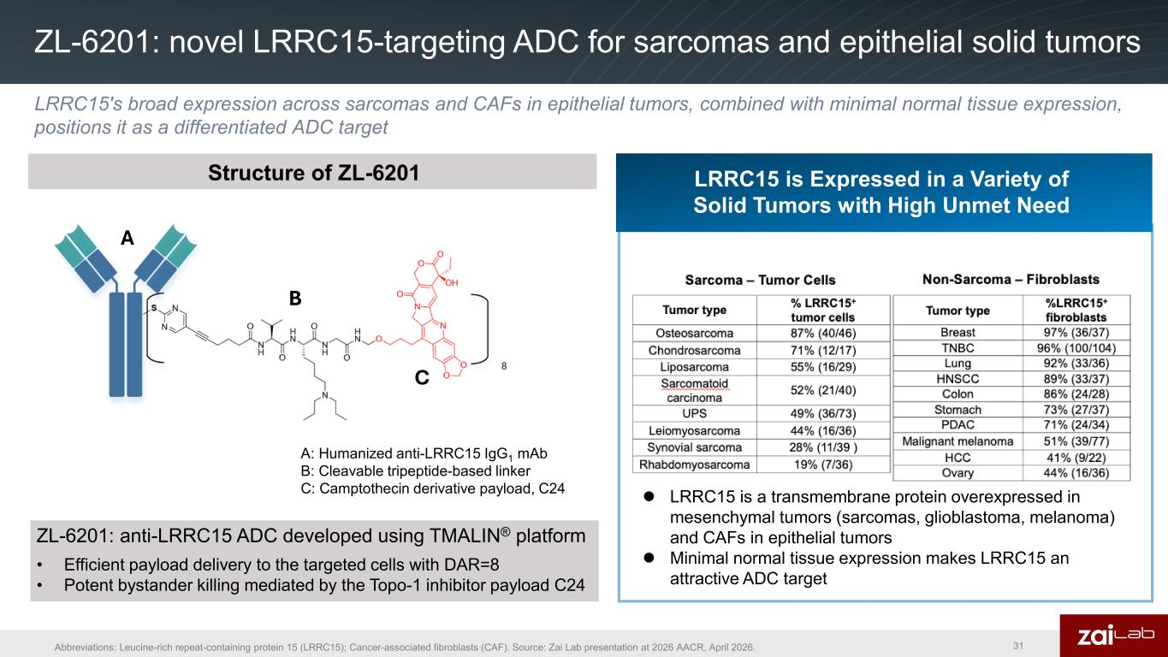
ZL-6201: novel LRRC15-targeting ADC for sarcomas and epithelial solid tumors 31 Structure of ZL-6201 LRRC15 is Expressed in a Variety of Solid Tumors with High Unmet Need A: Humanized anti-LRRC15 IgG1 mAb B: Cleavable tripeptide-based linker C: Camptothecin derivative payload, C24 ZL-6201: anti-LRRC15 ADC developed using TMALIN® platform • Efficient payload delivery to the targeted cells with DAR=8 • Potent bystander killing mediated by the Topo-1 inhibitor payload C24  LRRC15 is a transmembrane protein overexpressed in mesenchymal tumors (sarcomas, glioblastoma, melanoma) and CAFs in epithelial tumors  Minimal normal tissue expression makes LRRC15 an attractive ADC target A B C LRRC15's broad expression across sarcomas and CAFs in epithelial tumors, combined with minimal normal tissue expression, positions it as a differentiated ADC target Abbreviations: Leucine-rich repeat-containing protein 15 (LRRC15); Cancer-associated fibroblasts (CAF). Source: Zai Lab presentation at 2026 AACR, April 2026.

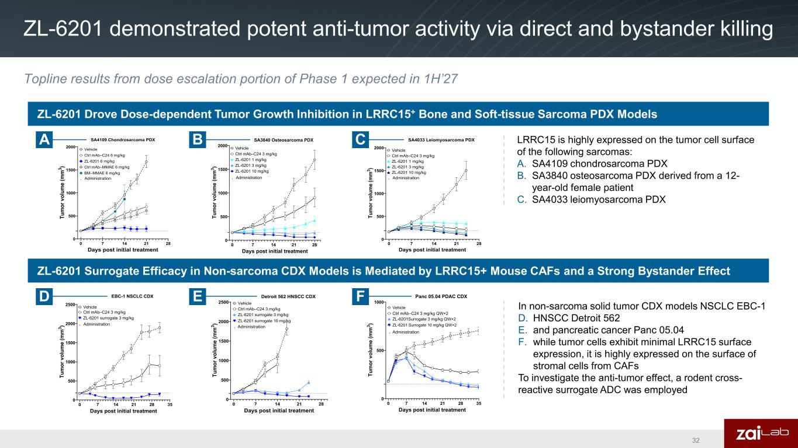
ZL-6201 demonstrated potent anti-tumor activity via direct and bystander killing 32 ZL-6201 Drove Dose-dependent Tumor Growth Inhibition in LRRC15+ Bone and Soft-tissue Sarcoma PDX Models ZL-6201 Surrogate Efficacy in Non-sarcoma CDX Models is Mediated by LRRC15+ Mouse CAFs and a Strong Bystander Effect 0 7 14 21 28 0 500 1000 1500 2000 SA4109 Chondrosarcoma PDX Days post initial treatment Tu m or v ol um e (m m 3 ) Vehicle Ctrl mAb–C24 6 mg/kg ZL-6201 6 mg/kg Ctrl mAb–MMAE 6 mg/kg BM–MMAE 6 mg/kg Administration 0 7 14 21 28 0 500 1000 1500 2000 SA3840 Osteosarcoma PDX Days post initial treatment Tu m or v ol um e (m m 3 ) Vehicle Ctrl mAb–C24 3 mg/kg ZL-6201 1 mg/kg ZL-6201 3 mg/kg ZL-6201 10 mg/kg Administration 0 7 14 21 28 0 500 1000 1500 2000 SA4033 Leiomyosarcoma PDX Days post initial treatment Tu m or v ol um e (m m 3 ) Vehicle Ctrl mAb–C24 3 mg/kg ZL-6201 1 mg/kg ZL-6201 3 mg/kg ZL-6201 10 mg/kg Administration 0 7 14 21 28 35 0 500 1000 1500 2000 2500 EBC-1 NSCLC CDX Days post initial treatment Tu m or v ol um e (m m 3 ) Vehicle Ctrl mAb–C24 3 mg/kg ZL-6201 surrogate 3 mg/kg Administration 0 7 14 21 28 0 500 1000 1500 2000 2500 Detroit 562 HNSCC CDX Days post initial treatment Tu m or v ol um e (m m 3 ) Administration ZL-6201 surrogate 10 mg/kg Vehicle Ctrl mAb–C24 3 mg/kg ZL-6201 surrogate 3 mg/kg 0 7 14 21 28 35 0 500 1000 Panc 05.04 PDAC CDX Days post initial treatment Tu m or v ol um e (m m 3 ) Administration ZL-6201 Surrogate 10 mg/kg QW×2 Vehicle Ctrl mAb–C24 3 mg/kg QW×2 ZL-6201Surrogate 3 mg/kg QW×2 LRRC15 is highly expressed on the tumor cell surface of the following sarcomas: A. SA4109 chondrosarcoma PDX B. SA3840 osteosarcoma PDX derived from a 12- year-old female patient C. SA4033 leiomyosarcoma PDX In non-sarcoma solid tumor CDX models NSCLC EBC-1 D. HNSCC Detroit 562 E. and pancreatic cancer Panc 05.04 F. while tumor cells exhibit minimal LRRC15 surface expression, it is highly expressed on the surface of stromal cells from CAFs To investigate the anti-tumor effect, a rodent cross- reactive surrogate ADC was employed A B C D E F Topline results from dose escalation portion of Phase 1 expected in 1H’27


© 2023. Zai Lab. All Rights Reserved.NASDAQ:ZLAB | HKEX:9688 Other pipeline

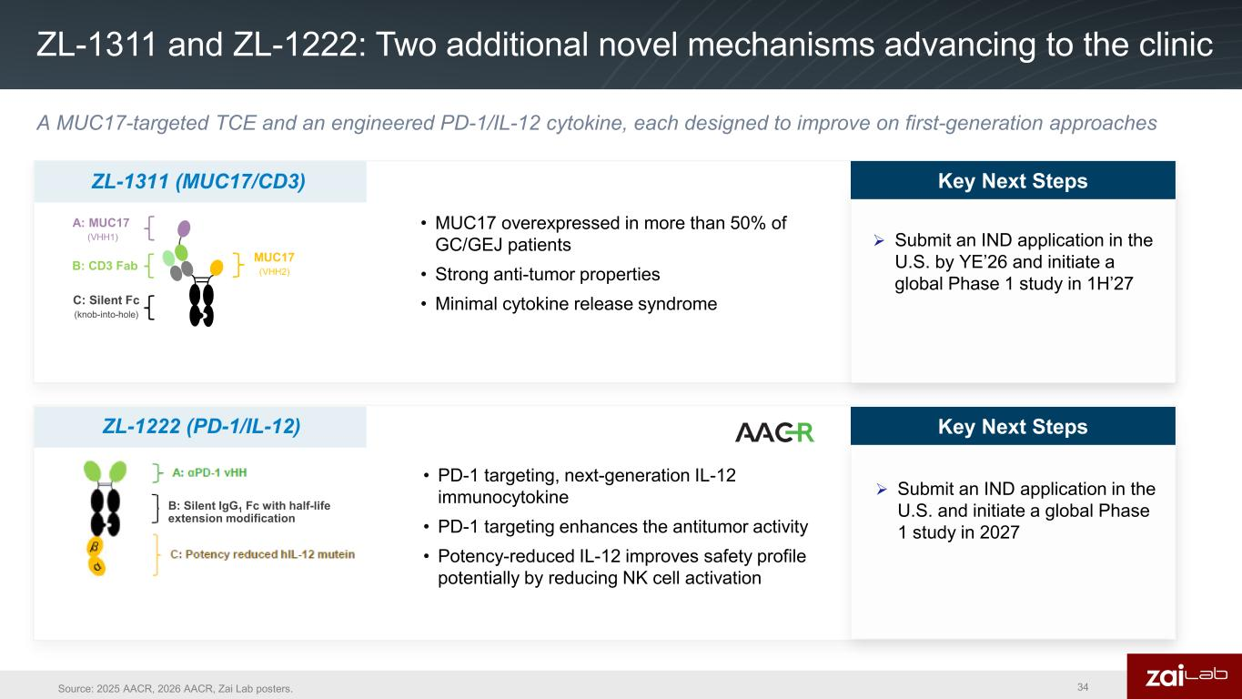
ZL-1311 and ZL-1222: Two additional novel mechanisms advancing to the clinic • PD-1 targeting, next-generation IL-12 immunocytokine • PD-1 targeting enhances the antitumor activity • Potency-reduced IL-12 improves safety profile potentially by reducing NK cell activation Key Next Steps ➢ Submit an IND application in the U.S. and initiate a global Phase 1 study in 2027 ZL-1222 (PD-1/IL-12) B: Silent IgG1 Fc with half-life extension modification Key Next Steps Source: 2025 AACR, 2026 AACR, Zai Lab posters. A MUC17-targeted TCE and an engineered PD-1/IL-12 cytokine, each designed to improve on first-generation approaches 34 • MUC17 overexpressed in more than 50% of GC/GEJ patients • Strong anti-tumor properties • Minimal cytokine release syndrome Key Next Steps ➢ Submit an IND application in the U.S. by YE’26 and initiate a global Phase 1 study in 1H’27 ZL-1311 (MUC17/CD3) Key Next Steps


© 2023. Zai Lab. All Rights Reserved.NASDAQ:ZLAB | HKEX:9688 China regional business

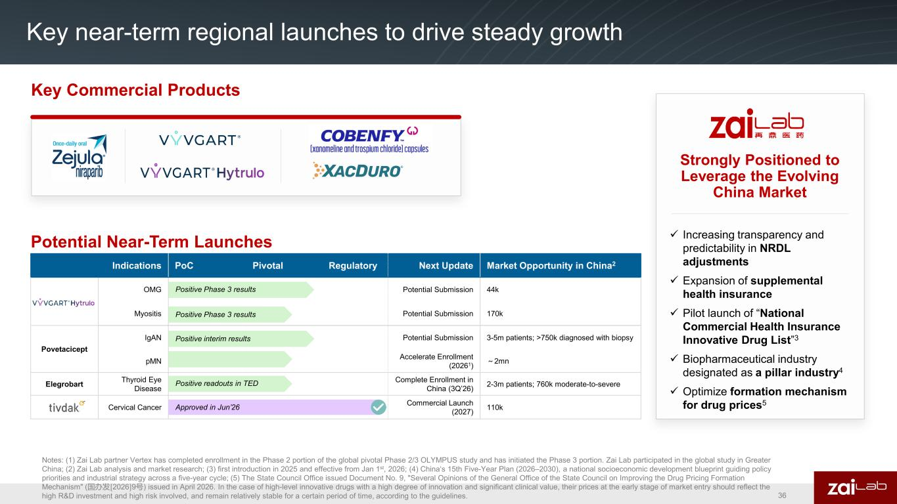
Potential Near-Term Launches Indications PoC Pivotal Regulatory Next Update Market Opportunity in China2 OMG Potential Submission 44k Myositis Potential Submission 170k Povetacicept IgAN Potential Submission 3-5m patients; >750k diagnosed with biopsy pMN Accelerate Enrollment (20261) ～2mn Elegrobart Thyroid Eye Disease Complete Enrollment in China (3Q’26) 2-3m patients; 760k moderate-to-severe Cervical Cancer Commercial Launch (2027) 110k Positive Phase 3 results Positive interim results Approved in Jun’26 Positive Phase 3 results Key Commercial Products Key near-term regional launches to drive steady growth Strongly Positioned to Leverage the Evolving China Market ✓ Increasing transparency and predictability in NRDL adjustments ✓ Expansion of supplemental health insurance ✓ Pilot launch of “National Commercial Health Insurance Innovative Drug List”3 ✓ Biopharmaceutical industry designated as a pillar industry4 ✓ Optimize formation mechanism for drug prices5 Positive readouts in TED Notes: (1) Zai Lab partner Vertex has completed enrollment in the Phase 2 portion of the global pivotal Phase 2/3 OLYMPUS study and has initiated the Phase 3 portion. Zai Lab participated in the global study in Greater China; (2) Zai Lab analysis and market research; (3) first introduction in 2025 and effective from Jan 1st, 2026; (4) China‘s 15th Five-Year Plan (2026–2030), a national socioeconomic development blueprint guiding policy priorities and industrial strategy across a five-year cycle; (5) The State Council Office issued Document No. 9, "Several Opinions of the General Office of the State Council on Improving the Drug Pricing Formation Mechanism" (国办发〔2026〕9号) issued in April 2026. In the case of high-level innovative drugs with a high degree of innovation and significant clinical value, their prices at the early stage of market entry should reflect the high R&D investment and high risk involved, and remain relatively stable for a certain period of time, according to the guidelines. 36

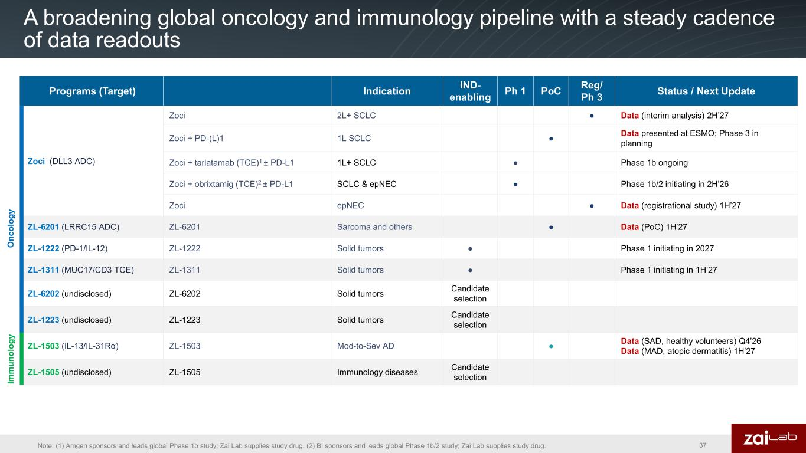
A broadening global oncology and immunology pipeline with a steady cadence of data readouts 37Note: (1) Amgen sponsors and leads global Phase 1b study; Zai Lab supplies study drug. (2) BI sponsors and leads global Phase 1b/2 study; Zai Lab supplies study drug. Programs (Target) Indication IND- enabling Ph 1 PoC Reg/ Ph 3 Status / Next Update Zoci (DLL3 ADC) Zoci 2L+ SCLC ● Data (interim analysis) 2H’27 Zoci + PD-(L)1 1L SCLC ● Data presented at ESMO; Phase 3 in planning Zoci + tarlatamab (TCE)1 ± PD-L1 1L+ SCLC ● Phase 1b ongoing Zoci + obrixtamig (TCE)2 ± PD-L1 SCLC & epNEC ● Phase 1b/2 initiating in 2H’26 Zoci epNEC ● Data (registrational study) 1H’27 ZL-6201 (LRRC15 ADC) ZL-6201 Sarcoma and others ● Data (PoC) 1H’27 ZL-1222 (PD-1/IL-12) ZL-1222 Solid tumors ● Phase 1 initiating in 2027 ZL-1311 (MUC17/CD3 TCE) ZL-1311 Solid tumors ● Phase 1 initiating in 1H’27 ZL-6202 (undisclosed) ZL-6202 Solid tumors Candidate selection ZL-1223 (undisclosed) ZL-1223 Solid tumors Candidate selection ZL-1503 (IL-13/IL-31Rα) ZL-1503 Mod-to-Sev AD ● Data (SAD, healthy volunteers) Q4’26 Data (MAD, atopic dermatitis) 1H’27 ZL-1505 (undisclosed) ZL-1505 Immunology diseases Candidate selection O nc ol og y Im m un ol og y

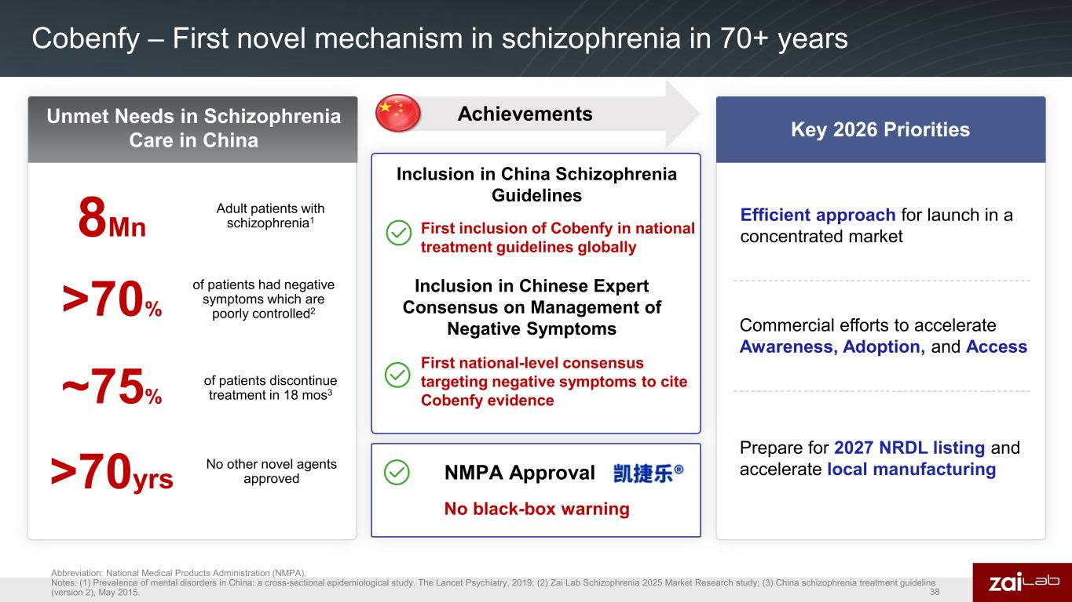
75% of patients medication before 18 months Cobenfy – First novel mechanism in schizophrenia in 70+ years First National-Level Consensus Targeting Negative Symptoms to Cite X/T Evidence Unmet Needs in Schizophrenia Care in China 8Mn Adult patients with schizophrenia1 >70yrs No other novel agents approved Inclusion in China Schizophrenia Guidelines Key 2026 Priorities of patients discontinue treatment in 18 mos3 of patients had negative symptoms which are poorly controlled2 ~75% NMPA Approval Efficient approach for launch in a concentrated market Commercial efforts to accelerate Awareness, Adoption, and Access Prepare for 2027 NRDL listing and accelerate local manufacturing First inclusion of Cobenfy in national treatment guidelines globally No black-box warning Achievements Inclusion in Chinese Expert Consensus on Management of Negative Symptoms First national-level consensus targeting negative symptoms to cite Cobenfy evidence Abbreviation: National Medical Products Administration (NMPA). Notes: (1) Prevalence of mental disorders in China: a cross-sectional epidemiological study. The Lancet Psychiatry, 2019; (2) Zai Lab Schizophrenia 2025 Market Research study; (3) China schizophrenia treatment guideline (version 2), May 2015. >70% 38

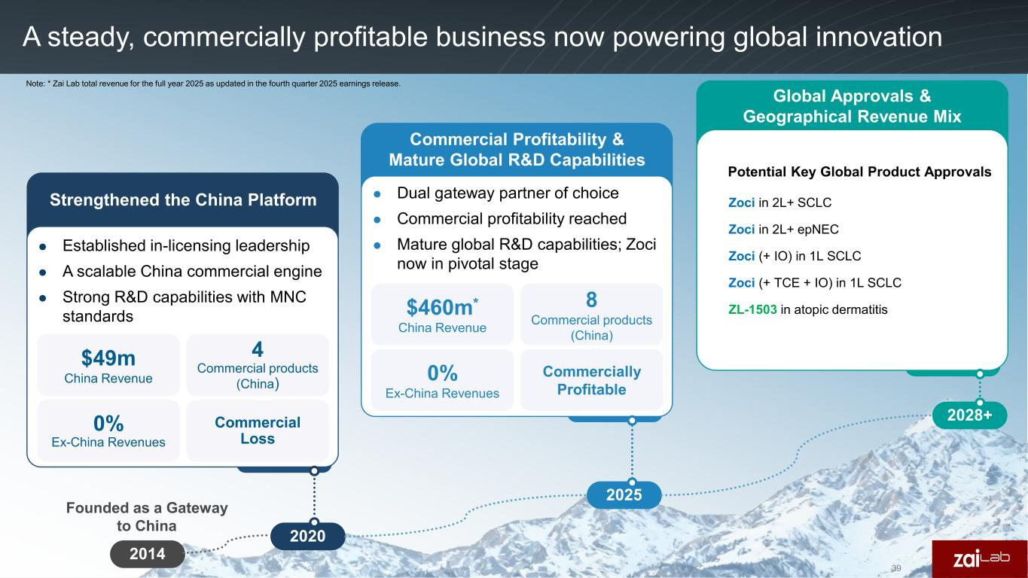
A steady, commercially profitable business now powering global innovation 2020 2025 2028+ $460m* China Revenue 8 Commercial products (China) Commercially Profitable  Established in-licensing leadership  A scalable China commercial engine  Strong R&D capabilities with MNC standards  Dual gateway partner of choice  Commercial profitability reached  Mature global R&D capabilities; Zoci now in pivotal stage Strengthened the China Platform Commercial Profitability & Mature Global R&D Capabilities Global Approvals & Geographical Revenue Mix 0% Ex-China Revenues $49m China Revenue 0% Ex-China Revenues 4 Commercial products (China) Commercial Loss Note: * Zai Lab total revenue for the full year 2025 as updated in the fourth quarter 2025 earnings release. 2014 Founded as a Gateway to China Potential Key Global Product Approvals Zoci in 2L+ SCLC Zoci in 2L+ epNEC Zoci (+ IO) in 1L SCLC Zoci (+ TCE + IO) in 1L SCLC ZL-1503 in atopic dermatitis 39

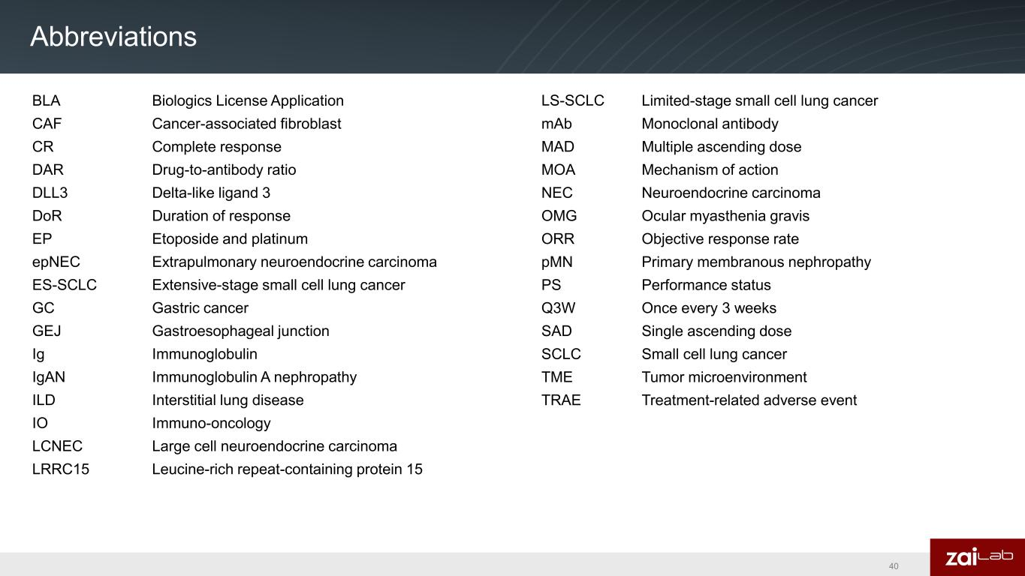
Abbreviations BLA Biologics License Application CAF Cancer-associated fibroblast CR Complete response DAR Drug-to-antibody ratio DLL3 Delta-like ligand 3 DoR Duration of response EP Etoposide and platinum epNEC Extrapulmonary neuroendocrine carcinoma ES-SCLC Extensive-stage small cell lung cancer GC Gastric cancer GEJ Gastroesophageal junction Ig Immunoglobulin IgAN Immunoglobulin A nephropathy ILD Interstitial lung disease IO Immuno-oncology LCNEC Large cell neuroendocrine carcinoma LRRC15 Leucine-rich repeat-containing protein 15 LS-SCLC Limited-stage small cell lung cancer mAb Monoclonal antibody MAD Multiple ascending dose MOA Mechanism of action NEC Neuroendocrine carcinoma OMG Ocular myasthenia gravis ORR Objective response rate pMN Primary membranous nephropathy PS Performance status Q3W Once every 3 weeks SAD Single ascending dose SCLC Small cell lung cancer TME Tumor microenvironment TRAE Treatment-related adverse event 40

Exhibit 99.2

Zai Lab Announces $250 Million Private Placement
SHANGHAI & CAMBRIDGE, Mass.--(BUSINESS WIRE)--Oct. 22, 2026--Zai Lab Limited (NASDAQ: ZLAB; HKEX: 9688) an innovation-driven, global biopharma company, today announced that it has entered into a securities purchase agreement for the sale of 11,340,000 American Depositary Shares (“ADSs”), each representing ten ordinary shares of the Company, to certain investors in a private investment in public equity (“PIPE”) financing. The purchase price of each ADS is $22.04. Gross proceeds from the PIPE financing are expected to be approximately $250 million, before deducting placement agent fees and other offering expenses. The PIPE financing is expected to close on or about October 27, 2026, subject to customary closing conditions.
The financing is led by TCGX and includes participation from other new and existing investors including abrdn World Healthcare Fund, ADAR1 Capital Management, Balyasny Asset Management, Cormorant Asset Management, Frazier Life Sciences, RA Capital Management, RTW Investments, Sirenia Capital Management LP, Wellington Management, and Woodline Partners LP.
Zai Lab intends to use the net proceeds from the PIPE financing primarily to support the continued global development of zocilurtatug pelitecan (zoci), the Company's Delta-like ligand 3 (DLL3)-targeting antibody-drug conjugate (ADC).
Leerink Partners is acting as exclusive placement agent for the PIPE financing. Ropes & Gray is acting as legal advisor to Zai Lab.
The sale and issuance of the foregoing ADSs are being made in a transaction not involving a public offering and have not been registered under the Securities Act of 1933, as amended (the “Securities Act”). The ADSs being issued in the PIPE may not be offered or sold in the United States absent registration or pursuant to an exemption from the registration requirements of the Securities Act and applicable state securities laws. The Company has agreed to file a registration statement with the Securities and Exchange Commission covering the resale of the ADSs acquired by the investors in the Private Placement.
This press release shall not constitute an offer to sell or the solicitation of an offer to buy any securities, nor shall there be any sale of securities in any state or jurisdiction in which such an offer, solicitation or sale would be unlawful prior to registration or qualification under the securities laws of any such state or jurisdiction.
About Zai Lab
Zai Lab Limited (NASDAQ: ZLAB; HKEX: 9688) is an innovative, research-based, commercial-stage biopharmaceutical company based in China and the United States. We are focused on discovering, developing, and commercializing innovative products that address
Exhibit 99.2

medical conditions with significant unmet needs in the areas of oncology, immunology, neuroscience, and infectious disease. Our goal is to leverage our competencies and resources to positively impact human health.
Zai Lab Forward-Looking Statements
This press release contains forward-looking statements relating to our future expectations, plans, and prospects, for Zai Lab, including, without limitation, statements relating to our prospects and plans for developing and commercializing zoci and related timing, the potential treatment of extensive-stage small cell lung cancer (ES-SCLC), our ability to successfully complete the PIPE indicated and with terms and conditions satisfactory to us, the expected closing of the PIPE and the expected use of proceeds from the PIPE. All statements, other than statements of historical fact, included in this press release are forward-looking statements, and can be identified by words such as “aim,” “anticipate,” “believe,” “could,” “estimate,” “expect,” “forecast,” “goal,” “intend,” “may,” “plan,” “possible,” “potential,” “will,” “would,” and other similar expressions. Such statements constitute forward-looking statements within the meaning of the Private Securities Litigation Reform Act of 1995 and U.S. federal securities laws. There can be no assurance that we will be able to complete the PIPE on the anticipated terms, or at all. Forward-looking statements are not guarantees or assurances of future performance. Forward-looking statements are based on our expectations and assumptions as of the date of this press release and are subject to inherent uncertainties, risks and changes in circumstances that may differ materially from those contemplated by the forward-looking statements. We may not actually achieve the plans, carry out the intentions or meet the expectations or projections disclosed in our forward-looking statements, and you should not place undue reliance on these forward-looking statements. Actual results may differ materially from those indicated by forward-looking statements as a result of various important factors, including but not limited to (1) our ability to successfully commercialize and generate revenue from our approved products, (2) our ability to obtain funding for our operations and business initiatives, (3) the results of our clinical and pre-clinical development of our product candidates, (4) the content and timing of decisions made by the relevant regulatory authorities regarding regulatory approvals of our product candidates, (5) risks related to doing business in China, and (6) other factors identified in our most recent annual and quarterly reports and in other reports we have filed with the U.S. Securities and Exchange Commission (SEC). We anticipate that subsequent events and developments will cause our expectations and assumptions to change, and we undertake no obligation to update or revise any forward-looking statements, whether as a result of new information, future events, or otherwise, except as may be required by law. These forward-looking statements should not be relied upon as representing our views as of any date subsequent to the date of this press release.

Exhibit 99.2

View source version on businesswire.com: https://www.businesswire.com/news/home/20261022292690/en/
For more information, please contact:
Investor Relations:
Christine Chiou / Cyan Liu
+1 (917) 886-6929 / +86 195 3130 8895
christine.chiou1@zailaboratory.com / cyan.liu@zailaboratory.com
Media:
Shaun Maccoun / Xiaoyu Chen
+1 (857) 270-8854 / +86 185 0015 5011
shaun.maccoun@zailaboratory.com / xiaoyu.chen@zailaboratory.com

